VALIDATION LAB

**CREO for Analyst**



**STUDENT MANUAL**

## VALIDATION LABORATORY

This course covers the details of the FEA processes from preparing a model, meshing, applying boundary conditions, solving, and post processing the results, and covers applications of various analysis types, this lab allows us to analyze and validate the performance of our 3D virtual prototypes before we make the first part. That means we can iterate more quickly and design with greater confidence while saving money and time.

|  |  |  |
| --- | --- | --- |
| Sr.No. | **Course** | **Duration/Hrs.** |
| 1 | Creo for Analyst | 60 |

## CREO FOR ANALYST

|  |  |  |  |
| --- | --- | --- | --- |
| **Sr.No** | **Domain** | **Course Title** | **Total Duration (Hrs)** |
| **1** | CAE | Creo for Analyst | 60 |

***SOFTWARE PACKAGES: -***

* ***PTC Creo***
* ***PTC Windchill***

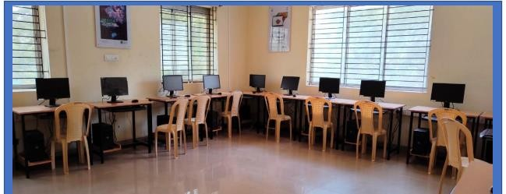

Table of Contents:

Module 01 ― Introduction to Cero Simulate Module 02 ― Theoretical Foundations Module 03 ― Simulation Models

Module 04 ― Materials and Material Properties Module 05 ― Structural Constraints

Module 06 ― Structural Loads Module 07 ― Meshing

Module 08 ― Structural Analysis

Module 09 ― Creating Mechanism Connections Module 10 ― Configuring Motion and Analysis

Module 11 ― Adding Dynamic Entities to a Mechanism Module 12 ― Analysing the Mechanism Model

Module 13 ― Evaluating Analysis Results

Module 14 ― Creating Model Property Features on Creo Parametric Models Module 15 ― Creating Analysis Features on Creo Parametric Models

Module 16 ― Conducting Design Studies and Optimizing Models

**Creo for Analyst:**

Introduction to Creo Simulate 9

Simulate Analysis Functionality 10

Simulate Model Functionality 11

The Simulate Application 12

The Simulate User Interface Functionality 13

The Typical Simulation Process 14

Theoretical Foundations 24

The Finite Element Method 25

The h- and p-Versions of Finite Elements 26

The p-Method 27

Structural Mechanics – Stress Definitions and Hooke’s Law 32

Structural Mechanics – Strain Energy and Failure Theories 33

Simulation Models 35

Preparing a CAD Model 36

Using Inheritance and Remove Features 37

Managing Units 38

Understanding Model Types 41

Element Types Overview 42

Defining Simulate Model Geometry 44

Using Simulate Coordinate Systems 45

Using Surface Regions 47

Using Volume Regions 49

Controlling the Display of Simulation Entities 51

Using Measures 53

Materials and Material Properties 62

Understanding Material Properties 63

Defining Linear Elastic Materials 64

Understanding Failure Criteria 67

Creating Materials 68

Using 3-D Material Orientation 71

Using 2-D Material Orientation 74

Understanding Material Libraries 77

Structural Constraints 78

Defining Constraints 79

Understanding Displacement Constraints 83

Understanding Planar, Pin, and Ball Constraints 92

Understanding Mirror Symmetry Constraints 102

Understanding Cyclic Symmetry Constraints 104

Structural Loads 107

Understanding Structural Loads 108

Defining Global Loads 109

Defining Forces, Moments, and Pressure 111

Defining Loads as Functions 117

Meshing 121

Understanding Meshes 122

Understanding Mesh Options 123

Using AutoGEM Settings 127

Structural Analysis 142

Fundamentals of a Linear Static Analysis 143

Defining a Linear Static Analysis 145

Understanding Modal Analysis 156

Setting Up the Simulate Solver 162

Starting, Stopping, and Monitoring the Simulate Solver 165

Understanding the Batch Process 167

Creating Mechanism Connections 169

Creating Mechanism Bodies 170

Understanding Constraints and Connection Sets 172

Understanding Predefined Connection Sets 172

Configuring Motion Axis Settings 173

Using Rigid Connection Sets 174

Using Pin Connection Sets 176

Using Slider Connection Sets 178

Using Cylinder Connection Sets 180

Using Planar Connection Sets 182

Using Ball Connection Sets 185

Using Weld Connection Sets 186

Using Bearing Connection Sets 189

Using General Connection Sets 191

Using Slot Connection Sets 192

Creating Cam-Follower Connections 194

3D Contact 196

Creating Generic Gear Connections 198

Creating Dynamic Gear Connections 201

Creating Belt Connections 204

Using the Drag and Snapshot Tools 207

Configuring Motion and Analysis 212

Understanding Servo Motors 213

Understanding Analysis Definitions 215

Creating Geometry Servo Motors 217

Creating Motion Axis Servo Motors 220

Creating Slot Motors 222

Graphing the Magnitude of Servo Motors 224

Assigning Constant Motion 225

Assigning Ramp Motion 227

Assigning Cosine Motion 229

Assigning SCCA Motion 231

Assigning Parabolic Motion 233

Assigning Polynomial Motion 236

Assigning Table Motion 238

Adding Dynamic Entities to a Mechanism 238

Defining Mass Properties for a Dynamic Analysis 239

Creating Force Motors 242

Creating Springs 246

Creating Dampers 249

Creating Dynamic Gear Connections 254

Creating Belt Connections 255

Using Dynamic Properties and Set Zero Position 258

Applying Friction and Restitution 259

Applying Force and Torque Loads 262

Applying Gravity 265

Analyzing the Mechanism Model 274

Understanding Mechanism Dynamics Option Analysis Definitions 275

Configuring a Dynamic Analysis 277

Configuring a Static Analysis 280

Configuring a Force Balance Analysis 283

Defining Initial Configurations 286

Creating Measures 289

Understanding Redundancies and Degrees of Freedom 291

Evaluating Analysis Results 299

Running Mechanism Analyses 300

Evaluating Playback Results for Collisions 301

Configuring Playback Results 303

Evaluating Results Using Display Arrows 306

Graphing Measure Results 308

Creating Model Property Features on Creo Parametric Models 310

Comparing Model Property Analyses 311

Measuring Mass Properties 312

Measuring X-Section Mass Properties 314

Measuring Pairs Clearance 316

Creating Analysis Features on Creo Parametric Models 321

Comparing Analysis Features 322

Creating a Relation Analysis Feature 323

Creating a Motion Analysis Feature 327

Creating a Creo Simulate Analysis Feature 331

Creating an MS Excel Analysis Feature 333

Creating an External Analysis Feature 336

Monitoring the Parameters of Analysis Features 336

Statistical Design Study 339

Conducting Design Studies and Optimizing Models 340

Comparing Design Studies 341

Translating Design Specifications 342

Performing Sensitivity Analysis 343

Performing Feasibility Design Studies 350

Performing Optimization Design Studies 355

# Module 1

## Introduction to Creo Simulate

  

## Simulate Analysis Functionality

##### Creo Simulate is a structural and thermal analysis code working exclusively with the p- Finite-Element-Method.

The following types of analyses are supported by Simulate:

* Structural: Static Figure 1 – Analysis Results
* Structural: Dynamic
* Simulate Thermal

**Simulate Analysis Functionality**

Creo Simulate is a structural and thermal analysis code working exclusively with the Finite-Element-Method. This ensures that the numerical quality of the results delivered can be accurately controlled by the user.

Creo Simulate can be operated in two different modes: Embedded and Standalone modes. In Embedded mode, Creo Simulate is operated as one module of Creo Parametric. Simulate can be accessed directly from Parametric, the model analyzed and optimized for selected dimension and property parameters, and given back to Parametric. In Standalone mode, Creo Simulate is operated as a standalone app which can perform analyses on Creo Direct, Parametric, or other CAD system geometry.

In FEM Mode, NASTRAN and ANSYS h-meshes can be prepared for analysis by those FEA solvers and the results post-processed.

The following types of analyses are supported by Simulate:

* Structural: Static
  + Linear static analysis (SDA – Small Displacement Analysis).
  + Linear static analysis with prestress (based on SDA).
  + Large Displacement Static analysis (LDA) – In this analysis, external loads are iteratively applied to the deformed structure, until the final equilibrium of forces and moments is reached.
  + Static contact analysis (based on SDA or LDA).
  + Linear Buckling Analysis (stability analysis).
  + Nonlinear stability analysis, based on LDA – this is called snap-through analysis in Simulate.
* Structural: Dynamic
  + Modal analysis.
  + Modal analysis with prestress.
  + Dynamic frequency analysis.
  + Dynamic time analysis.
  + Random response analysis.
  + Dynamic shock analysis (earthquake analysis).
* Simulate Thermal
  + Steady-state thermal analysis
  + Transient thermal analysis

Simulate Thermal enables you to analyze temperature fields and heat flows within the mechanical structure for given thermal boundary conditions and heat loads. It does not calculate these conditions automatically, since it is not a Computational Fluid Dynamics (CFD) tool. Temperature fields analyzed by Simulate Thermal can be read into the Simulate Structure to calculate thermal displacements and stresses. Additional Design Studies enable you to study the influence of design variables to the model and optimize it to certain goals for all of the analysis types listed above.

## Simulate Model Functionality

##### Simulate directly works on the CAD Geometry given by Creo Parametric or Creo Direct.

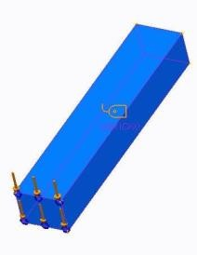Simulate offers different:

* Model types
* Idealized element types
* Predefined assembly connections
* Materials

Figure 1– Solid Element

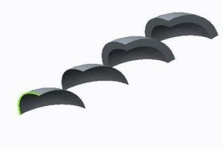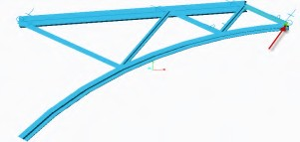

Figure 2 – Shell Element Figure 3 – Idealized Beam Element

**Simulate Model Functionality**

Simulate directly works on the CAD Geometry given by Creo Parametric or Creo Direct. During preprocessing, Simulate works directly on the CAD geometry. This makes Simulate very powerful when changes or iterative design optimizations are performed, since the simulation features are linked to the CAD geometry. Just before the meshing starts, the CAD geometry is translated into the simulation geometry on which the Finite Element analysis is based. Legacy Independent Mode directly works with this simulation geometry, not with the CAD geometry. Results can be evaluated with the postprocessor which provides extensive functionality. Simple parts and large and complex assemblies can be analyzed with Simulate.

**Model types supported:**

* 3-D volumes – element types: tetrahedrons, wedges, bricks
* 2-D plane stress – element types: triangles, quadrilaterals
* 2-D plane strain – element types: tris, quads, and 2-D shells
* 2-D axial symmetric – element types: tris, quads, and 2-D shells

**Idealized element types supported:**

* p-shells – element types: tris, quads.
* p-beams.
* Rigid and Weighted Links.
* Discrete Masses and Springs.

**Predefined assembly connections supported:**

* Features to connect shell midsurfaces in assemblies.
  + Welds – Manually defined shell elements.
  + Bonding elements – Automatically created orthotropic shells/volumes.
  + Assembly links – Automatically created multi-point constraints (MPCs).
    - Spot Welds – Beam Fasteners.
    - Fasteners – Idealized Bolts.
    - Pretension elements – Prismatic or general volumes for which a pretension can be defined.

**Materials Supported:**

* + - Linear Elastic
      * Isotropic – Direction-independent properties.
      * Transversely Isotropic and Orthotropic – Direction-dependent properties.
      * Composites – Laminates containing different plies, for analysis with shell elements.
    - Hyperelastic — Elastomers, rubber
    - Plasticity

## 

## The Simulate Application

Creo Simulate is used as an embedded application in the Creo Parametric interface, Embedded Mode, or as a separate application with a similar user interface, Standalone Mode**.** When starting Simulate, you may choose Structure Mode (default) or Thermal Mode. You should also define the following:

* Mode
* Model Type
* Default Interface

#### The Simulate Application

Creo Simulate is used as an embedded application in the Creo Parametric interface, Embedded Mode, or as a separate application with a similar user interface, Standalone Mode. Creo Simulate enables you to handle assemblies with different units. Also, you may select individual units for all quantities you enter. You should be careful with units, as this is a common source of error.

The model units system has to be defined in the CAD tool you use. In Creo Parametric, you can do this by clicking File

**>** Prepare **>** Model Properties **>** Units.

When starting Simulate, you may choose Structure Mode (default) or Thermal Mode. In addition to this selection, in the ribbon, select the Home tab. Click Model Setup in the Set Up group to define the following:

Mode – You can select to use the FEM Mode. This uses the Simulate UI for creating h-meshes for the classical ANSYS or NASTRAN FEM solvers. If you use the default, Simulate is run in Native Mode. Native mode uses unique p-element technology and Simulate’s own equation solver.

* + - Model Type – Select 3-D, default, or various 2-D idealizations.
    - Default Interface – Select bonded, free, or contact in Structure Mode, or bonded, adiabatic, or thermal resistance in Thermal Mode. This selection defines how Simulate treats touching surfaces in assemblies.

For Structure mode, you can also select the Capability Mode. The selection for this mode is Creo Simulate Lite. This activates a very simple Simulate with a reduced command set for use with a Creo Parametric license.

## The Simulate User Interface Functionality

##### The most common commands for simulation model definition, analysis, and postprocessing can be accessed by using commands located on the Simulate tabs.

The following tabs are available:

* File
* Home
* Refine Model
* Inspect
* Tools
* 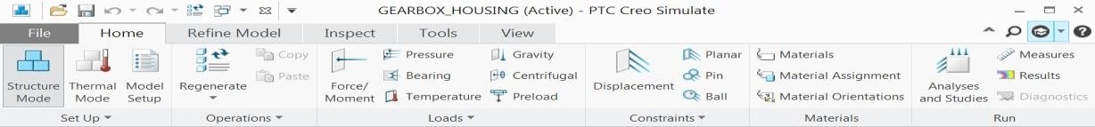View

Figure 1 – The Simulate Tabs

**The Simulate User Interface Functionality**

The most common commands for simulation model definition, analysis, and postprocessing can be accessed by using commands located on the Simulate tabs. The tabs are located in a ribbon at the top of the workspace and group-related commands.

The following tabs are available:

* **File**
  + Commands to create new (available in embedded mode), open, or save a file.
  + Commands to manage a file or session.
* **Home**
  + Select current coordinate system, and enter Simulation Model Setup.
  + Commands for simulation model definition and properties. Create and review loads, constraints, materials, and measures.
  + Enter Simulate analysis definition dialog, and enter the postprocessor.
  + Access Diagnostics for model debugging.
* **Refine Model**
  + Commands for simulation model refinement, idealizations, connections, surface and volumes, regions, datums, and editing.
  + Commands to define mesh settings and create mesh (AutoGEM), and define geometry tolerance for the simulation geometry translation, and simulation geometry and connectivity review.
* **Inspect**
  + Commands to obtain information about the model, geometry (length or distance), interferences, mass properties, short edges (important for meshing), or model size.
    - **Tools**
      * Reports information about the simulation and CAD model, such as regeneration tolerances, feature information, or parameters. There also is a search tool.
    - **View**
      * Commands for model display settings such as datum planes, points, or coordinate systems.
      * Commands for model orientation such as zoom operations, appearances, and layer display.

The Quick Access toolbar is located above the main ribbon on the left and contains frequently used commands. You can customize the Quick Access toolbar by adding or removing commands. You can also display the Quick Access toolbar above or below the ribbon. Help is located above the main ribbon on the right. In addition to the traditional help files, there is a Command Search utility and Context-Sensitive help.

## 

## The Typical Simulation Process

##### A simulation with Creo Simulate always follows a typical three-step process with an optional fourth step.

1. Preprocessing
2. Analysis
3. Post-processing
4. Design variation and optimization (optional)

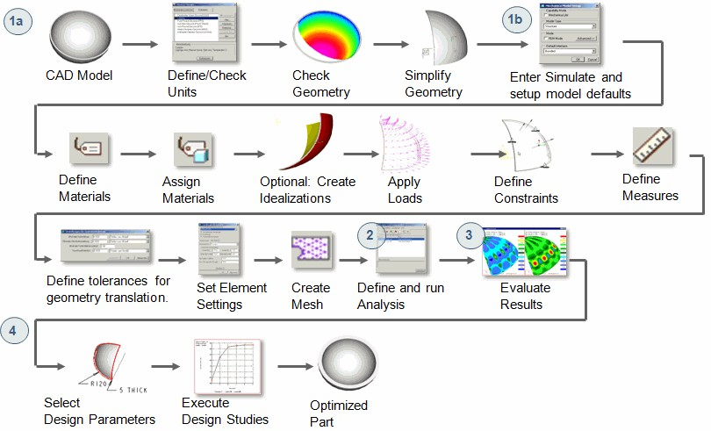

Figure 1 – The Typical Simulation Process

**The Typical Simulation Process**

A simulation with Creo Simulate always follows a typical three-step process with an optional fourth step.

1. Preprocessing – Geometry is prepared using Creo Parametric and the analysis model is defined in Creo

Simulate.

* 1a – Geometry Preparation – Geometry is simplified with Creo Parametric, or Creo Direct, to optimize mesh quality and minimize model size and calculation time.
* 1b – Model Preparation – Define the material and assign it. The following are optional tasks:
  + Create shells, beams, springs, interfaces, or other idealizations and simulation features.
  + Define loads and constraints. These are always required, except in a free-free modal analysis.
  + Define Measures.
  + Define tolerances for geometry translation.
  + Define mesh controls and create mesh.

1. Analysis – The analysis type and settings are defined and the matrix equation system is solved by the Simulate engine.
2. Post-processing – Evaluate analysis results. Carefully execute a validity check and document the

results.

1. Design variation and optimization (optional) – Defined property and dimensioning parameters can be modified by using design studies to optimize the model to certain goals. Vary the parameters to study the model sensitivity with respect to these parameters. Optimize the model based on the results.

**Typical simulation documentation contains:**

* The simulation information – The task, function of product, objective of the simulation, geometry simplification, and idealizations used.
* A description of the simulation model, including material, loads, constraints, mesh type, and calculation settings.
* The results – Result graphs, fringe plots of deformation and stress, status and report files, conclusions, error estimates, software release information, and a summary.

**PROCEDURE - The Typical Simulation Process Exercise**

### Objectives

After successfully completing this exercise, you will be able to:

* Review the complete simulation process using the new Creo Simulate user interface.

This example shows a simple and complete simulation process for a single structural component under a quasi-static load. Keep in mind the simulation workflow as a guideline when approaching this example.

The structural component models a special gearbox housing made of gray cast iron. The reaction forces of the shafts acting on the gearbox are known from a separate gear analysis. From that analysis, and combined with the nature of the geometry, constraints, and materials, we conclude that the housing can be analyzed using symmetry. Cutting the model along the symmetry plane provides

the same results as analyzing the full model. This operation (when possible) enables the analysis to complete in a shorter amount of time than the analysis for the full 3-D model. In this example, you are interested to find out if the brittle cast housing can withstand these bearing reaction loads.

**Step 1: Open and investigate the geometry model.**

1. 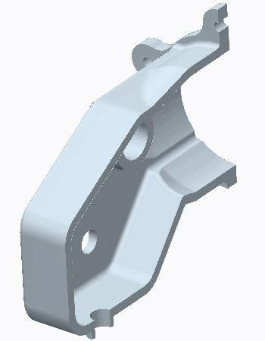For Creo Simulate users, open GEARBOX_ HOUSING_SIMULATE.PRT. The cosmetic features have been suppressed and the symmetry cut has been made and stored already in the model.
2. For Creo Parametric users, open GEARBOX_HOUSING.PRT. Examine the CAD geometry and review the suppressed

cosmetic features in the model tree, which do not affect the maximum stress or deformation values in the model:

* + Chamfer Id 1645 and 4677
  + Cut Id 5450 and Round 2

Also, note that half of the housing is cut away for symmetry reasons. The model, prepared for simulation purposes, should look like the figure shown.

**Step 2: Investigate the model properties.**

1. Click **File > Prepare > Model Properties**. The Model Properties dialog box appears.
2. Review the units used to create the model. It is useful to understand the overall size of the model, although it may not carry any importance if the designer has used mass-driven or force-driven units to create the geometry. In this current model, the designer used force-driven system of units, mm-N-sec.

For Creo Simulate users, the model uses the system of units with which the model was originally created.

**Step 3: Define the materials.**

|  |
| --- |
| 1. In the Model Properties dialog box, click **change** on the Material row. The Materials dialog box appears. 2. Click **File > New**. The Material Definition dialog box appears. 3. Complete the fields as shown in the figure and click **Save To Model** to close the Material Definition dialog box and return to the Materials dialog box. |
| 1. In the Materials dialog box, click **OK** to return to the Model Properties dialog box. 2. In the Model Properties dialog box, click **Close**. 3. In the model tree, select GEARBOX_HOUSING_SIMULATE.PRT and click **Material Assignment**   from the mini toolbar.   1. The Material Assignment dialog box appears. Since there is only one model available, click **OK**.   ***Note:*** *The values for the material properties have been compiled from a list of engineering references. Among other characteristics of the system, such as constraints and geometrical dimensions, these material properties are*  *critical in establishing the stiffness of the structure.* |

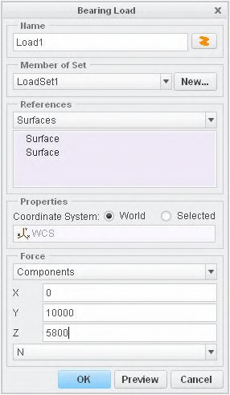**Step 4: Define bearing loads.**

1. Enable **Csys Display **.
2. The first larger diameter hole in the model carries a bearing load magnitude of 10000 N along the positive Y-axis and 5800 N along the positive Z-axis. To define this load, in the ribbon, select the **Home** tab.
3. Click **Bearing ** from the Loads group. The Bearing Load dialog box appears.
4. Select **Hole id 843** from the model tree. On the model, select any of the periodic surfaces of the Hole Id 843 feature.
5. Complete the Bearing Load dialog box as shown.

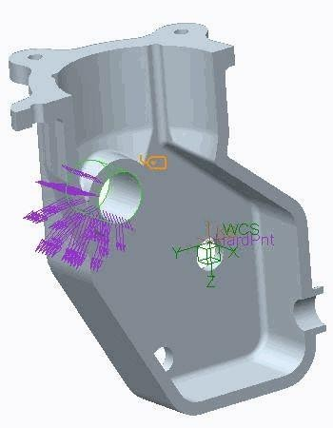

|  |
| --- |
| 1. Click **Preview** to display the graphical representation of this load distribution as shown in the figure. 2. In the Bearing Load dialog box, click **OK**. |
| 1. Repeat the above process to assign bearing load components to the identified holes, as defined:    1. Hole id 818 – Load2       * X=0       * Y=–3600       * Z=–1000    2. Hole id 792 – Load3       * X=0       * Y=5700       * Z=0 |

**Step 5: Define the model constraints.**

* 1. 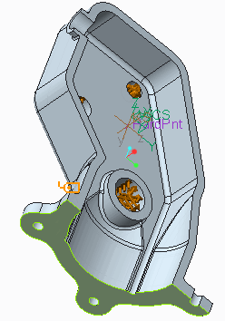Select the surface shown in the figure and click **Displacement ** from the mini toolbar. The Constraint dialog box appears.



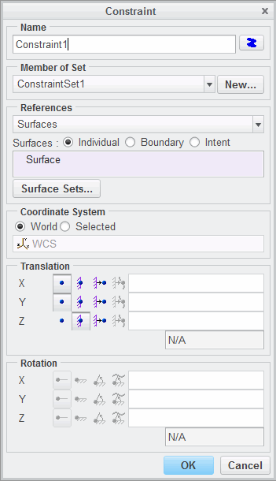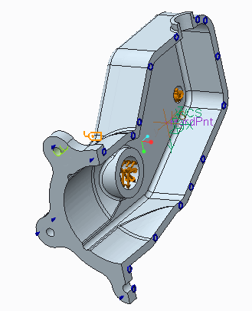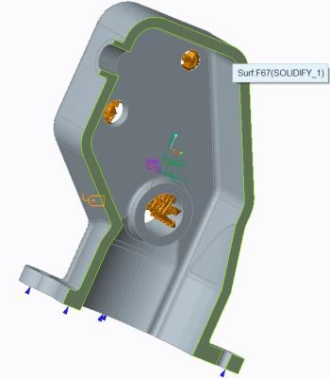

|  |
| --- |
| 2. Free the x and y translational degrees of freedom  by selecting **Free Translation** as shown. Click **OK** to complete the definition of  this constraint. |
| 1. To create the mirror cut constraint for the symmetry/cutting surface, in the ribbon, select the **Home** tab. 2. Click the Constraints group drop-down menu and select **Symmetry** . The Symmetry Constraint dialog box appears. 3. Select the surface as shown in the figure as reference for the symmetry constraint. 4. In the Symmetry Constraint dialog box, click **OK**   to complete the definition of this constraint. |
| 1. Select a surface of one of the tab holes as shown and click **Pin**  from the mini toolbar. 2. The Pin Constraint dialog box appears. In the Properties section, select **Free Translation** for both the Angular and Axial constraints. 3. Click **OK**. |

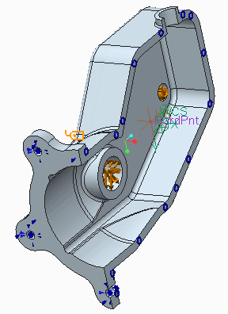10. Repeat the above process to assign pin constraints to the remaining two tab holes as shown.

**Step 6: Create the Finite Element mesh using the AutoGEM tool.**

1. 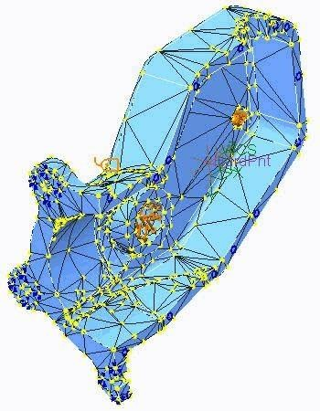In the ribbon, select the **Refine Model** tab.
2. Click **AutoGEM** from the AutoGEM group. The AutoGEM dialog box appears. Click **Create**. This process takes several seconds to complete.

***Note:*** *You can inspect the mesh by spin/pan/zoom and rotating the model*

*as you would normally do in a Creo application.*

1. Click **Close** to close all dialog boxes and click

**No** to the prompt to save the mesh.

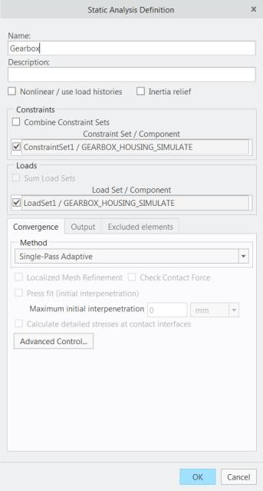

**Step 7: Define and run a Static Analysis**.

1. In the ribbon, select the **Home** tab.
2. Click **Analyses and Studies ** from the Run group. The Analyses and Design Studies dialog box appears.
3. Click **File > New Static**. The Static Analysis Definition dialog box appears.
4. Type in the analysis name and settings as shown.
5. Click **OK**.

|  |
| --- |
| 1. To configure the run settings, click **Configure Run Settings**  in the Analyses and Design Studies dialog box. The Run Settings dialog box appears. 2. The results and temporary output directories are set by default in the working directory. There is no need to change them for this exercise. Click **OK**. |
| 1. Click **Start Run**  in the Analyses and Design Studies dialog box to start the analysis. 2. Click **Yes** to run the interactive diagnostics. 3. Click **Display Study Status**  to monitor the status of the run. The time to run the analysis may vary but it should not take more than 1 minute to complete. 4. The content shown appears at the end of the summary report after the analysis is completed. Do not close any dialog boxes. |

**Step 8: Review the summary report.**

1. Carefully inspect the information displayed in the Run Status dialog box. On the **Summary** tab, notice the resultant load on the model. Also notice the maximum values for the most sought quantities, stresses, and deformations. The Simulation diagnostics and Analysis Details are also displayed.
2. Click **Close** in the Run Status dialog box. Leave the Analyses and Design Studies dialog box open.

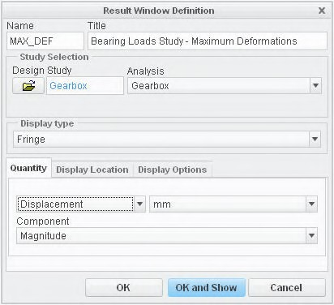

**Step 9: Create Results Windows and inspect the results**.

1. In the Analyses and Design Studies dialog box, select the analysis that just completed.
2. Click **Review Results ** to start generating the results window. The Result Window Definition dialog box appears.
3. To create a fringe plot results window, complete the dialog box and the **Quantity** tab fields as shown.

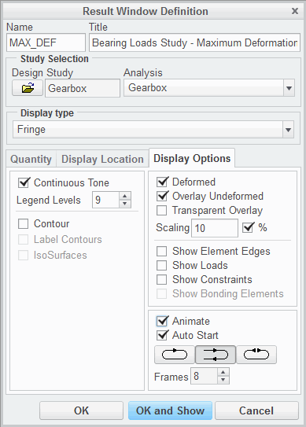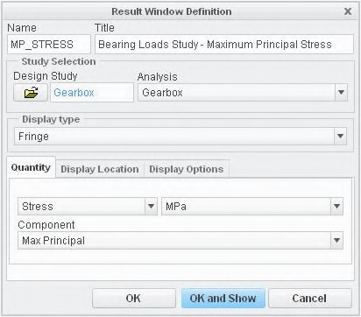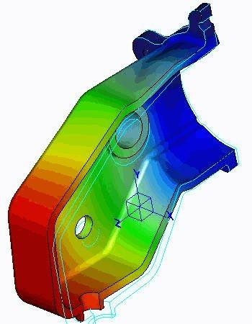

|  |
| --- |
| 4. Complete the **Display Location** fields as shown. |
| 5. Complete the **Display Options** fields as shown. |
| 6. Click **OK and Show** to display the results. You can spin/pan/zoom/rotate the model in the postprocessor as you would normally do in any Creo Simulate application. Review the displacements on the model. The base is fixed and displays a displacement of essentially zero, increasing to a maximum displacement at the free edge.  ***Note:*** *To stop the animation, in the ribbon, select the*  ***View*** *tab. Click* ***Stop***  *in the Animation group.* |
| 1. To display the Maximum Principal Stresses developed in the model due to the bearing loads, in the ribbon, select the **Home** tab. Click **Copy**  from the Window Definition group. 2. The Result Window Definition dialog box   appears. Customize the dialog box content and the **Quantity** tab as shown. |

|  |
| --- |
| 9. Customize the **Display Location** tab as shown. |
| 10. Customize the **Display Options** tab as shown. |
| 1. Click **OK and Show** to display the results. 2. Adjust the legend such that the value below the maximum is 50 MPa. Click in the Maximum Principal Stress window to select it. In the ribbon, select the **Format** tab. Click **Edit**  from the Legend group. 3. The Edit Legend dialog box appears. In the Value column, type **50** in the Max row. 4. Click **OK**. Notice the maximum stress values and locations of the maximum principal stresses.   Rotate the model to view the high stress areas. Compare these values to the maximum allowable stresses for the cast iron used in the component. |
| 1. Click **File > Close** to exit and return to the Creo Simulate window. 2. Click **Don’t Save** in the Confirm Exit dialog box. 3. Click **File > Manage Session > Erase Current**. 4. Click **Yes** in the Erase Confirm dialog box. |

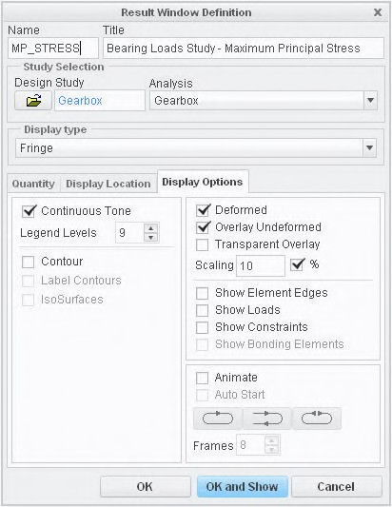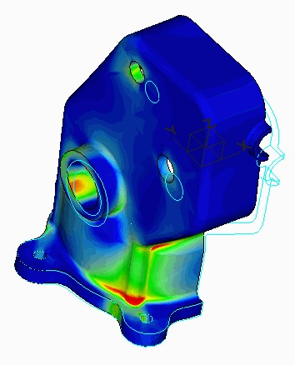

This completes the procedure.

# Module 2

## Theoretical Foundations

## The Finite Element Method

The Finite Element Method (FEM) is a method that subdivides complex geometry with unknown structural behavior into a finite number of simple geometric elements with known structural behavior.

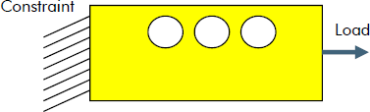The Finite Element method includes the following:

* Identify the geometry and loadcase.
* Mesh the geometry into a finite number of elements.

Calculate the structural behavior of each single element.

Fig. 1 – Geometry and Loadcase

* Relate the behavior of each element to its neighboring element.
* Numerically solve the resulting matrix equation

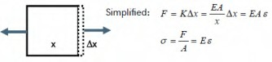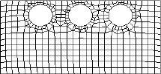system for the displacements.

Figure 2 – Meshed Geometry (h-type Finite Elements Used)

###### The Finite Element MethodFig. 3 – Simplified Structural Behavior of a Single Element

The Finite Element Method (FEM) is a method that subdivides complex geometry with unknown structural behavior into a finite number of simple geometric elements with known structural behavior. At the element boundaries, the displacements are equated with the neighboring elements and a matrix equation is developed. The equation is numerically solved and the results are graphically viewed using a post-processor.

Classical methods express the problem using a partial differential equation. This partial differential equation is typically the result of simplifying assumptions, such as linearly elastic material, or small displacements. These equations may not yield answers because the geometry and loading are too complicated. Therefore, a numerical solution is required, and a method that provides it is the FEM.

The FEM includes the following:

* Identify the geometry and loadcase.
* Mesh the geometry into a finite number of elements – A mesh is an arrangement of nodes and elements. Finite elements can have quadrilateral and/or triangular shapes. The nodes are the locations where the elements are connected to one another. In general, the finer the mesh, the more accurate the results.
* Calculate the structural behavior of each single element – In stress analysis problems, the dependent variable that is used is the displacement from a reference position, typically the unloaded position. In thermal analysis problems, the dependent variable used is the temperature.
* Relate the behavior of each element to its neighboring element – In a finite element, the displacements are computed only at the nodes of the element. By combining all the elements in the mesh, a set of simultaneous linear algebraic equations is developed.
* Numerically solve the resulting matrix equation system for the displacements – After the displacements have been calculated, the strains, displacement per unit length, can also be calculated by taking the derivative with respect to position. If stresses are required, they can be calculated from the strains.

If the interpolating polynomial for the spatial variation of the displacement field is linear within an element, then the strains and stress within are constant. Furthermore, the stresses are only

continuous (smooth) within an element. At the border of the neighbor element, stresses may become discontinuous (jump). This difference is usually smoothed away in the post-processor by different averaging techniques. This difference can also be used for error estimation and convergence improvement during the solution process. Simulate uses super converged stresses for this purpose, as described in a later module.

## The h- and p-Versions of Finite Elements

The results of a finite element analysis can be improved by refining the mesh of the same kind of element, or by increasing the displacement field accuracy in each element.

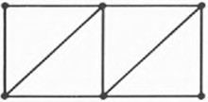Currently, two types of Finite Element methods are in use:

* + h-method
  + p-method

Figure 1 – Original Mesh

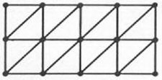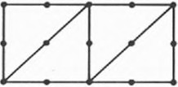

Figure 2 – h-refinement Figure 3 – p-refinement

###### The h- and p-Versions of Finite Elements

The results of a finite element analysis can be improved by refining the mesh of the same kind of element, or by increasing the displacement field accuracy in each element. A simple rectangle can originally be divided, or meshed, using a certain number of triangles for analysis.

Currently, two types of Finite Element methods are used to demonstrate the numerical convergence of the solution. The h- and p-versions of the finite element method are different ways of adding degrees of freedom (dof) to the model.

* h-method – The h-method improves results by using a finer mesh of the same type of element. This method refers to decreasing the characteristic length (h) of elements, dividing each existing element into two or more elements without changing the type of elements used.
* p-method – The p-method improves results by using the same mesh but increasing the displacement field accuracy in each element. This method refers to increasing the degree of the highest complete polynomial (p) within an element without changing the number of elements used.

The p-version represents the displacements or temperatures within each element using high-order polynomials (the maximum order used in Simulate is 9), as opposed to the linear and sometimes quadratic or cubic functions used in conventional finite elements (h-method). Only one analysis of a meshed geometry may be needed to determine if a solution has converged. With the h-method, a sequence of successively refined meshes must be created to produce convergence toward correct results. Higher order elements produce more accurate results in examples where the gradient of the displacements cannot be approximated by low-order polynomials. In general, a finer mesh improves the result quality, but just until numeric noise downgrades the solution again.

## The p-Method

A basic understanding of the p-method is necessary so you can define the model and analysis correctly to take full advantage of the p-method’s benefits.

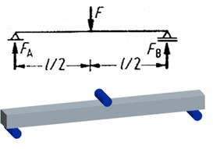Example: Simply supported beam with a concentrated load.

Figure 1 – Load Diagram and CAD Geometry

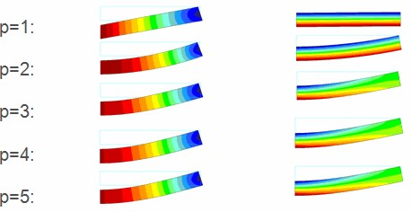

Figure 2 – Deflection and Longitudinal Stress Results

###### The p-Method

A basic understanding of the p-method is necessary so you can define the model and analysis correctly to take full advantage of the p-method’s benefits. This very simple example can help you to understand how it works.

We have a simple bending bar with loaded length l=40 mm, width b=4 mm, and height h=3 mm. The material is steel with E=200 GPa. We apply a force of 200 N. Using these values and the analytical equations, the maximum stress is 333.3 MPa, and the maximum deflection is 0.1481 mm. Note that the analytical equations from the simple beam theory do not take into account additional deflections from shear stresses.

The CAD geometry, including the load rollers, and the load diagram are shown in Figure 1. We use half symmetry in the idealized physical model and cut away the load-free beam end. In Simulate, we use just one p- brick element to mesh the half beam. One percent (1%) convergence is requested on measures: displacements, strain energy, maximum and minimum principal stress, von Mises stress, and longitudinal stress.

When p=5 the maximum stress is 335.23 MPa, and the maximum deflection is 0.1507 mm. The maximum deflection does not change between p=3 and p=5, and the maximum stress changes by less than 1%. The deflection and stress diagrams are shown in Figure 2 for the different values of p. The maximum deflection in the displacement plot is scaled to 20% of the model size, and in the stress plot to 20 times the absolute value. The plotting grid in the plots was set to 10.

In the exact solution, the ratio of position x to length l (x/l), is raised to a power of 3. The finite element method uses polynomial functions to approximate the exact solution. Using the p-method the polynomial functions can be up to the ninth order. In this example, when Simulate uses a cubic, p=3, the solution is very accurate.

Adding higher order functions with p>3 does not significantly change the solution.

***Note:*** *For more information on the p-method see Finite Element Analysis (Wiley Series in Computational Mechanics) by Szabo and Babuska.*

## PROCEDURE - Using the p-Method

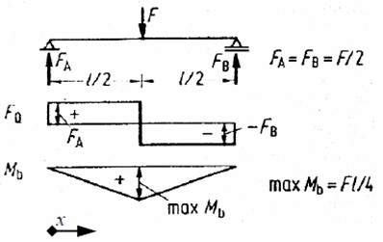

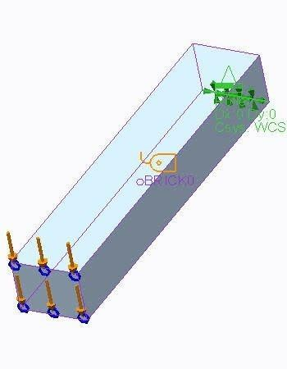**Task 1:** Open and investigate the geometry model.

|  |
| --- |
| 1. For Creo Simulate users, open SIMPLY _ SUPPORTED_SIMULATE.PRT. The symmetry cut has been made and stored already in the model. All the simulation features should be already defined.   For Creo Parametric users, open SIMPLY  _SUPPORTED.PRT. Examine the CAD geometry. The model, prepared for simulation purposes, should look like the model shown in the figure.   1. This model represents a simply supported 3- point bending bar. The bar is steel and is loaded with an external force of 200 GPa   equally spaced from the supports. Symmetry is used in the model given the nature of the geometry, loading, constraint conditions and material. Review these features directly from the model tree by completely expanding the following and reviewing each definition:   * + Material Assignments   + Loads / Constraints |
| 3. Note the model is statically determinate. Using an analytical solution the calculated maximum deflection is 0.1481 mm, and the bending stress is 333.3 MPa. |

**Task 2:** Investigate the Finite Element Control and mesh using the AutoGEM tool.

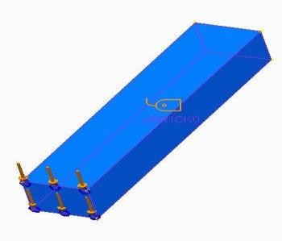

|  |
| --- |
| 1. In the ribbon, select the **Refine Model** tab. 2. Click **AutoGEM** from the AutoGEM group. The AutoGEM dialog box appears. 3. Using the default settings, click **Create**. The AutoGEM Summary and the Diagnostics:AutoGEM Mesh window appears. This mesh has been customized so that a single brick solid element is created as shown. |
| 1. Inspect the mesh. Click **Close** in all dialog boxes. 2. Click **No** when prompted to save the mesh. |

**Task 3:** Run the static analysis defined in the model.

* 1. In the ribbon, select the **Home** tab.
  2. Click **Analyses and Studies ** from the Run group. The Analyses and Design Studies dialog box appears.
  3. Select **Simply_Supported**.
  4. Click **Edit > Analysis/Study**. The Static Analysis Definition dialog box appears.
  5. Review the Static Analysis settings. Note the analysis uses the Multi-Pass Adaptive method with a 1% convergence on the selected measures. Click **OK**.
  6. Click **Configure Run Settings **. The Run Settings dialog box appears.
  7. Review the Run settings. Click **OK**.
  8. Click **Start Run ** to run the Static analysis. Click **Yes** to run the interactive diagnostics. When the run is complete, the Run Status dialog box appears.
  9. Click **Display Study Status ** to monitor the status of the run. Do not close any dialog boxes.

**Task 4:** Review the Summary Report.

1. Review the Summary Report in the Run Status dialog box. Notice the maximum displacement (expressed in mm) and longitudinal stress (MPa) values. Verify and compare these values with analytical solutions.
2. In the Run Status dialog box, click **Close**.

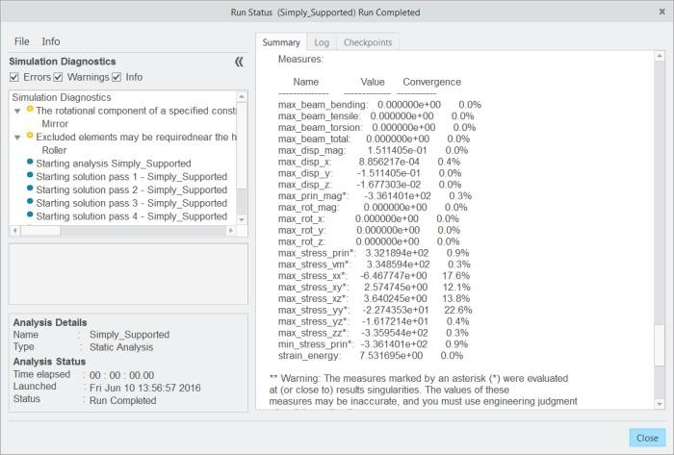

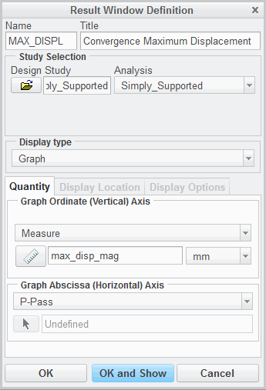**Task 5:** Create Results window and interpret the results.

|  |
| --- |
| 1. In the Analyses and Design Studies dialog box, select the analysis that just completed. Click **Review Results** . The Result Window Definition dialog box appears. 2. Complete the dialog box and **Quantity** tab fields as shown.    * In the Name field, type **MAX_DISPL**.    * In the Title field, type **Convergence Maximum Displacement**.    * Select **Graph** from the Display type drop-down menu.    * Select the **Quantity** tab.    * Select **Measure** from the Graph Ordinate (Vertical) Axis drop-down menu.    * Click **Measures** . The Measures dialog box appears.    * Select **max_disp_mag**, and click **OK**. |
| 3. Click **OK and Show** to display the graph. Note the value of the maximum displacement corresponds with the maximum displacement reported in the Run Status dialog box on the Summary tab. The analytical solution is a cubic polynomial function for this model. Therefore adding functions with a higher order than 3 does not significantly change the solution. |
| 1. Click **File > Close**. 2. Click **Don’t Save** in the Confirm Exit dialog box. |

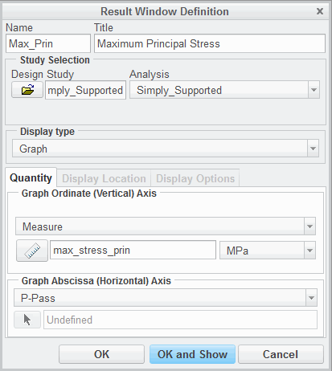

|  |
| --- |
| 1. In the Analyses and Design Studies dialog box, select the analysis that just completed. Click **Review Results** . The Result Window Definition dialog box appears. 2. Complete the dialog box and **Quantity** tab fields as shown.    * In the Name field, type **MAX_Prin**.    * In the Title field, type **Maximum Principal Stress**.    * Select **Graph** from the Display type drop-down menu.    * Select the **Quantity** tab.    * Select **Measure** from the Graph Ordinate (Vertical) Axis drop-down menu.    * Click **Measures** . The Measures dialog box appears.    * Select **max_stress_prin**, and click **OK**. |
| 8. Click **OK and Show** to display the graph. Note the value of the maximum principal stress corresponds with the value reported in the Run Status dialog box. |
| 1. Click **File > Close**. 2. Click **Don’t Save** in the Confirm Exit dialog box. 3. In the Creo Simulate window, click **File > Manage Session > Erase Current**. 4. Click **Yes** in the Erase Confirm dialog box. |

This completes the procedure.

## Structural Mechanics – Stress Definitions and Hooke’s Law

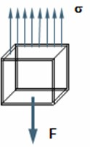When using Finite Element Analysis methods, an understanding of mechanical stress definitions and Hooke’s

Law is useful.

All linear analyses provided in Simulate depend on Hooke's material law.

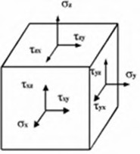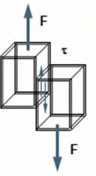Fig. 1 – Normal Stresses

Figure 2 – Shear Stresses Figure 3 – General Triaxial Stress State

***Structural Mechanics*** *– Stress Definitions and Hooke’s Law*

When using Finite Element Analysis methods, an understanding of mechanical stress definitions and Hooke’s Law is useful. By carefully interpreting displacements, stress and strain in the post-processor, possible errors in the model definition or numerical solution can be found.

All linear analyses provided in Simulate depend on Hooke's material law. This topic explains the essentials you should understand when performing structural analysis.

* Normal Stresses – Stresses normal, perpendicular, to the cutting plane. Normal stresses are either tensile or compressive.
* Shear Stresses – Stresses that act parallel to the cutting plane. They act in pairs, couples, on opposite faces.
* Triaxial Stresses – The nine stress components that could act on an infinitesimal cube. The stresses shown in Figure 3 are all shown in a positive direction.

The triaxle stress cube shown in Figure 3 is used to represent the applied stresses acting on an element. For any combination of applied stresses, there is a continuous distribution of the stress field at any point analyzed. Normal and Shear stresses vary with direction in any coordinate system used. There will always be planes on which the components of shear stress will be equal to zero. The normal stresses acting on these planes are called principal stresses. The planes on which they act are called principal planes. These stresses are often termed and ordered as 1 > 2 >



3.

Principal stresses and the resulting principal strains *ϵ*1, *ϵ*2 , *ϵ*3 act perpendicular to each other and lie on the same principal axes, in an isotropic material.

Hooke’s Law provides a relationship between stress and strain. The simple form of Hooke’s Law for uniaxial tension states that stress is proportional to strain. The constant of proportionality is the modulus of elasticity of the material, E. Hooke’s Law is described using the following equations:

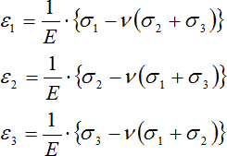

For the general case of triaxle stress, the relationship between stress and strain also depends on Poisson’s ratio. Poisson’s ratio is the ratio between lateral and longitudinal strain. For most materials, Poisson’s ratio is approximately 0.3. For materials with no lateral contraction, no influence of lateral stresses to the strain, Poisson’s ratio is equal to zero. Incompressible materials, materials that have no volume change under load, have a Poisson’s ratio of 0.5.

***Note:*** *Check principal stresses in a vector plot after an analysis is performed where you need accurate stress results. If you find principal stress vectors normal to an unloaded surface, this indicates an error in the solution, or the load/constraint definition. For equilibrium conditions, those surfaces cannot have any normal stresses.*

## Structural Mechanics – Strain Energy and Failure Theories

The strain energy of the total model and comparative stresses may be used as convergence criteria in Simulate.

* Strain Energy
* 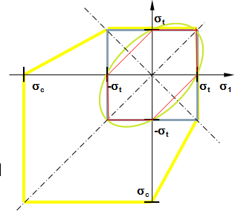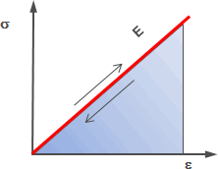Comparative Stresses – Failure Theories

Figure 1 – Strain Energy Density Fig. 2 – Failure Theories

*Structural Mechanics – Strain Energy and Failure Theories*

The strain energy of the total model and comparative stresses may be used as convergence criteria in Simulate. Comparative stresses are also important when analyzing a multi-axial stress loading of the model.

*Strain Energy*

When loading and unloading a linear elastic material, the work done by the load results in an increase of energy associated with the deformation of the material. This energy is called the strain energy density and is depicted by the area under the stress-strain curve for the load, as shown in Figure 1 (for a uniaxial loaded linear elastic material).

*Comparative Stresses – Failure Theories*

The two-axial or triaxle stress state in a mechanically loaded part has to be transformed into a uniaxial comparative stress. This enables a comparison with the uniaxial yield or ultimate strength determined for the material used in a pure tensile test. It can then be determined if failure, yielding or rupture, will occur. Four failure theories are graphically shown in Figure 2. The figure shown is for a 2-D case where

2 is assumed to be zero. These failure theories can be used in Simulate.

  

Distortion Energy Theory – The Distortion Energy theory uses the effective von Mises stress. This theory predicts that failure occurs when the distortion energy in a unit volume exceeds the distortion energy in a unit volume in a tensile test at failure. This value can be output by Simulate and is a scalar quantity. This failure theory is most used in the case of ductile materials that have equal strength in tension and compression under a static load. The von Mises stress is represented by the following equations:

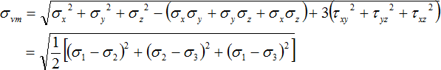

Maximum Shear Stress Theory – The Maximum Shear Stress theory states that failure occurs when the maximum shear stress in a part exceeds the shear stress in a tensile specimen at yield, one half of the tensile yield strength. It is more conservative than the Distortion Energy theory and can also be used for ductile materials. The following equation represents the Maximum Shear Stress Theory:



Maximum Principal Stress Theory – The Maximum Principal Stress theory, Maximum Normal Stress theory, states that failure occurs if the maximum principal stresses exceed the uniaxial tensile strength. This theory is used for brittle materials. The Maximum Principal Stress theory is a special case of the modified Mohr’s theory, which takes into account a higher compression than tensile strength.

You can enter the material allowable to Modified Mohr in Simulate as failure criteria when you define a material. If you want to predict failure according to the Maximum Principal Stress theory, you enter a uniaxial compression strength close to the uniaxial tensile strength in the Modified Mohr data form.

Under two-axial tension, which is very common in engineering applications, the differences between the criteria are small. As the compression increases and the stress state becomes more triaxle, the bigger the differences become.

In general, it is your responsibility to judge which criteria are best suitable to describe the behavior of the material. As a guideline, use Distortion Energy or Maximum Shear Stress for estimating the yielding in ductile materials (Maximum Shear Stress is just a little bit more conservative for certain stress states). For rupture in brittle materials, use principal stress. If the compression strength is much higher than the tensile strength, like for many brittle engineering ceramics or casts, use Modified Mohr. However, take into account that ductility or brittleness are not necessarily properties which are valid in general for a material. It may happen that a ductile material behaves very brittle under certain stress states,

for example, isostatic tension.

34

# Module 3

## Simulation Models

## Preparing a CAD Model

The CAD model can be prepared for the simulation so that geometry meshing becomes possible and a minimum number of elements can be used for a quick, but accurate, analysis.

To prepare an existing CAD model:

* + Prepare the model in Creo Parametric.
  + Defeature complex models in Creo Parametric.
  + Check the model for possible singularities.
  + Determine if you want to keep the associativity between the simulation and CAD model.

###### Preparing a CAD Model

The CAD model can be too complex to use as direct simulation geometry. The CAD model can be prepared for the simulation so that geometry meshing becomes possible and a minimum number of elements can be used for a quick, but accurate, analysis. To prepare an existing CAD model:

* Prepare the model in Creo Parametric. The basic steps for preparation include:
  + Check and/or set the appropriate units system.
  + Validate the part or assembly accuracy and increase if necessary. As a guideline, use absolute accuracy especially for assemblies. A value of 0.001 to 0.01 mm in the mm-N-s system typically gives best results.
    - Relative accuracy is the accuracy according to the ratio of the smallest to the largest distance.
    - Absolute accuracy is the minimum allowed distance in an actual length unit. This can be set using a config.pro option: enable absolute accuracy yes.
  + Validate for geometry checks. In the ribbon, select the Tools tab. Use Geometry Checks from the Investigate group. AutoGEM may have problems with locations identified, so remove if necessary.
* The meshing of small edges, small surfaces, surfaces with extreme continuity leaps, and surfaces with negative angles is complex and may cause problems.
* Defeature complex models in Creo Parametric.
  + Analyze the relationships of the features to be suppressed. In the ribbon, select the Tools tab. Use Reference Viewer or Feature from the Investigate group. Use Model in the Investigate group to analyze model history.
  + Suppress outer rounds.
  + Suppress inner rounds if you are not interested in stresses, just stiffness and displacements, or if they are not in the load path.
  + Suppress small chamfers.
  + Suppress all other non-simulation relevant details.
  + Use symmetries; cut away until the smallest symmetric unit remains.
* Check the model for possible singularities. Singularities appear at loaded sharp inner corners. If necessary, create rounds there to eliminate.
* Determine if you want to keep the associativity between the simulation and CAD model. There are advantages and disadvantages associated with each option. If you select to maintain the associativity:
  + Changes in the CAD model are automatically seen by the simulation model. The model can be reanalyzed without creating a new simulation model.
  + In a product management system, the simulation model is automatically linked to the CAD model for archival storage.
  + Since there are often many changes required for the simulation model, this may create very complex relations to the CAD model and create instability in your simulation model.

If you do not select to maintain the associativity:

* You can work on a simple, independent copy of the CAD model just for the simulation, without taking into account relations.
* Your simulation model behaves stable if a designer changes the original CAD geometry and deletes references.
* You cannot automatically take into account changes in the original geometry. A manual maintenance of the simulation model is required.

## Using Inheritance and Remove Features

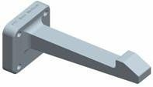The Inheritance and Remove features are very powerful features you may use to prepare your CAD geometry for analysis.

* Inheritance Feature
* Remove Feature

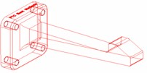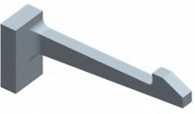Figure 1 – CAD Geometry

Figure 2 – CAD Import Geometry Figure 3 – Simulation Geometry

###### Using Inheritance and Remove Features

The Inheritance and Remove features are very powerful features you may use to prepare your CAD geometry for analysis. The Inheritance Feature is used if you want to keep the simplified simulation model geometry independent from the CAD geometry. The Remove Feature enables you to simplify a non-feature-based import CAD geometry. An example of original CAD geometry is shown in Figure 1.

A wireframe example of CAD import geometry is shown in Figure 2. The final, simplified simulation geometry is shown in Figure 3.

The Inheritance Feature is the feature to use if you want to keep the simulation model independent from the CAD geometry. Simplifying the geometry for the analysis can be done in a separate simulation part, which is independent from the design part and therefore recognizes changes in the original CAD geometry by use of this feature. The design geometry does not have to be simplified directly and can be further used in the PDM system. The simplifications performed in the simulation part do not destroy the original CAD part (unidirectional dependence). The Inheritance Feature has the following advantages:

* Easy and variable part copying.
* Robust in master model modifications.
* Changes in the Inheritance Feature model tree do not change the original geometry.
* The feature can be updated for a special request or temporarily made independent.

The Remove Feature enables powerful creation of simplified geometry from non-parametric,

non-featurized import data. It can be combined with the Inheritance Feature to have the advantages listed above.

## Managing Units

Creo Simulate uses the units defined in Creo Parametric for the model. Available systems of units:

* + Centimeter Gram Second (CGS)
  + Foot Pound Second (FPS)
  + Inch lbm Second (Creo Parametric Default)
  + Inch Pound Second (IPS)
  + Meter Kilogram Second (MKS)
  + millimeter Kilogram Sec (mmKs)
  + millimeter Newton Second (mmNS)

*Managing Units*

Fig. 1 – Creo Parametric Units Manager

Dialog Box

Creo Simulate uses the units defined in Creo Parametric for the model. In addition to the predefined systems of units such as mmNs (millimeters, Newton, seconds) or IPS (Inch, Pound, Second),

user-defined systems can be defined in Creo Parametric. If the system of units is modified, you have to decide whether the model should maintain the same size and if the dimensional values have to be converted. The available systems of units are listed in the Units Manager dialog box in Creo Parametric and are as follows:

* Centimeter Gram Second (CGS)
* Foot Pound Second (FPS)
* Inch lbm Second (Creo Parametric Default)
* Inch Pound Second (IPS)
* Meter Kilogram Second (MKS)
* millimeter Kilogram Sec (mmKs)
* millimeter Newton Second (mmNs)

For the use of the International System of Units (SI), an adapted system can be defined with the units m, kg, s, K. For models in millimeters, the mmNs system is preferred because of the consistency of the derived parameters and quantities.

In Simulate, you can specify all quantities, loads, displacements, or material properties in any unit supported by the individual drop-down menus that are provided. After the analysis is run, the results can be viewed in any combination of units.

## PROCEDURE - Managing Units

**Task 1: Edit the pressure load on the model.**

* 1. Disable all Datum Display types.
  2. In the model tree, expand **Loads/Constraints**.
  3. In the model tree, expand **Load Set LoadSet1**.
  4. Select **Gas_Pressure** and click **Edit Definition ** from the mini toolbar.
  5. 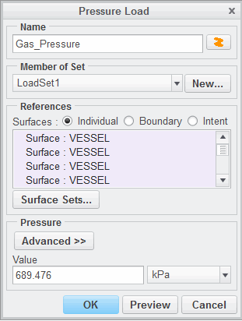The Pressure Load dialog box appears. The default unit system for this model is IPS (inch-pound- seconds). Therefore, the default

units for loads, constraints, and all measures are in this system. Note that the current pressure is 100 psi. Right-click in the Value field and click **Convert To Unit**

##### > kPa.

* 1. Click **OK** to close the Pressure Load dialog box.

**Task 2: Run the analysis.**

1. In the ribbon, select the **Home** tab. Click **Analyses and Studies ** from the Run group.
2. The Analyses and Design Studies dialog box appears. Select **Static_Analysis**.
3. Click **Start Run ** to run the Static analysis. Click **Yes** to run the interactive diagnostics. When the run is complete, the Run Status dialog box appears.
4. Click **Display Study Status ** to monitor the status of the run.
5. When the run is complete, review the summary report in the Run Status dialog box.
6. In the Run Status dialog box, click **Close**.

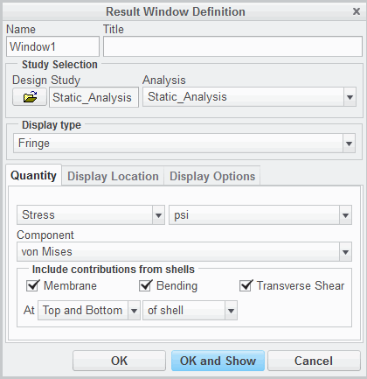**Task 3: Review the analysis results using different units**.

1. In the Analyses and Design Studies dialog box,

select **Static_Analysis**.

1. Click **Review Results **. The Result Window

Definition dialog box appears.

1. Select the **Quantity** tab. Verify that **Stress**, **psi**,

and **von Mises** are selected, as shown.

|  |
| --- |
| 4. Select the **Display Options** tab.  Select **Deformed** and type **5** in  the Scaling field, as shown. |
| 5. Click **OK and Show**. Examine the von Mises stress results. |
| 1. In the Creo Simulate Results window, select the Home tab. Click Copy  from the Window Definition group. 2. The Result Window Definition dialog box appears. Select the Quantity tab. 3. Select MPa from the units drop-down list. 4. Click OK and Show Compare the two results windows. Note that there is no difference in the fringe plots between the two results. The differences appear in the text & legend values accompanying each window. |

* 1. When you have completed reviewing the results, click **File > Close**.
  2. The Confirm Exit dialog box appears. Click **Don’t Save**.
  3. The Creo Simulate window appears. In the Analyses and Design Studies dialog box, click **Close**.

##### Click File > Manage Session > Erase Current.

* 1. The Erase dialog box appears. Click **Select All** .
  2. Click **OK**.

This completes the procedure.

## Understanding Model Types

There are four model types available in Creo Simulate.

* 3-D
* 2-D Plane Stress
* 2-D Plane Strain
* 2-D Axisymmetric

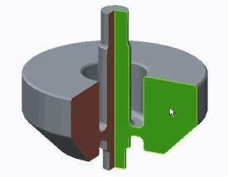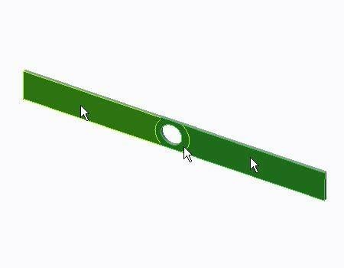Figure 1 – 3-D

Figure 2 – 2-D Plane Stress Figure 3 – 2-D Axisymmetric

*Understanding Model Types*

There are four model types available in Creo Simulate.

* 3-D – The 3-D model is used when none of the other idealized model types can be used. It consists of three- dimensional elements and represents the most complex model type available. Because it makes no assumptions, it can be used to represent all types of design models.
* 2-D Plane Stress – The 2-D Plane Stress model is a two-dimensional idealized model that is much thinner in one coordinate direction as compared to the other two coordinate directions. To use this type of model in Simulate, the user must specify a coordinate system and a surface that lies in the XY plane of the selected coordinate system. The Simulate analysis proceeds by creating

a two-dimensional analysis model that assumes no stresses in the Z direction. Models that lend themselves well to this type of analysis are thin plates that are subjected to in-plane loads (loads in the X and Y directions only).

* 2-D Plane Strain – The 2-D Plane Strain model is a two-dimensional idealized model that is much thicker in one coordinate direction as compared to the other two coordinate directions. To use this

type of model in Simulate, the user must specify a coordinate system and a surface (in the case of solid model) or edges/curves (in the case of shell models) that lie in the XY plane of the selected coordinate system. The Simulate analysis proceeds by creating a two-dimensional analysis model that assumes no strains in the Z direction. Models that lend themselves well to this type of analysis are prismatic shapes like beams or pressure vessels that are long in the Z direction and have a cross section that does not vary appreciably in the Z direction.

* + 2-D Axisymmetric – The 2-D Axisymmetric model can be used for models that are symmetric about an axis. This model type requires all aspects of the analysis model (loads, constraints, and geometry) to be symmetric about the axis. To use this type of model in Simulate, the user must specify a coordinate system and a surface (in the case of a solid model) or edges/curves (in the case of a shell model) that lie in the XY plane of the selected coordinate system. All of the geometry must be in the X >= 0 section of the plane, and all of the loads and constraints must be specified in the XY plane. Models that lend themselves well to this type of analysis are tanks, flanges, and hubs.

## Element Types Overview

There are many different element types that can be used in Simulate analysis.

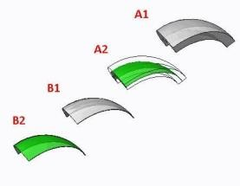

* + - Solid Elements
    - Shell Elements
    - 2-D Elements
    - Idealized Elements: Mass, Spring, and Beam

Figure 1 - Shell Elements

###### Element Types Overview

Simulate uses the Automatic Geometric Element Mesher, known as AutoGEM, for the creation of meshes for analyses. AutoGEM is capable of generating elements that fall into four basic categories: Solid elements, Shell elements, 2-D elements, and Idealization elements that include mass, spring, and beam analytical representations.

*Solid Elements*

There are basically three solid element types that can be created by AutoGEM.

* + Tetrahedron element: The tetrahedron element is a four-sided element. Each side is triangular and can be planar or curved. Tetrahedrons are the most widely used of the solid element types.
  + Brick element: A brick element has two opposite quadrilateral faces and four faces between the two opposite faces. They are useful in models that have volumes with two opposing faces with similar shapes. The brick can represent planar volumes as well as curved volumes. To connect a brick element to a tetrahedron element, AutoGEM must create links so triangular faces of two tetrahedrons can interface with a single quadrilateral brick face.
  + Wedge element: A wedge element has two opposite triangular faces and three quadrilateral faces between them. Similar to the brick element, wedges are useful in models that have volumes with two opposing faces with similar shapes, and can represent planar volumes as well as curved volumes.

*Shell Elements (3-D)*

A shell element can be effectively used in structures with a constant thickness that is relatively small compared to the length and width. AutoGEM can create two types of shell elements:

* Triangles: A triangular element is a three-sided element. Unlike geometric triangles, each side of the element can be curved.
* Quadrilaterals: A quadrilateral element is a four-sided element. Unlike geometric quadrilaterals, each side of the element can be curved.

*2-D Elements*

AutoGEM can create three types of 2-D elements, but it will only create those that are applicable to the type of 2-D model being analyzed. 2-D elements lay entirely in the XY plane of a specified coordinate system. The three element types are:

* 2-D Shell: The 2-D shell element is actually a one dimensional element; it is a curve in the XY plane that has a thickness associated with it. 2-D shell elements can be used in 2-D plane strain or 2-D axisymmetric models.
* 2-D Solid: The 2-D solid element is used to represent a thin slice of a solid in 2-D plane strain or 2-D axisymmetric models. 2-D solid elements are quadrilateral or triangular in shape, similar to 3-D shell elements.
* 2-D Plate: The 2-D plate element is used to represent a solid in 2-D plane stress models only. Although they are two dimensional in representation, they do have a thickness associated with them in the Z direction (the thickness of the thin plate they are being used to represent).

*Idealized Elements: Beams, Springs, and Masses*

* Beams: A beam idealization is a one-dimensional idealization that can follow a curve in three dimensions. Beams are created by specifying a cross-section, and degrees of freedom at the beam ends.
* Springs: A spring idealization connects two points or a point to ground in a model and provides a user- specified translational force or rotational torque. Spring rates are linear only.
* Masses: A mass idealization enables the placement of a user-specifiable mass at a point. It is useful in representing the mass of an object, that when in a model, will be analyzed without having to model geometry.

**Best Practices**

For 3-D shell elements, 2-D shell elements, and 2-D plate elements, the ratio of the length and width dimensions compared to the thickness of the element should fall somewhere in the range of greater than 10 but less than 1,000.

## Defining Simulate Model Geometry

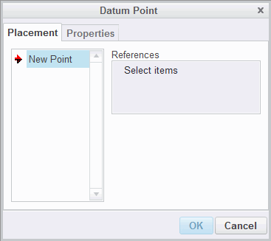Simulate enables you to create datums and model geometry that only appear in the model tree when Simulate is used.

The following datums and model geometry can be created:

* + Points
  + Datum curves or planes
  + Coordinate systems
  + Surface regions
  + Volume regions

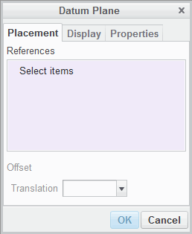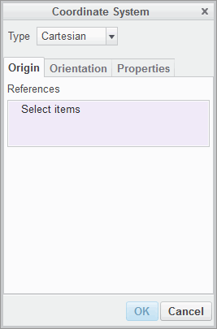Figure 1 – Datum Point Tool

Figure 2 – Datum Plane Tool Figure 3 – Coordinate System Tool

*Defining Simulate Model Geometry*

Simulate enables you to create datums and model geometry that only appear in the model tree when Simulate is used. Most important are user-defined Cartesian, cylindrical and spherical coordinate systems, and surface or volume regions. The subdivision of surfaces into surface regions or volumes into volume regions are effective tools to create references for loads and constraints, or a refined mesh. They are also useful as references for measures, shells, and rigid or weighted links.

The following datums and model geometry can be created:

* Points – Create points as in Creo Parametric. They can be moved into the Creo Parametric model tree, if not dependent from other simulation datums.
* Datum curves or planes – Create datum curves and planes. Curves, spline or sketched, can be taken into account by AutoGEM.
* Coordinate systems – Coordinate Systems in Simulate differ from Creo Parametric. Not only Cartesian but also Cylindrical and Spherical are allowed. These can be referenced for loads, constraints, functions, measures, material orientations, and in the postprocessor. When defining measures, loads, and so forth, by default they refer to the active coordinate system.
* Surface regions – These are used to subdivide existing surfaces, also surfaces within the volume from volume regions, so that loads or constraints can be precisely placed or a special local mesh can be enforced.
* Volume regions – These subdivide part volumes and create surfaces that can be referenced. Volume regions can have different materials and all their boundaries are taken into account by AutoGEM.

Use the Mesh Surface command to check the defined regions. This creates a set of grid lines on the selected surfaces.

***Note:*** *The sketch of a surface region must not necessarily lie on the surface to be subdivided; it can also be projected on the surface. Use volume or surface regions to create loads or constraints on partial areas of a cylindrical surface. Otherwise, thewhole circumference area is selected by default.*

## Using Simulate Coordinate Systems

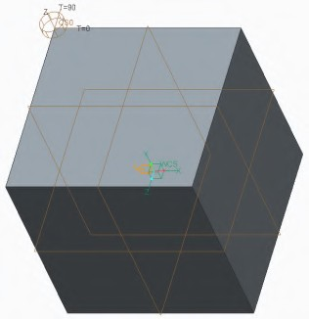Simulate Coordinate systems can be used for loads and constraints as well as locations.

Coordinate System Types

* World Coordinate System (WCS)
* User Coordinate System (UCS)

Figure 1 - Types of Coordinate Systems

*Using Simulate Coordinate Systems*

Simulate Coordinate systems can be used for loads and constraints as well as locations. There are two different types of coordinate systems present in an Integrated Simulate Analysis Model:

* WCS (world coordinate system): The default Simulate coordinate system. It is a Cartesian coordinate system at 0, 0, 0. An example of a WCS is shown in the center of figure 1.
* UCS (user coordinate system): A user created coordinate system that can be Cartesian, cylindrical, or spherical. A UCS can be set at the current coordinate system in place of the WCS.
* Cartesian: coordinates are measured in X, Y, and Z directions.
* Cylindrical: coordinates are measured in R, Θ, and Z directions. An example of a cylindrical UCS is shown on the top left side of figure 1.
* Spherical: coordinates are measured in R, , and Φ directions.

*Coordinate System Uses*

Coordinate systems can be used for several different activities in Simulate.

* Location: Unless otherwise noted, Simulate will always return the location of a queried item in terms of the current coordinate system.
* Loads: Loads can be applied relative to the WCS or a UCS designated in the Loads dialog box.
* Constraints: Like loads, constraints can be applied relative to the WCS or a UCS designated in the constraints dialog box. Consider a hole that needs to be constrained such that the sides of the hole must be fixed radially, but allowed to translate axially. A Cartesian coordinate system would need fixed X and Y translation. The same hole with a cylindrical coordinate system would only need fixed R translation.

Coordinate systems can also be referenced for measures, material orientations, and in the postprocessor.

## PROCEDURE - Using Simulate Coordinate Systems

**Task 1:** Create a coordinate system in the part.

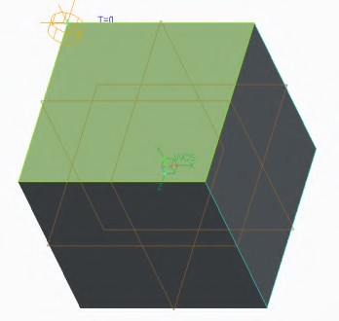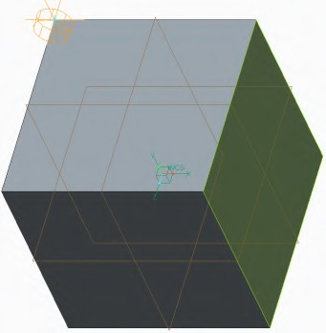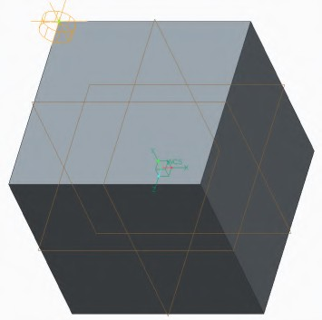

|  |
| --- |
| ***Note:*** *Enable* ***Csys Display*** *.* |
| 1. In the ribbon, select the **Refine Model** tab. 2. Click **Coordinate System**  from the Datum group. 3. The Coordinate System dialog box appears. Select   **Cylindrical** from the Type drop down list.   1. On the model select the vertex shown. |
| 1. In the Coordinate System dialog box select the **Orientation** tab. Click in the first Use field to enable the selection of a reference. 2. Select the surface on the right side of the model as shown. |
| 1. Select **T=0** from the to determine drop down list. 2. Click in the second Use field and select the top surface of the model as shown. |
| 9. Select **Z** from the to project drop down list. |
| 10. Click **OK** to create the coordinate system and close the dialog box. The model should appear as shown. |

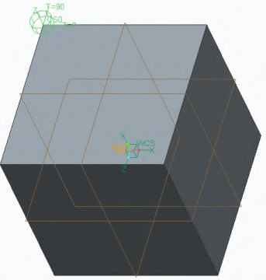

1. Click **File > Manage Session > Erase Current** to erase the model from memory.
2. 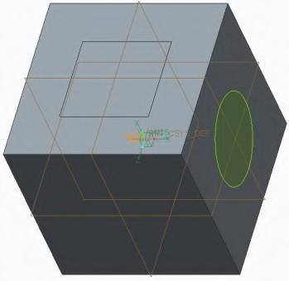Click **Yes** in the Erase Confirm dialog box. This completes the procedure.

## Using Surface Regions

Models can be optimized for analysis using surface regions.

Surface regions divide your models into areas where you can apply loads and constraints.

Figure 1 - Surface Regions

*Using Surface Regions*

You use regions to apply loads and constraints to particular “footprints” on a model. You can create surface regions in Simulate to apply loads and constraints to specific localized surface areas. Surface region creation is a two-step process:

* Defining the region boundary – is accomplished by sketching a datum curve feature to represent the boundary. You can create a separate datum curve feature for each region that you need to define. You cannot define multiple region boundaries with only one datum curve feature.
* Creating the region – consists of splitting a model surface into smaller surfaces, or regions, using the datum curve as a boundary.

You should define regions before mid-surfaces for shell modeling because creating regions can invalidate existing shell pairs.

## PROCEDURE - Using Surface Regions

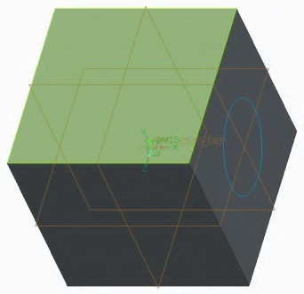**Task 1:** Create a sketched surface region.

|  |
| --- |
| ***Note:*** *Enable all Datum displays.* |
| 1. In the ribbon, select the **Refine Model** tab. 2. Click **Surface Region**  from the Regions group. 3. The Surface Region tab appears. Right-click in the display area and select **Define Internal Sketch...**. 4. The Sketch dialog box appears. Select the top surface as the sketching plane reference as   shown. |



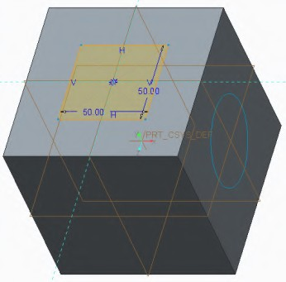

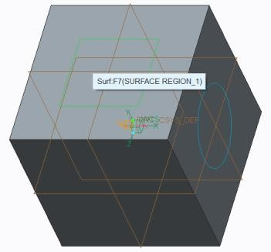

|  |
| --- |
| 1. In the Sketch dialog box click **Sketch**. 2. Sketch a rectangle as shown. |
| 1. Click **OK** . 2. Select the top surface of the model, the same surface selected as the sketching plane, as the surfaces to split references. 3. Click **Apply-Save Changes** . |
| 10. Cursor over the top of the model and note that the created surface region can be selected. |

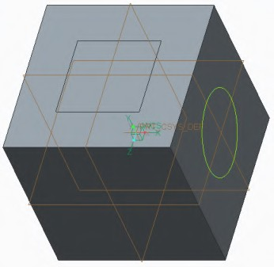**Task 2:** Create a surface region by selecting a datum curve.

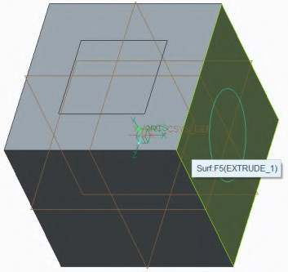

|  |
| --- |
| 1. Click **Surface Region**  from the Regions group. 2. The Surface Region tab appears. Select the circular datum curve as shown. |
| 3. Select the right side surface that the circular datum curve is sketched on as shown. |



|  |
| --- |
| 1. Click **Apply-Save Changes** . 2. Move the mouse over the right surface of the model and note that the created surface region can be selected. |
| 1. Click **File > Manage Session > Erase Current** to erase the model from memory. 2. Click **Yes** in the Erase Confirm dialog box. |

This completes the procedure.

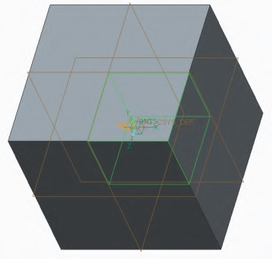

## Using Volume Regions

Models can be optimized for analysis by using volume regions.

Volume regions divide your models into volumes where you can apply loads and constraints.

Figure 1 - Volume Region

###### Using Volume Regions

While you can create surface regions in Simulate to apply loads and constraints to specific localized surface areas, you can use similar functionality to split solids into three-dimensional regions. You accomplish this by creating Volume Regions.

Creation of volume regions is similar to that of the cut feature in Creo Parametric. You can create them in parts or assembly models and they inherit the material properties from the solid geometry within which they are created. Since you can view results by volume, these regions are beneficial in preparing a model for postprocessing, making it easier to view internal stresses, strains, and so on. Since you must create elements within a volume region, you can also use them as an effective means of increasing mesh density when required.

Simulate uses the Creo Parametric user interface to create volume regions. To create a volume region select the Refine Model tab. Then select one of the creation methods from the Volume Region

drop-down list in the Regions group.

## PROCEDURE - Using Volume Regions

**Task 1:** Create an extruded volume region.

***Note:*** *Enable all Datum display types.*

* 1. In the ribbon, select the **Refine Model** tab.
  2. Select **Extrude ** from the Volume Region types drop-down menu in the Regions group.
  3. Select the top surface as the sketching plane reference, as shown, to start the Sketch mode.

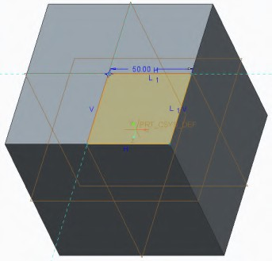

* 1. Sketch a rectangle, as shown.

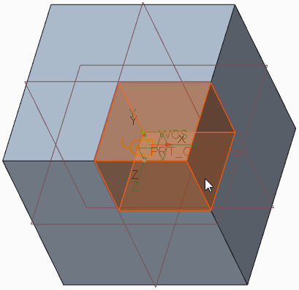

* 1. Click **OK** to return to the Extrude tab.
  2. Type **40.0** in the Depth value field and press ENTER.
  3. Click **Apply-Save Changes** .
  4. In the status bar, edit the selection filter to

##### Features.

* 1. Cursor over the model and note that the created volume region can be selected.
  2. Click **File > Manage Session > Erase Current** to erase the model from memory.
  3. Click **Yes** in the Erase Confirm dialog box. This completes the procedure.

## Controlling the Display of Simulation Entities

Controlling which simulation entities are displayed and how

they are displayed is useful for managing the appearance

of a simulation model.

* + Simulation Display
* Settings
* Modeling Entities
* Load/Constraint
* Set Visibilities
* Mesh
  + Overriding Default Load and Constraint Colors
  + Moving Tags

Figure 1 - The Simulation Display Dialog Box

###### Controlling the Display of Simulation Entities

Controlling which simulation entities are displayed and how they are displayed is useful for managing the appearance of a simulation model.

###### The Simulation Display Dialog Box

There are five tabs in the Simulation Display dialog box that are used to control the display properties of items in the Simulate model.

* Settings – The settings tab contains three areas that are used to manage the display of various items.
* Common Settings – Options in this area enable you to control some generic display settings. Two of the most useful items here are:
  + Z-buffer Icons – This option enables the model geometry to block icons. It is very useful in that it reduces the clutter on a simulation model by enabling you to see only the icons that are visible from the “front” of the model as it is currently oriented.
  + Display Current Csys Triad – This option places a coordinate system triad in the lower right corner of the display area that is in the current orientation of the model. This is useful in discerning the vectorial directions of the model while applying loads and constraints, without having to turn on the display of datum coordinate systems.
* Load/Constraint Display – Options in this area enable you to control the display of items related to loads and constraints. The options here control the display of each item as a whole as opposed to by type as is the case on the Loads / Constraints tab. Specific items include the display of names and values, as well as the scale and density of the icons displayed on the model.
* AutoGEM Control Display – Options in this area can be used to turn the display of AutoGEM controls as a whole on or off (that is, icons, names, and values), or it can be used to turn AutoGEM names and AutoGEM values on and off independent of each other and the their icons.
* Modeling Entities – This tab can be used to control the display of specific types of idealizations and connections. For instance, you can use this tab to turn off the display of spring and mass idealizations along with weld connections, while leaving shell idealizations and rigid link connections turned on.
* Loads / Constraints – This tab can be used to turn the display of specific types of loads and constraints on and off by their type. For instance, you could turn off the display of all pressure loads and displacement constraints, while leaving force/moment loads and symmetry constraints displayed.
* Set Visibilities – This tab can be used to turn the display of entire load sets and constraint sets on and off. It is analogous to adding load sets and constraint sets to a layer and then hiding or showing the layer.

medium, or coarse) of the mesh elements can be controlled on this tab as well. Another particularly useful option in this tab is the Shrink Elements option. This option is extremely useful for visualizing the mesh, particularly inside the model.

###### Load and Constraint Colors

When you are creating a load or constraint, you can override the default color of the load or constraint by clicking **Change Color **. This opens the Color Editor dialog box, enabling you to change the color of the entities associated with the load or constraint.

###### Tags

To make models easier to view it is possible to move the name and value tags associated with a load or constraint to a new location. This is done by selecting the load or constraint, right-clicking and selecting Move Tag. You can then click a new location where you want to move the tag. The tag will move to that location and a leader will connect to the reference it was originally attached to.

## PROCEDURE - Controlling the Display of Simulation Entities

**Task 1: Change the color of an existing constraint tag.**

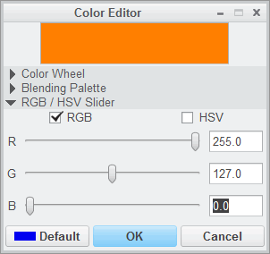

|  |
| --- |
| 1. In the model tree, expand **Loads/Constraints**   and **Constraint Set ConstraintSet2**.   1. Select **Surface_Thrust** and click **Edit Definition**   from the mini toolbar.   1. The Constraint dialog box appears. Click   **Change Color** .   1. The Color Editor dialog box appears. Type **255** in the R field, **127** in the G field and **0** in the B field. Press ENTER to create an orange color. |
| 1. Click **OK** to return to the Constraint dialog box. 2. Click **OK**. |

**Task 2: Modify some of the simulation display settings.**

1. Click **Simulation Display ** from the In Graphics toolbar.
2. The Simulation Display dialog box appears.
3. Select the **Settings** tab.
4. Select the **Display Current Csys Triad** check box.
5. Select the **Modeling Entities** tab. Clear the **Material Assignments** check box.
6. Select the **Loads/Constraints** tab. Clear the **Force/Moment Loads** check box.
7. Click **OK** to close the Simulation Display dialog box.

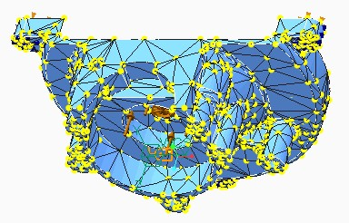**Task 3: Mesh the model and modify the display settings of the mesh.**

1. In the ribbon, select the **Refine Model** tab.
2. Click **AutoGEM** in the AutoGEM group.
3. 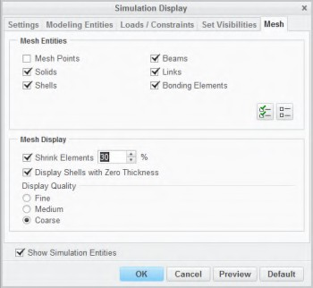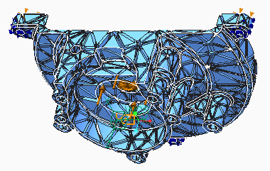The AutoGEM dialog box appears. Click **Create**.

|  |
| --- |
| 1. In the Diagnostics:AutoGEM Mesh dialog box, click **Close**. 2. In the AutoGEM Summary dialog box, click **Close**. |
| 1. Click **Simulation Display** . 2. The Simulation Display dialog box appears. Select the **Mesh** tab. 3. Clear the **Mesh Points** check box. 4. Select the **Shrink Elements** check box and type   **30** in the percentage field as shown. |
| 10. Click **OK** to close the Simulation Display dialog box and view the changes. |
| 1. In the AutoGEM dialog box, click **Close**. When you are prompted to save the mesh, click **No**. 2. Click **File > Manage Session > Erase Current** to erase the model from memory. 3. Click **Yes** in the Erase Confirm dialog box.   This completes the procedure. |

## Using Measures

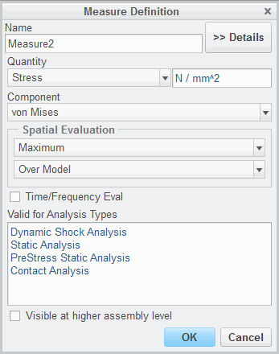Measures enable you to evaluate certain results, or result quantities, as discrete numbers in the engine report file or as a graph plot using the postprocessor.

To define a measure:

* + Type the name of the measure.
  + Specify the quantity to be measured.
  + Select a component or sub-option and a referenced user coordinate system.
  + Select the spatial evaluation.
  + Enter further options, if necessary.

Fig. 1 – Measure Definition

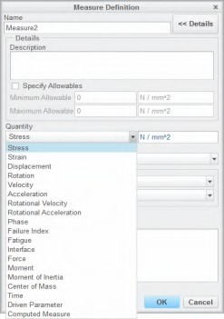 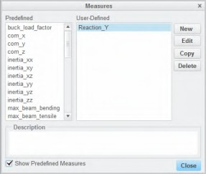

Figure 2 – User-Defined Measures Figure 3 – Predefined Measures

*Using Measures*

Measures enable you to evaluate certain results, or result quantities, as discrete numbers in the engine report file or as a graph plot using the postprocessor. The postprocessor also enables you to plot a measure versus another measure. Measures can be used as a convergence norm in a multipass adaptive analysis. In static, modal, and buckling analyses, Simulate provides several system predefined measures. In addition, for these and other analyses, the user can create measures for specific requirements in the postprocessor.

To define a measure, use the Measure Definition dialog box and complete the following:

* Type the name of the measure – Type a meaningful name. If required, enter a description.
* Specify the quantity to be measured – The available quantities are shown in Figure 2.
* Select a component or sub-option and a referenced user coordinate system – Select sub-options for each quantity. The types of sub-options depend on the quantity selected.
* Select the spatial evaluation – Options may be point, minimum, or maximum (near point, over model, over selected idealizations, and so forth). Select the geometry linked with the measurement.
* Enter further options if necessary.

Predefined measures are also available, as shown in Figure 3.

When working with measures on defined points, you must ensure that these points move or stay as required in the sensitivity study during geometry update. The convergence plot can be checked for

every measure when running the study in MPA. Computed measures enable you to further process existing measure results in analytical expressions. These can then be output in the report file.

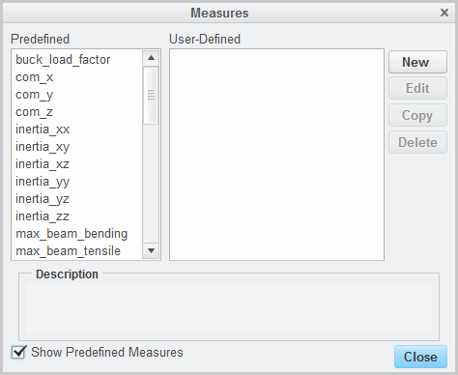

## PROCEDURE - Using Measures

**Task 1: Open the measure dialog box and explore**

**the predefined measures.**

1. In the ribbon, select the **Home** tab.
2. Click **Measures ** from the Run group.
3. The Measures dialog box appears. Select the **Show Predefined Measures** check box. Review the default measures defined for the model.

**Task 2: Create a new measure.**

|  |
| --- |
| 1. In the Measures dialog box, click **New**. 2. The Measure Definition dialog box appears.    * In the Name field, type **Point_Accel**.    * Select **Acceleration** from the Quantity   drop-down list.   * + Select **Magnitude** from the Component   drop-down list.   * + Select **At Point** from the Spatial Evaluation   drop-down list.   * + Click **Select Reference** The Points Selection   Dialog box appears.   * + Select **PNT0** on the model or from the model tree.   + In the Points Selection dialog box, click **OK**. |
| 1. Verify the Measure Definition dialog box appears as shown and click **OK**. 2. In the Measures dialog box, click **Close**. 3. Click **File > Manage Session > Erase Current** to erase   the model from memory.   1. Click **Yes** in the Erase Confirm dialog box. |
| This completes the procedure. |

## Exercise 1: Using Measures

### Objectives

After successfully completing this exercise, you will be able to:

* + Prepare a model for measures specification.
  + Create resultant and moment measures.
  + Create displacement measures.
  + Create computed measures.
  + Create stress evaluation measures.

### Scenario

In this exercise, you examine some of the capabilities in Creo Simulate that enable user-defined evaluations of stresses, deformations, or other quantities at certain locations in the model. These may be quantities that are not maximum or minimum throughout the model, but only at specific locations.

In this exercise, you examine a plastic clip subjected to a unit load. You are interested in finding reaction forces at supports, as well as shear forces and moments along the length of the clip and stresses at critical areas in the model. In addition, you are interested in finding the spring force and energy stored in the model when it is loaded. To accomplish this, you utilize the Measure feature in Creo Simulate.

**Task 1: Investigate the model properties.**

1. Click **File > Prepare > Model Properties**. The Model Properties dialog box appears.
2. Review the units used in the model. To close the Model Properties dialog box, click **Close**.
3. In the model tree, expand **Materials**. Right-click **THERMOPLAST_LIGHTGREY_RAL_7035** and select **Edit Definition **. The Material Definition dialog box appears.
4. Review the values for Young’s Modulus (E) and Poisson’s Ratio. Click **Ok** to close the Material Definition dialog box.
5. Review the unit surface load that has been defined in the model, causing the clip to bend. The constraints are defined to simulate that bolts are holding the clip. The bolts are not actually defined in the model; rather, the constraints in the model simulate that the bolt hole surfaces are not deforming.

**Task 2: Prepare the model for measure specification by creating a volume region simulation feature and a datum point.**

1. 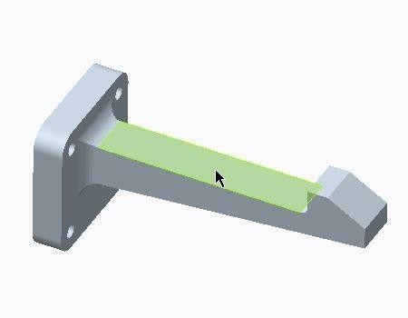In the ribbon, select the **Refine Model** tab.
2. Select **Extrude ** from the Volume Region drop-down menu in the Regions group. The Extrude dashboard appears.
3. Select the surface shown in the model.



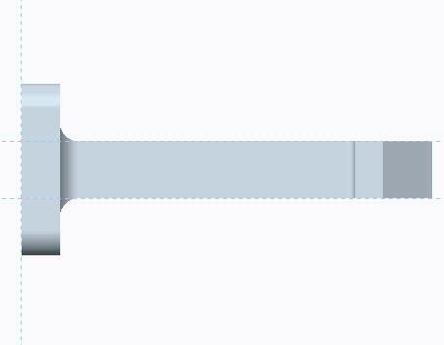

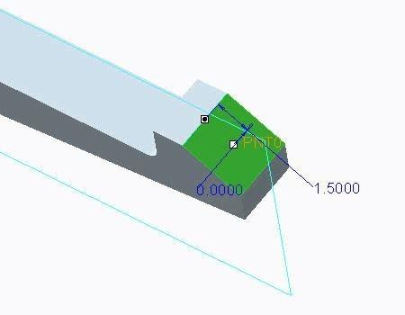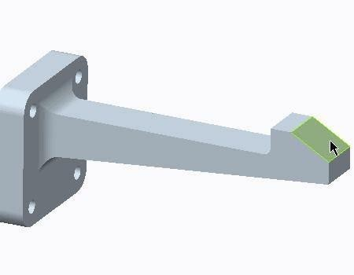

|  |
| --- |
| 1. In the ribbon, select the **Sketch** tab. 2. Click **Sketch View**  in the Setup group to orient the sketch plane. 3. Click **References**  in the Setup group. The References dialog box appears. 4. On the model, select the references for the sketch geometry as shown. Delete any unused references that are listed. 5. In the References dialog box, click **Close**. |
| 1. Select **Corner Rectangle**  from the Rectangle types drop-down menu in the Sketching group. 2. Sketch a rectangle and dimension it as shown. 3. Click **OK** to complete the sketch and return to the Extrude dashboard. |
| 1. Select **Through All** from the depth drop-down menu. 2. Click **Apply-Save Changes** . |
| 1. In the ribbon, select the **Refine Model** tab. 2. Select the surface as shown in the model. 3. Click **Point** from the Datum group. The Datum Point dialog box appears.   *Note: The point you create in the model does not have to be a hard point (a flnite element node), but it must reside on the geometry. You can also place measures inside the geometry, but those must be created on*  *references such as edges of Volume Regions.* |
| 1. Enable **Plane Display** . 2. In the Datum Point dialog box, select **PNT1** if necessary and click in the Offset references field. 3. Press CTRL and select the **Front_XY** datum plane and the edge, as shown. |
| 1. In the Offset references section of the Datum Point dialog box, type **0.0** for the Front offset reference and **1.50** for the edge offset reference. 2. Click **OK**. |

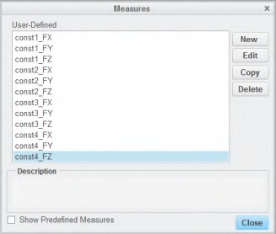

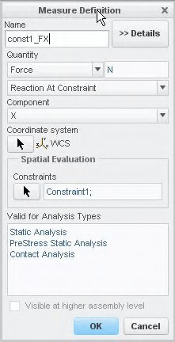**Task 3:** Create a resultant and moment measure.

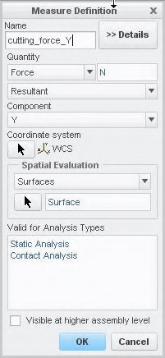

|  |
| --- |
| ***Note:*** *These measures evaluate the reaction force at the constraints. Four measures are created for each reaction direction.* |
| 1. In the ribbon, select the **Home** tab. 2. Click **Measures**  from the Run group. The Measures dialog box appears. 3. Click **New**. The Measure Definition dialog box appears. 4. Complete the Measure Definition dialog box as shown. In the Spatial Evaluation section, click **Select Reference** . Select **Constraint1** in the model tree and click **OK** in the Select dialog box. 5. In the Measure Definition dialog box, click **OK**.   Do not close the Measures dialog box.   1. Using the previous steps, create an X force measure for each of the remaining three constraints. 2. Using the previous steps, create a Y and Z direction force measure for all four constraints. Maintain the same naming convention. There are a total of 12 measures. Do not close the Measures dialog box. |
| 1. In the Measures dialog box, click New. The Measure Definition dialog box appears. 2. Complete the Measure Definition dialog box as shown. After selecting Surfaces in the Spatial Evaluation section, click Select Reference  . Select the surface generated by creating the volume region, as shown in the model, and click OK in the Select dialog box. 3. In the Measure Definition dialog box, click OK. |
| 11. Using the previous steps, create an X force measure at the same location. Do not close the Measure dialog box. |

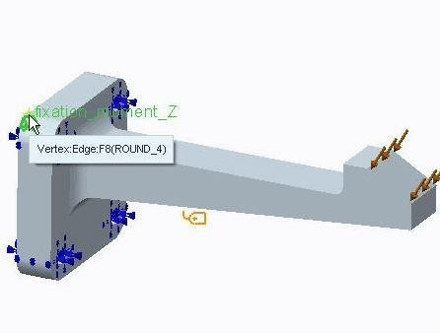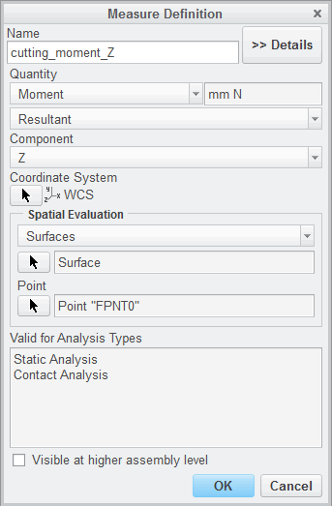

|  |
| --- |
| 1. Define a resultant for measure at the 8 mm offset from the supports. In the Measure dialog box, click **New**. 2. Complete the Measure Definition dialog box as shown. After selecting **Surfaces** in the Spatial Evaluation section, complete the following:    * Click **Select Reference**  to select the surface generated by creating the volume region, as in the previous step.    * In the Point section, click **Select Reference**  to select the point, as shown in the figure. Click **OK** in the Select dialog box. 3. In the Measure Definition dialog box, click **OK**. Do not close the Measures dialog box. |
| 15. Using the previous steps, create another moment measure at the same location, but using a different point for Spatial Evaluation as shown. Do not close  the Measures dialog box. |

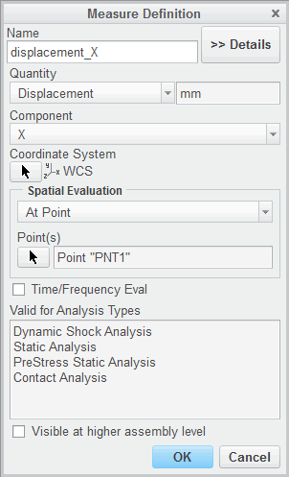

**Task 4: Create a displacement measure.**

1. In the Measures dialog box, click **New**. The Measure Definition dialog box appears.
2. Complete the fields as shown. The point selected is the datum point created in a previous task.
3. Click **OK**. Do not close the Measures dialog box

**Task 5:** Create a computed measure.

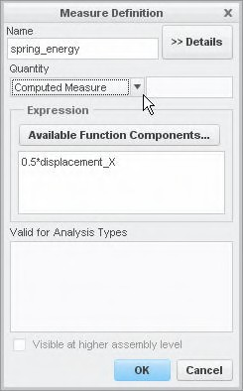

1. In the Measures dialog box, click **New**. The Measure Definition dialog box appears.
2. Complete the dialog box as shown.
3. Click **OK**. Do not close the Measures dialog box.

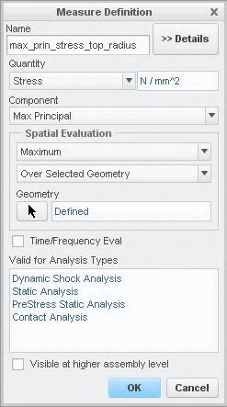

**Task 6: Create stress evaluation measures.**

1. In the Measures dialog box, click **New**. The Measure Definition dialog box appears.
2. Complete the Measure Definition dialog box as shown. After selecting **Over Selected**

**Geometry** in the Spatial Evaluation section, click **Select Reference ** . Select the surface shown in the model and click **OK** in the Select dialog box.

1. In the Measure Definition dialog box, click **OK**. Do not close the Measures dialog box.
2. Using the previous steps, create another stress evaluation measure. Evaluate the Minimum Principal Stress over the fillet opposite the one just selected
3. In the Measures dialog box, click **Close**.

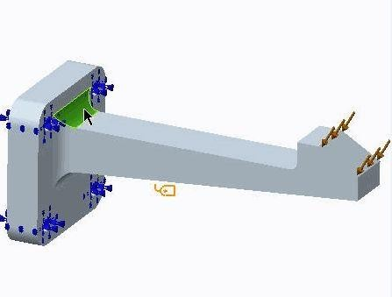

  

**Task 7: Investigate the measures as output from a static analysis.**

* 1. In the ribbon, select the **Home** tab.
  2. Click **Analyses and Studies ** from the Run group. The Analyses and Design Studies dialog box appears.
  3. Select the study that is already defined. Click **Start Run **.
  4. Click **Yes** to run the interactive diagnostics.
  5. Click **Display Study Status ** to monitor the run.
  6. In the Run Status dialog box, identify the list of default measures reported by Creo Simulate (minimum or maximum quantities) and the list of your defined measures. Since the load does not vary with time or frequency, only single values are reported for the measures you have created.

***Note:*** *Measures can also be used as quantities on which the solution can converge. In any*

*Multi-Pass Adaptive Analyses dialog box, select the Measures radio button and select any default or user- deflned measures.*

* 1. In the Run Status dialog box, click **Close**.
  2. In the Analyses and Design Studies dialog box, click **Close**.

##### Click File > Manage Session > Erase Current.

* 1. The Erase Confirm dialog box appears. Click **Yes**. This completes the exercise.

61

# Module 4

## Materials and Material Properties

## Understanding Material Properties

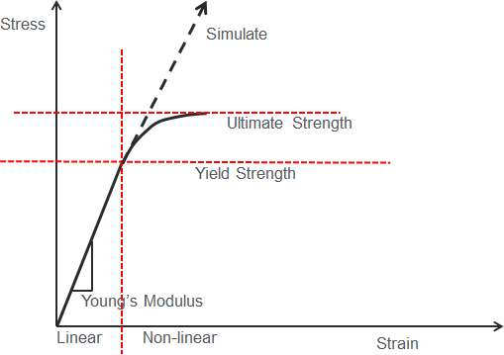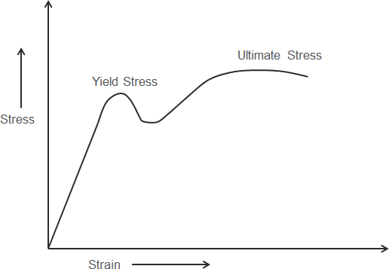It is important to understand how Simulate models materials.

Figure 1 - Typical Material Stress Strain Curve Figure 2 - Simulate Linear Material Model

*Understanding Material Properties*

It is important to understand how Simulate models materials.

*Typical Material Stress Versus Strain Curve*

The stress/strain curve for a typical material is shown in figure 1. It starts out with a linear relationship between stress and strain, and if the yield stress of the material is not exceeded, it will return to its original shape if the stress is removed from the material. However, once the yielding stress is exceeded, the slope graph of the stress/strain curve changes and the graph becomes non-linear as the material plastically deforms during yielding.

*The Simulate Linear Material Model*

Most of the materials used in this course are assumed to be linear materials. While Simulate can analyze nonlinear materials, they are beyond the scope of this concept and not covered here. When analyzing linear materials, Simulate assumes that the linear relationship between stress and strain continues infinitely. For this reason, when using linear materials in Simulate analyses, it is important to keep peak stresses in the linear region for the material. For most materials, this means maintaining peak stress values that are below the yield stress for the material.

## Defining Linear Elastic Materials

Simulate enables you to define various material types. To define a linear elastic material:

* + Select a material from the library, or create a new one.
  + Describe material properties as a function of temperature or a parameter.
  + 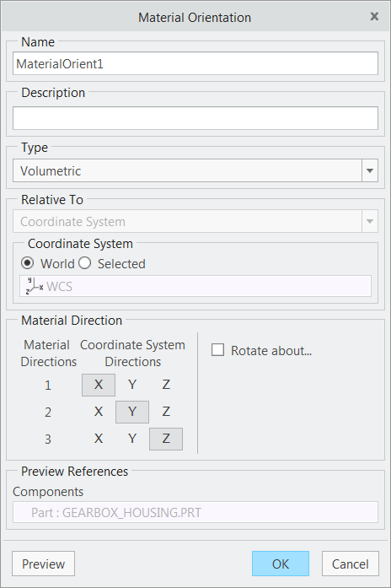Apply material to parts or volumes.

Fig.1 – Material Orientation

*Defining Linear Elastic Materials*

Simulate enables you to define various material types.

* Isotropic
* Linear
* Hyperelastic
* Elastoplastic
* Orthotropic
* Transversely Isotropic

In this course, you treat only linear elastic and isotropic materials. Simulate can use the materials defined in Creo Parametric. All material data necessary for the calculation can be entered there. Additionally, in Simulate, further materials can be defined and stored in the same library or in the model itself (part or assembly).

Materials defined and assigned in Simulate override the part material defined in Creo Parametric.

To define a linear isotropic material:

* + Select a material from the library, or create a new one.
  + Describe material properties as a function of temperature or a parameter.
* Define Poisson’s Ratio, Modulus of Elasticity, E, and Coefficient of Thermal Expansion, CTE, and Thermal Conductivity as functions of temperature.
* Define all material properties as parameters. Later you can then vary and optimize them using a design study. To create a design parameter, select a specific material value and connect it to a previously defined Creo Parametric parameter, or create a new parameter.
  + Apply material to parts or volume regions. In the case of idealizations, directly reference the materials from those (for example, beams, shells).

Creo Parametric, Direct, and Simulate store materials in a *.mat file in the location defined with the config.pro option pro_material_dir. Check materials for their system of units when switching to Legacy Independent mode (only possible from Simulate Embedded Mode).

## PROCEDURE - Defining Linear Elastic Materials

**Task 1: Apply the Brass material that has been already added to the assembly..**

|  |
| --- |
| 1. Disable all Datum Display types. 2. In the model tree, expand **Materials**.   Note that Brass is already added to the assembly materials.   1. In the model tree, select **ASSIGN_MAT1.PRT** 2. click **Material Assignment**  from the mini toolbar. 3. The Material Assignment dialog box appears.   Select **BRASS** from the Material drop-down list. |
| 5. Click **OK** to assign the material and close the Material Assignment dialog box. |

**Task 2: Assign a material by adding it to the assembly from the material library, and then assign it to the ASSIGN_MAT2.PRT component.**

|  |
| --- |
| 1. In the model tree, right-click **ASSIGN_MAT.ASM** and select **Edit Materials** . 2. The Materials dialog box appears. Double-click the Legacy-Materials folder, and right-click   **tipure.mtl** and select **Add to Model** to add it to the Materials in Model section. |
| 3. Click **OK** to close the Materials dialog box. |
| 1. In the model tree, select ASSIGN_MAT2.PRT and click **Material Assignment**  from the mini toolbar. 2. In the Material Assignment dialog box, select **TIPURE** from the Material drop-down list. |
| 6. Click **OK** to assign the material and close the Material Assignment dialog box. |

**Task 3: Assign a material by adding it to the assembly from the material library, and then assigning it to the ASSIGN_MAT3.PRT component.**

1. In the ribbon, select the **Home** tab.
2. Click **Material Assignment ** from the Materials group.
3. The Material Assignment dialog box appears. In the model tree, select ASSIGN_MAT3.PRT.
4. In the Material Assignment dialog box, click **More...** next to the Material drop-down list.
5. The Materials dialog box appears. Double-click the Legacy-Materials folder, and right-click

**al6061.mtl** and select **Add to Model** to add it to the Materials in Model section.

1. Click **OK** to close the Materials dialog box.
2. Verify that the Material field is set to **AL6061** and click **OK** to assign the material and close the Material Assignment dialog box.

|  |
| --- |
| 8. The model should now appear as shown. Note the Material Assignment icon on each component of the  assembly. |
| 1. Click **File > Manage Session > Erase Current**. 2. The Erase dialog box appears. Click **Select All** . 3. Click **OK**. |

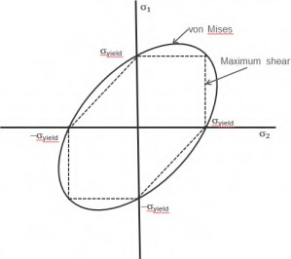

This completes the procedure.

## Understanding Failure Criteria

Failure criteria can be specified for Simulate materials. Material Failure

* + Available Criteria
    - Isotropic: Modified Mohr, Maximum Shear, von Mises
    - Transversely Isotropic: Tsai-Wu, Maximum Stress, Maximum Strain
  + Results: Failure Index

*Understanding Failure Criteria*

Failure criteria can be specified for Simulate materials.

Figure 1 - Maximum Shear and von Mises Failure Criteria

When using Isotropic or Transversely Isotropic material, Simulate enables the specification of failure criteria. Simply stated, failure criteria defines when a material will fail due to static loading. Depending on the material type, the following failure criteria are available in Simulate:

* Isotropic
  + Modified Mohr: Useful for materials that behave significantly different in compression than in tension.
  + Maximum Shear Stress (Tresca) and von Mises (Distortion Energy): Both behave quite similarly, with Maximium Shear Stress returning more conservative (failure occurs at lower stresses) than Distortion Energy. A plot of these two similar criteria is shown for two dimensional stress.
* For Transversely Isotropic
  + Tsai-Wu: Useful for laminates
  + Maximum Stress and Maximum Strain

In general, it is your responsibility to judge which criteria are best suitable to describe the behavior of the material. As a guideline, use Distortion Energy or Maximum Shear Stress for judging about yielding

in ductile materials (Maximum Shear Stress is just a little bit more conservative for certain stress states). If the compression strength is much higher than the tensile strength, like for many brittle engineering ceramics or casts, use Modified Mohr. However, take into account that ductility or brittleness are not necessarily properties which are valid in general for a material. It may happen that a ductile material behaves very brittle under certain stress states, for example, isostatic tension.

*Failure Index Results*

When an analysis is run on a component that has some specified failure criteria, the Failure Index is available as a result quantity. Material that has exactly met the failure criteria has a value of one; thus a value higher than one indicates how much the failure index has been exceeded. It is often useful to edit the legend's maximum value for Failure Index fringe plots to a value of one. If the maximum legend value is set to 1 when viewing Failure Index results, all areas exceeding the failure criteria display in a single color. If default colors are used, making this legend change enables simple identification of the area where the Failure Index has been exceeded: they will appear as red on the fringe plot.

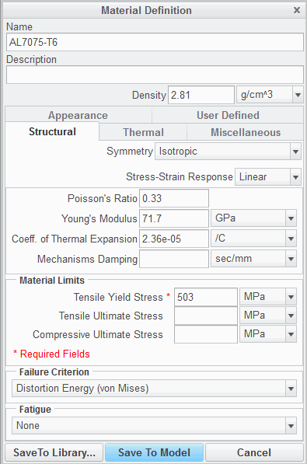Remember failure Index results apply to statically loaded members. Members exposed to cyclic stresses will typically fail due to fatigue at much lower stresses.

## Creating Materials

Materials can be created for Simulate analysis. Basic material properties

* Generic
* Structural
* Thermal
* Miscellaneous
* Appearance
* User Defined

Functionally dependent properties:

* Symbolically/Table driven

Fig. 1 - Structural Properties

###### Creating Materials

Materials can be created for Simulate analysis.

###### Basic Material Properties

If a material does not exist, it can be created and added to the part and/or the Material Library. When creating isotropic materials, the following attributes and properties can be defined:

* Generic: Name, Description, Density.
* Structural: Material Type, Poisson's Ratio, Young's Modulus, Coefficient of Thermal Expansion (CTE), Failure Criterion, and Fatigue characteristics. Each of these properties can be set to a user entered numerical value or an existing parameter.
* Thermal: Specific Heat Capacity, Thermal Conductivity.
* Miscellaneous: Sheetmetal Properties, Surface Properties, Detailing cross hatching.
* Appearance: Appearances specific to the material (color, highlights, bump maps, transparency, and so on).



* + User Defined: User defined material level parameters.

For non-isotropic material types, the direction specific Poisson's Ratio, Young's Modulus, CTE, Shear Modulus, and Thermal Conductivity are definable.

###### Functionally Dependent Properties

For Isotropic materials, in addition to being able to set values equal to parameters or numerical values, the values of Poisson's Ratio, Young's Modulus, and the CTE can be made functionally dependent on temperature if desired. Temperature dependent material properties can be defined symbolically or by using a table.

* + Symbolically Driven: With a symbolically driven function, any mathematical symbol recognized by Creo Parametric (such as sin, abs, sqrt, and so on) can be used. Logic statements can also be employed in defining the function.
  + Table Driven: With a table driven function, the values in the table can either be entered manually or imported from a text file.

###### Advanced Material Properties

In addition to basic material properties, more advanced material properties can be defined for materials. These advanced properties include non-linear Stress-Strain responses, Failure Criterion, and Fatigue characteristics.

These advanced properties are beyond the scope of this topic and will not be covered here.

## PROCEDURE - Creating Materials

**Task 1: Create a new material.**



|  |  |  |  |
| --- | --- | --- | --- |
| In the ribbon, select the **Home** tab.  Click **Materials** from the Materials  The Materials dialog box appears. Click **New material** | | | |
| 4. The Material Definition dialog box appears. Select the **Structural** tab and complete the fields | | | |
|  | **Field** | **Value** | **Units** |
| **Name** | **AL7075–T6** | N/A |
| **Density** | **2.81** | **g/cm^3** |
| **Symmetry** | **Isotropic** | N/A |
| **Stress-Strain Response** | **Linear** | N/A |
| **Poisson’s Ratio** | **0.33** | N/A |
| **Young’s Modulus** | **71.7** | **GPa** |
| **Coeff. of Thermal Expansion** | **2.36e-05** | **/C** |
| **Tensile Yield Stress** | **503** | **MPa** |
| **Failure Criterion** | **Distortion Energy (von Mises)** | N/A |
| ***Note:*** *If prompted with the Changing Parameter Units dialog box, select* ***Interpret Value*** *and* ***In the future, do not show this dialog****, then click* ***OK****. This dialog box appears when you type in numerical values before changing the units for those* | | | |



1. The **Structural** tab should appear as shown.
2. Select the **Thermal** tab and complete the fields as follows:

|  |  |  |
| --- | --- | --- |
| **Field** | **Value** | **Units** |
| **Symmetry** | **Isotropic** | N/A |
| **Specific Heat Capacity** | **960** | **joule/kg K** |
| **Thermal Conductivity** | **130** | **W/(m K)** |

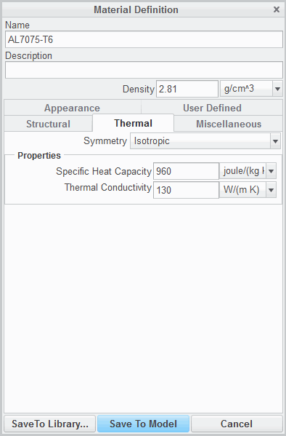

1. The **Thermal** tab should appear as shown.
2. Click **Save To Model**.
3. In the Materials dialog box click **OK**.
4. Click **File > Manage Session > Erase Current**

to erase the model from memory.

1. Click **Yes** in the Erase Confirm dialog box. This completes the procedure.

## Using 3-D Material Orientation

Transversely Isotropic and Orthotropic materials need material orientations.

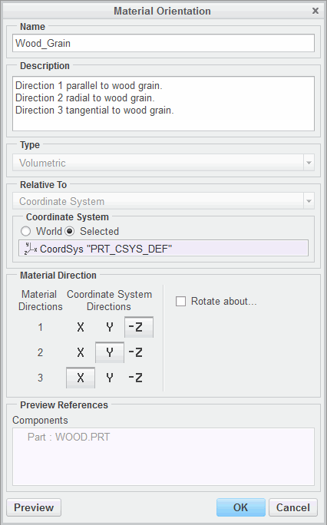

3-D material orientation:

* + Referenced coordinate system
  + Material Direction grid

3-D material direction rotation

Figure 1 – Material Orientation Dialog Box

###### Using 3-D Material Orientation

Material orientations are used to define the principal material directions for orthotropic or transversely isotropic materials being assigned to entities. The material directions 1, 2, and 3 (as defined by the material orientation) correspond to the directions in the Material Orientation dialog box entered for orthotropic or transversely isotropic material properties. Also, some results (stress, displacement, flux, and so on) can be considered relative to the material orientation. Material orientations can be defined for 3-D entities, components, volumes, and solids. The following fields can be defined when creating a 3-D material orientation:

* Referenced coordinate system: The referenced coordinate system sets up the three base orthogonal coordinate vectors, whether in Cartesian (X,Y,Z), Cylindrical (R, ,Z), or Spherical (R, , ) coordinate systems.



* Material Direction Grid: Relates material coordinate directions 1,2, and 3 with base orthogonal vectors of the referenced coordinate system. The material grid displays near the bottom of the Material Orientation dialog box shown in Figure 1.
* The Rotate About field can be used to rotate the material orientation out of coincidence with the defined orthogonal entity directions (such as X, Y, and Z). This rotation can occur around any of the three orthogonal axes for 3-D applications.

If an orthotropic or transversely isotropic material is assigned in a model and a material orientation is not specified, Simulate issues a warning, and for 3-D solid materials, the principal material directions are aligned with the World Coordinate System (WCS) base vectors. Orientations are assigned to entities and not a material.

## PROCEDURE - Using 3-D Material Orientation

**Task 1:** Examine the REDWOOD material in the model.

1. In the model tree expand **Materials**.
2. Right-click **REDWOOD** and select **Edit Definition **.
3. The Material Definition dialog box appears. Note the following:
   * REDWOOD is a Transversely Isotropic material.
   * Young’s Modulus is much greater in direction 1 than it is in direction 2 and 3. Direction 1 is the direction parallel to the wood grain. Woods products demonstrate a greater strength parallel to the wood grain.
4. When your review is complete, click **OK** to close the Material Definition dialog box.

**Task 2:** Create a material orientation and apply it with a material to the part.

|  |
| --- |
| 1. In the ribbon, select the **Home** tab. 2. Click **Material Assignment**  from the Materials group. 3. The Material Assignment dialog box appears. In the Properties section, verify that **REDWOOD** is in the Material field. 4. Click **More** next to the Material Orientation field. 5. The Material Orientations dialog box appears. Click **New**. |
| 1. The Material Orientation dialog box appears. In the Name field, type **Wood_Grain**. 2. Type the following description in the Description field:    * **Direction 1 parallel to wood grain.**    * **Direction 2 radial to wood grain.**    * **Direction 3 tangential to wood grain.** 3. In the Coordinate System section, select **Selected**. 4. Select **PRT_CSYS_DEF** from the model tree. 5. In the Material Direction grid, direction 1, click **Z**. This orients direction 1 in the Z direction, relative to the PRT_CSYS_DEF coordinate system. Direction 1 is the direction parallel to the grain. Therefore, you are assigning the Z direction to be parallel to the grain.   ***Note:*** *Note that when* ***Z*** *is selected for direction 1, the sign changes to negative and the coordinate system directions are adjusted for the remaining two directions.* |

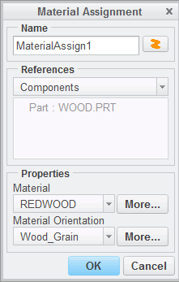

|  |
| --- |
| 11. The Material Orientation dialog box should  appear as shown. Click **OK** to close the dialog box. |
| 1. In the Material Orientations dialog box, click **OK**. 2. In the Material Assignment dialog box verify that the Material Orientation field is set to **Wood_Grain**. Click **OK** to assign the material and the material orientation to the component. |
| 1. Click **File > Manage Session > Erase Current** to erase the model from memory. 2. Click **Yes** in the Erase Confirm dialog box. |

This completes the procedure.

## Using 2-D Material Orientation

Transversely Isotropic and Orthotropic materials need material orientations.

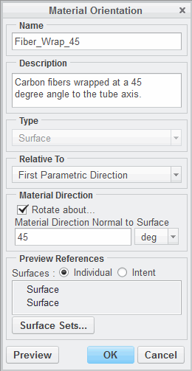

2-D orientation directions:

* Referenced Coordinate System
* First Parametric Direction
* Second Parametric
* Projected Vector
  1. material direction rotation

Figure 1 – Material Orientation Dialog Box

###### Using 2-D Material Orientation

Material orientations are used to define the principal material directions for orthotropic or transversely isotropic materials being assigned to entities. The material directions 1, 2, and 3 (as defined by the material orientation) correspond to the directions in the Material Definition dialog box entered for orthotropic or transversely isotropic material properties. Also, some results (stress, displacement, flux, and so on) can be considered relative to the material orientation. Material orientations can be defined for 3-D or 2-D entities. When applying a materials Orientation to a 2-D entity (shells, 2-D surfaces for 2-D axisymmetric, and 2-D plane strain analysis models), the orientation can be made relative to

one of the following:

* Referenced Coordinate System: Current coordinate system is used to specify material directions.
* First Parametric Direction: Direction 1 is defined as the first parametric direction of the surface (the U direction in a U, V parametric system on a surface). Direction 3 is always in the direction of the surface normal, and direction 2 is normal to directions 1 and 3.
* Second Parametric Direction: Direction 1 is defined as the second parametric direction of the surface (the V direction in a U, V parametric system on a surface).
* Projected Vector.

Additionally, the Rotate About field can be used to rotate the material orientation out of coincidence with the defined orthogonal entity directions (such as X, Y, and Z). This rotation can occur around the surface normal for 2- D applications.

If an orthotropic or transversely isotropic material is assigned in a model and a material orientation is not specified, Simulate issues a warning and the orientation must be assigned. Remember that orientations are assigned to entities, not to a material itself.

Material orientations assigned to entities that get compressed to a surface (as is the case with

mid-surface shells) will be changed from one defined over a part to one defined over a surface. This material orientation will be applied to all the surfaces that Simulate creates when compressing the part.

## PROCEDURE - Using 2-D Material Orientation

**Task 1:** Examine the CARBON_COMP material in the model.

* + 1. In the model tree expand **Materials**.
    2. Right-click **CARBON_COMP** and select **Edit Definition **.
    3. The Material Definition dialog box appears. Note the following:
       - CARBON_COMP is a Transversely Isotropic material.
       - Young’s Modulus is much greater in direction 1 than it is in direction 2 and 3. Direction 1 is the direction parallel to the carbon fibers. Carbon fiber composites demonstrate their greatest strength parallel to the fibers. Directions 2 and 3 are directions perpendicular to the fibers.
    4. When your review is complete, click **OK** to close the Material Definition dialog box.

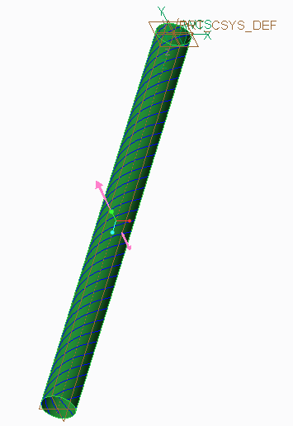**Task 2:** Create a shell with a material orientation that matches the fiber wrapping direction.

|  |
| --- |
| 1. In the ribbon, select the **Refine Model** tab. 2. Click **Shell**  from the Idealizations group. 3. The Shell Definition dialog box appears. In the Type field, select **Advanced** from the drop-down list. |
| 4. On the model select the cylinder as shown. |
| 1. In the Properties section, click **More...** next to the Shell Property field. 2. The Shell Properties dialog box appears. Click **New**. 3. The Shell Property Definition dialog box appears. Type **3** in the Thickness field. 4. Click **OK** to return to the Shell Properties dialog box. 5. Click **OK** to return to the Shell Definition dialog box. |

|  |
| --- |
| 1. Click **More...** next to the Material field. 2. The Materials dialog box appears. Verify that **CARBON_COMP** is selected in the Materials in Model section. Click **OK** to select the material and return to the Shell Definition dialog box. 3. Click **More...** next to the Material Orientation field. 4. The Material Orientations dialog box appears. Click **New...**. 5. In the Name field, type **Fiber_Wrap_45**. 6. In the Description field, type **Carbon fibers wrapped at a 45 degree angle to the tube axis**. 7. Select **First Parametric Direction** from the Relative to drop-down list. 8. In the In Graphics toolbar, click **Saved Orientations**  and select **Top**. 9. The datum curves on the surface of the cylinder represent the angle that the carbon fibers are wrapped around the cylinder. Note that the 1,2,3, coordinate frame does not currently align to these datum curves. In the Material Direction section, select the **Rotate about.** check box. 10. In the Material Direction Normal to Surface field, type **45**. |
| 20. On the model, select the cylindrical surface. Two surface references will be listed in the Preview References section, as shown. |
| 1. Click **Preview**. Note that direction 1 is now aligned with   the fiber wrap direction.   1. Click **OK** to return to the Material Orientations dialog box. 2. Click **OK** to return to the Shell Definition dialog box. 3. Click **OK** to complete the shell definition. |
| 1. Click **File > Manage Session > Erase Current**. 2. Click **Yes** in the Erase Confirm dialog box. |

This completes the procedure.

  

## Understanding Material Libraries

Material libraries enable the reuse of materials in more than one model.

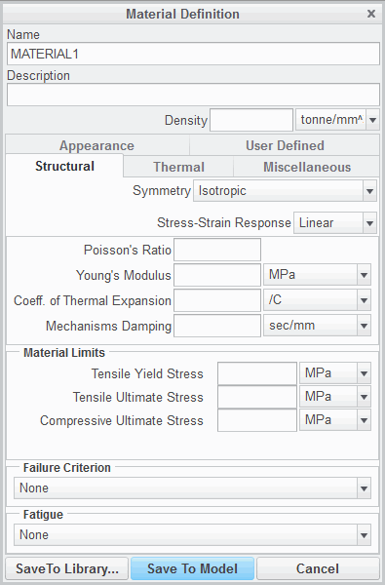

Default Material

Library Saving New Materials

* + - * Save to Model
      * Save to Library Custom Material Libraries

Figure 1 - Save Materials Options

###### 

###### Understanding Material Libraries

Material libraries enable the reuse of materials in more than one model.

###### Default Material Library

As installed, Creo Parametric provides a default library of materials. The default material library is located in the text subdirectory of the Creo Parametric installation directory, and contains a few selected materials. This library is intended, primarily, as a template for you to follow when creating your own material library.

###### Saving New Materials

If a material does not exist, it can be created by the user and stored in one of two places:

* The current model: A material stored with the Save To Model option will be stored only in the current model and cannot be used in other models.
* A material library: A material stored with the Save To Library... option will be stored in a user specified directory. Often the directory specified is a corporate or division level materials directory. The default is the current working directory.

###### Custom Material Libraries

By default, Creo Parametric will always look in the default library path for materials. However, Creo Parametric can be directed to look elsewhere for materials by using the pro_material_dir configuration option to specify a different path.

77

# Module 5

## Structural Constraints

## Defining Constraints

Applying constraints in Simulate restricts degrees of freedom in the model. The following constraints can be defined:

* + Standard constraints in any Cartesian, cylindrical, or spherical coordinate system.
  + 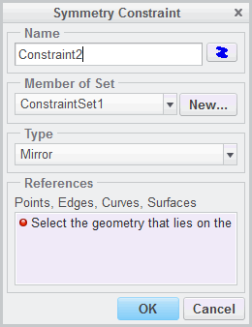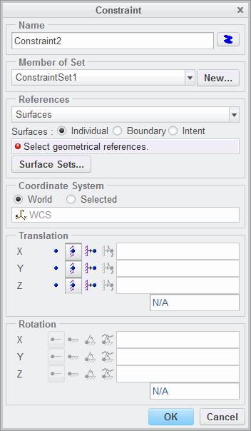Symmetry constraints.
  + Planar, Pin, or Ball constraints.

Figure 1 – Constraint Dialog Box Figure 2 – Symmetry Constraint Dialog Box

###### Defining Constraints

Applying constraints in Simulate restricts degrees of freedom in the model. Every point in space has 6 degrees of freedom: 3 in translation and 3 in rotation. The option fixed locks the corresponding degree offreedom. Anenforced displacement can be assigned as well. All geometries in the model which are not restricted by a constraint can move freely in space.

The following constraints can be defined:

* Standard constraints in any Cartesian, cylindrical, or spherical coordinate system – These are defined using the Constraint dialog box. In this dialog box, define the following:
  + Select the type of reference to be constrained: surface, edge, or point.
  + The coordinate system – The constraints are defined in the currently active coordinate system, but you can also select any other system if required. The dialog box selections and degrees of freedom change depending on the coordinate system type: Cartesian, cylindrical, or spherical. The effect of all other constraint types available in Simulate can be obtained with an equivalently defined standard constraint, with the only exception being cyclic constraints.
  + The constraints placed on the translational and rotational degrees of freedom, free, fixed, or prescribed. A prescribed displacement enforces reactions in the model.
* Symmetry constraints – Symmetry constraints are defined in the Symmetry Constraint dialog box. There are two types of symmetry that can be used in Simulate:
  + Cyclic Symmetry – This enables you to calculate “pieces of pie” as long as deformations and stress on both similar-shaped cross-sections are equal. It must be defined before AutoGEM starts.
  + Mirror Symmetry – This constraint fixes the translational direction normal to the selected surface and its two in-plane rotational directions.
* Planar, Pin, or Ball constraints.
* Planar – This constraint feature fixes the translational direction normal to the selected planar surface.
* Pin – This constraint enables you to fix the normal direction of a cylindrical surface (radial).

Optionally, you can also fix its translation along and rotation around the cylinder axis. Internally, a constraint defined in cylindrical coordinates is created. Use Legacy Independent Mode to study which rotational degrees of freedom are constrained. This is important for shell elements.

* Ball – This constraint constrains the normal direction of a spherical surface, the radial direction expressed in a spherical coordinate system at the ball center.

When setting constraints, the model has to be statically determinate; no remaining rigid body movement is allowed in static analysis. It may be over-constrained and redundant. Alternatively, a model can be calculated with Inertia Relief without any constraints. This equates quasi-static

accelerations with the external forces. The constraints are valid for all possible points on the selected geometry.

***Note:*** *For constraints deflned in a cylindrical or spherical coordinate system, or constraints deflned in a Cartesian system not orthogonal to the World Coordinate System, no reaction load measures can be calculated. As a work around, you may use the Resultant measures for the constrained surfaces.*

If you use standard constraints as symmetry conditions, equivalent to a mirror constraint, the following general rule is valid: The degree of freedom for translation normal to the symmetry plane and the two other rotational degrees of freedom have to be fixed. The constraint type mirror symmetry can only be used with planar references being parallel or perpendicular; otherwise, use a standard constraint with a local coordinate system. Unlike load sets, only one constraint set at once can be used for calculation, or several can be combined to one resulting set.

## PROCEDURE - Defining Constraints

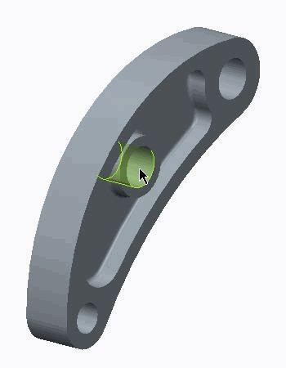**Task 1:** Investigate model properties.

|  |
| --- |
| 1. Disable all Datum Display types. 2. To review the model settings, click **File > Prepare > Model Properties**. The Model Properties dialog box appears. 3. Review the units used in the model and click **Close**. |
| 1. In the ribbon, select the **Inspect** tab. 2. Select **Diameter**  from the Measure types drop-down menu in the Measure group. 3. The Measure: Diameter dialog box appears. Select any half of the hole as shown in the figure. The value of the diameter is reported. Repeat for the remaining holes.   ***Note:*** *To view the diameter results in the Measure: Diameter dialog box expand the dialog box and the Results section.*   1. Close the Measure: Diameter dialog box. |
| 1. In the model tree, expand **Materials**. 2. Right-click **AL2014** and select **Edit Definition** . The Material Definition dialog box appears. 3. Review the values for Young’s Modulus, Poisson’s Ratio, and the units specified. Click **OK**. |

**Task 2:** Define a cylindrical coordinate system.

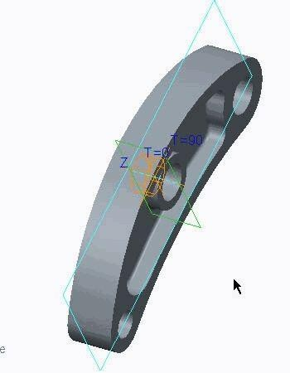

|  |
| --- |
| 1. In the ribbon, select the **Refine Model** tab. 2. Click **Coordinate System**  from the Datum group. The Coordinate System dialog box appears. 3. Select **Cylindrical** from the Type drop-down list. 4. Enable **Plane Display** and **Axis Display** . Press CTRL andinthe model tree, select **Hole_B** and select the datum plane **Front** on the model. 5. In the Coordinate System dialog box, select the   **Orientation** tab.   1. To orient the Z axis, click in the first Use field. Select   **Hole_B** in the model tree.   1. Select **Z** from the to determine drop-down list. 2. Click in the second Use field. Select the datum plane   **Right** in the model.   1. Select **T=90** from the to project drop-down list. The coordinate system is displayed as shown. 2. In the Coordinate System dialog box, click **OK**. |
| 1. Define a second coordinate system for hole C using the same method. Use the following references:    * axis **Hole_C**    * datum plane **Front**    * datum plane for orientation **Right** |

**Task 3:** Define the constraints.

|  |
| --- |
| ***Note:*** *The type of constraint that is deflned here simulates a steel rod placed in the hole. This enables the lever to rotate*  *and translate along the hole axis, but does not enable radial deformation.* |
| 1. In the model, select any of the half surfaces of hole B and click **Displacement**  from the  mini toolbar. The Constraint dialog box appears. The remaining half of the hole is automatically selected and two surfaces are listed in the References section  as shown. |

1. In the Coordinate System section, select **Selected**.

***Note:*** *By default, Creo Simulate deflnes the constraints using WCS (World Coordinate System), a Cartesian coordinate system. Notice that the Translation degrees of freedom is currently displaying X, Y, and Z as directions for the constraints.*

1. In the model tree, expand **Simulation Features** and select the Hole_B cylindrical coordinate system,

**CS1**.

***Note:*** *Note that the Translation section displays R, Theta, and Z.*

1. Click **Free Translation** for Theta and Z.
2. Click **OK**.
3. Apply the same constraint conditions to Hole C, using the cylindrical coordinate system created for Hole C,

**CS2**.

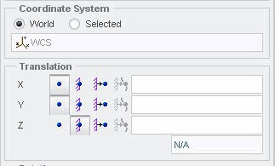

|  |
| --- |
| 7. In the model tree, expand **Simulation Features**. Select **PNT0** and click **Displacement**  from the mini toolbar. The Constraint dialog box appears. |
| 1. Use the WCS and complete the Translation section as shown. 2. Click **OK**.   ***Note:*** *All these constraints are part of the same constraint set and, therefore, act on the system at the same time.*   1. Click **File > Manage Session > Erase Current**. 2. Click **Yes** in the Erase Confirm dialog box.   This completes the procedure. |

## Understanding Displacement Constraints

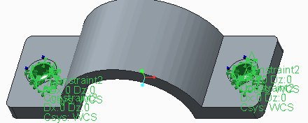Constraints are applied to restrict the degrees of freedom of selected entities. Settings:

* Free
* Fixed
* Prescribed

Six degrees of freedom:

* Three Translational
* Three Rotational Figure 1 - Displacement Constraints

###### Understanding Displacement Constraints

Displacement Constraints (sometimes referred to simply as constraints) are used to limit the degrees of freedom of an analysis model and to prevent rigid body motion (in most cases). Constraints

can be applied to surfaces, edges, and points. Analyses in Simulate solve specific equations, and these equations rely on certain assumptions. For a static problem, it is assumed that the model is in equilibrium, so the force is proportional to the displacement. In a dynamic or vibration problem, the sum of the inertial, damping, elastic, and external forces are also in balance. As such, an insufficiently constrained model can make the analysis impossible to solve.

From a practical perspective, constraints can also enable an engineer to simplify a model. Rarely is an engineer able to analyze a single complex system such as an engine or super-structure in one analysis. For example, consider a book. The book is sitting on a desk, and the desk sits on the floor. The floor is held up by a building and the building is anchored into the ground, which belongs to a planet floating in space. Clearly, if someone wanted to model how the book deformed under its own weight while sitting on the desk, the model would include only the handbook with constraints preventing it from moving downwards. Similarly, if you wanted to model a driveshaft, you can remove the bearings and assign constraints in their place and perform an analysis on the simplified model. If necessary, an analysis on the bearings could be done separately.

When a constraint is defined on an entity, each degree of freedom can be assigned one of three values:

* Free: This setting designates that the selected entity is free in this degree of freedom.
* Fixed: This setting designates that the selected entity cannot move in this degree of freedom.
* Prescribed: The user specifies a discrete amount of deformation that the entity will move in. This is used in situations where the user does not know the magnitude of the external load, but does know the desired deformation.

Any model in space has six degrees of freedom:

* + Three translational degrees of freedom
* forward/backward
* left/right
* up/down
  + Three rotational degrees of freedom
* Yaw
* Pitch
* Roll

Because of the way solid elements are created in Simulate, they only have three unique degrees of freedom (three translation) because any face on a tetrahedral cannot rotate without translation in one of the three directions. Because of this, Simulate will ignore rotational constraints on solids. However, rotational constraints can still be used on shell and beam idealizations.

When a model is insufficiently constrained for an analysis, it can manifest itself in several ways. Most often, the Simulate solver engine will report that the model is insufficiently constrained for the analysis. If this occurs, the best way to tackle the problem is to run a constrained modal analysis with rigid mode search. An animation of the rigid body motion should expose which component or degree

of freedom is causing the problem.

Constraints in a model will generate a reaction force if there is an attempt to deform the model in the direction being constrained. For example, a constraint that limits motion in the X and Y directions will create reaction forces with X and Y components, but no Z component. In other words, reactions can only be evaluated where a degree of freedom is being constrained. In a prescribed displacement constraint, the reaction force reported is the force required to produce that displacement.

## PROCEDURE - Understanding Displacement Constraints

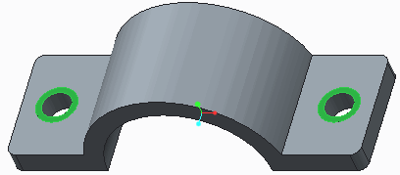**Task 1:** Create two displacement constraints.

* 1. Disable all Datum Display types.
  2. Press CTRL and select the surface regions shown.
  3. Click **Displacement ** from the mini toolbar. The Constraint dialog box appears.

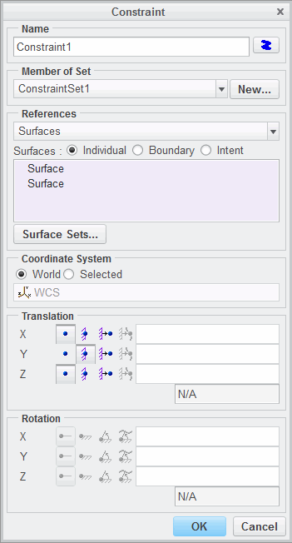

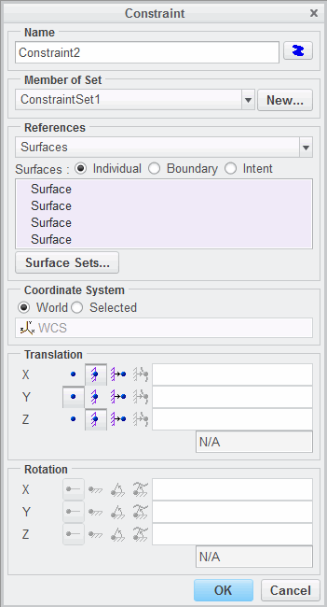

|  |
| --- |
| 1. In the Constraint dialog box, click **Free Translation** for the X and Z translational degrees of freedom. 2. The dialog box should appear as shown. Click **OK** to create the constraint and close the dialog box. |
| 1. Select the inner surface of one of the holes shown and click **Displacement**  from the mini toolbar. 2. The Constraint dialog box appears. Press CTRL and select the inner surface of the remaining hole. |
| 1. In the Constraint dialog box, click **Free Translation**   for the Y translational degree of freedom.   1. The dialog box should appear as shown. Click **OK** to create the constraint and close the dialog box. |
| 10. The model now has icons for both constraints on each of the holes as shown. |

1. Click **File > Manage Session > Erase Current** to erase the model from memory.
2. Click **Yes** in the Erase Confirm dialog box. This completes the procedure.

## Exercise 1: Understanding Displacement Constraints

### Objectives

After successfully completing this exercise, you will be able to:

* + Define constraints in a model.
  + Define loads in a model.
  + Define and run a static analysis.
  + Review a summary report.
  + Create a result window and review results.

### Scenario

In this exercise, you investigate a structural component made of a brittle material. Your goal is to find out if the material is able to withstand the maximum stress in the model. You also improve on how to create and investigate results using Creo Simulate.

The model to be analyzed is a chair under a 4500 N load. You can use symmetry since the material, loads, and constraints are also symmetrical but, in this case, radial.

***Note:*** *Creo Parametric users open OFFICE_CHAIR_LEVER.*

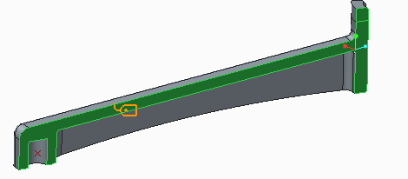

**Task 1:** Define constraints in the model.

* 1. On the model, select a surface as shown in the first image and click **Displacement ** from the mini toolbar. The Constraint dialog box appears.
  2. 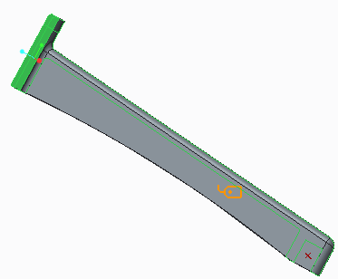Press CTRL and in the model select four surfaces as shown. Four surfaces should be listed in the References section in the Constraint dialog box.



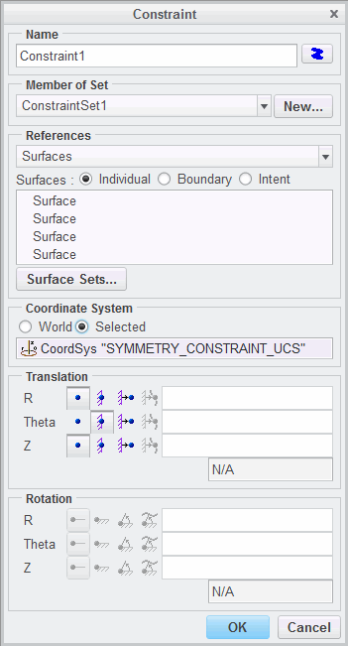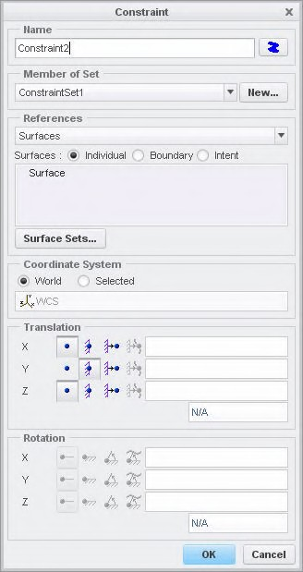

|  |
| --- |
| 1. In the Coordinate System section, select   **Selected**.   1. In the model tree, expand **Simulation Features**   and select **SYMMETRY_CONSTRAINT_UCS**.   1. In the Translation section, click **Free Translation** for R and Z translations. The dialog box should now appear as shown. 2. Click **OK**. |
| 7. Select the surface shown on the model and click **Displacement**  from the mini toolbar. The Constraint dialog box appears. |
| 8. Complete the remainder of the dialog box as shown and click **OK**. |

**Task 2:** Define the load on the model.

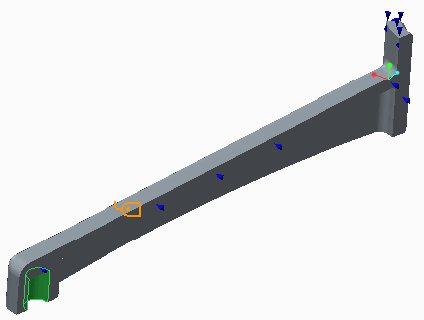

|  |
| --- |
| 1. On the model, select the curved surface as shown  and click **Force/Moment**  from the mini toolbar. The Force/Moment Load dialog box appears. |
| 1. Type **450** in the Y field in the Force section. 2. Click **Preview** to review the load distribution. 3. Click **OK**. |

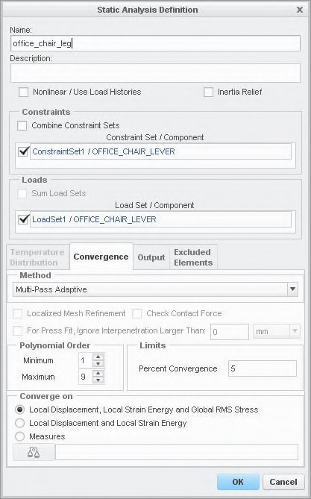**Task 3:** Define and run the static analysis.

1. In the ribbon, select the **Home** tab.
2. Click **Analyses and Studies ** from the Run group. The Analyses and Design Studies dialog box appears.
3. Click **File > New Static**. The Static Analysis Definition dialog box appears.
4. Complete the dialog box as shown.
5. Click **OK**.
6. In the Analyses and Design Studies dialog box, click **Run > Settings**. The Run Settings dialog box appears.
7. Review the default settings and click **OK**.
8. In the Analyses and Design Studies dialog box, click **Start Run **.
9. Click **Yes** in the Question dialog box.
10. Click **Display Study Status ** to monitor the run. The Run Status dialog box appears.
11. Review the information displayed in the Run Status dialog box after the run is complete. Notice the maximum values for the stresses and deformations, and also check the convergence of the solution.

***Note:*** *The values reported in the Summary report help you understand only the magnitude of the quantities you are looking for. You need to create fringe/vector plots and graphs for a better interpretation of the results. These plots help you flnd the maximum stress location and deformed shape.*

1. In the Run Status dialog box, click **Close**.

**Task 4:** Create result window and inspect results.

1. In the Analyses and Design Studies dialog box, select the analysis that just completed.
2. Click **Results > Define Result Window**. The Result Window Definition dialog box appears.
3. Create and review the following four result windows:
   * Failure Index
   * Maximum Displacement Magnitude
   * Principal Stress Convergence Graph
   * P-Level Plot

***Note:*** *Review the following:*

* *Did the solution converge?*
* *Are you able todistinguish the deformed shape?*
* *Note the maximum deformation at the center of the hole is approximately 1.25 mm.*

1. In the Creo Simulate Results window, click **File > Close**.
2. The Confirm Exit dialog box appears. Click **Don’t Save**.
3. In the Analyses and Design Studies dialog box, click **Close**.

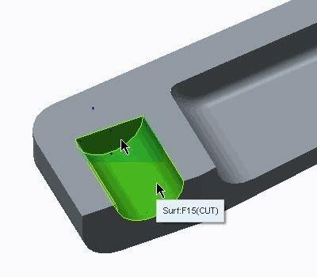**Task 5:** Use the maximum deformation noted at the center of the hole as an enforced displacement constraint in the model.

1. On the model, select the internal surface of the hole as shown and click **Displacement ** from the mini toolbar. The Constraint dialog box appears.
2. In the Translation section, click **Prescribed Translation **for the Y translation.
3. Type **1.25** in the Y translation field.
4. Select **mm** from the units drop down list in the Translation section.

***Note:*** *Using this value as an enforced displacement without deflning any external loads should result in the equivalent force causing the deformation to be equal to 450 N if the modeling technique is accurate.*

1. Click **OK**.

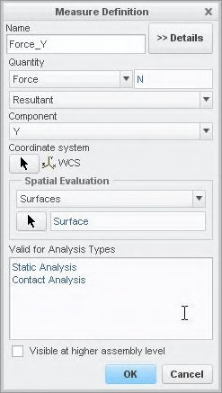

**Task 6:** Define the resultant force measure.

1. In the ribbon, select the **Home** tab.
2. Click **Measures ** from the Run group. The Measures dialog box appears.
3. Click **New**. The Measure Definition dialog box appears.
4. Complete the dialog box as shown. When selecting the Surface, select surface **SURF:F12(PROTRUSION)**, the same top surface constrained in an earlier step.
5. Click **OK**.
6. In the Measures dialog box, click **Close**.

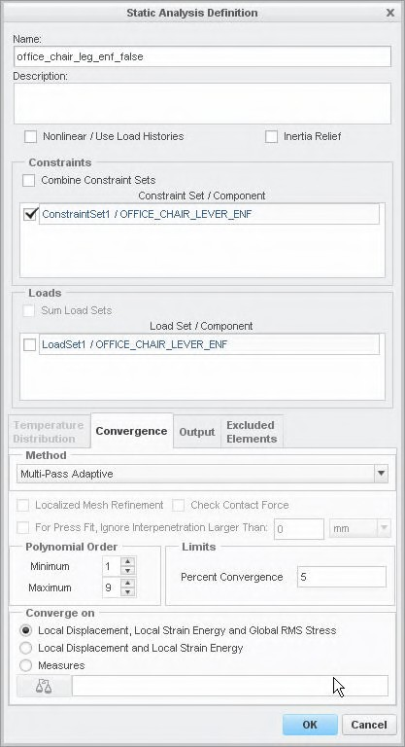**Task 7:** Define a new static analysis.

|  |
| --- |
| 1. In the ribbon, select the **Home** tab. 2. Click **Analyses and Studies**  from the Run group. The Analyses and Design Studies dialog box appears. 3. Click **File > New Static**. The Static Analysis Definition dialog box appears. 4. Complete the dialog box as shown. Note that the Load Set check box is cleared, removing the Load set from the analysis. 5. Click **OK**. |
| 1. In the Analyses and Design Studies dialog box, select the new analysis and click **Start Run** . 2. Click **Yes** in the Question dialog box. 3. Click **Confirm** in the next dialog box. 4. Click **Display Study Status**  to monitor the run. The Run Status dialog box appears. 5. Review the information displayed in the Run Status dialog box after the run is complete. Notice the maximum values for the stresses and deformations, and also check the convergence of the solution. Also note that Force_Y is higher than the expected value of 450N. The deformed shape needs to be reviewed to fully understand the behavior of the structure. 6. In the Run Status dialog box, click **Close**. |

**Task 8:** Create result window and inspect results.

|  |
| --- |
| 1. In the Analyses and Design Studies dialog box, select the analysis that just completed. 2. Click **Results > Define Result Window**. The Result Window Definition dialog box appears. 3. Create and review the following three result windows:    * Failure Index    * Maximum Displacement Magnitude Fringe Plot    * Maximum Principal Stress Fringe Plot 4. In the Creo Simulate Results window, click **File > Close**. 5. The Confirm Exit dialog box appears. Click **Don’t Save**. 6. In the Analyses and Design Studies dialog box, click **Close**. |
| 1. Click **File > Manage > Erase Current**. 2. Click **Yes** in the dialog box. |

This completes the exercise.

## Understanding Planar, Pin, and Ball Constraints

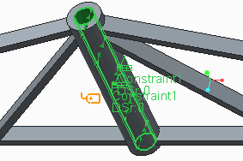Planar, pin, and ball constraints enable you to easily specify engineering constraints. Types:

* Planar
* Pin
* 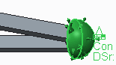Ball

Figure 2 - Ball Constraint Figure 1 - Pin Constraint

###### Understanding Planar, Pin, and Ball Constraints

When creating planar, pin, and ball constraints you must select the type of constraint from the Constraints group on the Home tab.

* Planar constraints enable the creation of a constraint that allows full planar movement, but constrains off-plane displacement. You can select only planar surfaces for this type of constraint.
* Pin constraints enable the creation of a constraint that controls the translation or rotation about the axis of a cylindrical surface in 3-D models. The pin constraint is particularly useful when you need

the surface to move in one or more directions, but be held in place in the remaining directions—for example, a piston that slides within a cylinder, but stays tight to the inner cylinder wall and does not rotate. You can select only cylindrical surfaces for this type of constraint. Additionally, the pin constraint enables you to specify the Angular degree of freedom as Free or Fixed, and the Axial degree of freedom as Free or Fixed.

* Ball constraints enable the creation of a constraint that represents a ball joint in which translation is fixed while rotation is free. You can select only spherical surfaces for this type of constraint.

## PROCEDURE - Understanding Planar, Pin, and Ball Constraints

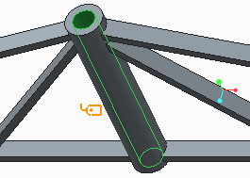**Task 1:** Create a pin constraint.

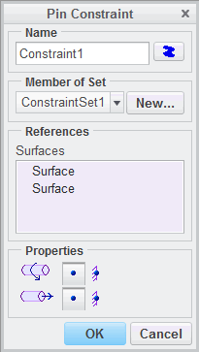

|  |
| --- |
| 1. Disable all Datum Display types. 2. Select the surface inside the hole as shown and click **Pin**  from the mini toolbar. The Pin Constraint dialog box appears. |
| 3. In the Pin Constraint dialog box, verify that the angular rotation and axial translation degrees of freedom are set to Free as shown. |
| 4. Click **OK** to create the constraint. |



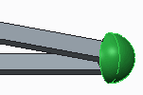

**Task 2:** Create a ball constraint.

|  |
| --- |
| 1. Select the spherical surface as shown and click **Ball** from the mini toolbar. The Ball Constraint dialog box appears. |
| 2. In the Ball Constraint dialog box, click **OK** to create the constraint. |
| 1. Click **File > Manage Session > Erase Current** to erase the model from memory. 2. Click **Yes** in the Erase Confirm dialog box. |

This completes the procedure.

## Exercise 2: Understanding Planar, Pin, and Ball Constraints

### Objectives

After successfully completing this exercise, you will be able to:

* + Define Pin constraints in cylindrical holes.
  + Use the three-point constraint rule for statically determinate constrained models.
  + Use the Inertia Relief functionality as an alternate for those models.
  + Review the stiffening effects of constraints and related errors.

### Scenario

In this example, you investigate the influence of the constraints and loads for an Aluminum tilt lever subjected to a quasi-static bending load of 1500 N. The load is caused by steel rods placed with some clearance inside of the cylindrical holes. You are interested in the lever’s stiffness and strength.

An accurate analysis of the stress state around the holes can be performed with a nonlinear contact analysis of the complete assembly, taking into account the tolerances and stiffness (geometry and material) of the steel rods.

Since this is very resource- and time-consuming, you learn different approximate solutions of how to constrain and load the part. You use these solutions to judge what the best and worse loading condition may be in reality.

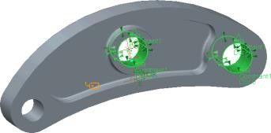**Task 1:** Define the pin constraints using predefined pin constraints.

1. On the model, select one of the holes as shown and click **Pin ** from the mini toolbar. The Pin Constraint dialog box appears.
2. Press CTRL and on the model, select the second of the larger holes as shown.

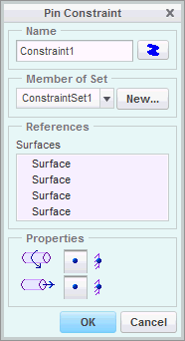

|  |
| --- |
| 1. Validate that the axial translations and rotations are set to free as shown.   ***Note:*** *Axial translations are not flxed in the pin constraint because this would prevent the material at the hole surfaces from shortening or*  *expanding axially due to Poisson’s effect (lateral strain effect). This would artiflcially stiffen the lever, especially at the central hole where the bending moment is highest.*   1. Click **OK**. |
| 1. On the model, select **PNT1** and click **Displacement**  from the mini toolbar. The Constraint dialog box appears. 2. In the Translation section, click **Free Translation** for the X and Y translations. 3. Click **OK**.   ***Note:*** *Simulate requires, in a static analysis, that the model is at least statically determinate. It also may be redundantly constrained. To prevent the complete lever from sliding along the bearing hole axes, one arbitrary point on the lever surface in WCS Z-direction is constrained. Since there is no applied force in the Z-direction, this*  *cannot cause a singularity.* |

**Task 2:** Define the bearing load.

1. In the ribbon, select the **Home** tab.
2. In the Loads group, click **Bearing **. The Bearing Load dialog box appears.
3. On the model, select a half surface of the small hole. Two surfaces are listed in the dialog box.



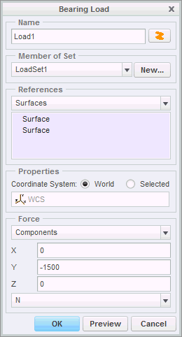

1. In the Force section, type **–1500** in the Y field. The completed dialog box is shown.
2. Click **OK**.

**Task 3:** Mesh the model.

1. In the ribbon, select the **Refine Model** tab.
2. Click **AutoGEM** from the AutoGEM group. The AutoGEM dialog box appears.
3. Click **Create**. Note there are approximately 1500 solid elements created.
4. Click **Close** in all dialog boxes and **No** to the prompt to save the mesh.

**Task 4:** Define and run the static analysis.

|  |
| --- |
| 1. In the ribbon, select the **Home** tab. 2. Click **Analyses and Studies**  from the Run group. The Analyses and Design Studies dialog box appears. 3. Click **File > New Static**. The Static Analysis Definition dialog box appears. |
| 1. Complete the following:    * In the Name field, type **tilt_lever_pinconstrained**.    * Select the constraint and load sets displayed in the Constraint Set/Component and Load Set/Component sections.    * Select the **Convergence** tab and click **Single-Pass Adaptive** from the Method drop-down menu. 2. Click **OK** to return to the Analyses and Design Studies dialog box. |
| 1. Click **Configure Run Settings** . The Run Settings dialog box appears. 2. The results and temporary output directories are set by default in the working directory. Both analyses are stored in this location. Click **OK**. |
| 1. In the Analyses and Design Studies dialog box, select the analysis just defined and click **Start Run**   . Click **Yes** to run interactive diagnostics.   1. Click **Display Study Status**  to view the summary report after the analysis is complete. 2. Carefully inspect the information displayed in the summary file. Note the maximum values for the most sought quantities (stresses and deformations). Close all dialog boxes and return to the Analyses and   Design Studies dialog box. |

**Task 5:** Create result windows and inspect the results.

|  |
| --- |
| 1. In the Analyses and Design Studies window, select **tilt_lever_pinconstrained**. 2. Click **Results > Show Default Result Windows**. Three default result windows appear:    * von Mises Stress Animation    * Displacement Magnitude Fringe    * Principal Stress Vectors 3. Review the following:    * Observe the movements and deformations of the lever in the animated results. The pin constrained bearing holes can rotate, but they cannot deform in the constrained directions, since these become infinitely stiff.    * In the principal stress vector plot, observe the non-realistic principal stress vector directions at the two constrained holes. Since the real bearing rod can just carry forward compression forces, there can be no tension stresses normal to the hole surfaces. In the outer big bearing hole, observe that the vectors normal to the hole surface do not point down, but are oriented   towards the left side. The reason is that the idealized pin constraint fixes the through rod within the hole in the WCS-X direction also, not only in Y.   * + As a consequence, the stress near the constraints may be inaccurate. |
| 1. Click **File > Close** to return to Creo Simulate. Click **Don’t Save** in the Confirm Exit dialog box. 2. In the Analyses and Design Studies dialog box, click **Close**. 3. Click **File > Manage Session > Erase Current** to close the displayed window and erase the model from memory. 4. Click **Yes** in the erase confirm prompt. |

**Task 6:** Open the model to begin a three-point constraint modeling approach.

|  |
| --- |
| ***Note:****:*   * *The points can be anywhere on the model surface, but are not allowed to be collinear.* * *Fix the flrst point in all translational directions.* * *Fix the second point in the two orthogonal directions relative to the axis through point 1 and point 2.* * *Fix the third point normal to the surfaces through all points.* |
| 1. Open the file TILT _LEVER_CONSTRAINEFFECTS_SIM.PRT. |

**Task 7:** Define the three-point constraints.

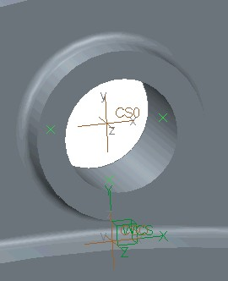

1. On the model, locate points **PNT0**, **PNT1**, and

**PNT2** as shown. Note they are not collinear.

|  |
| --- |
| 1. In the ribbon, select the **Home** tab. 2. In the Constraints group, click **Displacement** . The Constraint dialog box appears. 3. In the Member of Set section, click **New**. The Constraint Set Definition dialog box appears. 4. In the Name field, type **3point**. 5. Click **OK** to return to the Constraint dialog box. 6. Select **Points** from the References drop-down menu. 7. On the model, select **PNT2**. 8. In the Translation section, click **Fixed**  for the X, Y, and Z translations. This is the first point fixed in all translational directions. 9. Click **OK**. |
| 1. In the ribbon, select the **Home** tab. 2. In the Constraints group, click **Displacement** . The Constraint dialog box appears. 3. Select **Points** from the References drop-down menu. 4. On the model, select **PNT0**. 5. In the Translation section, click **Free Translation** for the X translation. Verify that the Y and Z translations are fixed. This is the second point fixed in the two orthogonal directions relative to the axis through point 1 and point 2. 6. Click **OK**. |
| 1. In the ribbon, select the **Home** tab. 2. In the Constraints group, click **Displacement** . The Constraint dialog box appears. 3. Select **Points** from the References drop-down menu. 4. On the model, select **PNT1**. 5. In the Translation section, click **Free Translation** for the X and Y translations. Verify that the Z translation is fixed. This is the third point fixed normal to the surfaces through all points. 6. Click **OK**. |



**Task 8:** Define the bearing loads.

|  |
| --- |
| 1. In the ribbon, select the **Home** tab. 2. In the Loads group, click **Bearing** . The Bearing Load dialog box appears. 3. In the Member of Set section, click **New**. The Load Set Definition dialog box appears. 4. In the Name field, type **force_equilibrium**. 5. Click **OK** to return to the Bearing Load dialog box. 6. On the model, select a half surface of the small hole. Two surfaces are listed in the dialog box. 7. In the Force section, type **–1500** in the Y field. 8. Click **OK**. |
| 1. In the ribbon, select the **Home** tab. 2. In the Loads group, click **Bearing** . The Bearing Load dialog box appears. 3. On the model, select a half surface of the middle hole. Two surfaces are listed in the dialog box. 4. In the Force section, type **3152.81** in the Y field. 5. Click **OK**. |



|  |
| --- |
| 1. In the ribbon, select the **Home** tab. 2. In the Loads group, click **Bearing** . The Bearing Load dialog box appears. 3. On the model, select a half surface of the remaining third hole. Two surfaces are listed in the dialog box. 4. In the Force section, type **–1652.81** in the Y field. 5. Click **OK**. |
| 1. To review the resultant load in the model, click the Loads group drop-down menu and select   **Review Total Load**. The Load Resultant dialog box appears.   1. In the Loads section, click **Select Reference**  . 2. In the model tree, expand Loads/Constraints and Load Set force_equilibrium. Press CTRL and select   **Load1**, **Load2**, and **Load3**.   1. In the Select dialog box, click **OK**. 2. In the Load Resultant dialog box, click **Compute Load Resultant**. 3. Note that all the Load Resultant values are approximately zero. This confirms the correct values for the balanced bearing loads, and the fact the model is in equilibrium. Click **OK**. |

**Task 9:** Define and run the static analyses.

|  |
| --- |
| 1. In the ribbon, select the **Home** tab. 2. Click **Analyses and Studies**  from the Run group. The Analyses and Design Studies dialog box appears. 3. Define this first static analysis using the three-point constraint defined. Click **File > New Static**. The Static Analysis Definition dialog box appears. |
| 1. Complete the following:    * In the Name field, type **tilt_lever_3point**.    * Select **3point/TILT_LEVER_CONSTRAINEFFECTS_SIM** in the Constraint Set/Component section. De-select any other constraint set if required.    * Select **force_equilibrium/TILT_LEVER_CONSTRAINEFFECTS_SIM** in the Load Set/Component section. De-select any other load set if required.    * Select the **Convergence** tab and select **Single-Pass Adaptive** from the Method drop-down menu. 2. Click **OK** to return to the Analyses and Design Studies dialog box. |
| 1. Click **Configure Run Settings** . The Run Settings dialog box appears. 2. The results and temporary output directories are set by default in the working directory. Both analyses are stored in this location. Click **OK**. |
| 1. In the Analyses and Design Studies dialog box, select the analysis just defined and click **Start Run**   . Click **Yes** to run interactive diagnostics.   1. Click **Display Study Status**  to view the summary report after the analysis is complete. 2. Carefully inspect the information displayed in the summary file. Note the maximum values for the most sought quantities (stresses and deformations). Also note that the resultant load is zero. Close all dialog   boxes and return to the Analyses and Design Studies dialog box. |

|  |
| --- |
| 1. In the Analyses and Design Studies dialog box, define a second static analysis using inertia relief. Click **File > New Static**. The Static Analysis Definition dialog box appears. 2. Complete the following:    * In the Name field, type **tilt_lever_inertiarelief**.    * Select **Inertia Relief**. Note the constraint sets are grayed out in the Constraints section.    * Select **force_equilibrium/TILT_LEVER_CONSTRAINEFFECTS_SIM** in the Load Set/Component section. De-select any other load set if required.    * Select the **Convergence** tab and select**Single-Pass Adaptive** from the Method drop-down menu. 3. Click **OK** to return to the Analyses and Design Studies dialog box. |
| 1. Click **Configure Run Settings** . The Run Settings dialog box appears. 2. The results and temporary output directories are set by default in the working directory. Both analyses are stored in this location. Click **OK**. |
| 1. In the Analyses and Design Studies dialog box, select the analysis just defined and click **Start Run**   . Click **Yes** to run interactive diagnostics.   1. Click **Display Study Status**  to view the summary report after the analysis is complete. 2. Carefully inspect the information displayed in the summary file. Note the maximum values for the most sought quantities (stresses and deformations) and resultant load. Close all dialog boxes and return to the Analyses   and Design Studies dialog box. |

**Task 10: Create result windows and inspect the results.**

|  |
| --- |
| 1. Create three result windows displaying the von Mises stress using the following output folders:    * tilt_lever_pinconstrained    * tilt_lever_3point    * tilt_lever_inertiarelief 2. Review the following:    * Notice that the stiffening effect from the constraint is missing and observe significant higher stress (+50%) around the central bearing hole. The completed bearing load is transferred to the upper bearing hole half cylinder. Compare these results with the ones used pin constraints. |
| 1. Create three additional result windows displaying the principal stress vectors using the following output folders:    * tilt_lever_pinconstrained    * tilt_lever_3point    * tilt_lever_inertiarelief 2. Review the following:    * The stress results for the three-point constraint and inertia relief are the same.    * The principal stress vectors, especially in the central hole, look more reasonable for the models analyzed in force equilibrium. |
| 1. Create three additional result windows displaying the displacement magnitude using the following output folders:    * tilt_lever_pinconstrained    * tilt_lever_3point    * tilt_lever_inertiarelief 2. Compare the differences between them. |

|  |
| --- |
| 1. Note the advantages and disadvantages of these methods:    * Cylindrical CSYS/Pin Constraints      + Easy and fast to create, especially the pin constraints. Suitable for redundantly constrained structures where the external forces cannot be analyzed by hand without taking into account the structural stiffness.      + Inaccurate results near the constraints. The constrained directions become infinitesimally stiff.    * Three-point      + Resultant load in the report file enables checking that the force balance was correct.      + Also, “hot spot” check at the point constraints enables furthermore checking free moments, even if the   force balance is correct.   * + - Defined Zero point for displacements.     - Tedious and long operation to define the point constraints.   + Inertia Relief     - Easy and fast to create (no constraint definition necessary).     - Just the force balance can be checked. A free moment is difficult to control since no “hot spots” appear (no constraints prevent the part deformation from a free moment, balanced with rotational acceleration).     - No defined “Zero”-point for displacements. |
| 1. Click **File > Close** to return to Creo Simulate. Click **Don’t Save** in the Confirm Exit dialog box. 2. In the Analyses and Design Studies dialog box, click **Close**. 3. Click **File > Manage Session > Erase Current** to close the displayed window and erase the model from memory. 4. Click **Yes** in the erase confirm prompt. |

This completes the exercise.

## Understanding Mirror Symmetry Constraints

Mirror symmetry constraints can be used to significantly reduce model size.

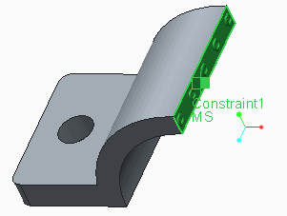

Symmetrical about a plane:

* Loads
* Constraints
* Geometry

Figure 1 - Mirror Symmetry Constraint

*Understanding Mirror Symmetry Constraints*

When the loads, constraints, and geometry of a model are symmetrical, you can take advantage of symmetry to analyze a portion of the model instead of the entire model. Symmetric constraints work by preventing the model from deforming through the plane(s) of symmetry. There are two types of symmetry constraints that can be created in Simulate: Mirror and Cyclic. We will focus on Mirror symmetry in this topic.

Mirror symmetry is applied when the model, loads and constraints are symmetrical about a plane. The model is cut in half through the plane, and then the constraint is applied through the surface (solid model), edge (shell model), or point (beam model) that lies on the plane of symmetry.

It should be noted that symmetry can only be used when the model, loads, and constraints are symmetrical. If only the model is symmetrical, then the results generated will not be correct, or may be correct for stress but not displacement, or vice versa. The symmetry requirement for loads and constraints is often overlooked.

Finally, users should note that when taking advantage of symmetry in models, a modal analysis or buckling analysis will only report the modes that are symmetrical. As such, not all modes may be captured. For such analyses it is recommended to not use symmetry.

## PROCEDURE - Understanding Mirror Symmetry Constraints

**Task 1:** Create a mirror symmetry constraint.



|  |
| --- |
| 1. In the ribbon, select the **Home** tab. 2. Click **Symmetry**  from the Constraints group drop-down list. 3. The Symmetry Constraint dialog box appears. Select **Mirror** from the Type drop-down list. |
| 4. Select the surface on the right side of the model as the reference for the mirror symmetry constraint as shown. |
| 5. The dialog box should now appear as shown. Click **OK**  to complete the symmetry constraint. |
| 6. The model should now appear with the Mirror Symmetry icon as shown. |

1. Click **File > Manage Session > Erase Current** to erase the model from memory.
2. Click **Yes** in the Erase Confirm dialog box. This completes the procedure.

## Understanding Cyclic Symmetry Constraints

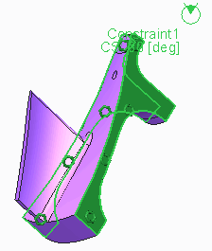Cyclic symmetry constraints can be used to significantly reduce model size. Symmetrical about an axis:

* Loads
* Constraints
* Geometry

Fig. 1 - Cyclic Symmetry Constraints

###### Understanding Cyclic Symmetry Constraints

When the loads, constraints, and geometry of a model are symmetrical, you can take advantage of symmetry to analyze a portion of the model instead of the entire model. Symmetric constraints work by preventing the model from deforming through the plane(s) of symmetry. There are two types of symmetry constraints that can be created in Simulate: Mirror and Cyclic. We will focus on Cyclic symmetry in this topic.

Cyclic symmetry is applied to models that are symmetrical about an axis. This is different from axisymmetric models in that the model does not have to be a body of revolution. The model can have patterns of features that are repeated at the same interval about an axis. Using cyclic symmetry requires that the user create a cut feature that reduces the model to a single “slice.”

Symmetry can only be used when the model, loads, and constraints are symmetrical. If only the model is symmetrical, then the results generated will not be correct, or may be correct for stress but not displacement, or vice versa. The symmetry requirement for loads and constraints is often overlooked.

In cyclic symmetry, the angular dimension of the “slice” being used must return an integer when 360 degrees is divided by the dimension. Therefore, dimensions such as 15, 18, 30, 45, 60 are all valid. In addition, the surfaces selected for cyclic symmetry must map to one another.

Note that when taking advantage of symmetry in models, a modal analysis or buckling analysis will only report the modes that are symmetrical. As such, not all modes may be captured. For such analyses it is recommended to not use symmetry.

## PROCEDURE - Understanding Cyclic Symmetry Constraints

**Task 1:** Create a cyclic symmetry constraint.

1. In the ribbon, select the **Home** tab.
2. Click **Symmetry ** from the Constraints group drop-down list.
3. The Symmetry Constraint dialog box appears. Select **Cyclic** from the Type drop-down list.

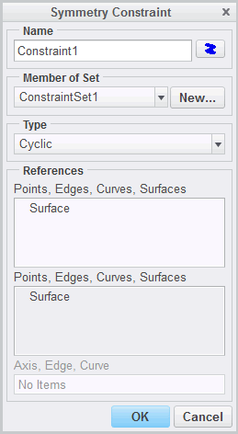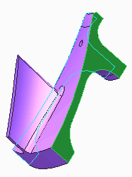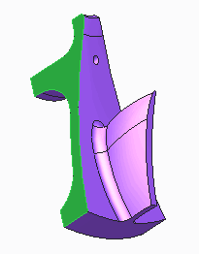

|  |
| --- |
| 4. On the model, select the left side surface as the first  reference as shown. |
| 1. Right-click anywhere in the display area and select **Second Side**. 2. On the model, select the right side surface as the second reference as shown. |
| 7. The dialog box should now appear as shown. Click **OK**  to complete the symmetry constraint. |

  

|  |
| --- |
| 8. The model should now appear with the Cyclic  Symmetry icon as shown. |
| 1. Click **File > Manage Session > Erase Current** to erase the model from memory. 2. Click **Yes** in the Erase Confirm dialog box. |

This completes the procedure.

106

# Module 6

## Structural Loads

## Understanding Structural Loads

Structural loads are applied to the model to simulate what the model must endure to perform its function.



Structural Loads

* Force/Moment
* Bearing
* Centrifugal
* Gravity
* Pressure
* Temperature
* Mechanism

Figure 1 - Bearing Load

###### Understanding Structural Loads

Structural Loads are forces and moments that cause stress or deformation in the model. Loads can be applied to surfaces, edges, and points. The loads applied are intended to simulate what the model would be subjected to during its operation. These loads can be defined using a number of different options:

* Force/Moment Loads: This load requires the user to specify the Force or Moment vector acting on an entity.
* Bearing Loads: Simulates the load on a hole or pin when the force is only acting on one half of the circular surface or edge.
* Centrifugal Loads: The user specifies an axis of rotation, angular velocity and/or angular acceleration. Simulate will then use the model’s mass properties to determine what radial force or axial torque needs to be applied to all entities in the model.
* Gravity Loads: Can be used to simulate how a model will deform under gravity. Users will specify the value and direction of gravitational acceleration. Simulate will use the model’s mass properties to apply the appropriate force over the entire model.
* Pressure Loads: Applying this load type will create a distributed force per unit area across a surface. Simulate will guarantee the load is always normal to the surface.
* Temperature Loads: User can specify a uniform global temperature or import a temperature field. Simulate will use the coefficient of thermal expansion specified in the model’s materials to calculate the resulting deformation and stresses.
* Mechanism Loads: Import forces calculated using Creo Parametric Mechanism Dynamics Option.

Correct application of loads is one of the key factors in obtaining correct results. When applying loads, take the time to scrutinize the load dialog and confirm that the load is correct for the units being used. In addition, the load set and distribution options should be confirmed.

For body forces such as Gravity, Centrifugal, and Temperature Loads, the calculated load will be dependent on the material properties defined for the model.

## Defining Global Loads

Global loads are loads that act on the whole analysis model, not only on a region of it.

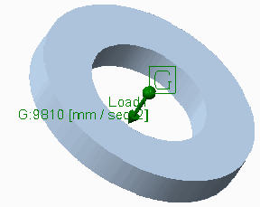The following global loads are available:

* + Gravitational
  + Centrifugal
  + Temperature

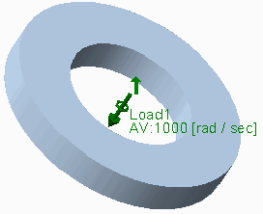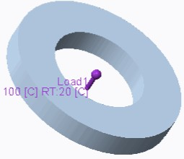Figure 1 – Gravitational Load

Figure 2 – Centrifugal Load Figure 3 – Temperature Load

###### Defining Global Loads

Simulate provides a large number of options to apply global loads to a model. Global loads are gravitational, centrifugal, and temperature loads which always impact the entire model. Loads can be edited in the model tree. Information can be obtained in this way, and they can be hidden. Loads can be assigned to load sets. Then, each load set can be solved separately in a linear static analysis run.

The following global loads are available:

* Gravitational – When defining gravitational loads, enter components of earth acceleration in one of the offered units systems.
* Centrifugal – Define vector of rotation axis and angular speed in one of the three offered units (rad/sec, deg/sec, RPM) by selecting the corresponding option and enter the corresponding values. You can also define a rotational acceleration (in rad/sec2 or deg/sec2).
* Temperature – Define the actual and reference temperature. The actual temperature may be constant for the complete model, a function of coordinates (to be defined by a symbolic or tabular function), or imported from a file containing the externally calculated temperature field (*.fnf – FEM Neutral Format). The reference temperature is the temperature before the load is applied.

A MEC/T temperature load can also be applied. Structural calculations with MEC/T loads are based on the results from Simulate Thermal.

The loads are defined by default in the currently active coordinate system. Other coordinate systems may be selected if required. Only for constraints defined in the World Coordinate System can reaction load measures be calculated.

For global structural loads in structural and in transient thermal analyses, the density has to be specified correctly; otherwise, volumetric forces and the heat capacity are calculated wrong.

## PROCEDURE - Defining Global Loads

**Task 1:** Create a Centrifugal load.

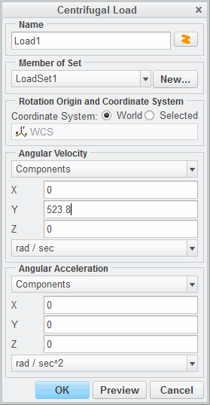

|  |
| --- |
| 1. In the model tree, select IMPELLER.PRT and click **Centrifugal**  from the mini toolbar. 2. The Centrifugal Load dialog box appears. |
| 3. In the Angular Velocity section, type **523.8** in the Y field as shown. |
| 4. Click **OK** to create the Centrifugal load and close the dialog box. The model should appear as shown. |
| 1. Click **File > Manage Session > Erase Current** to erase the model from memory. 2. Click **Yes** in the Erase Confirm dialog box. |

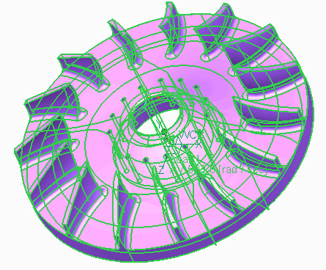This completes the procedure.

## Defining Forces, Moments, and Pressure

Simulate provides a number of options to apply a geometry-related load to a model.

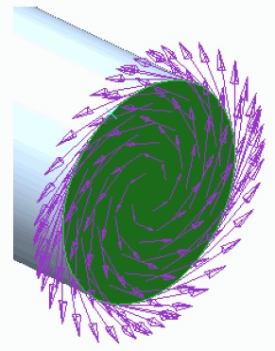Loads that can be applied are:

* + Forces
  + Moments
  + Pressures
  + Bearing Load

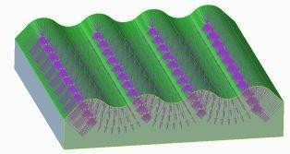Figure 1 – Applied Moment

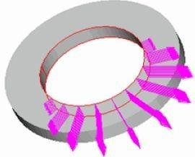

Figure 2 – Applied Pressure Figure 3 – Applied Bearing Load

###### Defining Forces, Moments, and Pressure

Simulate provides a number of options to apply a geometry-related load to a model. Loads can be applied on points, curves, edges, and surfaces. The load resultant at a specific point (force, moment) with respect to an arbitrary Cartesian coordinate system can be determined directly in the Simulate UI using the Review Total Load command without starting the Simulate solver.

Loads that can be applied are:

* Forces and Moments – When defining a force or moment, you can select the distribution as:
* Total Load – If this is selected when the surface geometry is changed, the total load remains unchanged.
* Force Per Unit Area – If this is selected, the total load changes depending on the surface area.
* Total Load at Point – In addition to the surface on which the load acts, a point is selected where the total load is applied. This functionality has different purposes:
  + Apply a moment load to volumes – Since volume elements do not support rotations, moments are converted to surface forces that create an equivalent moment. Never apply a moment directly to a point of a volume without using the Total Load at Point option, or this moment is ignored. The point position is not important if values are entered only in the moment data fields.
  + Automatically create a resulting moment (with the help of surface forces) out of the applied force if the point referenced in the Total Load at Point has a certain distance to the loaded surface (lever arm).
* Total Bearing Load at Point – This is a load distribution option to automatically define resulting surface forces which a cylindrically shaped part (for example, a pin) creates in the corresponding hole or vice versa. It is especially useful if a bearing cutting load is imported from MDO.
* Pressures – The load vector is always oriented perpendicular to the selected surfaces. This is to be noted especially in large deformation analysis, when surfaces may tilt significantly. If the load is applied as pressure, the direction moves with the surface. If it is applied as force per unit area, the direction is always the same. A tilting surface has no influence on the load direction then.
* Bearing Load – A bearing load approximates the contact pressure of an axis in a hole by applying the load with a parable-shaped distribution. To define a bearing load, select a cylindrical surface or edge. Define the force by selecting the corresponding option for magnitude and direction.

All loads support object-action and action-object. If you select the geometry first and then the load definition icon, the geometry is already pre-selected. Loads are defined using the following steps:

1. Define the reference geometry.
2. Define the coordinate system. You can modify the related coordinate system later in the definition window of the geometry-related load.
3. Define the spacial distribution.
4. Define the X, Y, and Z load components, or direction vector and load magnitude.

Loads can be grouped in one load set by selecting a load set in the Member of set section in the Load dialog boxes. New load sets can be defined in these dialog boxes. A new load set can also be defined by selecting the Home tab. Click the Loads group drop-down menu and select Load Sets.

In a single linear static analysis, multiple load sets can be taken into account. You can combine and scale load sets with the postprocessor. Avoid loads on points and curves since they may lead to singularities in shell and volume models. Instead, create a small region, volume or surface, to apply the force as a surface load with the Total Load at Point selection.

## PROCEDURE - Defining Forces, Moments, and Pressure

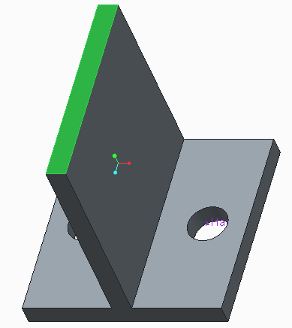**Task 1:** Create a uniform force on a surface.

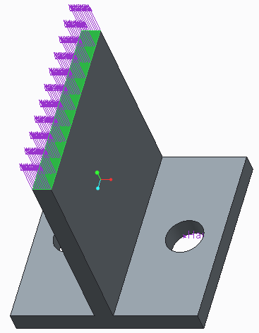

|  |
| --- |
| 1. Disable all Datum Display types. 2. On the model, select the top surface of the part as shown and click **Force/Moment**  from the mini toolbar. The Force/Moment Load dialog box appears. |
| 1. In the Force section, type **300** for the Y component. 2. Click **Preview** to preview the load. The part should appear as shown. |

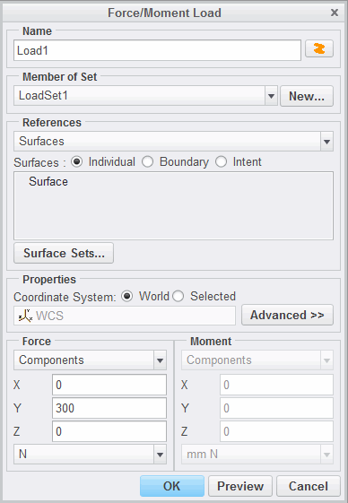

1. Click **OK** to create the force and close the dialog box.

**Task 2:** Create a uniform moment on a surface.

|  |
| --- |
| 1. On the model, select the surface of the hole as shown  and click **Force/Moment**  from the mini toolbar. The Force/Moment Load dialog box appears. |
| 1. In the Properties section, click **Advanced**. 2. In the Distribution section select **Total Load at Point** from the drop-down list. 3. In the model, or from the model tree, select **PNT0**. 4. In the Moment section, type **300** for the Y component. |
| 6. Click **Preview** to preview the load. The part should appear as shown. |

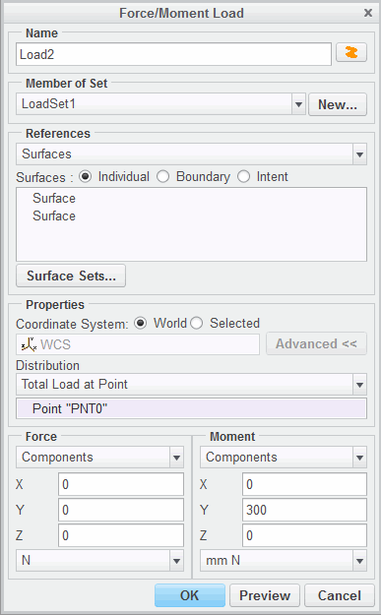

|  |
| --- |
| 7. Click **OK** to create the moment and close the dialog  box. |
| 1. Click **File > Manage Session > Erase Current** to erase the model from memory. 2. Click **Yes** in the Erase Confirm dialog box. |

This completes the procedure.

## 

## Exercise 1: Defining Forces, Moments, and Pressure

### Objectives

After successfully completing this exercise, you will be able to:

* Identify when using a total load at a point can be useful.
* Apply a Force/Moment with the “Total Load At Point” option selected.

### Scenario

There are instances where a part is being designed to carry a specific load, but the load’s origin lies outside the part. It could be the weight of a book that a shelf is carrying, or a moment arm exerted by a person on a bolt through a wrench or similar tool. In these instances, you have no interest in modeling the book (any generic payload) or the wrench, but you do want to include the load. An engineer would draw a free body diagram and attempt to transpose the force, adding whatever moments may be needed to create the equivalent load on the shelf or on the bolt.

In Simulate, the user need not get into complex calculations or draw free body diagrams. Here the user can make use of the “Total Load At Point” distribution option. The model for this assembly is a bracket that holds a battery in place.

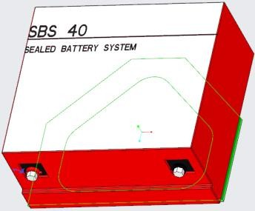**Task 1:** Apply a load to the top surface of the bracket.

1. The Force/Moment Load dialog box appears. Select the top surface of the bracket as shown. On the model, select the top surface of the bracket as shown and click **Force/Moment ** from the mini toolbar. The Force/Moment Load dialog box appears.

|  |
| --- |
| 1. In the Properties section, click **Advanced**. 2. Select **Total Load at Point** from the Distribution drop down list. 3. For the reference point, select the center of gravity of the battery, point **PNT_COG** on the model. |
| 5. In the Force Y component field, type  **-battery_weight** as shown. This will place the negative value of the **BATTERY_WEIGHT** parameter as the force in the Y direction. |
| 1. Click **Preview** to view the load. 2. Click **OK** to create the load and close the Force/Moment Load dialog box. |

**Task 2:** Verify the load application.

|  |
| --- |
| 1. Select **Review Total Load** from the Loads group drop down list. 2. The Load Resultant dialog box appears. In the Loads section, click **Select Reference**  . 3. In the model tree, expand **Loads/Constraints** and **Load Set LoadSet1**. Select **Load1** and click   **OK** in the Select dialog box. |
| 1. In the Evaluation Point section, click **Select Reference**  . 2. On the model, select **PNT_COG** and click **OK** in the Points Selection dialog box. |

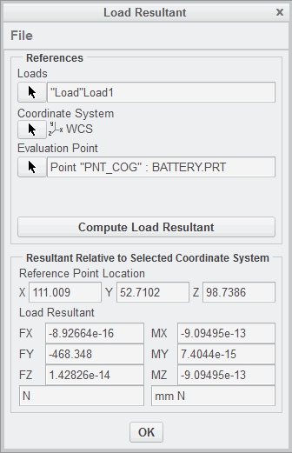

1. Click **Compute Load Resultant**. The dialog box appears as shown. The resultant is in agreement the battery weight parameter's value being applied in the negative Y direction. Also, the Moment registered around the evaluation

point is zero which corroborates the load being applied at the point PNT_COG.

***Note:*** *Values that are expressed in terms of 10e- 13 and smaller can be considered zero.*

1. When your review is complete, click **OK** to close the dialog box.

**Task 3:** Investigate the effects of using the default Total Load option instead of the Total Load at Point option.

|  |
| --- |
| 1. In the model tree, select **Load1** and click **Edit Definition** . 2. Select **Total Load** from the Distribution drop down list. 3. Click **OK** to close the dialog box. |
| 1. Select **Review Total Load** from the Loads group drop down list. 2. The Load Resultant dialog box appears. In the Loads section, click **Select Reference**  . 3. In the model tree, select **Load1** and click **OK** in the Select dialog box. |
| 1. In the Evaluation Point section, click **Select Reference**  . 2. On the model, select **PNT_COG** and click **OK** in the Points Selection dialog box. |
| 1. Click **Compute Load Resultant**. The dialog box appears as shown. Note that the applied load is creating moments about the X and Z axes. This scenario does not match the real world load because the battery's weight should not be exerting moments about its center of gravity. 2. When your review is complete, click **OK** to close the dialog box. |
| 1. Click **File > Manage Session > Erase Current**. 2. The Erase dialog box appears. Click **Select All** . 3. Click **OK**. |

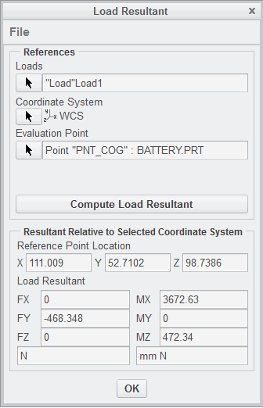

This completes the exercise.

## 

## Defining Loads as Functions

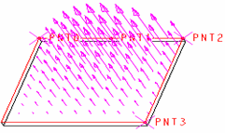A load can be defined as spatial function by tables, formulas, or interpolated over entity relative to the selected coordinate system.

To define a load as a function:

* + Select spatial distribution.
  + Define the function.
  + Reference the coordinate system used to describe the spatial distribution.

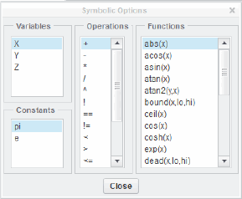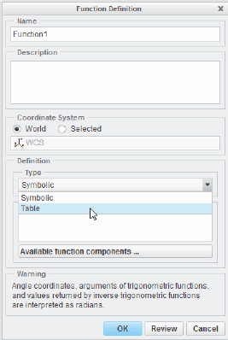

Figure 2 – Function Definition Dialog Box Figure 3 – Symbolic Options Dialog Box

###### Defining Loads as Functions

In case of edge or curve, surface, and pressure loads, it is possible to vary the loads by selecting Interpolated Over Entity or Function Of Coordinates in the Spatial Variation section of the Load dialog box. By interpolation,

the load values at the selected support points are linked by a linear (select two points), squared (select three points), or cubic (select four points) function. A load can be defined as spatial function by tables or formulas, relative to the selected coordinate system. For pressure, scalar data can be imported via the PTC *.fnf-file (FEM neutral format).

**To define a load as a function:**

* Select spatial distribution – In the Load dialog box, Spatial Variation section, select Interpolated Over Entity or Function Of Coordinates. Define up to four support points with scaling factor on an edge.
* Define the function – In the Function Definition dialog box:
  + Select the coordinate system referenced by the function.

  

* + In the Type section, define the function as a formula, Symbolic, or table.
  + If the function is a formula, click Available function components .................. The Symbolic Options dialog box appears. Create the function by selecting the applicable variables, operators, constants, and functions. When complete, click Close. The function appears in the Symbolic Expression section of the Function Definition dialog box. If you already know the command syntax, you can directly enter your function without using the Symbolic Options dialog box.
  + To preview the function as a graph, click Review in the Function Definition dialog box.
  + To preview the vectorial load distribution over the loaded references, click Preview in the Load Definition dialog box after the function definition is completed.
* Reference the coordinate system used to describe the spatial distribution.

Simulate Structure can calculate multiple load sets in one analysis run which can then be superposed in the postprocessor. The assignment of loads to load sets can be verified in the model tree. Check the resulting total force on the model, especially in case of force-balanced simulations, by selecting Review Total Load and compare it with the resulting total force in the *.rpt file.

  

## PROCEDURE - Defining Loads as Functions

**Task 1:** Measure the tank height.

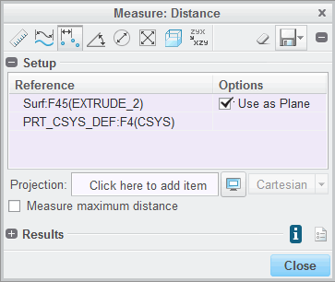

|  |
| --- |
| 1. Enable only the following Datum Display types:   **Csys Display** .   1. In the ribbon, select the **Inspect** tab. 2. Click **Distance**  from the Measure types drop-down menu in the Measure group. 3. The Measure:Distance dialog box appears. Expand the dialog box. 4. Press CTRL and on the model select the top surface of the tank and the PRT_CYSY_DEF coordinate system as shown. The distance should be reported as 4.1. |
| 1. Select **Save Analysis** from the Save drop-down list as shown and click **OK**. 2. Close the Measure:Distance dialog box. |
| ***Note:*** *The hydrostatic pressure in the tank will be equal to zero gauge pressure at the water’s free surface, so the distance or height of that surface with respect to the coordinate system has to be measured. The equation of hydrostatic pressure is p= gh. The density of water is 1000 kg/m3, the acceleration of gravity is 9.81 m/s2. The depth h is the depth from the free surface of the tank. If 4.1 m is the distance to the free surface, then thedepth of the water in any point in the tank is given by the expression (4.1–y). The equation governing the hydrostatic pressure then*  *becomes p=(1000)(9.81)(4.1–y).* |

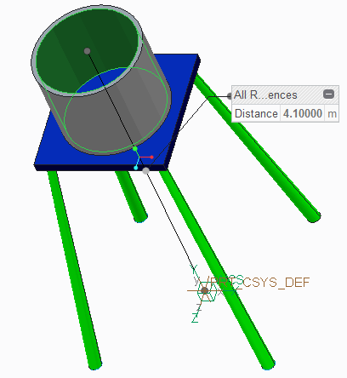**Task 2:** Write the equation to be applied and apply the pressure load.

1. Select the inner surface of the tank as shown for the load application and click **Pressure ** from the mini toolbar. The Pressure Load dialog box appears.

  

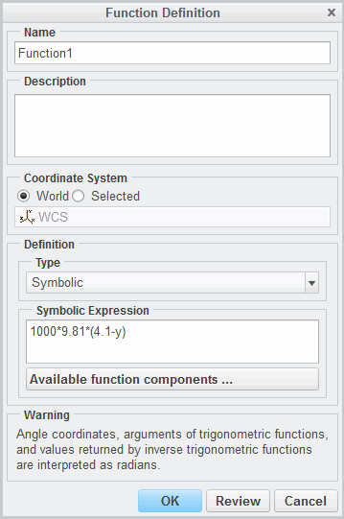

1. In the Pressure section, click **Advanced**.
2. Select **Function of Coordinates** from the Spatial

Variation drop-down list.

1. Click **Function** .
2. The Functions dialog box appears. Click **New**.
3. The Function Definition dialog box appears. In the Definition section, select **Symbolic** from the Type drop-down list.
4. In the Symbolic Expression field, type **1000*9.81*(4.1–y)**. The dialog box should appear as shown.
5. Click **Review**.
6. A Warning dialog box appears. Click **OK**.
7. The Graph Function dialog box appears. Type

**3.1** in the Lower Limit field and type **4.1** in the Upper Limit field.

1. 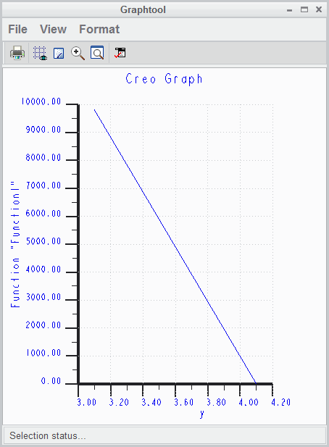 Click **Graph**. The Graphtool dialog box appears as shown.
2. Click **File > Exit** to close the Graphtool dialog box.
3. Click **Done** to close the Graph Function dialog box.
4. Click **OK** to close the Function Definition dialog box.
5. Click **OK** in the Functions dialog box.
6. In the Pressure Load dialog box, type **1.0** in the Value field. This will act as a scaling factor for the values that will be returned from the function.
7. Click **Preview** to preview the load.
8. Click **OK** to close the Pressure Load dialog box.
9. Click **File > Manage Session > Erase Current** to

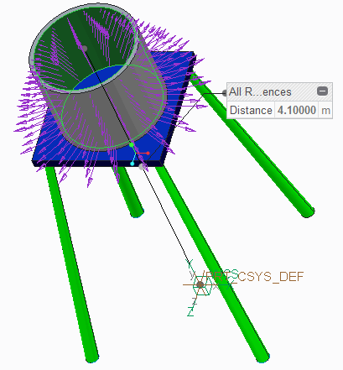erase the model from memory.

1. Click **Yes** in the Erase Confirm dialog box. This completes the procedure.

120

# Module 7

## Meshing

## Understanding Meshes

AutoGEM enables you to create meshes composed of geometric elements.

* + Prepare Model
  + Generate Mesh
  + Review and Refine Mesh

Figure 1 - Simulate Mesh

###### Understanding Meshes

Meshes can be created before an analysis is run or at the time an analysis is run. If a mesh is not present when an analysis is run, Simulate automatically uses the current AutoGEM settings and controls to create one.

Meshes can be created, loaded, copied from a design study, and saved. Meshes are saved in a file with the same name as the Creo Parametric model with a .mmp extension added for single parts or a .mma file for assemblies.

*Preparing a Model*

Before generating a mesh, consider completing the following steps as necessary:

* If more elements are desired in a particular area of interest, add geometry (such as points, datum curves, or datum surfaces), or simulation features (such as surface or volume regions) to increase the element density.
* Assign beam idealizations before meshing to avoid errors.
* Assign shell (simple or advanced) idealizations.
* Define 2-D model idealizations (plane strain, plane stress, and axisymmetric).
* Ensure that the Insert Points and Move Or Delete Existing Points options are set in the AutoGEM Settings dialog box. In almost all cases, having these options selected will result in a more optimal set of mesh elements.
* Assign materials wherever necessary (solids, shell, and other idealizations).

###### Generating Meshes

Once the model has been prepared, the process of actually generating a mesh is usually quite simple. Once the AutoGEM dialog box is open, the default option of All with Properties is usually accepted.

Alternatively, AutoGEM can be restricted to create meshes only in a Component, Volume, Region, or Curve that the user selects.

###### Reviewing and Refining Meshes

Anytime AutoGEM finishes creating a mesh, the results are posted in the AutoGEM Summary dialog box and may be reviewed. The mesh can also be saved at this point, enabling the user to leave the mesh creation mode. At this point, the user may opt to make some changes to the AutoGEM settings and/or controls. The user can then return to the mesh creation mode, load the existing mesh, and further refine the mesh for the analysis model. This process can be repeated until the desired set of mesh elements has been generated.

## Understanding Mesh Options

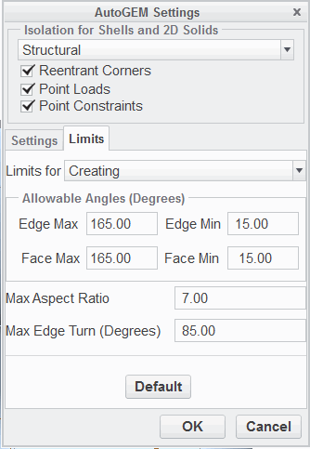In Simulate, the meshing of geometry can be carried out automatically during the calculation run or prior to the analysis in the user interface.

Options available to influence the mesh:

* + Different angles and the maximum aspect ratio, longest/shortest edge, can be set separately for creation and modification.
  + Create surface and/or volume regions.
  + Use AutoGEM control settings.
  + Create points or point patterns in Creo Parametric and make them Hard Points for meshing.
  + Create curves on a part surface and activate them for meshing by referencing them with the AutoGEM control Hard Curve.

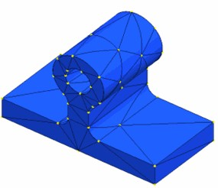Figure 1 – Recommended Shell Mesh Settings

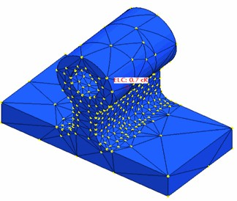

Figure 2 – Default Mesh

###### Understanding Mesh Options

Figure 3 – Using Mesh Control Edge Length by Curvature

In Simulate, the meshing of geometry can be carried out automatically during the calculation run or prior to the analysis in the user interface. All commands for meshing are available using AutoGEM.

In Creo Simulate Embedded and Standalone modes, wedge and brick meshes can be created

semi-automatically by the use of special new AutoGEM controls, Prismatic Elements, Thin Solid, and Mapped Mesh. These enable you to create meshes especially for thin-walled structures with just a few brick and wedge elements, giving very accurate results and low analysis times, also in nonlinear analysis. Also mapped meshes can be created for regular-shaped geometry to deliver exact results. By using the adaptive p-method, the meshing in Simulate in general needs less attention compared to h-meshing. Nevertheless, in some cases, the mesh needs to be optimized.

Options available to influence the mesh:

* Different angles, maximum and minimum between element edges and faces, and allowable edge turn, and the maximum aspect ratio, longest/shortest edge, can be set separately for creation and modification. It is helpful to refine the settings for shell models, especially to limit the maximum edge turn. The default AutoGEM settings, which are fine for volume elements, can be too coarse for shells.
* Create surface and/or volume regions. Geometry created by these features, edges, surfaces, surfaces within the part volume, is taken into account by AutoGEM.
* Use AutoGEM control settings.

– Maximum Element Size – The maximum allowed element size on components, volumes, surfaces, or edges can be defined. If an element touches a surface with an element size control even with just one point, the size is valid for all edges of this element.

* Minimum Edge Length – Defines the minimum length of geometry edges that is taken into account for meshing. It is often better to suppress unwanted details in Creo Parametric instead of using this control.
* Isolate for Exclusion – Possible singularities in the model are meshed with smaller elements; these elements can then be excluded from the convergence loop.

***Note:*** *Be careful when using this AutoGEM control. This may prevent you from flnding unknown “hot spots” in the model. Use it to obtain convergence plots for the non-singular model locations just if you know where your critical areas are.*

* Edge Distribution – Set points on edges that become mesh points.
* Prismatic Elements – With this control, line and surface references can be selected that define the creation direction for brick and wedge elements.
* Thin Solid – Like for shell elements, a pair of similar-shaped surfaces can be defined, but instead of tri and quad shells, wedge and brick solids are created.
* Mapped Mesh – You can define regions with regular region shapes (brick, wedge, quad, tri), so the referenced surfaces must be four-sided or three-sided. Then, you can define the number of subdivisions per side.
* Hard Points create points or point patterns in Creo Parametric – Hard Points on a surface are taken into account for meshing; Hard Points within a volume are not, if not located on an interior surface of a volume region. Note that you have to make these points and point patterns Hard Points with this AutoGEM control; otherwise, they are ignored during meshing.
* Hard Curves create curves on a part surface and activate them for meshing by the Hard Curve AutoGEM control – This is helpful to obtain an element edge path for evaluating a graph in the postprocessor.
* Hard Surfaces define a set of internal surfaces. Internal faces of elements align along these surfaces. These are activated for meshing by using the Hard Surface AutoGEM control. This mesh control requires quilts to be present in the model. You can select entire (multi-surface) quilts, or individual quilt surfaces and datum planes. Selected surfaces may have internal contours. Only the portions of the selected surfaces that are inside the solid will participate in meshing as hard surfaces. If none of the selected surfaces intersects the solid (because they are either fully outside or fully inside the solid), a warning will be reported during meshing. This mesh control is available in FEM and Native modes, for 3-D models only. It is not available for 2-D models.

Highly curved shell elements or a contact region in a contact analysis may require a locally refined mesh to improve the results quality. For 2-D idealizations, a very fine mesh for results of highest accuracy can be requested since these idealizations do not require a lot of resources for the analysis.

## PROCEDURE - Understanding Mesh Options

1. In the ribbon, select the **Refine Model** tab.
2. Click **Maximum Element Size ** from the Control drop-down list in the AutoGEM group.
3. The Maximum Element Size Control dialog box appears. In the References section select

**Components** from the drop-down list.

1. In the Element Size field type **30**.

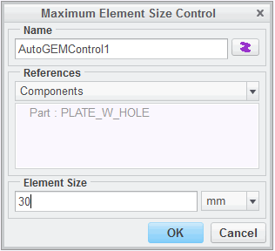

1. The dialog box should appear as shown. Click

**OK** to complete the AutoGEM control definition.

**Task 2:** Create an Edge Length By Curvature control.

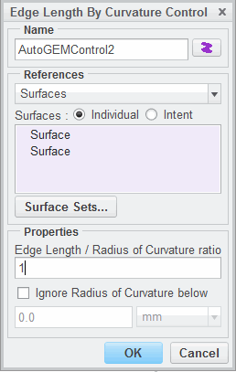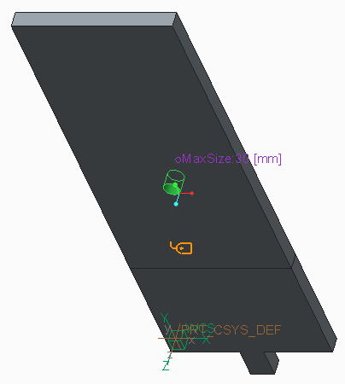

|  |
| --- |
| 1. Click **Edge Length By Curvature**  from the Control drop-down list in the AutoGEM group. 2. The Edge Length By Curvature Control dialog box appears. In the References section select   **Surfaces** from the drop-down list. |
| 3. Select the cylindrical surface inside the hole as shown. |
| 1. In the Edge Length / Radius of Curvature ratio field type **1**. 2. The dialog box should appear as shown. Click   **OK** to complete the AutoGEM control definition. |

**Task 3:** Create an Isolate for Exclusion Mesh control.

1. Click **Isolate for Exclusion** from the Control drop-down list in the AutoGEM group.

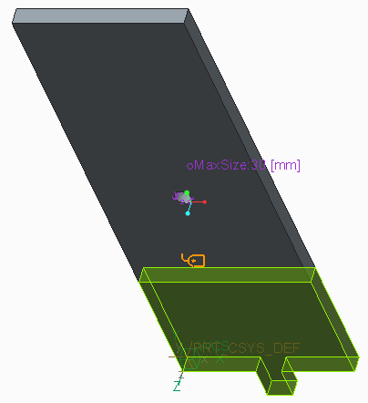

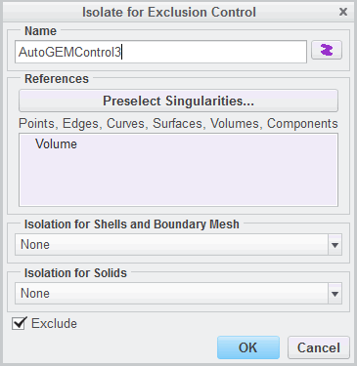

|  |
| --- |
| 2. The Isolate for Exclusion Control dialog box  appears. On the model select the volume region as shown. |
| 3. The dialog box should appear as shown. Click  **OK** to complete the AutoGEM control definition. |

**Task 4:** Create an Edge Distribution Mesh control.

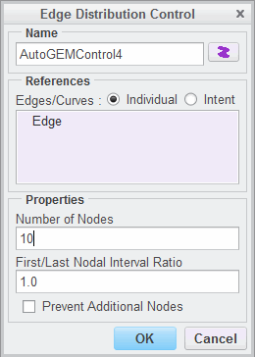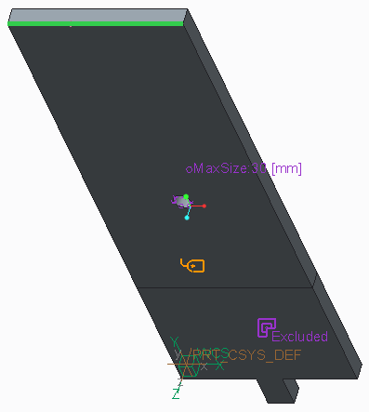

|  |
| --- |
| 1. Click **Edge Distribution**  from the Control drop-down list in the AutoGEM group. 2. The Edge Distribution Control dialog box appears. On the model select the edge as shown. |
| 1. In the Number of Nodes field type **10**. 2. The dialog box should appear as shown. Click   **OK** to complete the AutoGEM control definition. |

1. Click **File > Manage Session > Erase Current** to erase the model from memory.
2. Click **Yes** in the Erase Confirm dialog box. completes the procedure.

## Using AutoGEM Settings

The default AutoGEM settings are optimized to result in a superior mesh in most cases.

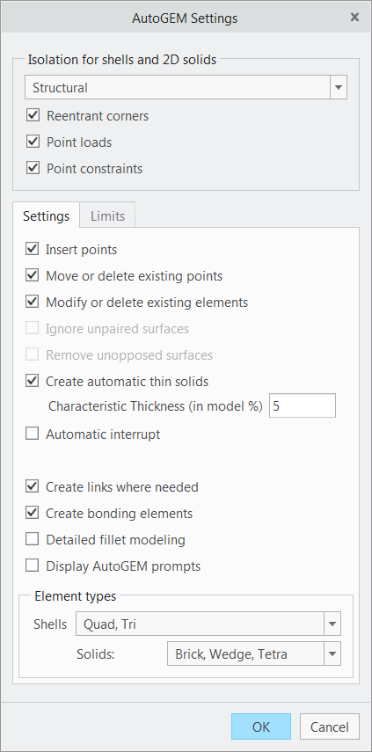The following AutoGEM settings can be used

if your model cannot be meshed using the defaults:

* Isolation for Shells and 2-D Solids
* Insert Points
* Modify or Delete existing Points/Elements
* Ignore Unpaired Surfaces
* Remove Unopposed Surfaces
* Create Links
* Create Bonding Elements
* Detailed Fillet Modeling
* Display AutoGEM Prompts
* Element Types

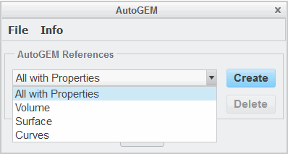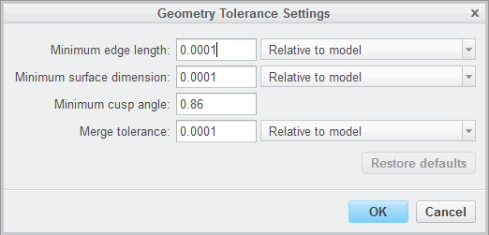Figure 1 – AutoGEM Settings Dialog Box

Figure 2 – Geometry Tolerance Settings Dialog Box Figure 3 – AutoGEM Dialog Box

###### Using AutoGEM Settings

The default AutoGEM settings are optimized to result in a superior mesh in most cases. The meshing of the simulation geometry can be influenced by various settings.

Tolerance for geometry translation can be set by selecting Geometry Tolerance. It is helpful to set this tolerance to the regeneration tolerance used in Creo Parametric. The default settings for the geometry transfer are shown in Figure 2. Often, absolute values adjusted to your model size and unit system lead to better results. Use absolute values for assemblies containing both very small and very big parts and/or copy geometry. For the mm-N-s system and typical mechanical engineering applications, absolute values between 0.01 and 0.001 mm are fine.

The following AutoGEM settings can be used if your model cannot be meshed using the defaults:

This

* Isolation for Shells and 2-D Solids – Handling of singularities for 2-D models, not applicable for 3-D solids.
* Insert Points – Enable AutoGEM to create additional points for the mesh.
* Modify or Delete existing Points/Elements – If a partial mesh is already existing, this enables you to change it or leave it untouched. It is also useful for point measures in an optimization study with activated remeshing/element smoothing.
* Ignore Unpaired Surfaces – If you did not create shell pairs for all geometry of the model, this option enables you to mesh the model just with shells. Pairs are already defined for test reasons, ignoring the remaining volumes.
* Remove Unopposed Surfaces – In midsurface models, surfaces without an opposed surface are ignored during meshing.
* Create Automatic Thin Solids – This automatically detects and creates thin solids.
* Create Links – This forces AutoGEM to automatically create links at shell-solid connections to prevent hinges or at solid element faces with non-fitting geometry (three-sided or four-sided) to prevent cracks.
* Create Bonding Elements – For connection of shell midsurfaces in assemblies, special orthotropic solids or shells are used. Otherwise, assembly links (default models created before WF4) are created. For the latter, set env var sim_accurate_asm_links to yes for translation-rotation coupling. This increases accuracy, but is more time-consuming.
* Detailed Fillet Modeling – Finer Mesh for shell and 2-D model fillets.
* Display AutoGEM Prompts – Toggles AutoGEM prompts. This is important if you want to use bricks and wedges, since otherwise all AutoGEM prompts are answered automatically with yes and you lose control.
* Element Types – Change default for solids from tetrahedrons to wedges and bricks for thin and simple shaped models. In this case, often additional mesh controls or volume regions should be defined for successful meshing. Also, config.pro-option sim_agem_model_thickness can be set.

In the AutoGEM dialog box, the selection All with Properties indicates that everything that has properties is meshed, volumes with material, midsurfaces with shell, and curves and edges with beam properties. The selection Solid/Midsurface directs Simulate to use midsurfaces for shell creation where existent.

The mesh can be saved as *.mmp file (for single parts) or as *.mma file (for assemblies) and recopied for further use in other simulations. Information about the mesh and the AutoGEM log file can be obtained by selecting the Info menu in the AutoGEM dialog box.

***Note:*** *The elements and element types are shown in different colors. Solids are shown in blue, tets in light blue, bricks in dark blue, and wedges in between. Similar is valid for shells in green.*

## PROCEDURE - Using AutoGEM Settings

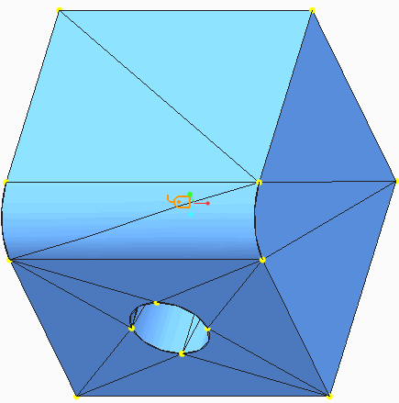**Task 1:** Create a p-mesh using AutoGEM default limits.

|  |
| --- |
| 1. In the ribbon, select the **Refine Model** tab. 2. Select **AutoGEM** from the AutoGEM group. 3. The AutoGEM dialog box appears. Click **Create** to create a mesh using the default settings. Note that the resulting mesh contains a total of 41 elements. |
| 1. Examine the resulting mesh. Click **Close** in the Diagnostics:AutoGEM Mesh and the AutoGEM Summary dialog boxes. 2. Click **Close** in the AutoGEM dialog box and click **No** when prompted to save the mesh. |

**Task 2:** Modify the default AutoGEM limits.

* 1. Select **Settings** from the AutoGEM drop-down list in the AutoGEM group.
  2. The AutoGEM Settings dialog box appears. Select the **Limits** tab.
  3. Select **Creating** from the Limits for drop-down list.
  4. Type in the following values:

|  |  |
| --- | --- |
| **Field** | **Value** |
| Edge Max | **165** |
| Edge Min | **15** |
| Face Max | **165** |
| Face Min | **15** |
| Max Aspect Ratio | **5** |
| Max Edge Turn | **85** |

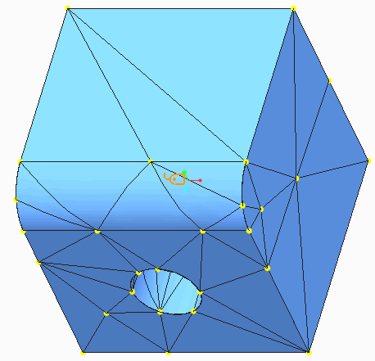 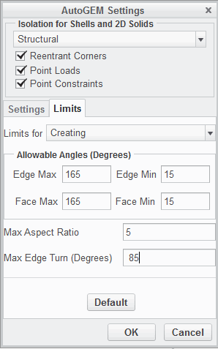

|  |
| --- |
| 5. The dialog box should appear as shown. Click  **OK**. |
| 6. After reviewing the warning, click **OK** in the Information dialog box. |

**Task 3:** Create a p-mesh using the modified AutoGEM limits.

|  |
| --- |
| 1. In the ribbon, select the **Refine Model** tab. 2. Select **AutoGEM** from the AutoGEM group. 3. The AutoGEM dialog box appears. Click **Create** to create a mesh using the modified settings. Note that the resulting mesh contains a total of 124 elements. |
| 1. Examine the resulting mesh. Click **Close** in the Diagnostics:AutoGEM Mesh and the AutoGEM Summary dialog boxes. 2. Click **Close** in the AutoGEM dialog box and click **No** when prompted to save the mesh. |
| 1. Click **File > Manage Session > Erase Currrent** to erase the model from memory. 2. Click **Yes** in the Erase Confirm dialog box. |

This completes the procedure.

## Exercise 1: Using AutoGEM Settings — Meshing a Part

### Objectives

After successfully completing this exercise, you will be able to:

* + Mesh a model using the AutoGEM tool.
  + Create a volume region for mesh refinement.
  + Create a surface region for mesh refinement.
  + Create curves and points for mesh refinement.
  + Create AutoGEM controls driven by model curvature.

### Scenario

In this exercise, you explore additional meshing capabilities in Creo Simulate. You make use of an imported data file, a STEP file.

You adjust some AutoGEM settings and controls. Other options are used and explained throughout and all can be applied to any type of geometry (imported or created in Creo Parametric). Also, you create additional geometry simulation features (such as curves and points) and make use of these when creating elements using the AutoGEM tool.

Close Window  Erase Not Displayed   Simulate_Modeling\Meshing

**Task 1:** Open and investigate the geometry model.

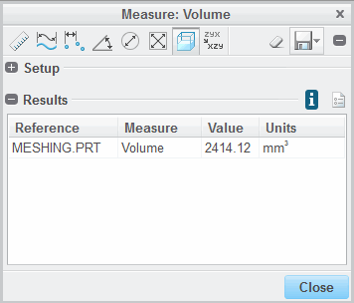

|  |
| --- |
| 1. Click **File > Open**. The File Open dialog box appears. 2. Select **STEP (.stp, .step)** from the Type drop-down list. 3. Select **meshing.stp** and click **Import**. The Import New Model dialog box appears. 4. Keep all the default settings and click **OK**. The geometry is displayed in the window. |
| 1. In the ribbon, select the **Inspect** tab. 2. Select **Volume**  from the Measure drop-down list in the Measure group. The Measure:Volume dialog box appears. 3. In the Measure:Volume dialog box, expand the Resultssection. Themodel volume is reported in the Measure:Volume dialog box as shown.   ***Note:*** *If Solid Geometry is selected and only surfaces are available in the model, no volume is reported.*   1. Close the Measure:Volume dialog box. |

**Task 2:** Assign material properties to the model.

|  |
| --- |
| 1. In the ribbon, select the **Home** tab. 2. Click **Materials** from the Materials group. The Materials dialog box appears. 3. Right-click **brass.mtl** from the materials list and select **Add to Model**. 4. Click **OK**. 5. In the model tree, select MESHING.PRT and click **Material Assignment**  from the mini toolbar. The Material Assignment dialog box appears. 6. Verify that **Part:MESHING** is listed in the References section, and **BRASS** is listed as the material in the Properties section. 7. Click **OK**. |

**Task 3:** Add a mesh to the model.

1. 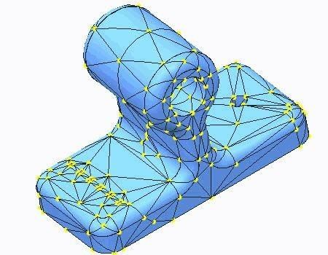In the ribbon, select the **Refine Model** tab.
2. Click **AutoGEM** from the AutoGEM group. The AutoGEM dialog box appears.
3. Keep all the default settings and click **Create**. The model is meshed as shown.
4. In the AutoGEM Summary dialog box, click

##### Close.

1. In the Diagnostics:AutoGEM Mesh dialog box, click **Close**.
2. In the AutoGEM dialog box, click **Close**. Click **No**

when prompted to save the mesh.

**Task 4:** Create a volume region for mesh refinement.

1. In the ribbon, select the **Refine Model** tab.
2. 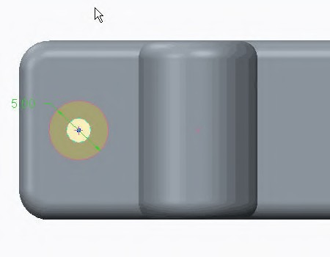Click **Extrude ** from the Volume Region drop- down menu in the Regions group. The Extrude dashboard appears.
3. Select the surface shown in the model.

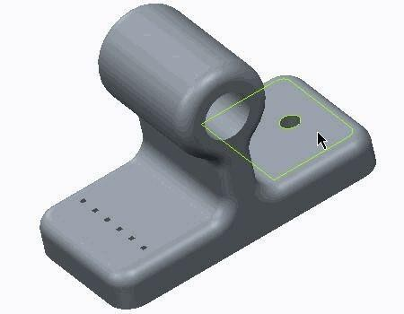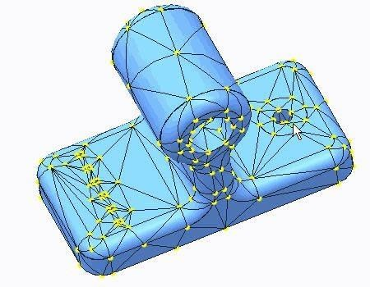

|  |
| --- |
| 1. In the ribbon, select the **Sketch** tab. 2. Click **Sketch View**  from the Setup group to orient the sketch plane. 3. Click **References**  from the Setup group. The References dialog box appears. 4. Select the edge of the hole as a reference for the geometry that will be sketched. 5. Click **Close**. 6. Sketch a circle with a 5.0 mm diameter centered on the hole as shown. 7. Click **OK** to return to the Extrude dashboard. 8. Click **Through All** . 9. Click **Apply-Save Changes** . |
| 1. In the ribbon, select the **Refine Model** tab. 2. Click **AutoGEM** from the AutoGEM group. The AutoGEM dialog box appears. 3. Keep all the default settings and click **Create**. The model is meshed as shown. Note the distribution of the elements around the hole.   ***Note:*** *The virtual boundary of the volume region is now part of the model and therefore nodes are forced to be created using this boundary. Also, notice that the back of the model (where the other boundary of the volume*  *region is) is meshed, too.* |

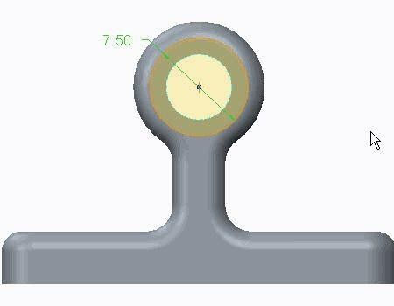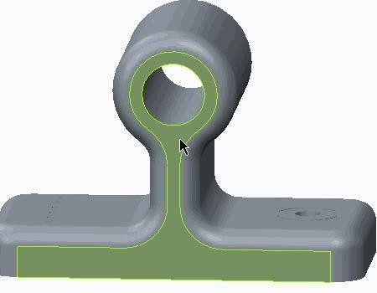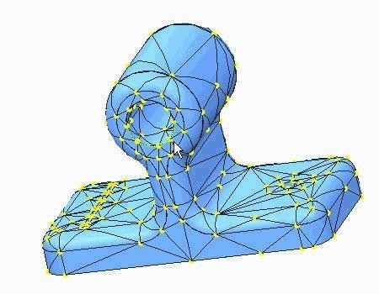

* 1. In the AutoGEM Summary dialog box, click **Close**.
  2. In the Diagnostics:AutoGEM Mesh dialog box, click **Close**.
  3. In the AutoGEM dialog box, click **Close**. Click **No** when prompted to save the mesh.

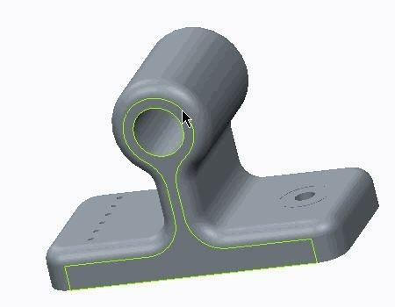**Task 5:** Create a surface region for mesh refinement.

|  |
| --- |
| 1. In the ribbon, select the **Refine Model** tab. 2. Click **Surface Region**  from the Regions group. The Surface Region dashboard appears. 3. Select the **References** tab. 4. In the Sketch section, click **Define**. The Sketch dialog box appears. 5. Select the surface shown in the model. 6. Click **Sketch**. |
| 1. In the ribbon, select the **Sketch** tab. 2. Click **Sketch View**  from the Setup group to orient the sketch plane. 3. Select the edge of the hole as a reference for the geometry that will be sketched. 4. Click **Close**. 5. Sketch a circle with a 7.5 mm diameter centered on the hole as shown. 6. Click **OK** to return to the Surface Region dashboard. |
| 1. Select the surface shown in the model. 2. Click **Apply-Save Changes** . |
| 1. In the ribbon, select the **Refine Model** tab. 2. Click **AutoGEM** from the AutoGEM group. The AutoGEM dialog box appears. 3. Keep all the default settings and click **Create**. The model is meshed as shown. Note the distribution of the elements around the hole.   ***Note:*** *The virtual boundary of the surface region is now part of the model and therefore nodes are forced to be created using this boundary. Now, the back of the model is not meshed.* |
| 1. In the AutoGEM Summary dialog box, click **Close**. 2. In the Diagnostics:AutoGEM Mesh dialog box, click **Close**. 3. In the AutoGEM dialog box, click **Close**. Click **No** when prompted to save the mesh. |

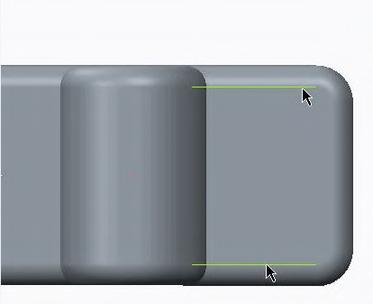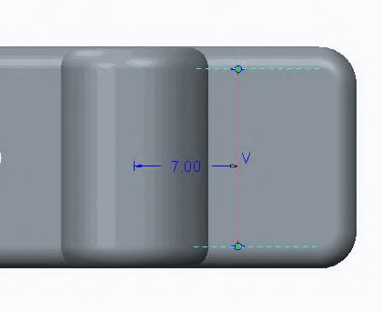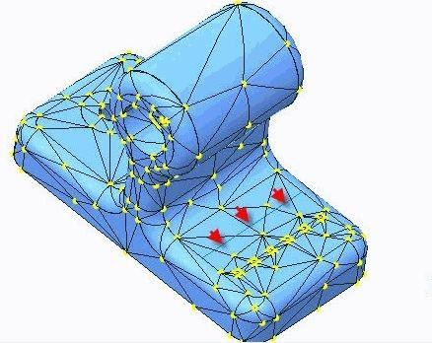

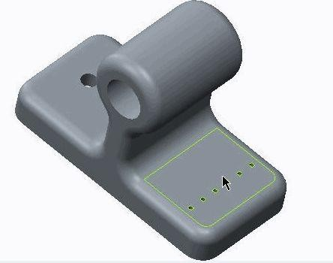**Task 6:** Create curves and points for mesh refinement.

|  |
| --- |
| 1. In the ribbon, select the **Refine Model** tab. 2. Click **Sketch** from the Datum group. The Sketch dialog box appears. 3. Select the surface shown in the model. |
| 1. Using the default orientation, in the Sketch dialog box, click **Sketch**. 2. Click **Sketch View**  from the Setup group to orient the sketch plane. 3. Click **References**  from the Setup group. The References dialog box appears. |
| 1. Select the edges shown as a reference for the geometry that will be sketched. 2. Click **Close**. |
| 1. Click **Line Chain** from the Sketching group. 2. Sketch a line and dimension it with respect to the CSYS reference as shown. 3. Click **OK** to complete the sketch. |
| 1. In the ribbon, select the **Refine Model** tab. 2. Click **AutoGEM** from the AutoGEM group. The AutoGEM dialog box appears. 3. Keep all the default settings and click **Create**. The model is meshed as shown.   ***Note:*** *Note that the curve does not participate in the mesh. There are no nodes to and from the curve.* |
| 1. In the AutoGEM Summary dialog box, click **Close**. 2. In the Diagnostics:AutoGEM Mesh dialog box, click **Close**. 3. In the AutoGEM dialog box, click **Close**. Click **No** when prompted to save the mesh. |
| 1. Click **Hard Curve** from the Control drop-down list in the AutoGEM group. 2. The Hard Curve Control dialog box appears. On the model, select the curve just created. 3. Click **OK**. |

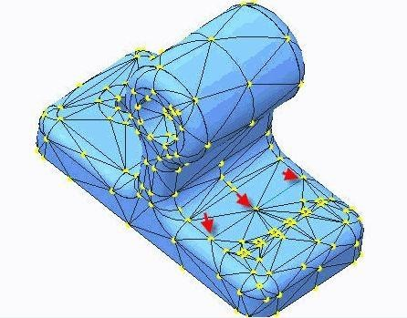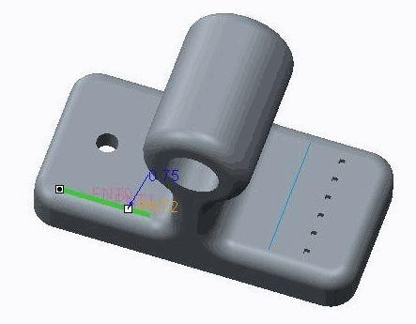

|  |
| --- |
| 1. In the ribbon, select the **Refine Model** tab. 2. Click **AutoGEM** from the AutoGEM group. The AutoGEM dialog box appears. 3. Keep all the default settings and click **Create**. The model is meshed as shown.   ***Note:*** *Note that the curve does participate in the mesh. Nodes are generated and reside on the curve. Also notice*  *the change in the flnite element count.* |
| 1. In the AutoGEM Summary dialog box, click **Close**. 2. In the Diagnostics:AutoGEM Mesh dialog box, click **Close**. 3. In the AutoGEM dialog box, click **Close**. Click **No** when prompted to save the mesh. |
| 1. Click **Point** from the Datum group. The Datum Point dialog box appears. 2. Place three points along the edge as shown. Dimension these points at 0.25, 0.5, and 0.75 based on default length ratio dimensioning. 3. Click **OK**. |
| 1. Click **Hard Point** from the Control drop-down list in the AutoGEM group. 2. The Hard Point Control dialog box appears. In the References section, select **Feature**. 3. Select any one of the three datum points just created. All three will be selected since they are part of the same feature. One datum point feature appears in the selection section. 4. Click **OK**. |
| 1. In the ribbon, select the **Refine Model** tab. 2. Click **AutoGEM** from the AutoGEM group. The AutoGEM dialog box appears. 3. Keep all the default settings and click **Create**. The model is meshed as shown.   ***Note:*** *Note the distribution of the elements that are using the datum points created as a node. Also notice the change*  *in the flnite element count.* |
| 1. In the AutoGEM Summary dialog box, click **Close**. 2. In the Diagnostics:AutoGEM Mesh dialog box, click **Close**. 3. In the AutoGEM dialog box, click **Close**. Click **No** when prompted to save the mesh. |

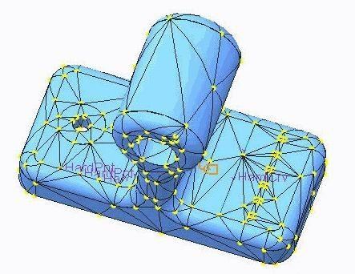**Task 7:** Create AutoGEM controls driven by model curvature.

1. Click **Edge Length By Curvature ** from the Control drop-down list in the AutoGEM group.
2. The Edge Length By Curvature Control dialog box appears. In the Edge Length/Radius of Curvature ratio field, type **0.7**.
3. Click **OK**.

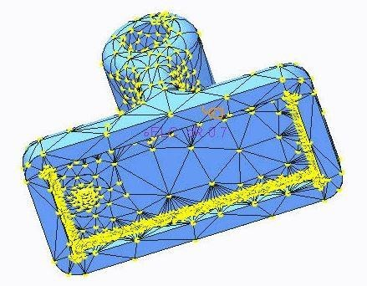

|  |
| --- |
| 1. In the ribbon, select the **Refine Model** tab. 2. Click **AutoGEM** from the AutoGEM group. The AutoGEM dialog box appears. 3. Keep all the default settings and click **Create**. The model is meshed as shown.   ***Note:*** *Note the change in the flnite element count.* |
| 1. In the AutoGEM Summary dialog box, click **Close**. 2. In the Diagnostics:AutoGEM Mesh dialog box, click **Close**. 3. In the AutoGEM dialog box, click **Close**. Click **No** when prompted to save the mesh. |
| 1. In the model tree, expand **AutoGEM Controls**. 2. Right-click **AutoGEMControl3** and select **Edit Definition** . 3. The Edge Length By Curvature Control dialog box appears. Select the Ignore Radius of Curvature below check box, and type **0.51** in the field. Select **mm** from the Units drop-down list. 4. Click **OK**. |
| 1. In the ribbon, select the **Refine Model** tab. 2. Click **AutoGEM** from the AutoGEM group. The AutoGEM dialog box appears. 3. Keep all the default settings and click **Create**. The model is meshed as shown.   ***Note:*** *Note the change in the flnite element count and distribution.* |
| 1. In the AutoGEM Summary dialog box, click **Close**. 2. In the Diagnostics:AutoGEM Mesh dialog box, click **Close**. 3. In the AutoGEM dialog box, click **Close**. Click **No** when prompted to save the mesh. |
| 1. Click **File > Manage Session > Erase Current**. 2. The Erase Confirm dialog box appears. Click **Yes**. |

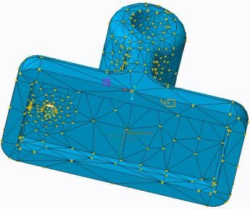This completes the exercise.

## Exercise 2: Using AutoGEM Settings — Mixed Meshes

### Objectives

After successfully completing this exercise, you will be able to:

* Create a mixed mesh using solid and shell elements.

### Scenario

In this exercise, you explore some of the meshing capabilities using Creo Simulate.

Close Window  Erase Not Displayed 

 Simulate_Modeling\MixedMeshes MESHING_SIMULATE.PRT

***Note:*** *Creo Parametric users open MESHING.PRT.*

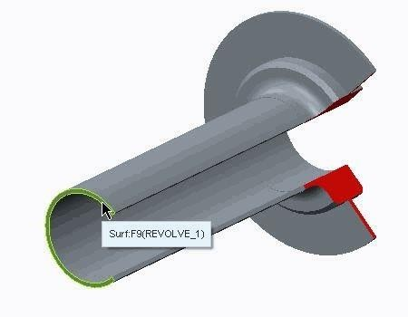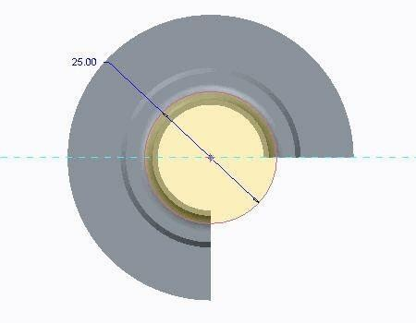**Task 1:** Create a volume region.

|  |
| --- |
| 1. In the ribbon, select the **Refine Model** tab. 2. Select **Extrude**  from the Volume Region drop-down menu in the Regions group. The Extrude dashboard appears. 3. Select the surface shown in the model. |
| 1. In the ribbon, select the **Sketch** tab. 2. Click **Sketch View**  from the Setup group to orient the sketch plane. 3. Sketch a circle with a 25.0 mm diameter centered on the hole as shown. 4. Click **OK** to return to the Extrude dashboard. 5. Click **Specified Depth** , type **65.0** in the field, and press ENTER. 6. Click **Apply-Save Changes** . |

**Task 2:** Create the shell pair.

1. In the ribbon, select the **Refine Model** tab.
2. Click **Shell Pair > Detect Shell Pairs** from the Shell Pair drop-down menu in the Idealizations group. The Auto Detect Shell Pairs dialog box appears.
3. Verify **Use Geometry Analysis** is selected.
4. Type **1.0** in the Characteristic Thickness field.
5. Click **Start**. The Auto Detect Shell Pairs dialog box closes.
6. In the model tree, expand **Idealizations** and **Shell Pairs**. Note that there are three shell pairs listed. Select each shell pair to highlight it in the model.
7. Right-click **ShellPair1** and select **Delete**. Click **Yes** in the Confirmation dialog box.

***Note:*** *This shell pair needs to be deleted because we want to account for uniform thickness in the stress evaluation.*

1. 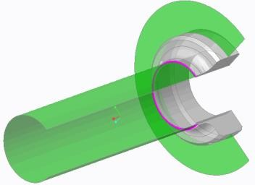Click **Review Geometry ** from the AutoGEM group. The Simulation Geometry dialog box appears.
2. Review that the shell surfaces were paired successfully. Note the color green is assigned by default in Creo Simulate for all the Shell Surfaces found in the model. Light gray color has been allocated to the Solid Surfaces. You can change the color by clicking **Change Color **

.

1. Click **Apply**. Note the mid-plane compression in the model, as shown.
2. Click **Close**.

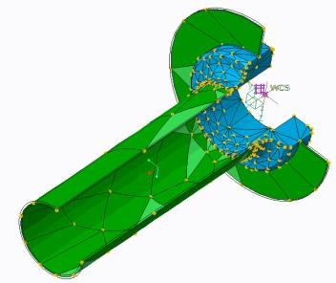**Task 3:** Apply a mesh to the model.

|  |
| --- |
| 1. In the ribbon, select the **Refine Model** tab. 2. Click**AutoGEM** from the AutoGEM group. The AutoGEM dialog box appears. 3. Keep all of the default settings and click **Create**. The model is meshed as shown. |
| 1. In the AutoGEM Summary dialog box, click **Close**. 2. In the Diagnostics:AutoGEM Mesh dialog box, click **Close**. 3. In the AutoGEM dialog box, click **Close**. Click **No** when prompted to save the mesh. |

**Task 4:** Apply a new mesh using new AutoGEM settings.

* 1. 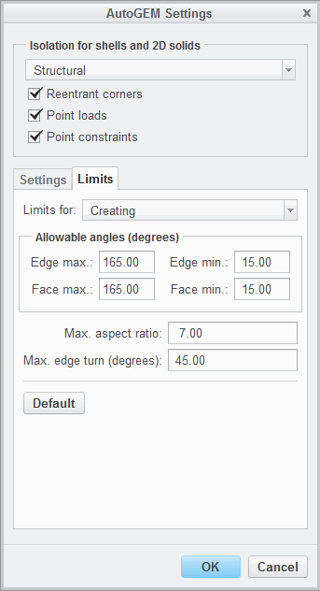Select **Settings** from the AutoGEM drop-down menu in the AutoGEM group. The AutoGEM Settings dialog box appears. On the Settings tab, select **Create links where needed**.
  2. Select the **Limits** tab. Complete the fields as shown.
  3. Click **OK**.

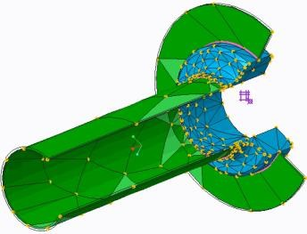  

|  |
| --- |
| 1. Click **AutoGEM** from the AutoGEM group. The AutoGEM dialog box appears. 2. Keep all of the default settings and click **Create**. The model is meshed as shown. Note the magenta lines connecting the Shells to the Solids. These are links automatically created by default in Creo Simulate when Solid and Shell elements are connected. They account for rotational coupling between these types of elements.   ***Note:*** *Since the Solid elements do not have degrees of freedom enabling them to rotate, and since Shells have all available translation and rotation degrees of freedom, the software uses these links to properly transfer the deformations from Shells to Solids.* |
| 1. In the AutoGEM Summary dialog box, click **Close**. 2. In the Diagnostics:AutoGEM Mesh dialog box, click **Close**. 3. In the AutoGEM dialog box, click **Close**. Click **No** when prompted to save the mesh. |

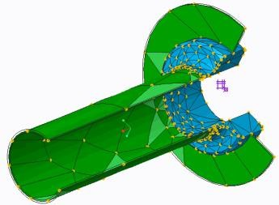**Task 5:** Adjust the AutoGEM settings to eliminate the solid shell links.

|  |
| --- |
| 1. Select **Settings** from the AutoGEM drop-down menu in the AutoGEM group. The AutoGEM Settings dialog box appears. 2. Select the **Settings** tab. Clear **Create links where needed**. 3. Click **OK**. |
| 1. Click **AutoGEM** from the AutoGEM group. The AutoGEM dialog box appears. 2. Keep all of the default settings and click **Create**.   ***Note:*** *There are no more magenta links between the elements. You have induced hinges between the elements. If a load is acting on this component, it may cause the regions modeled using Shells elements to pivot where connected to the Solid elements.* |
| 1. In the AutoGEM Summary dialog box, click **Close**. 2. In the Diagnostics:AutoGEM Mesh dialog box, click **Close**. 3. In the AutoGEM dialog box, click **Close**. Click **No** when prompted to save the mesh. |
| 1. Click **File > Manage Session > Erase Current**. 2. The Erase Confirm dialog box appears. Click **Yes**. |

This completes the exercise.

141

# Module 8

## Structural Analysis

## Fundamentals of a Linear Static Analysis

The standard linear static analysis applies loads to an unreformed structure and analyzes the resulting displacements and stresses.

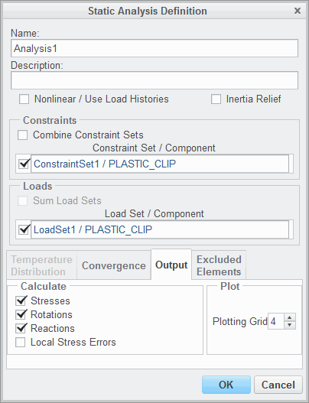The following items need to be considered before running a Linear Static analysis:

* + - Load Sets
    - Constraint Sets
    - Plotting Grids
    - Inertia relief
    - Desired result output quantities
    - Convergence methods
    - Excluded elements

Figure 1 – Static Analysis Definition Dialog Box

###### Fundamentals of a Linear Static Analysis

A static analysis is used to analyze deformations, stresses, or strains from time-independent loads. The standard linear static analysis applies loads to an undeformed structure and analyzes the resulting displacements and stresses. Displacements mustremain verysmall compared to theoverall structure dimensions so that this analysis type stays valid.

A load set groups loads (for example, forces, moments, pressure) which act simultaneously on the structure. In a constraint set, the constraints are grouped. Constraints define where the structure is fixed relative to the environment or where an enforced displacement is applied. Usually, at least one Load and one Constraint set must be selected to perform a Linear Static analysis, but there are the following exceptions:

* If you have defined a constraint set with at least one enforced displacement, you do not necessarily need a load set.
* If you select Inertia Relief, you cannot use a constraint set. Inertia Relief equates the externally applied loads with the resulting quasi-static translational and/or rotational accelerations of the structure due to these applied loads.

Only in linear static analysis, it is possible to use the principle of linear superposition for the load sets. It is assumed here that one loaded state does not interact with another loaded state. So, if two load sets act at the same time, the resulting displacements and stresses are simply the sum of both sets. The user has to decide if this principle is valid for his application problem. If it is not valid, the prestress or the large deformation static analysis might be alternate choices.

The following items need to be considered before running a Linear Static analysis:

* Load Set – If there is more than one load set, the following options are available:
  + If more than one load set is selected and the check box Sum Load Sets is not checked, the engine separately solves each load set and stores the result for each case on the hard disk. Later, each load case can be separately evaluated or arbitrarily combined and scaled in the postprocessor using the principle of linear superposition.
  + If the check box Sum Load Sets is checked, all selected load sets are combined and solved as one simultaneous set by the engine. Then the postprocessor can just access the results of this load combination.
* Constraint Set – The constraint sets can be combined and treated as one resulting set by the engine. Unlike load sets, just one constraint set per analysis can be solved; no linear superposition is possible in the postprocessor.

In assemblies, constraint and load sets from subassemblies and parts can be accessed for analysis definition.

* Plotting Grid – Simulate subdivides each element into a finer plotting grid for postprocessing. At the crossings of the plotting grid, the nodes are located where the results are evaluated, displacements, stress, and strain. The displacements are evaluated at the nodes of the plotting grid by interpolating in the element. For a p- element, the displacements are polynomial functions for which Simulate knows the coefficients after the problem has been solved, and the polynomials are used for interpolating. The plotting grid does not define the analysis accuracy, just the result display accuracy. In general, there should be a balance between element size (or number of elements in the model), element type (shell and especially beam result display benefits from a higher plotting grid), required analysis accuracy, desired result display quality, and the requested plotting grid.

The plotting grid can be adjusted between 2 and 10 in the Static Analysis Definition dialog box. A high plotting grid significantly increases calculation time and hard disc resource usage. Some recommendations are:

* Plotting Grid set equal to 4 (default): Model with volume elements in a static analysis with interest in stresses and standard accuracy demands.
* Plotting Grid set equal to 6: For shells/beams in a static analysis with interest in stresses.
* Plotting Grid set equal to 2: For a modal analysis with volumes, if just the global modal shapes and no modal stresses are of interest. This setting saves resources.
* Inertia relief – Use this option to analyze an unconstrained model. You can use this option only for a linear static analysis. Using this option, Simulate analyzes your model as if it were floating freely in space, without any constraints, but with the loads applied.
* Desired result output quantities – Even if no result output quantities are requested, Simulate always analyzes displacements and writes them on the hard disk. Optionally, you can request:
* Stresses – Stresses and strains are analyzed in addition to the displacements.
* Rotations – Rotations are output, too. This option has no influence to volume elements, since these do not support rotations, but it affects idealized finite elements, for example, shells, beams, and springs.
* Reactions – If this check box is selected, Simulate prints out the resulting force sum of all applied loads in the rpt-file. This is an important option to check which loads have been really applied and should therefore be used for quality assurance of your analysis. A moment balance is not reported, just the force balance.
* Local stress errors – This outputs different RMS stress errors in the result directory, as described in module error norms.
* Convergence methods – You can select one of the following convergence methods for Simulate to use when it runs your model:
* Single-Pass Adaptive
* Multi-Pass Adaptive
* Quick Check (No Convergence)
* Excluded elements – You can exclude elements in your model from convergence and measure calculations during an analysis.

## Defining a Linear Static Analysis

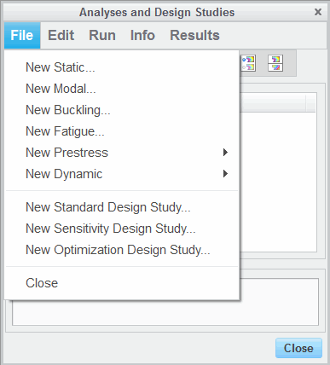A static analysis is used to analyze deformations, stresses, or strains from time-independent loads. The following steps are required to define a Linear Static

Analysis:

* + Select the type of analysis and assign a name.
  + Select a constraint and load set.
  + Select a convergence method.
  + Define the output.
  + Check and adjust run settings if required.
  + Run the analysis.

Figure 1 – Analyses and Design Studies Dialog

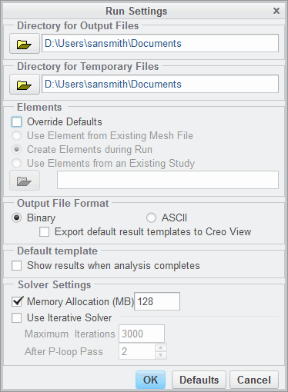Box

Figure 2 – Static Analysis Definition Dialog Box Figure 3 – Run Settings Dialog Box

###### Defining a Linear Static Analysis

A static analysis is used to analyze deformations, stresses, or strains from time-independent loads. The standard linear static analysis applies external loads on the undeformed structure and analyzes the resulting displacements. Therefore, displacements must remain very small compared to the overall structure dimensions so that this analysis type stays valid.

The following steps are required to define a Linear Static Analysis:

* Select the type of analysis and assign a name – Access the Analyses and Design Studies dialog box and select the type of analysis, as shown in Figure 1. In the Static Analysis Definition dialog box, Figure 2, assign a meaningful name to the analysis. For better reference, enter a description. This description is printed into the Simulate engine's rpt-file.
* Select a constraint and load set – In the Static Analysis Definition dialog box, Figure 2, select a constraint set and load set from the list, and combine constraint sets or sum load sets if desired.
* Select a convergence method – When using MPA, enter convergence in %, define minimum and maximum polynomial degree, and select convergence criteria in the Static Analysis Definition dialog box, Figure 2.
* Define the output – Displacements are always calculated and stored. Stresses, rotations (not for volume elements), and reactions (forces/moments at constraints and resultant load on model) can

be analyzed on demand. You can also select Local Stress Errors to obtain local RMS stress error information for each element in the postprocessor. Define a reasonable plotting grid. This is defined on the Output tab in the Static Analysis Definition dialog box.

* Check and adjust run settings, if required, in the Run Setting dialog box, as shown in Figure 3.

***Note:***

* *For both output and temporary directories, you should always use local hard disk drives. Never use a network drive, since the amount of data to be transferred may become large.*
* *You can override the default elements settings.*
* *Enter a suitable memory allocation; in most cases, 512 MB is adequate.*
* Run the analysis.

***Note:*** *Once the analysis has been deflned an Analyses node appears in the model tree. Expand the Analyses node and right-click on an analysis to run or stop theanalysis, view the results, and delete or copy the analysis. You can also edit the analysis deflnition using the mini toolbar.*

## PROCEDURE - Defining a Linear Static Analysis

**Task 1:** Investigate the existing simulation features and define a Static Analysis.

1. In the model tree, click **Show ** and select **Expand All** from the drop-down list.
2. Review the existing simulation features, including:
   * Internal and External Pressure Loads
   * Cyclic and Mirror Symmetry Constraints
   * A Translation Constraint
   * A Fastener and its associated Measures
3. In the ribbon, select the **Home** tab.
4. Click **Analyses and Studies ** from the Run group.
5. The Analyses and Design Studies dialog box appears. Click **File > New Static...**.
6. The Static Analysis Definition dialog box appears. In the Name field, type **FLANGES_STATIC** .
7. In the Constraints section, select the **Combine Constraint Sets** check box and select each of the constraint sets defined in the model.
8. In the Loads section, select **Pressure / FLANGES**.
9. Select the **Output** tab. Verify that **Stresses**, **Rotations**, and **Reactions** are selected and that the Plotting Grid field is set to **4**.

***Note:*** *Note that the value you specify for Plotting Grid determines the number of intervals along each edge of each element that Simulate uses to create plotting grids. Simulate calculates quantity values at the intersections of grid lines and reports precise results for each grid intersection point and interpolates these values to show results elsewhere.*

1. Select the **Convergence** tab. Select **Single-Pass Adaptive** from the Method drop-down list.

|  |
| --- |
| 11. The dialog box should appear as shown. Click **OK** to  complete the static analysis definition and close the dialog box. |
| 1. In the Analyses and Design Studies dialog box, click **Close**. 2. Click **File > Manage Session > Erase Current** to erase the model from memory. 3. The Erase dialog box appears. Click **Select All** . 4. Click **OK**. |

This completes the procedure.

## Exercise 1: Defining a Linear Static Analysis

### Objectives

After successfully completing this exercise, you will be able to:

* Configure and run a Simulate static analysis.
* Examine and set up the proper Simulate model type based on the input and material properties.
* Compare the results from 3-D, 2-D Axisymmetric, and 3-D with Cyclic Symmetry model types and identify the benefits of using each of these model types.

### Scenario

In this exercise, you will use Simulate to evaluate the stresses and deformations in a supporting component made out of Brass. The loads exerted on this component are internal pressure and external loads. The model is fully constrained and you will evaluate and compare the stresses and deformations for this component using the following model types:

* 3-D (the default model type)
* 2-D axisymmetric
* 3-D with cyclic symmetry

The model is a revolved feature with stiffeners placed transversely along the length of the cylinder. There are two loads in the model: an external surface load of 50 N and an internal pressure of 30 MPa. The model is held fully constrained at the bottom of the support housing.

The material is isotropic (BRASS) with Young’s modulus (E) of 103 GPa. The material is a rather soft, ductile material with a yield strength of about 190 MPa. Since the material is isotropic, the model has the same properties in all three directions.

You will start by running an analysis for this geometry using the 3-D (default) model type. That is, we are going to apply the load and constraints in the model in its current geometrical configuration.

However, you may wish to reduce the number of finite elements by using the advantage that the model exhibits the same properties in the 3-D domain. There are two possible solutions:

* Imagine you are slicing a sheet of paper-like sliver surface from this 3-D model. Next, revolve this sliver surface 360° around its axis of revolution. The outcome is the same, geometry-wise, as the full 3-D model. But, by using this idealization approach, we can reduce the number of elements (since we are now working in 2-D) and be able to provide the same results as a 3-D model. This model type is called 2-D axisymmetric in Simulate
* Another possibility is to cut the model (like a slice of pie) and use a special type of constraints (cyclic symmetry) to simulate the fact that the remaining model is still there. It is still going to be a 3-D model type, but the finite element count will dramatically drop.

Although each one of these design and analysis approaches are interesting to examine, we will concentrate our attention to the 2-D axisymmetric model type. In the end, we will examine the results from all these three model types and discuss the benefits of using any of these idealizations.

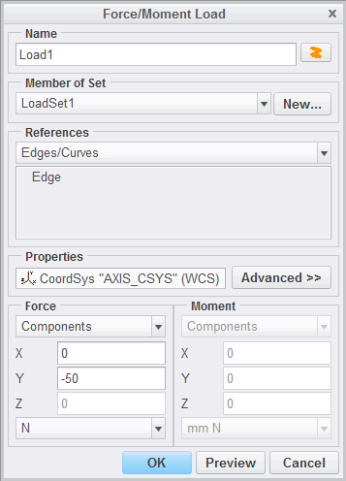

**Task 1:** Investigate the model.

1. In the ribbon, select the **Home** tab.
2. Click **Model Setup ** from the Setup group.
3. The Model Setup dialog box appears. Click **Advanced** to expand the dialog box.
4. In the Type section, select **2D Axisymmetric**.
5. In the model tree, select **AXIS_CSYS** as the coordinate system. Note that on the model, the **AXIS_CSYS** coordinate system is oriented so that the X- and Y-axes lie in the plane of the surface selected for the 2-D axisymmetric model. If this were not the case, you would need to create a coordinate system that was oriented in this way before continuing.
6. 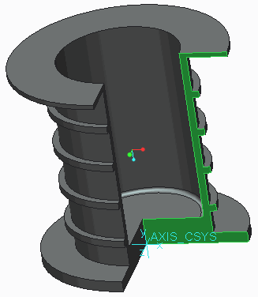Select the surface shown as the geometry reference.
7. Click **OK** to complete the model setup and close the dialog box. Click **Confirm** to acknowledge the deletion of all simulation modeling entities. Note Simulate adds a line around the perimeter of the surfaces you have selected for the model. This is a visual aid used to differentiate between a 2-D axisymmetric and a 3-D model type.

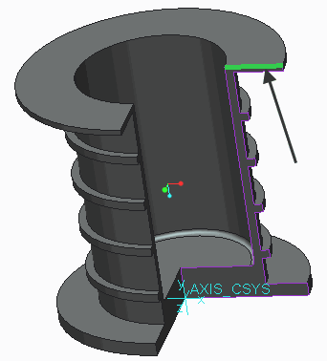**Task 2:** Define loads, constraints, and materials for the 2-D axisymmetric model.

|  |
| --- |
| 1. On the model, select the top edge of the 2-D geometry as shown, and click **Force/Moment**  from the mini toolbar. 2. The Force/Moment Load dialog box appears. |
| 3. In the Force section, type **–50** in the Y field. Verify that the units for the force are set to N. This load application is equivalent to applying the load on the entire top surface when in the original 3-D model. Because you are in a 2-D axisymmetric model you now select an edge. The dialog box should appear as shown.  ***Note:*** *Note that due to being in a 2-D axisymmetric model you are constrained in the XY plane. No forces can be applied in the Z-direction and moments can only be applied about the Z-axis.* |

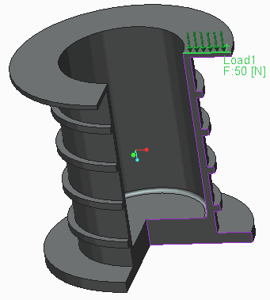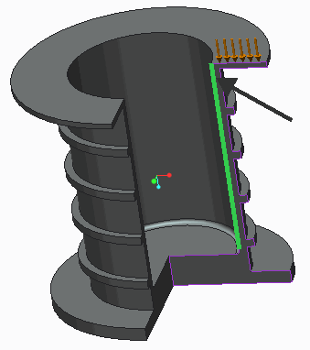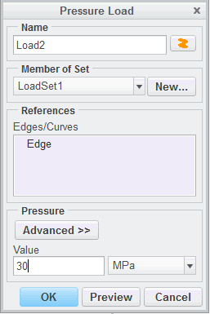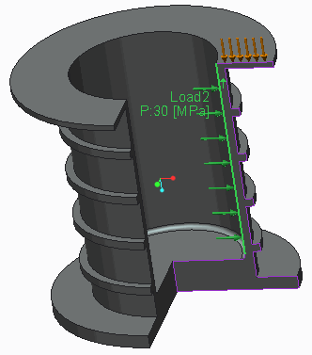

|  |
| --- |
| 4. Click **OK** to complete the Force/Moment Load  definition and close the dialog box. The load should now appear as shown. |
| 5. On the model, select the inside vertical edge as shown, and click **Pressure**  from the mini toolbar. The Pressure Load dialog box appears. |
| 6. In the Pressure section, type **30** in the Value field. Verify the units for the pressure are set to MPa.  This load application is equivalent to  applying a pressure load on the entire inner wall surface of the original 3-D model. The dialog box should appear as shown. |
| 7. Click **OK** to complete the Pressure Load definition and close the dialog box. The pressure load should now appear as shown. |

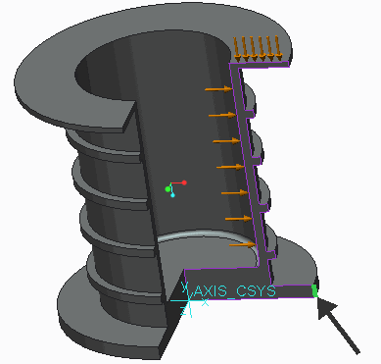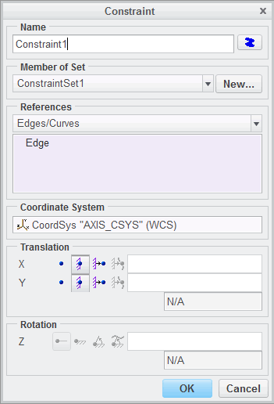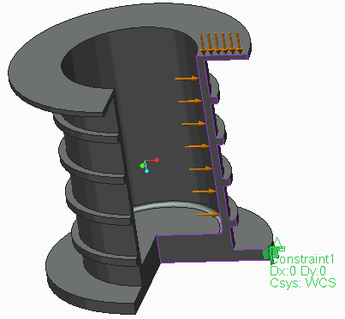

|  |
| --- |
| 8. On the model, select the bottom outside short  vertical edge as shown, and click **Displacement**  from the mini toolbar. The Constraints dialog box appears. |
| 9. In the Translation section, select **Fixed**  for both the X and Y degrees of freedom. This constraint is equivalent to constraining the entire outside surface that this edge is coincident within the original 3-D model. The dialog box should appear as shown. |
| 10. Click **OK** to complete the Constraint definition and close the dialog box. The constraint should now appear as shown on the model. |
| 1. In the model tree select HOUSING_SUPPORT.PRT and click **Material Assignment**  from the mini toolbar. 2. The Material Assignment dialog box appears. Next to the Material field in the Properties section, click   **More**.   1. The Materials dialog box appears. Right-click **brass.mtl** from the list of materials and select **Add to Model** to add it to the Materials in Model list. 2. Click **OK** to close the Materials dialog box. |

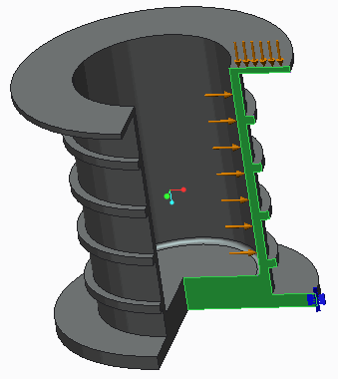

|  |
| --- |
| 15. Select the surface shown for the Reference surface. |
| 1. In the Properties section, verify the Material field is set to Brass. 2. The dialog box should appear as shown. Click   **OK** to assign Brass to the section. |

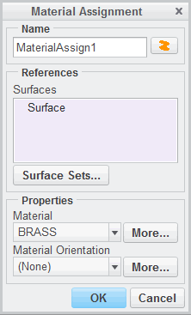**Task 3:** Define a static analysis.

1. Click **Analyses and Studies ** from the Run group.
2. The Analyses and Design Studies dialog box appears. Click **File > New Static...**.
3. The Static Analysis Definition dialog box appears. In the Name field, type **STATIC_AXISYMMETRIC**.
4. Verify that the constraint and load set you created are selected in the Constraints and Loads sections, respectively.
5. Select the **Convergence** tab. From the Method drop-down list, select **Multi-Pass Adaptive**.
6. In the Polynomial Order section, type **9** in the Maximum field.
7. In the Limits section, type **5** in the Percent Convergence field.
8. Verify that **Local Displacement, Local Strain Energy and Global RMS Stress** is selected.

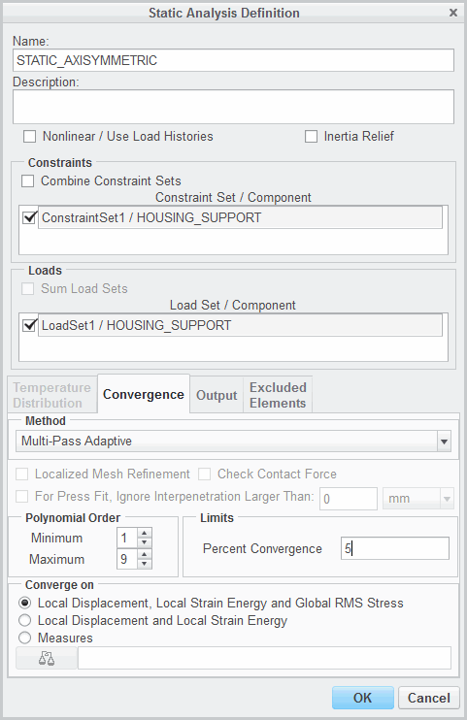

|  |
| --- |
| 1. The dialog box should appear as shown.   Click **OK** to complete the Static Analysis  Definition and close the dialog box. |
| 1. In the Analyses and Design Studies dialog box, verify that **STATIC _AXISYMMETRIC** is selected. Click **Start Run**  to start the design study. Click **Yes** to run interactive diagnostics. 2. Click **Display Study Status**  to view the run status. 3. When the analysis is complete, click **Close** in the Run Status and Diagnostics dialog boxes. |

**Task 4:** Review results.

* 1. In the Analyses and Design Studies dialog box, verify that **STATIC _AXISYMMETRIC** is still selected and click

##### Review Results .

* 1. The Result Window Definition dialog box appears. In the Name field, type **VM_STRESS**.
  2. 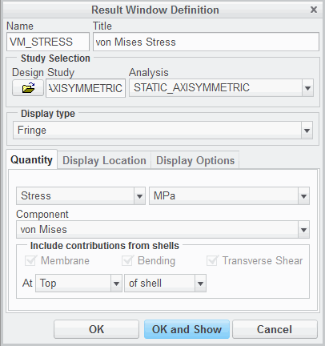In the Title field, type **von Mises Stress**.
  3. In the Display type field, verify that **Fringe** is selected.
  4. Select the **Quantity** tab.
  5. Verify that **Stress**, **MPa**, and **von Mises** are all selected from the drop-down lists. The dialog box should appear as shown.
  6. 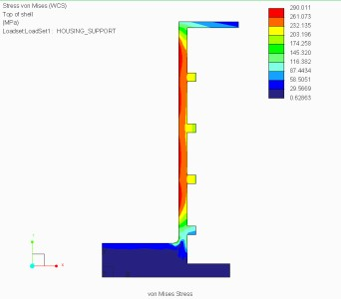Click **OK and Show** to display the results.

***Note:*** *Note the maximum von Mises stress is around 290 MPa; a value well beyond failure (100 MPa) for this material. Determine the kind of structural changes you would make to lower the stress in the model. Before you get started,*

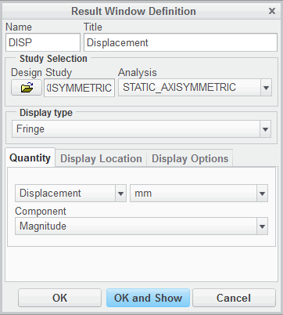*increase the stiffness by adjusting the thickness of the housing wall, or adjust the stiffeners pattern.*

|  |
| --- |
| 1. In the ribbon, select the **Home** tab. 2. Click **Copy**  from the Window Definition group. 3. The Result Window Definition dialog box appears. In the Name field, type **DISP**. 4. In the Title field, type **Displacement**. 5. In the Display type field, verify that **Fringe** is selected. 6. Select the **Quantity** tab. 7. Select **Displacement** from the first drop-down list. |
| 15. Verify that the units are set to mm and the Component field is set to Magnitude. The dialog box should appear as shown. |
| 16. Click **OK and Show** to display the results. |
| 1. Click **File > Close**. 2. The Confirm Exit dialog box appears. Click **Don’t Save**. |

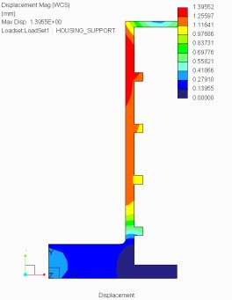**Task 5:** Review and compare the STATIC_AXISYMMETRIC results with the results from the full 3-D model and the 3-D model with cyclic symmetry.

|  |
| --- |
| ***Note:*** *These results can be generated by running the* ***STATIC_3D*** *analysis in the 3DHOUSING_SUPPORT.PRT part and the* ***STATIC _CYCLIC_SYMMETRY*** *analysis in the CYCL_HOUSING_SUPPORT.PRT. Otherwise, you can review the images and table here, or access the results for each of these analyses in the* ***Complete*** *directory.* |

1. Review and compare the fringe plot results for von Mises and displacement for all three models.

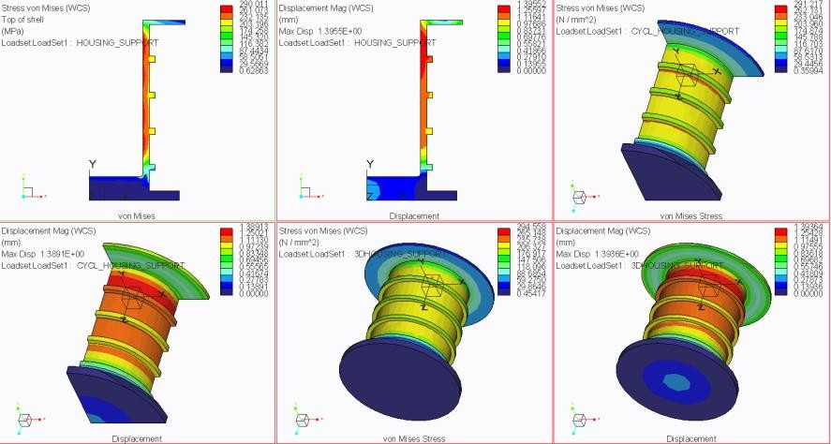

1. Review and compare the scalar results for von Mises stress and displacement for all three model types.

|  |  |  |  |  |
| --- | --- | --- | --- | --- |
| **Model Type** | **Maximum von Mises Stress (MPa)** | **Maximum Displacement (mm)** | **Elements** | **Approximate Solution Time (sec)** |
| 2-D axisymmetric | 290 | 1.396 | 80 | 12 |
| 3-D with cyclic symmetry | 291 | 1.389 | 396 | 35 |
| 3-D | 295 | 1.394 | 1531 | 61 |

***Note:*** *Although this example is not intended as a veriflcation model in Simulate, we can easily identify that the results for each model type are close for both Von Mises stress and displacement. The conclusion is more from productivity point of view: it takes less time and elements to mesh and solve the 2-D axisymmetric model versus the 3-D Simulate default model type. The 2-D axisymmetric model type can be applied for all cases where the loads, constraints, materials are symmetrical about an axis of revolution.*

1. If you viewed the results in the results window, exit the results window to return to Creo Simulate.
2. In Creo Simulate, close any remaining dialog boxes.
3. Click **File > Manage Session > Erase Current** to erase the model from memory.
4. Click **Yes** in the Erase Confirm dialog box. This completes the exercise.

## Understanding Modal Analysis

Modal analysis can be used to calculate the natural frequencies of a Simulate model.

Input:

* + No Loads
  + 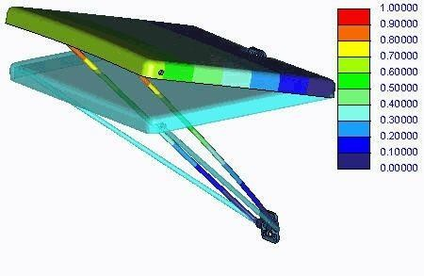No Prescribed Displacements
  + Geometry
  + Material
  + Constraints (optional) Output:
  + Frequency (Summary results)
  + Mode Shape (Fringe Plots) Figure 1 – Modal Analysis Output

###### Understanding Modal Analysis

You can use Modal Analysis to determine the vibration characteristics (natural frequencies and mode shapes) of a Creo Parametric part or assembly. You can also notice the response to the natural frequencies of your model when it is subjected to time-dependent and/or oscillatory/vibration loads by running any dynamic analysis: Dynamic Time, Dynamic Frequency, Dynamic Random, or Dynamic Shock. A modal analysis is a prerequisite for a dynamic analysis.

###### Modal Analysis Input

Modes are intrinsic properties of a structure and they are dependent on the material properties (mass, structural damping stiffness) and boundary conditions. Each mode is characterized by two modal parameters: frequency and shape. These modal parameters change as the stiffness and boundary conditions of the system change.

There are no loads required for a Modal Analysis. Any loads (steady or time/frequency-dependent) or Prescribed displacement constraints are neglected when running a Modal Analysis.

The model can be constrained (surface, curve/edge, and/or points) or not. A Modal Analysis can evaluate the modal parameters (including the rigid modes) from a specified minimum frequency on or within a certain frequency range.

###### Modal Analysis Output

The results from a Modal Analysis can be identified in the summary report and in fringe plots. The summary report reports the frequency values for each of the modes and fringe plots can be used to display the mode shapes. Units of modal frequency shown in results are always cycles per unit of time. The units of time are affected by the force/length/time units you used to define the model. Simulate never reports modal frequency in terms of radians per unit of time.

Simulate also reports Mass Participation Factors for each mode. The Mass Participation Factor for each mode represents the amount of system mass that is participating in that mode. A mode with a large effective mass typically provides a significant contribution to the system’s response.

The stress and displacement results from a Modal Analysis are all normalized. That is, the maximum deformation is always 1.0. Simulate unit normalizes displacements and rotations to 1.0 by dividing all displacements by the maximum displacement response. For Modal Analyses, values for all quantities are not absolute. You cannot compare them to quantities from any other type of analysis. It is possible to generate results that are mass- normalized when using the Simulate batch mode for solving purposes.

## PROCEDURE - Understanding Modal Analysis

**Task 1:** Define a modal analysis.

|  |
| --- |
| 1. In the model tree, click **Show** . 2. Select **Expand All** from the drop-down list. Examine the model and material assignments. |
| 1. In the ribbon, select the **Home** tab. 2. Click **Analyses and Studies**  from the Run group. 3. The Analyses and Design Studies dialog box appears. Click **File > New Modal...**. 4. The Modal Analysis Definition dialog box appears. In the Name field, type **Shears_Modal**.   ***Note:*** *Note that there are no Constraints to select. Simulate defaults to* ***Unconstrained*** *and selects the* ***With rigid mode search*** *option. This option is used when the model will exhibit free body motion. This option is typically used when running an unconstrained Modal Analysis. For a multi-degree of freedom system, there are normally six possible rigid modes of vibration at zero frequency, three Cartesian translations and three rotations. Also, this option can be used in a constrained Modal Analysis when the user is unsure if the model is sufflciently constrained.* |
| 1. Select the **Convergence** tab. 2. In the Method section, select **Single-Pass Adaptive** from the drop-down list 3. Select the **Modes** tab. 4. In the Number of modes field, type **20**. 5. In the Minimum frequency field, type **0**. 6. Select the **Output** tab. 7. In the Calculate section, select the **Stresses**, **Rotations**, and **Reactions** check boxes. 8. In the Plot section, type **4** in the Plotting Grid field.   ***Note:*** *In general, we are interested in the modal parameters and less in the stress or deformations; however, the stress and deformation fringe plots can provide us with information as to where to set Simulate measures in order to make readings at maxima for a Dynamic Time/Frequency/Shock/Random Analysis.* |
| 15. The dialog box should appear as shown. Click **OK** to complete the Modal Analysis definition and close the dialog box. |
| 1. Click **Close** in the Analyses and Design Studies dialog box. 2. Click **File > Manage Session > Erase Current** to erase the model from memory. 3. Click **Select All** and click **OK** in the Erase dialog box. |

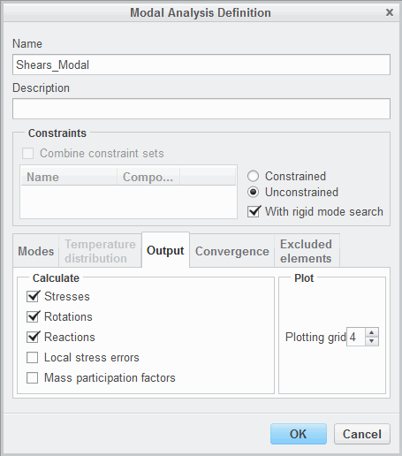This completes the procedure.

## Exercise 2: Understanding Modal Analysis

### Objectives

After successfully completing this exercise, you will be able to:

* Define and run a modal analysis.

### Scenario

In this exercise, you set up a simulation model for a folding tray table. The goal is to identify the mode shapes and frequency values as output from a modal analysis. The model is made of steel and PVC and is analyzed in its functional position.

In this exercise, the folding tray is constrained to a fixed reference, a wall, at the bracket locations. The clamping yoke is allowed to rotate at the supports to accommodate folding. None of the components of this folding tray idealization are actually bonded; they are allowed to rotate independently.

Therefore, a Free, instead of the default Bonded, interface is defined. The components are connected at their direct contact (for example, between the clamping yoke and the brackets or between the yoke and the table). Therefore, a combination of the Spring and Weighted Link idealizations is used to simulate this type of interaction.

Only some of the simulation features are defined, some of the Spring and Weighted Link idealizations. There are no loads in a Modal Analysis. You define some of the remaining Spring idealization properties, and the connections between these Spring idealizations and the surfaces of the brackets. Also, you define the constraints and assign material properties.

**Task 1:** Investigate the model properties.

1. Click **File > Prepare > Model Properties**. The Model Properties dialog box appears.
2. Review the units used in the model. To close the Model Properties dialog box, click **Close**.
3. In the model tree, expand **Loads/Constraints** and **Constraint Set ConstraintSet1**. Right-click

**Constraint1** and select **Edit Definition **. The Constraint dialog box appears.

1. Review the constraints defined and notice that the constraint is defined to the surfaces of the brackets that are bolted to the fixed reference. Click **Cancel** to close the Constraint dialog box.
2. In the model tree, expand **Idealizations** and **Springs**. Right-click **Spring1** and select **Edit Definition**

. The Spring Definition dialog box appears.

1. Review the spring defined and notice that the spring is defined between two collinear points in the same part. Defining the Spring in the same part instead of connecting it to other parts is a valid solution. We are going to use this simulation because we want the Spring to actually impose the rotation we are looking for between the YOKE.PRT and BRACKET.PRT. In the Properties section, click **More**.
2. The Spring Properties dialog box appears. Select **all_trans_fixed** and click **Edit**.
3. The Spring Property Definition dialog box appears. Note there is a high translational stiffness set; therefore, the spring is not allowed to translate. There is no torsional stiffness set; therefore, the spring is allowed to rotate. Click **OK** to close all dialog boxes.
4. In the model tree, expand **Connections** and **Weighted Links**. Right-click **WeightedLink5** and select **Edit Definition **. The Weighted Link Definition dialog box appears.
5. Note the references used to define this weighted link. Two surfaces from JOINT_AXIS.PRT pin component and the end point on BRACKET.PRT are used as references. The point on the bracket is the same on that the spring idealization reviewed is connected. Also note that all the translation degrees of freedom are enabled. Click **OK** to close the dialog box.

**Task 2:** Define a free interface between all components in the assembly.

* 1. In the ribbon, select the **Home** tab.
  2. Click **Model Setup ** from the Set Up group. The Model Setup dialog box appears.
  3. Select **Free** from the Default Interface drop-down list.
  4. Click **OK**.

**Task 3:** Define the materials for the components in the assembly.

|  |
| --- |
| 1. In the ribbon, select the **Home** tab. 2. Click **Materials** from the Materials group. The Materials dialog box appears. 3. Right-click **ss.mtl** from the Materials list and select **Add to Model**. 4. Right-click **pvc.mtl** from the Materials list and select **Add to Model**. 5. Click **OK**.   ***Note:*** *It is always a good practice to knowthe properties of the materials you are using independent of their source (default or customized library). You can do this by right-clicking material in the Materials list and selecting*  *Properties.* |
| 1. Press CTRL and from the model tree, select JOINT_AXIS.PRT and CLAMPING_YOKE.PRT and click **Material Assignment**  from the mini toolbar. The Material Assignment dialog box appears. 2. In the Properties section, select **SS** from the Material drop-down list, and verify that **(None)**   is selected in the Material Orientation field.   1. Click **OK**. 2. Click **Material Assignment**  from the Materials group. The Material Assignment dialog box appears. 3. Press CTRL and from the model tree, select DESK_PLATE.PRT , both BRACKET.PRT components and click   **Material Assignment**  from the mini toolbar. The Material Assignment dialog box appears.   1. In the Properties section, select **PVC** from the Material drop-down list, and verify that **(None)**   is selected in the Material Orientation field.   1. Click **OK**. |

**Task 4:** Define and run the modal analysis.

|  |
| --- |
| 1. In the ribbon, select the **Home** tab. 2. Click **Analyses and Studies**  from the Run group. The Analyses and Design Studies dialog box appears. 3. Click **File > New Modal**. The Modal Analysis Definition dialog box appears. 4. Complete the dialog box as follows:    * In the Name field, type **desk_modal**.    * Verify that **With rigid mode search** is not selected.    * Select the **Modes** tab. Type **6** in the Number of Modes field.    * Select the **Output** tab. Deselect all boxes in the Calculate section.    * Type **2** in the Plotting Grid field.   ***Note:*** *If you have an interest just in the mode shapes and their frequencies, you can turn off any extra computations and lower the default setting for the Plotting Grid. This eliminates the use of extra disk space or RAM resources, and the simulation run is faster.*   * + Select the **Convergence** tab. Select **Single-pass adaptive** in the Method field.  1. Click **OK**. |
| 1. In the Analyses and Design Studies dialog box, select **desk_modal** and click **Start Run** . Click   **Yes** to run interactive diagnostics.   1. Click **Display Study Status**  to view the summary report after the analysis is complete.   ***Note:*** *Note that the Modal Analysis has failed. In the summaryreport, Creo Simulate specifles the reason for the failure. The reason is that the folding tray has a rigid body mode. In other words, it can freely move without deformations. That is true considering the connections deflned between the components.*   1. Close all dialog boxes and return to the Analyses and Design Studies dialog box. |
| 1. Right-click **desk_modal** and select **Edit**. The Modal Analysis Definition dialog box appears. 2. Complete the dialog box as follows:    * Select **With rigid mode search**.    * Keep all other settings the same. 3. Click **OK**. |
| 1. In the Analyses and Design Studies dialog box, select **desk_modal** and click **Start Run** . Click   **Yes** to run interactive diagnostics and to remove existing files, if required.   1. Click **Display Study Status**  to view the summary report after the analysis is complete.   ***Note:*** *Notice in the summary report the frequency values for each of the modes. Notice the frequency of the rigid mode (Mode 1). This is reported since you have turned on the option to search for the rigid mode.*   1. Close all dialog boxes and return to the Analyses and Design Studies dialog box. |

**Task 5:** Create result window and investigate results.

|  |
| --- |
| 1. In the Analyses and Design Studies dialog box, select **desk_modal**. 2. Click **Review Results** . The Result Window Definition dialog box appears. 3. Complete the following:    * Type **Mode_2** in the Name field.    * Type **Deformed Shape at Mode 2** in the Title field.    * Select **Mode2** from the list of modes. Deselect any other mode.    * Select the **Quantity** tab. Verify that **Displacement** and **Magnitude** are selected.    * Select the **Display Options** tab.    * Select **Deformed**, **Overlay Undeformed**, and **Transparent Overlay**.    * Type **25** in the Scaling field. |
| 1. Click **OK and Show**. 2. Repeat this operation for other modes and inspect the results. |
| 1. When complete, click **File > Close** to return to the Creo Simulate window. 2. The Confirm Exit dialog box appears. Click **Don’t Save**. 3. In the Analyses and Design Studies dialog box, click **Close**. 4. Click **File > Manage Session > Erase Current**. 5. The Erase dialog box appears. Click **Select All** 6. Click **OK**. |

This completes the exercise.

## Setting Up the Simulate Solver

In this topic you will explore the Simulate solver settings necessary to accomplish a successful analysis run.

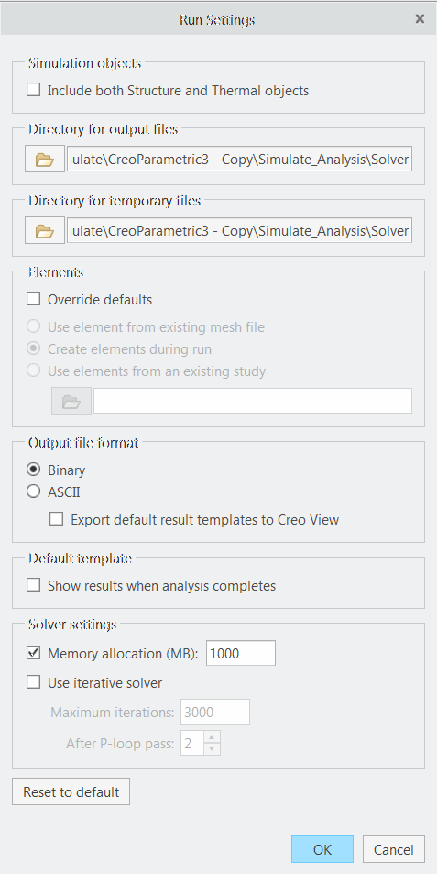

Solver Choices:

* + Direct (default)
  + Interactive Run Settings
  + Directory for Output Files
  + Directory for Temporary Files
  + Elements
  + Output File Format
  + Solver Settings
* Memory Allocation (MB)
* Use Iterative Solver
  + Defaults

Figure 1 – The Run Settings Dialog Box

###### Setting Up the Simulate Solver

Simulate uses one of two solvers for an analysis or design study. You can use either the Direct Solver or the Iterative Solver. These solvers are different methods by which Simulate solves systems of simultaneous equations that arise from the geometric element model. By default, Simulate uses the Direct Solver because it usually requires less time, disk space, and/or memory than the Iterative Solver.

You should use the Direct Solver in the following situations: if the model has thin features and does not converge using the Iterative Solver, or if the design study contains any analyses other than linear Static, such as Contact, Modal, or Transient Thermal.

All the options for setting or adjusting the solver are found in the Run Settings dialog box and can be adjusted for each of the analyses defined in a model. The Run Settings dialog box includes the following options:

* Simulation Objects - Include both Structure and Thermal objects in the analysis run.
* Directory for Output Files - Select the directory for the output files generated by the run. Typically, this can be a local or a mapped network drive where sufficient disk space exists. You are limited to 64 characters for the actual path name.
* Directory for Temporary Files - Select the directory for the temporary files generated by the run. This directory gets deleted upon a successful analysis run but, during the analysis run and for larger count finite element models, it can balloon to considerable sizes. Therefore, set it to a location that has sufficient disk space to accommodate it. You are limited to 64 characters for the actual path name.
  + Elements - Select the Override Default check box to change the default source of elements. Select the source of the elements Simulate uses during a run: create the elements as initial step during the analysis, use the elements from a saved mesh file or from an existent analysis directory.
  + Output File Format - Select an output format for the output file. The default is Binary (in other words, the generated content cannot be read using standard text editors) or can be exported to ASCII

(text only format).

* + Solver Settings - Use this area to specify settings for the solver:
* Memory Allocation (MB) - Select the check box and enter the appropriate number of megabytes to allocate for the memory. The value you enter sets the amount of RAM reserved for solving equations and for storing element data created by the Iterative Solver. The engine dynamically allocates the rest of the memory it needs for the run. Depending on the amount of RAM installed in your machine, you might be able to improve the engine solver performance by changing this setting. You can use the default Memory Allocation for any run. But, if you have a lot of RAM on your machine, you may want to enter a higher RAM allocation number so large models will run faster. You can also slow the run if you do not specify sufficient memory, especially if you specify less than the default.
* Use Iterative Solver - Select the check box to use the Iterative Solver and enter the maximum number of iterations and at which P-loop pass the iterative solver should take over from the direct solver.
  + Defaults - Select this button to return the settings on the dialog box to the default values.

## PROCEDURE - Setting Up the Simulate Solver

**Task 1:** Specify Simulate solver run settings for a static analysis.

|  |
| --- |
| 1. In the model tree, click **Show** . 2. Click **Expand All** from the drop-down list. 3. Review the existing simulation features including:    * A Material and Material Assignments    * Simulation Features (Points)    * Constraints    * Loads |
| 1. In the ribbon, select the **Home** tab. 2. Click **Analyses and Studies**  from the Run group. 3. The Analyses and Design Studies dialog box appears. Select **Initial** from the list of Analyses and Design Studies. 4. Click **Run > Settings**. 5. The Run Settings dialog box appears. Note the following:    * The Directory for Output Files and the Directory for Temporary Files default to the current working directory. You can browse to and select another directory.    * The Elements option defaults to **Create elements during run**. When this setting is used Simulate will mesh the model before the solver proceeds with the calculations of the equations. If you wish to use a saved mesh for the analysis, you can select the **Override defaults** check box and select the **Use element from existing mesh file** radio button. |

|  |
| --- |
| 1. In the Output file format section, verify that **Binary** is selected. 2. In the Solver settings section, type **1000** in the Memory Allocation (MB) field. The allocation of 1000 MB of memory assumes that the machine has 2000 MB of RAM and we are allocating 50% of it for the analysis.   ***Note:*** *It is difflcult tostateaprecise RAMAllocation that should be allocated for allmodels. This is because there are different types of analyses, model types, and flnite element count, that vary; this greatly impacts thedecision of how much the RAM Allocation should be. Generally speaking,*  *allocating between 25%-50% of theavailable physical memory for that speciflc workstation is a good place to start. However, you should try to stay on the lower range, or use even the default, for analysis models with a large number of flnite elements.* |
| 11. The dialog box appears as shown. Click **OK** to complete the Run Settings and close the dialog box. |
| 1. In the Analyses and Design Studies dialog box, click **Close**. 2. Click **File > Manage Session > Erase Current** to erase the model from memory. 3. Click **Yes** in the Erase Confirm dialog box. |

This completes the procedure.

## Starting, Stopping, and Monitoring the Simulate Solver

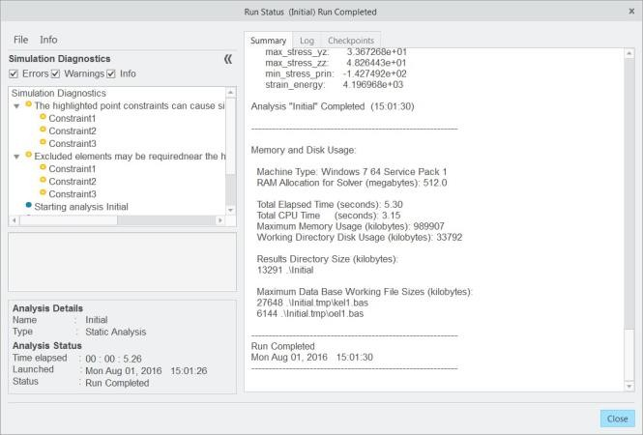In this topic, you will explore the tools available in Simulate to find information on the solver report once the analysis has started.

Starting and Stopping the Solver

* + - Start Run
      * Interactive Diagnostics
      * Delete Existing Files
    - Stop Run Monitoring the Solver
    - Interactive Diagnostics dialog box
    - Run Status Summary report
      * Summary
      * Log
      * Checkpoint

Figure 1 – A Typical Run Status Dialog Box

###### Starting, Stopping, and Monitoring the Simulate Solver

You can start and stop the solver using options from the Analyses and Design Studies dialog box or the Analyses node in the model tree. They are represented by two icons: **Start Run ** and **Stop Run **.

It is important to note you cannot use the Stop Run option to cancel a run you started in a previous

Simulate session, or a run you started directly from the operating system.

Upon starting an analysis (and implicitly, the solver) Simulate may present you with several prompts:

* + Do you want to run interactive diagnostics? This option verifies interactively both the pre-processing input as well as the progress of the analysis as seen from the solver perspective. It is important to understand that these checks don’t verify if you specified the correct magnitude for the loads or properly constrained the model—they simply check to determine whether there are loadsets with loads, materials assigned to the model, constraints in the selected constrained sets, or properly selected surfaces for Contact Regions, and so on.
  + Output files for “Analysis Name” already exist. They must be removed before starting the design study. Do you want to delete these files? You will see this option prompt only if the analysis Simulate is about to perform was already run in the same directory. If you choose not to delete the files, Simulate will stop the new run of the analysis. An affirmative answer will delete the existent analysis folder and the analysis will be rerun.

Upon stopping an analysis (and, the solver) Simulate will prompt you with a Yes/No option (to make sure that you do want to stop the analysis). If you answer Yes, the solver will stop the analysis. It

is important to understand that it is not possible to view results from partially completed, failed, or stopped analyses.

###### Monitoring the Solver

Monitoring the Solver is an integrated part of the Simulate solver workflow. It contains useful information that you might like to know in order to estimate aspects of the analysis such as:

* + How long did the analysis run for?
  + How much memory did the analysis use?
  + How much disk space did the analysis use?

The answers to these questions can help you to predict the resources necessary for analyses of similar models (with a similar number of finite elements, simulation features, and so on).

Monitoring the solver can be accomplished through the following different techniques:

* + The Interactive Diagnostics dialog box, in which Simulate writes error, warning, and information messages when an analysis is running.
  + The Run Status summary report, in which you can review the Summary, Log, and Checkpoint tabs. From these tabs, you can get a myriad of information pertaining to the current analysis. Some of this information includes run settings, model summary, convergence information, measure values, warning and error messages, memory and disk usage, run completion time and many others.

PROCEDURE - Starting, Stopping, and Monitoring the Simulate Solver

**Task 1:** Specify Simulate run settings for a static analysis.

|  |
| --- |
| 1. In the ribbon, select the **Home** tab. 2. Click **Analyses and Studies**  from the Run group. 3. The Analyses and Design Studies dialog box appears. Select **Initial** from the list of Analyses and Design Studies. 4. Click **Start Run**  and click **Yes** when prompted to run Interactive Diagnostics.   ***Note:*** *Answering Yes to the Interactive Diagnostics prompt enables Simulate to update the diagnostics as the analysis progresses.*   1. Click **Display Study Status**  once the analysis is started. |
| 1. Click **Stop Run** . Click **Yes** in the Question dialog box.   ***Note:*** *The simulation diagnostics are updated as soon as the solver makes it to another major step of calculations. Note that there are warnings, information, and errors that Simulate displays interactively. These are called Interactive diagnostics because you can click on a line item and Simulate will provide the diagnostics and, if possible, graphically display where the problem is located.*   1. Click **Close** in the Run Status dialog box. |

**Task 2:** Start the static analysis again and use the Summary Report to monitor the progress.

|  |
| --- |
| 1. In the Analyses and Design Studies dialog box verify that the **Initial** analysis is selected. Click   **Start Run**  to start the design study.   1. Click **Yes** each time when prompted to delete the existing files. 2. Click **Yes** when prompted to run interactive diagnostics. 3. Click **Display Study Status**  once the analysis is started. |
| 1. As the analysis is running select the Summary, Log, and Checkpoints tabs to view the information added to them as the analysis progresses.   Note: To identify if the Simulate solver is running, you can use your workstation process manager.   1. Close all open dialog boxes. |

|  |
| --- |
|  |
| 1. Click File > Manage Session > Erase Current to erase the model from memory. 2. Click Yes in the Erase Confirm dialog box. |

## Understanding the Batch Process

For efficient use of computer resources and time, multiple analyses can be defined in Simulate and then processed in a batch run.

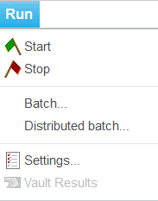Use the Batch menu options to:

* + - Create a new batch file.
    - Change the directory where the batch file is stored.
    - Append selected studies to an existing batch file.

Figure 1 – Batch Menu Options

*Understanding the Batch Process*

For efficient use of computer resources and time, multiple analyses can be defined in Simulate, even from different models, and then processed in a batch run. Use the Batch menu options to:

* + Create a new batch file.
  + Change the directory where the batch file is stored.
  + Append selected studies to an existing batch file.

Simulate, by default, writes a batch file named mecbatch.bat in the working directory. This batch file is then started at the system level (for example, DOS-shell or C-shell). This has an additional advantage, in that the Simulate graphical user interface is not running, freeing up memory for the solver. Also, analyses are run sequentially, using one engine license at a time, making optimal use of RAM. Even if an analysis fails, the next is

started automatically.

In addition to running analyses directly using the Simulate interface, or running at a later time, a new enhancement in Simulate enables you to also run simulation analyses using the Creo Pro Distributed Batch application. This application enables you to perform a variety of batch operations, not only

on your local computer, but also on a number of network computers. Since Simulate analyses are executed independently of user interaction and are computationally intensive, they make great candidates for this type of application.

Some of the advantages of using the Creo Pro Distributed Batch application for Simulate jobs include: scheduling tasks to be run during off-peak hours, using the processing power of idle computers,

and processing tasks in the background. This functionality requires that you have Creo Distributed Batch installed and be licensed to use it. Also, Creo Distributed Services Manager must be installed to distribute tasks among network nodes.

**Module 9**

## Creating Mechanism Connections

## Creating Mechanism Bodies

A body is a single component or group of components that moves as a single body within a mechanism.

Mechanism Bodies:

* 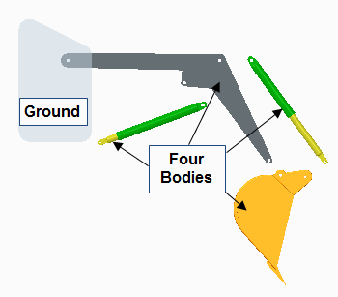A single part or sub-assembly that moves within the mechanism.
* A group of components that move as a single body within the mechanism.

Placement Constraints:

* User-Defined Constraints
* Mechanism Connection Sets Ground Bodies:
* Components within a

mechanism that do not move.

Figure 1 – Four Bodies and a Ground

#### Creating Mechanism Bodies

A body is a component or group of components placed in a mechanism using a predefined connection set. The component or group of components moves within the mechanism as a single body.

#### Mechanism Bodies

Creo Parametric automatically defines mechanism bodies based on the constraints used when positioning components in an assembly. For example, two parts that are assembled together using constraints (such as Coincident and Distance) and have no remaining degrees of freedom, are each grouped as a single body. If there is a degree of freedom remaining or the parts are assembled using predefined connection sets such as Pin, Slider, and so on, they are each identified as a unique body and they each move as such within the mechanism.

In Mechanism mode, you can expand each connection listed in the Mechanism Tree to view the identified bodies of the connection. If you select a body from the Mechanism Tree, the part or group of parts that make up that body are highlighted in the graphics area. If you right-click and select Info > Details, an information window opens and provides information regarding the contents of the selected body.

#### Placement Constraints

There are two types of constraints in the Component Placement dashboard. You can use standard user-defined constraints such as Coincident, Distance, and Angle Offset, or you can use predefined connection sets to define connections such as Pin and Slider. If you assemble two components using user- defined constraints, but they are only partially constrained, a connection is assumed.

When assembling components using predefined connection sets, you can only reference a single body in the assembly and a single body in the component being placed. When you select the first assembly entity for a predefined constraint set, you can select reference entities only from the same body for the remaining constraints of that connection. This is also true when selecting the component references.

#### Grounded Components

Ground bodies in a mechanism do not move with respect to the assembly. You can include several parts or sub-assemblies in the ground body. To define a ground body, you fully constrain a component with constraints that reference the default assembly datum or a part or assembly already in the ground. If you under constrain the component, it is not placed in the ground body and is considered a new body.

***Note:*** *Features belonging to a mechanism body, but with references to a grounded component, remain in position on the body as it is dragged. However, the feature position may change if the body is dragged to a new location and regenerated at that location.*

#### Understanding Constraints and Connection Sets

Constraints define the fixed position of a component while connections constrain the motion of a component.

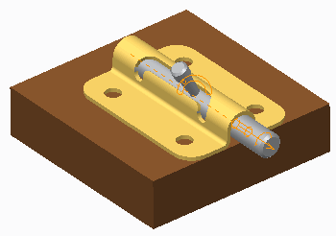User-Defined Constraints:

* Assemble components to form mechanism bodies.
* Are also called standard assembly constraints.
* Include constraints such as Coincide, Distance, and Angle Offset Predefined Connection Sets:
* Assemble components by constraining motion along axes, planes, and curves.
* Are also called mechanism connection sets.
* Include connections such as Pin, Cylinder, and Slider.

Figure 1 – Barrel Bolt Assembly

#### Understanding Constraints and Connection Sets

Constraints define the fixed position of a component while connection sets constrain the motion of a component.

#### User-Defined Constraints

To form bodies in mechanisms, you use standard constraints to assemble individual models.

These bodies act as a single unit and do not move in relation to one another.

In the barrel bolt assembly shown, the brown base, gold barrel, and four screws are assembled using user-defined constraints such as Coincident. These components do not move in relation to one another because they have been constrained so that all degrees of freedom (DOF) are removed. These components form the ground body of the mechanism.

User-defined constraints were also used to assemble the gray bolt and handle parts that slide in this mechanism. These two components form the second body of the mechanism.

***Note:*** *User-deflned constraints can also be referred to as standard assembly constraints.*

#### Predefined Connection Sets

Connection sets assemble components by constraining motion along certain axes, planes, and curves. Components assembled with connections are free to rotate and/or translate about one another. Pin, Cylinder, Slot, and Planar are examples of connection sets available in Creo Parametric.

Connection sets are important because they enable you to free certain DOF. Therefore,

connection sets are not rigid and enable you to impart realistic motion on your models. In the barrel bolt assembly shown, a Slot connection set is used to define the motion of the bolt and handle body as it moves through the mechanism.

***Note:*** *Predefined connection sets can also be referred to as mechanism connection sets.*

## Understanding Predefined Connection Sets

Predefined connection sets constrain the motion of a component while still permitting various degrees of freedom

|  |  |  |  |
| --- | --- | --- | --- |
| **Type** | **Total DOF** | **Rotation** | **Translation** |
| **Rigid** | 0 | 0 | 0 |
| **Pin** | 1 | 1 | 0 |
| **Slider** | 1 | 0 | 1 |
| **Cylinder** | 2 | 1 | 1 |
| **Planar** | 3 | 1 | 2 |
| **Ball** | 3 | 3 | 0 |
| **Weld** | 0 | 0 | 0 |
| **Bearing** | 4 | 3 | 1 |
| **General** | Varies | Varies | Varies |
| **6dof** | 6 | 3 | 3 |
| **Gimbal** | 5 | 0 | 0 |
| **Slot** | Varies | Varies | Varies |

## Understanding Predefined Connection Sets

There are several different types of predefined connection sets in Creo Parametric. The table displays each connection set type and the degrees of freedom in the set.

Before selecting a predefined connection set, you must understand how placement constraints and degrees of freedom are used to define movement. Then you can select the correct connections to define your mechanisms.

***Note:*** *The Total DOF column displays the connection's total number of degrees of freedom. The Rotation and Translation columns then break down the permitted motion of the mechanism in those terms.*

## Using Predefined Connection Sets

Select a predefined connection set from the Predefined Connection Set list in the Component Placement dashboard, within Assembly mode. Use the connection sets to position components and define movement in your assembly. Predefined connection sets serve three purposes:

* + 1. Define which placement constraints are used to place the component in the model.
    2. Restrict the motion of bodies relative to each other, reducing the total possible degrees of freedom (DOF) of the system.
    3. Define the kind of motion a component can have within the mechanism.

## Configuring Motion Axis Settings

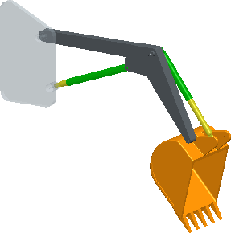Use motion axis settings to control the movement of component connections. Motion Axis Settings:

* + Regen Value
  + Zero Position
  + Minimum and Maximum Limits
  + Dynamic Properties

Figure 1 – Regenerated Position

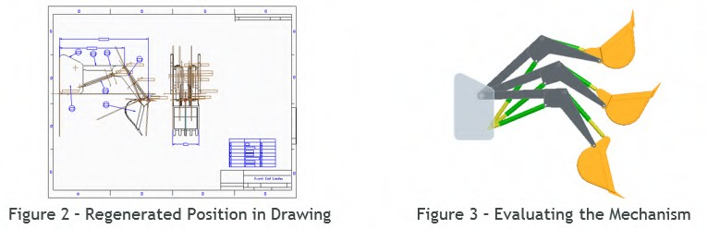

## Configuring Motion Axis Settings

Motion axis settings enable you to precisely control the displacement of connections in the direction of motion. Motion axis settings are important because they enable you to limit the range of motion and to define the regenerated configuration of the model. Motion axis settings enable you to control the motion of a model in each degree of freedom. For example, a connection with three degrees of freedom has three motion axes that can be defined.

You can configure motion axis settings to control the following values:

* + **Regen Value** – The motion axis regeneration value determines the position of the component in the assembly when the model is regenerated. The regeneration value of a motion axis is a dimension that can be used in family tables, relations, and wherever dimensions are used. This value is ignored during dragging and analysis operations.
  + **Zero Position** – Sets the dimension controlling the motion of the connection to be zero, at the component’s current position.
  + **Minimum and Maximum Limits** – Limits the minimum and maximum values that can be used to define the motion of a connection. The component cannot move outside of these limits either by dragging or by editing the dimension values.
  + **Dynamic Properties** – The Dynamic Properties functionality can be used to set friction and restitution parameters.

Motion axis settings can be set when placing or editing the placement of a component. Within Mechanism mode, the motion axis of a connection can be selected in the mechanism tree or graphics window and its definition can be edited in the Motion Axis dialog box.

***Note:*** *Both the Zero Position and Dynamic Properties functionality require the Mechanism Dynamics Option (MDO). The buttons to access these tools are not visible if you do not have a license for MDO.*

## The Regen Value

The Regen Value parameter is important for defining the final design position of each mechanism assembly. This final design position is the position in which your mechanism is documented and is often assembled to other components.

For example, if you dragged the position of a component in the assembly to a new location and then saved the model, that new position is propagated to every drawing and assembly in which the mechanism is used. However, you typically do not want your drawing to change every time the mechanism is evaluated. The Regen Value parameter can be used to ensure that this does not happen; each time your mechanism is regenerated; it returns to the defined regen values assigned to its connections.

***Tip:*** *The Regen Value can also be used as flexible dimensions when adding flexibility to a component. This means a regen value can be set to define the position of the mechanism in a drawing and also be made flexible when defining varying assembly positions.*

## Using Rigid Connection Sets

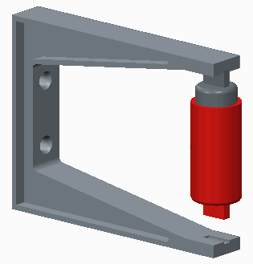Use the Rigid connection set to fully constrain a component so that it has no movement in the mechanism.

Rigid:

* + Standard Constraint Types
  + Motion Eliminated

## Using Rigid Connection Sets

Figure 1 – Motion Eliminated by a Rigid Connection

Rigid connection sets are used to connect two components so they do not move relative to one another. Components connected in such a way become a single body.

Similar to the User-Defined assembly constraint set, a Rigid connection set uses any valid combination of standard assembly constraints such as Coincident, Distance, and Angle Offset to constrain the position of a component. Rigid connections enable you to group any valid set of assembly constraints into the connection set. These constraints can be a fully constrained set or a partially constrained subset.

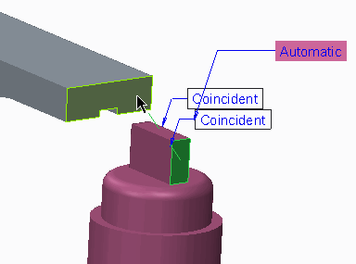

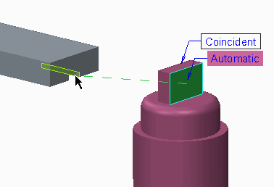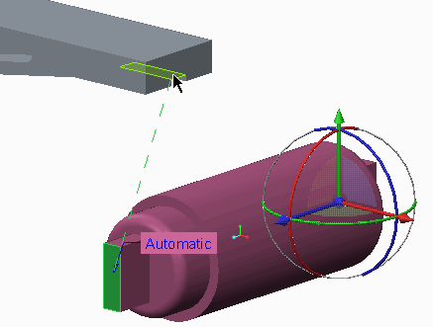

## Motion Eliminated

You cannot use a rigid connection set to connect multiple bodies of a sub-assembly and still maintain motion in that sub-assembly. When using a rigid connection to assemble a sub-assembly with Mechanism Design connections to a master assembly, the sub-assembly is considered as a ground body and loses its internal motion.

***Note:*** *In the assembly shown, if the piston sub-assembly is constrained using a Rigid connection set at each end of the piston sub-assembly (referencing both components of the sub-assembly), the motion in the sub- assembly is lost. A Weld connection set should be used in situations where multiple components need to be constrained but motion must be retained.*

## PROCEDURE - Using Rigid Connection Sets

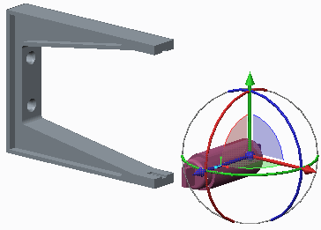**Task 1:** Assemble the piston sub-assembly using the Rigid connection set.

|  |
| --- |
| 1. Disable all Datum Display types. 2. In the ribbon, click Assemble  from the Component group. 3. In the Open dialog box, select RIGID_PISTON. ASM, then click Open. |
| 1. In the Component Placement dashboard, select Rigid  from the User Defined drop-down menu. 2. Select the near surface of PISTON2.PRT and the bottom surface of the slot in RIGID_BRACKET.PRT. 3. In the dashboard, select Coincident as the Constraint Type. |
| 1. Select the near planar surface of PISTON2.PRT and the far surface of the slot in RIGID_BRACKET.PRT. 2. In the dashboard, select Coincident as the Constraint Type. |
| 1. Select the near planar surface of PISTON2.PRT and the near surface of RIGID_BRACKET.PRT. 2. In the dashboard, select Coincident as the Constraint Type, if necessary. 3. Click Complete Component from the Component Placement dashboard. |

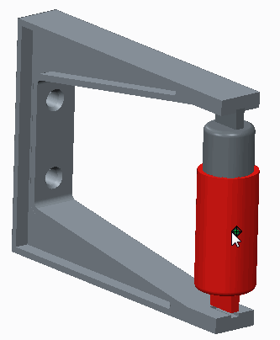**Task 2:** Rigidly constrain the bottom of the piston sub-assembly.

1. Click Drag Components  from the Component group, and select the red PISTON1.PRT part from the model tree.
2. Drag the part to observe that the sub-assembly has maintained its motion.
3. 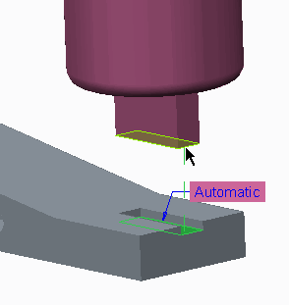Middle-click to abort the dragging, and click Close in the Drag dialog box.

|  |
| --- |
| 1. In the model tree, click RIGID_PISTON.ASM and select Edit Definition  from the mini toolbar. 2. In the Component Placement dashboard, click Placement tab and select New Set. 3. Select the bottom surface of PISTON1.PRT and the surface at the bottom of the slot in RIGID_BRACKET.PRT. 4. In the dashboard, select Coincident as the Constraint Type. |
| ***Note:*** *Notice the “Constraints Invalid” message in the dashboard. Adding a rigid connection to a second component of the sub-assembly has eliminated the motion of the sub-assembly so these surfaces cannot be coincident. To assemble this sub-assembly and maintain its motion, the Weld connection set should be used.* |
| 8. Click Cancel Component from the dashboard and click Yes to confirm. This completes the procedure |

## Using Pin Connection Sets

Use the Pin connection set to assemble a component with only a rotational degree of freedom. Pin Connection Sets:

* + 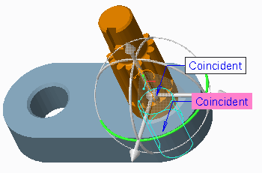Axis alignment – Constraint
  + Coincident – Constraint
  + Rotation Axis – Motion Axis

## Using Pin Connection Sets

Figure 1 – A Pin Connection

A Pin connection set is used to connect a component to a referenced axis, so that the component rotates or moves along this axis with one rotational degree of freedom. A Pin connection set contains two constraint settings and one rotation axis setting:

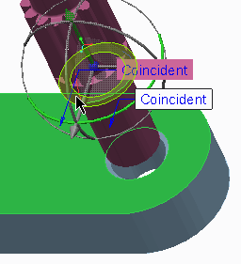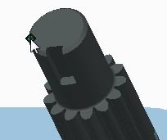

* + Axis alignment – This constraint defines the axis that the component is aligned to and rotates about. The reference can be a selected axis, edge, curve, or cylindrical surface.
  + Coincident – This defines the component's position along the alignment axis. The reference can be a selected datum point, vertex, datum plane, or planar surface.
  + Rotation Axis – This is the rotational motion axis element of the connection set. You use it to define rotational motion settings for the connection such as the zero position, regenerated position, minimum limits, and maximum limits.

## PROCEDURE - Using Pin Connection Sets

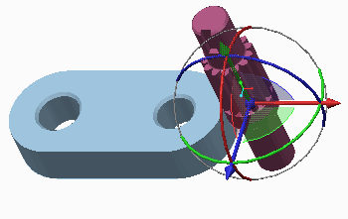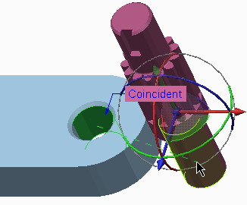**Task 1:** Assemble the gear component using the Pin connection set

|  |
| --- |
| 1. Disable all Datum Display types. 2. In the ribbon, click **Assemble**  from the Component group. 3. In the Open dialog box, select PIN_GEAR.PRT, and then click **Open**. |
| 1. In the Component Placement dashboard, select **Pin**   from the User Defined drop-down menu.   1. Select the cylindrical surface of PIN_BASE.PRT and the cylindrical surface of PIN_GEAR.PRT as references for the Axis alignment constraint. |
| 1. Select the top surface of PIN_BASE.PRT and query select the surface on the lower lip of PIN_GEAR.PRT as references for the Translation constraint. 2. Click **Complete Component** from the Component Placement dashboard. |
| 1. Click **Drag Components**  from the Component tab and select PIN_GEAR.PRT. 2. Drag the part through its remaining degree of freedom, the rotational degree of freedom. 3. Middle-click in the graphics area to release the model. 4. Click **Close** in the Drag dialog box. |
| ***Note:*** *If you drag a component to a new position, that position will be reflected in referencing assemblies and drawings. Define a fixed design position by setting a regeneration value for the model.* |

**Task 2:** Set a regeneration value for the rotational degree of freedom

1. 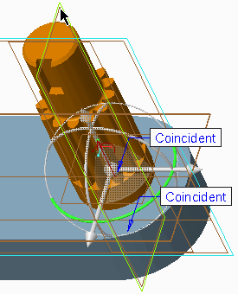Edit the definition of PIN_GEAR.PRT.
2. Enable **Plane Display **.
3. In the dashboard, select the **Placement** Tab. Complete the following:
   * Click **Rotation Axis**.
   * In the graphics area, select ASM_FRONT.
   * In the graphics area, select datum plane RIGHT from PIN_GEAR.PRT.
   * In the Placement tab, edit the value of the Current Position to **90**, if necessary, and press ENTER.
   * Click **Set** to set the Regen Value of the Rotation Axis.
   * Select the **Enable regeneration value**

check box.

1. Click **Complete Component** from the Component Placement dashboard.
2. Disable **Plane Display **.
3. Click **Drag Components ** from the Component group and select PIN_GEAR.PRT.
4. 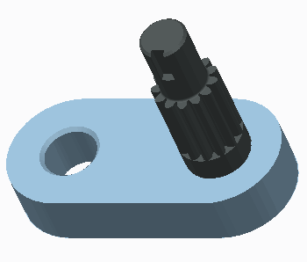Drag the part to a new position.
5. Click in the graphics area to release the model.
6. Click **Close** in the Drag dialog box.
7. Click **Regenerate ** from the Quick Access toolbar.

***Note:*** *Notice that the model has returned to the regeneration position you defined in the previous steps.*

This completes the procedure.

## Using Slider Connection Sets

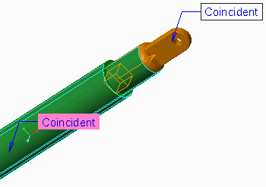Use the Slider connection set to assemble a component with only a translational degree of freedom. Slider Connection Sets:

* Axis alignment – Constraint
* Coincident – Constraint
* Translation Axis – Motion Axis

Figure 1 – A Slider Connection

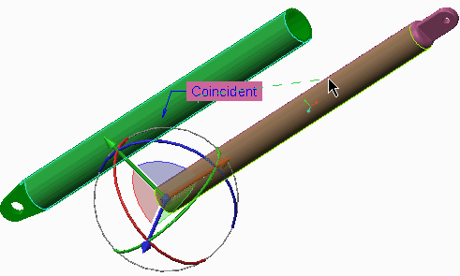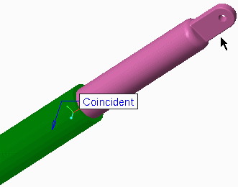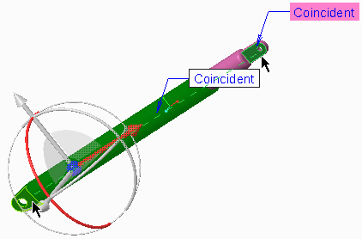

## Using Slider Connection Sets

A Slider connection set is used to connect a component to a referenced axis, so that the component slides or moves normal to this axis with one translational degree of freedom.

A Slider connection set contains two constraint settings and one translation axis setting:

* Axis alignment – This constraint defines the axis that the component slides along. The reference can be a selected axis, edge, curve, or cylindrical surface.
* Coincident – This constraint restricts the components rotation along the axis of alignment. The reference can be a selected datum plane or other planar surface.
* Translation Axis – This is the translational motion axis element of the connection set. You use it to define translational motion settings for the connection such as the zero position, regenerated position, minimum limits, and maximum limits.

## PROCEDURE - Using Slider Connection Sets

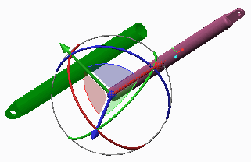**Task 1:** Assemble the piston components using the Slider connection set.

|  |
| --- |
| 1. Disable all Datum Display types. 2. In the ribbon, click **Assemble**  from the Component group. 3. In the Open dialog box, select SLIDER2.PRT, and then click **Open**. |
| 1. In the Component Placement dashboard, select **Slider**  from the User Defined drop- down menu. 2. Select the cylindrical surface of SLIDER1.PRT and the cylindrical surface of SLIDER2.PRT as references for the Axis alignment constraint. |
| 1. In the dashboard, select the **Placement** tab. Notice that the Axis alignment constraint has been defined and the Rotation constraint is now active. 2. Press CTRL+ALT and middle-click to drag the component in this yet to be defined, rotational degree of freedom (DOF). |
| 1. Select the planar surfaces shown on SLIDER1.PRT and SLIDER2.PRT as references for the Rotation constraint. 2. Press CTRL+ALT and middle-click to drag the component again.   Notice that this is no longer possible since the rotational DOF has been constrained. |

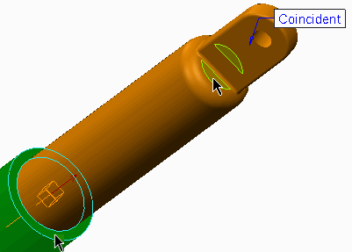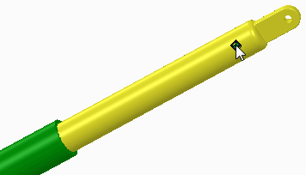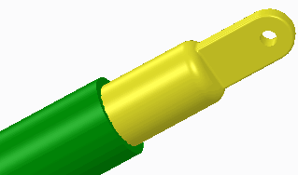

|  |
| --- |
| 1. Press CTRL+ALT and click to drag the component again.   Notice that this enables you to drag the component in the direction of its motion axis.   1. In the Placement tab, select Translation Axis. 2. Spin the model as required and select the planar surfaces shown on SLIDER1.PRT and SLIDER2.PRT. |
| 1. Configure the motion axis settings:    * Edit the value of the Current Position to 80 and press ENTER.    * Click Set to set the Regen Value of the Translation Axis.    * Select the Enable regeneration value check box.    * Select the Minimum Limit check box, edit the value to 80, and press ENTER.    * Select the Maximum Limit check box, edit the value to 425, and press ENTER. 2. Click Complete Component from the Component Placement tab. |
| 1. Click Drag Components  from the Component group and select SLIDER2.PRT. 2. Drag the part through its motion.   Note: Notice that the model cannot be dragged past the minimum and maximum translation limits you deflned in the Translation Axis. |
| 1. Click in the graphics area to release the model. 2. Click Close in the Drag dialog box. 3. Click Regenerate  from the Quick Access toolbar. |
| Note: Notice that the model has returned to the regeneration position you deflned in the Translation Axis.  This completes the procedure.  **Using Cylinder Connection Sets**  Use the Cylinder connection set to assemble a component with rotational and transitional degrees of freedom.  Cylinder Connection Sets:   * Axis alignment – Constraint * Translation Axis – Motion Axis * Rotation Axis – Motion Axis |

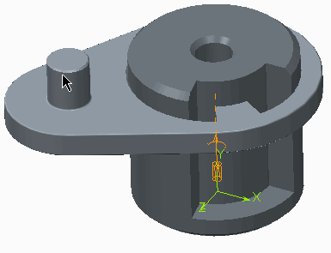Figure 1 – A Cylinder Connection

1

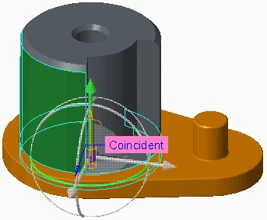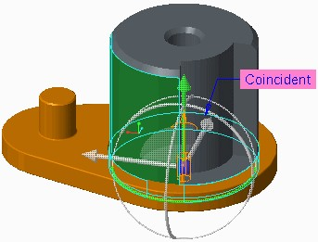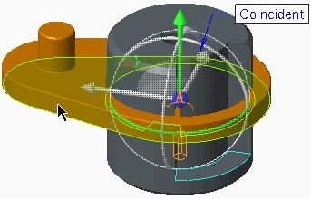

## Using Cylinder Connection Sets

A Cylinder connection set is used to connect a component to a referenced axis, so the component moves along and rotates about the axis of alignment with two degrees of freedom.

Creating Cylinder Connection Sets

A Cylinder connection set contains one constraint and two motion axis settings.

* Axis alignment – This constraint defines the axis along which the component slides. The reference can be a selected axis, edge, curve, or cylindrical surface.
* Translation Axis – This is the translational motion axis element of the connection set. You use it to define translational motion settings for the connection such as the zero position, regenerated position, minimum limits, and maximum limits.
* Rotation Axis – This is the rotational motion axis element of the connection set. You use it to define rotational motion settings for the connection such as the zero position, regenerated position, minimum limits, and maximum limits.

## PROCEDURE - Using Cylinder Connection Sets

**Task 1:** Assemble the component using the Cylinder connection set.

1. 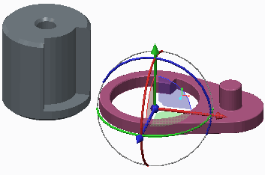Disable all Datum Display types.
2. In the ribbon, click **Assemble ** from the Component group.
3. In the Open dialog box, select CYLINDER2.PRT, and then click **Open**.
4. In the Component Placement dashboard, select **Cylinder ** from the User Defined drop-down menu.
5. In the Component Placement dashboard, select the **Placement** tab.

***Note:*** *The Axis alignment constraint is active, and neither the Translation Axis nor the Rotation Axis selections are visible.*

###### Select the cylindrical surface of CYLINDER1.PRT and the cylindrical surface of CYLINDER2.PRT as references for the Axis alignment constraint.

1. ***If necessary, click Flip in the Placement tab to orient the small boss, as shown.***

###### Press CTRL+ALT and middle-click to rotate the component approximately to the position shown.

1. ***Select Translation Axis.***

###### Select the planar surfaces shown on CYLINDER1.PRT and CYLINDER2.PRT as references for the Translation Axis motion.

1. ***Edit the value of the Current Position to 0 and press ENTER.***

###### Select the Enable regeneration value check box.

1. ***Select the Minimum Limit check box, edit the value to 0, and press ENTER.***

###### Select the Maximum Limit check box, edit the value to 130, and press ENTER.

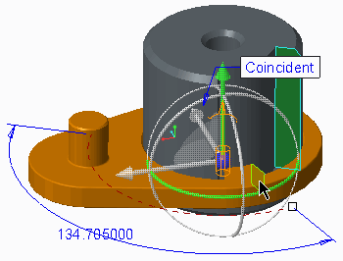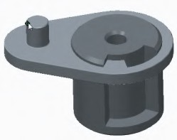

1. ***Select Rotation Axis.***

###### Select the planar surfaces shown on CYLINDER1.PRT and CYLINDER2.PRT as references for the Rotation Axis motion.

1. ***Edit the value of the Current Position to 180 and press ENTER.***

###### Click Set to set the Regen Value of the Translation Axis.

1. ***Select the Enable regeneration value check box.***

###### Select the Minimum Limit check box, edit the value to 130, and press ENTER.

1. ***Select the Maximum Limit check box, if necessary edit the value to 180, and press ENTER.***

###### Click Complete Component from the Component Placement tab.

1. Click Drag Components  from the Component group and select CYLINDER2.PRT.
2. Drag the part through its motion.

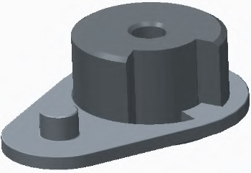Note: Notice that you cannot drag the component beyond the minimum and maximum limits.

1. Click in the graphics area to release the model.
2. Click Close in the Drag dialog box.
3. Click Regenerate  from the Quick Access toolbar.

Note: Notice that the model has returned to the regeneration position you deflned in the Motion Axes.

This completes the procedure.

## Using Planar Connection Sets

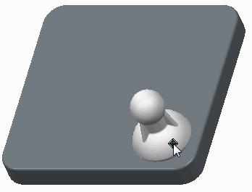Use the Planar connection set to assemble a component with rotational and transitional degrees of freedom.

Planar Connection Sets:

* + Planar – Constraint
  + Translation Axis 1 – Motion Axis
  + Translation Axis 2 – Motion Axis
  + Rotation Axis – Motion Axis

## Using Planar Connection Sets

Figure 1 – A Planar Connection

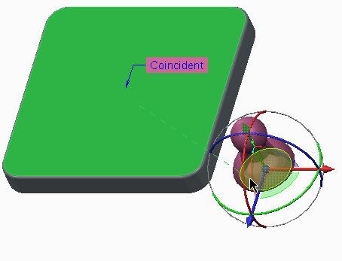A Planar connection set is used to connect a component to a referenced planar surface that the component moves along that plane, with three degrees of freedom.

A Planar connection set contains one constraint and three motion axis settings. There are two degrees of freedom in the referenced plane and one degree of freedom around an axis perpendicular to it.

* + Planar – This constraint defines the parallel plane that the component moves along. The constraint is a single planar mate or align constraint that can be flipped or offset as required. The reference can be a selected planar surface or datum plane.
  + Translation Axis 1 – This is the first translational motion axis element of the connection set. You use it to define translational motion settings for the connection such as the zero position, regenerated position, minimum limits, and maximum limits.
  + Translation Axis 2 – This is the second translational motion axis element of the connection set. You use it to define translational motion settings for the connection such as the zero position, regenerated position, minimum limits, and maximum limits.
  + Rotation Axis – This is the rotational motion axis element of the connection set. You use it to define rotational motion settings for the connection such as the zero position, regenerated position, minimum limits, and maximum limits.

## PROCEDURE - Using Planar Connection Sets

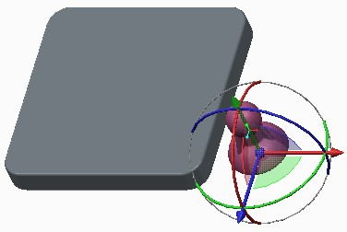**Task 1:** Assemble the component using the Planar connection set

|  |
| --- |
| 1. Disable all Datum Display types. 2. In the ribbon, click **Assemble**  from the Component group. 3. In the Open dialog box, select PLANAR2.PRT, then click **Open**. |
| 1. In the Component Placement dashboard, select **Planar**  from the User Defined drop- down menu. 2. Select the planar surface at the top of PLANAR1.PRT and the bottom of PLANAR2.PRT as references for the Planar constraint. |
| 1. Enable **Plane Display** and **Point Display** . 2. In the dashboard, select the **Placement** tab. |

1. 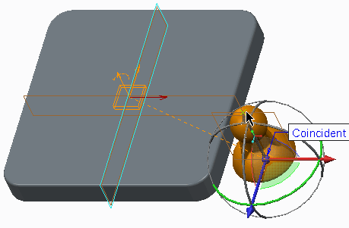Select **Translation Axis 1**.
2. In the graphics area, select datum plane RIGHT and datum point CONNECT_REF.
3. Edit the value of the Current Position to **0**

and press ENTER.

1. Select the **Enable regeneration value** check box.
2. Select the **Minimum Limit** check box, edit the value to **-28**, and press ENTER.
3. 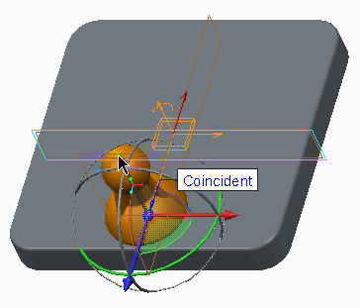Select the **Maximum Limit** check box, edit the value to **28**, and press ENTER.
4. Select Translation Axis 2.
5. In the graphics area, select datum plane FRONT and datum point CONNECT_REF.
6. Edit the value of the Current Position to 0 and press ENTER.
7. Select the Enable regeneration value check box.
8. Select the Minimum Limit check box, edit the value to –28, and press ENTER.
9. 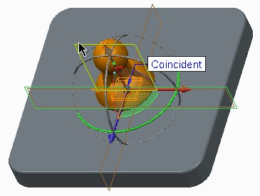Select the Maximum Limit check box, edit the value to 28, and press ENTER.
10. Select Rotation Axis.
11. In the graphics window, select the datum plane FRONT from both models.
12. If necessary, edit the value of the Current Position to 0 and press ENTER.
13. 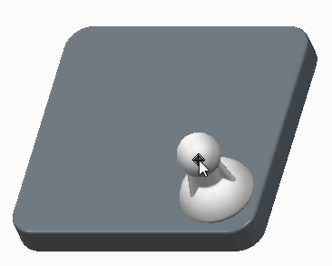Select the Enable regeneration value check box.
14. Click Complete Component

from the Component Placement tab.

1. Disable Plane Display  and Point Display .
2. Click Drag Components  from the Component group, then select PLANAR2.PRT and drag it through its motion.

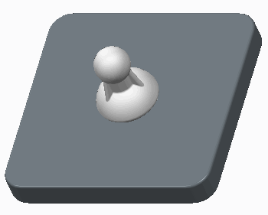Note: You can drag the component in all three DOF but you cannot drag the component beyond the minimum and maximum limits you have defined.

1. Click in the graphics window to release the model.
2. Click Close in the Drag dialog box.
3. Click Regenerate  from the Quick Access toolbar.

This completes the procedure.

## Using Ball Connection Sets

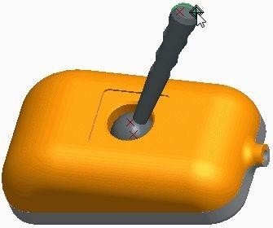Use the Ball connection set to assemble a component with three rotational degrees of freedom. Ball Connection Sets:

* + Point alignment – Constraint
  + No Motion Axis
  + Cone Axis (Optional)

## Using Ball Connection Sets

Figure 1 – A Ball Connection

A Ball connection set connects a component at a point so it can rotate in any direction with three degrees of freedom.

A Ball connection set contains one Point alignment constraint, three degrees of freedom, but no motion axis settings.

* + Point alignment – This constraint defines the point that the component rotates about. The constraint is a single point-to-point alignment. Select a datum point or vertex as the alignment references.
  + Cone Axis (Optional) – This optional constraint defines a limit to the motion of the ball connection. Select two datum point references to define the cone axis. Then specify the Cone Opening Angle to define the cone radius. The ball connection motion is restricted to the inside of the resulting cone. You can also specify an angle for the current position of the component for which the Ball connection is defined.

***Note:*** *In situations where you need to connect a true ball or sphere (rather than a point or vertex), create a datum point at the center of the sphere using the sphere as reference and the at Center*

## PROCEDURE - Using Ball Connection Sets

**Task 1:** Assemble the component using the Ball connection set

1. 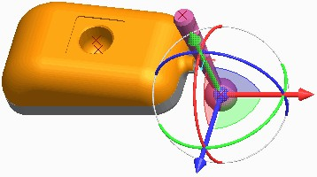Enable only the following Datum Display types: .
2. In the ribbon, click **Assemble ** from the Component group.
3. In the Open dialog box, select PIVOT_ARM.PRT, and then click **Open**.

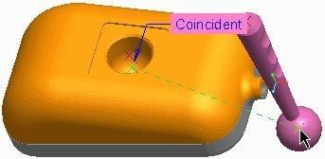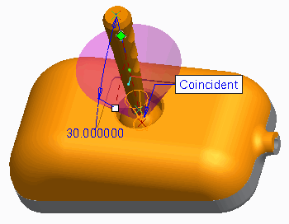

|  |
| --- |
| 1. In the Component Placement dashboard, select **Ball**  from the User Defined drop- down menu. 2. If necessary, click **3D Dragger**  from the Component Placement dashboard to hide the 3D Dragger. 3. In the graphics window, select the two datum points as shown. |
| 7. In the dashboard, select the **Placement** tab. |
| Note: Notice that there are no motion axes to define for the Ball connection set. |
| 1. Click Cone. 2. Click in the first field and then select PNT0:F10(Datum Point) as the component zero reference point from the pivot arm. 3. Click in the second field and then select APNT1:F9 (Datum Point) as the assembly zero reference point from the model. |
| 1. Ensure the value of Current Position field is set to 0.0. 2. Type 30.0 in the Cone Opening Angle field and press ENTER. 3. Click Complete Component . |
| 1. Click Drag Components  from the Component group, select PIVOT_ARM.PRT, and drag it through its three Degrees of Freedom. 2. Click in the graphics window to release the model. 3. Click Regenerate  from the Quick Access toolbar. |

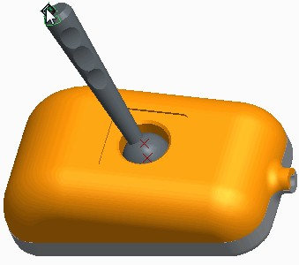***Note:*** *Because there is no motion axis control, the model remains in the position it was placed, even after regeneration.*

This completes the procedure.

## Using Weld Connection Sets

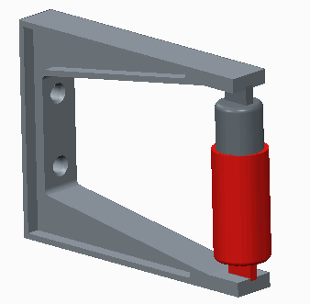Use Weld connections to rigidly constrain a sub-assembly, yet maintain open degrees of freedom in the sub-assembly.

Weld:

* + Coordinate System to Coordinate System
  + Fully Constrained
  + Maintains Movement

Figure 1 – Weld Connections

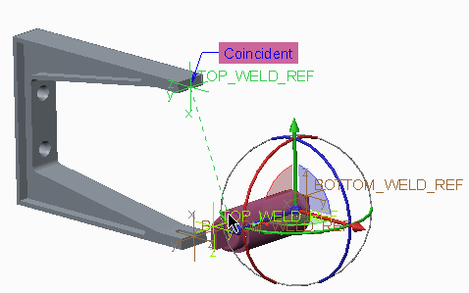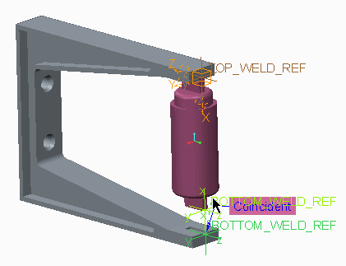

## Using Weld Connection Sets

As with the Rigid connections set, the Weld connection set is used to connect two components so they do not move relative to one another. Components connected in such a way become a single body.

Unlike the Rigid connection set, the Weld connection enables sub-assemblies to be rigidly constrained, yet it also enables for open degrees of freedom in the sub-assembly to be maintained.

***Note:*** *In the assembly shown, both ends of the piston sub-assembly are connected with a weld connection. This enables the piston sub-assembly to maintain its defined motion, so it can compress and expand as the bracket is flexed. This is not possible when using the rigid connection set.*

## Creating a Weld Connection

You create a weld connection by aligning coordinate systems, just as you do using the standard **Coord Sys ** constraint.

***Note:*** *In most cases, prior to the assembly operation, you have to create coordinate systems that properly position the components. You need to create one coordinate system for the component reference and one for the assembly reference.*

## PROCEDURE - Using Weld Connection Sets

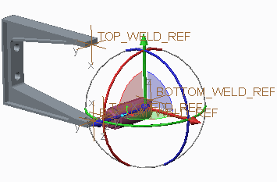**Task 1:** Assemble the piston sub-assembly using the Weld connection set.

|  |
| --- |
| 1. Enable only the following Datum Display types: . 2. In the ribbon, click **Assemble**  from the Component group. 3. In the Open dialog box, select WELD_PISTON. ASM, and then click **Open**. |
| 1. In the Component Placement dashboard, select **Weld**  from the User Defined drop-down menu. 2. Select the coordinate system   `TOP_WELD_REF from both models. |
| 1. In the Component Placement dashboard, select the **Placement** tab and then click **New Set**. 2. Select the coordinate system BOTTOM_WELD_ REF from both models. 3. Click **Complete Component**   from the Component Placement tab. |

***Note:*** *The motion defined in the piston sub-assembly enables it to expand and span the length of the bracket.*

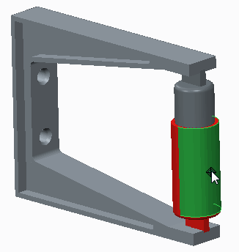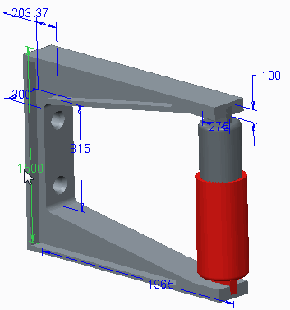**Task 2:** Verify the connections.

|  |
| --- |
| 1. Disable **Csys Display** . 2. Click **Drag Components**  from the Component group, and then select the WELD_PISTON.ASM. Move it to verify the connection. 3. Observe that there is no movement because each end of the piston is fixed with a weld connection set. 4. Click **Close** in the Drag dialog box. |
| 1. Click **Settings** from the model tree and select   **Tree Filters** .   1. In the Model Tree Items dialog box, select the   **Features** check box under Display and click **OK**.   1. In the model tree, click to expand WELD_BRACKET.PRT. 2. Select **Extrude 1** and edit the dimension 1500 to **1600**. 3. Click **Regenerate**  from the Quick Access toolbar. |
| ***Note:*** *The motion deflned in the piston sub-assembly enables it toexpand as the bracket changes.* |
| 1. In the model tree, click to expand WELD_BRACKET.PRT, if necessary. 2. Select **Extrude 1** and edit the dimension 1600 to **1300** and press ENTER. 3. Click **Regenerate**  from the Quick Access toolbar. |
| ***Note:*** *The motion deflned in the piston sub-assembly enables it to compress as the bracket changes.* |

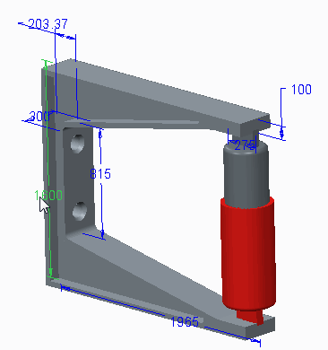This completes the procedure.

## Using Bearing Connection Sets

Use the Bearing connection set to assemble a component with four degrees of freedom.

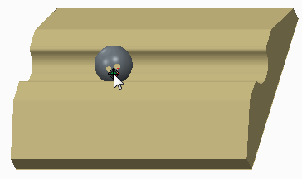Bearing Connection Sets:

* + Point alignment – Point on Line Constraint
  + Translation Axis – Motion Axis

## Using Bearing Connection Sets

Figure 1 – A Bearing Connection

A Bearing connection set is a combination of both Ball and Slider connections with four degrees of freedom. It is used to connect a point to a referenced axis, so that the component moves along the axis with one translational degree of freedom and three rotational degrees of freedom.

A Bearing connection set contains one constraint and one translation axis setting.

* + Point alignment – This constraint defines the connection between a point and an axis that the component is aligned to and rotates about. The point reference can be a datum point or vertex. The second reference can be an edge, axis, or curve.
  + Translation Axis – This defines the component's position along the alignment axis. The reference can be a selected datum point, vertex, datum plane, or planar surface.

***Note:*** *There are no axis settings for the three rotational degrees of freedom*

## PROCEDURE - Using Bearing Connection Sets

**Task 1:** Assemble the component using the Bearing connection set.

1. 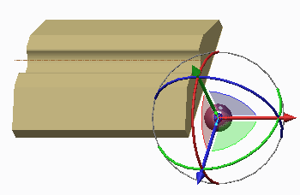Enable only the following Datum Display types:

.

1. In the ribbon, click **Assemble ** from the Component group.
2. In the Open dialog box, select BEARING2.PRT, and then click **Open**.

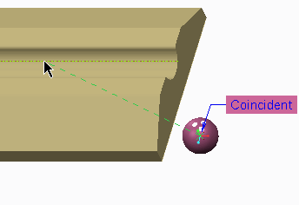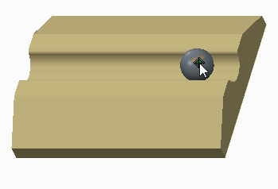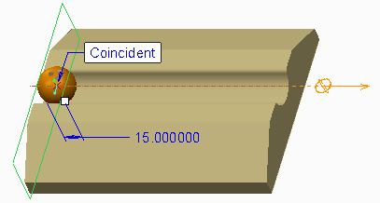

|  |
| --- |
| 1. In the Component Placement dashboard, select **Bearing**  from the User Defined drop-down menu. 2. If necessary, click **3D Dragger**  from the Component Placement dashboard to hide the 3D Dragger. 3. Select the datum point CENTER and axis A_1 in the graphics. 4. Disable **Axis Display**  and **Point Display** . |
| 1. In the Component Placement dashboard, select the Placement tab and do the following:    * Click Translation1 .    * Click the Placement tab to close it.    * Click Settings  from the model tree and select Tree Filters .    * In the Model Tree Items dialog box, select the Features check box under Display and click OK.    * In the model tree, select ASM_RIGHT.    * In the dashboard, select the Placement tab to reopen it.    * Edit the value of the Current Position to 15 and press ENTER.    * Click Set to set the Regen Value of the Translation Axis.    * Select the Enable regeneration value check box. |
| 1. Select the Minimum Limit check box, edit the value to 15, and press ENTER. 2. Select the Maximum Limit check box, edit the value to 185, and press ENTER. |
| 11. Click Complete Component from the Component Placement tab. |
| 1. Click Drag Components  from the Component group and select BEARING2.PRT. 2. Drag the part through its degrees of freedom (DOF). 3. Click in the graphics window to release the model. 4. Click Close in the Drag dialog box. |
| Note: It seems to be more difficult to control the movement of a component that contains three DOF when dragging. Because of the translation axis controls, the component does not move past the ends of the model. |

1. 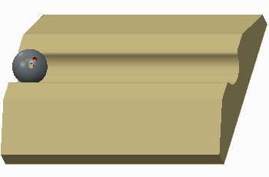Click Regenerate  from the Quick Access toolbar.

Note: The model returns to the Regen value defined in the translation axis. There is no axis control for the rotational DOF so the model remains at the rotation it was dragged to.

This completes the procedure.

## Using General Connection Sets

Use the General connection set to create any number of degrees of freedom in your model. General Connection Sets:

* + One or two constraints.
  + Varying translation and rotational Axis Settings.
  + Number and type of Axis Settings dependent on number and type of constraints.

## Using General Connection Sets

Figure 1 – A General Connection

When specific predefined connection sets do not adequately define your mechanism, use the General connection set to create any desired number of degrees of freedom when connecting your model.

After you determine the number of degrees of freedom, you can create the required type of general connection by selecting one or two placement constraints in the Placement dashboard.

After defining the placement constraint or constraints, you are presented with a number of axis settings. The type and number of axis settings varies, depending on the number and type of constraints that were used to constrain your model.

Most of the Creo Parametric constraints and relevant references are enabled for your selection when you define the general connection. However, the following constraint typescannot be used to define a General connection:

* + A point on a non-linear curve or a non-planar surface.
  + A Tangency constraint.

## Using Slot Connection Sets

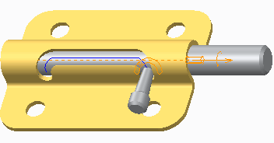Use the Slot connection set to make a point on a component connect to and follow a 2-D or 3-D trajectory. Slot Connection Sets:

* + Point Alignment – Point on Line Constraint
  + Slot Axis – Motion Axis

Figure 1 – A 3-D Slot Connection

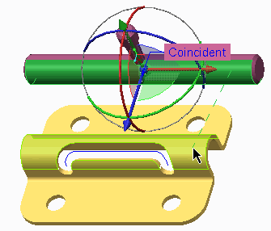

## Using Slot Connection Sets

A Slot connection has four degrees of freedom. As the reference point follows the trajectory, it is free to rotate in the X, Y, and Z directions. Start and endpoints of the trajectory can be configured using the slot axis settings.

Use the Slotconnection whenyou want to make apointconnect to and follow a 2-D or 3-D trajectory.

A Slot connection set contains one constraint setting and one slot axis setting.

* + Point Alignment – This constraint defines the connection between a point and the trajectory that the point follows. The point reference can be a datum point or vertex. The trajectory reference can be an edge or curve. To select multiple segments, press CTRL when selecting.
  + Slot Axis – This defines the start and endpoints of the trajectory. The reference can be a selected datum point or vertex.

***Note:*** *In the assembly shown, a Cylinder connection is also used so that the barrel of the mechanism stays on track as the sub-assembly moves along the slot.*

## PROCEDURE - Using Slot Connection Sets

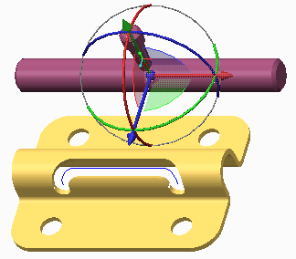**Task 1:** Assemble the component using the Slot connection set.

|  |
| --- |
| 1. Enable only the following Datum Display types:   .   1. In the ribbon, click **Assemble**  from the Component group. 2. In the Open dialog box, select SLOT_BARREL. ASM, and then click **Open**. |
| 1. In the Component Placement dashboard, select **Cylinder**  from the User Defined drop-down menu. 2. Select the cylindrical surface of SLOT_BARREL. PRT and SLOT_BASE.PRT. |
| 1. In the Component Placement dashboard, select the **Placement** tab and click **New Set**. 2. In the dashboard, select **Slot** from the **Cylinder**  drop-down menu. |

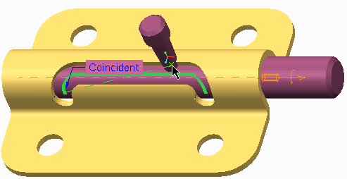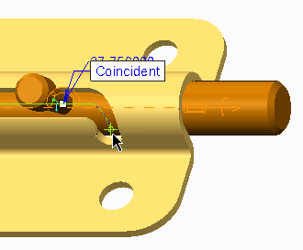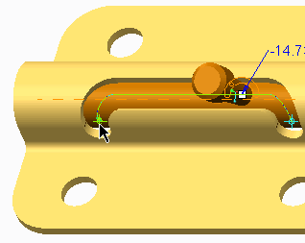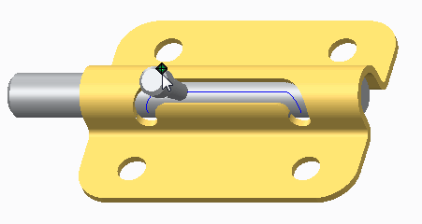

|  |
| --- |
| 1. If necessary, click **3D Dragger**  from the Component Placement dashboard to hide the 3D Dragger. 2. Press CTRL and select five segments of the trajectory curve shown. (There are two small segments at each end.) 3. Select the datum point **SLOT**. |
| 1. On the Placement tab, click **Slot**. 2. Select the far right endpoint of the trajectory curve; this is the zero location.   ***Note:*** *The model may temporarily shift out of position. This will be corrected when the connection is completed.* |
| 1. Select the Enable regeneration value check box. 2. Select the Minimum Limit check box and select the far right endpoint of the trajectory curve; this is the zero location. 3. Select the Maximum Limit check box and select the far left endpoint of the trajectory curve. 4. Click Complete Component   on the Component Placement tab. |
| 1. Click Point Display  to disable their display. 2. Click Drag Components  from the Component group and select SLOT_BARREL.ASM. |
| 19. Drag the part through its degrees of freedom. |
| 1. Click in the graphics window to release the model. 2. Click Close in the Drag dialog box. 3. Click Regenerate  from the Quick Access toolbar. |
| Note: The model returns to the Regen value defined as the far right endpoint of the trajectory. |

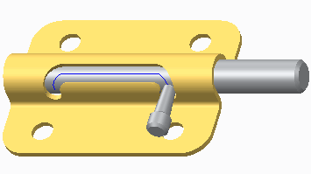This completes the procedure

## Creating Cam-Follower Connections

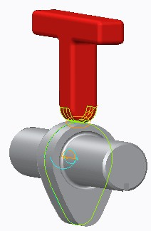Use Cam-Follower connections to create cam and follower motions in a 2-D plane.

Cam-Follower Connections:

* + Cam-Follower Connection Definition dialog box
  + Cam1 and Cam2 Definition
  + Cam-Follower Properties

## Using Cam-Follower Connections

Figure 1 – A Cam-Follower Connection

Unlike most connections in Creo Parametric, the Cam-Follower connection is not found in the assembly dashboard. The Cam-Follower connection tool is only available in Mechanism mode and is started by clicking **Cams ** from the Connections group in the ribbon. The connection is then applied to a component that has been previously placed in the assembly and is meant to define the remaining degree of freedom.

While Cam-Follower connections are applied to 3-D models, the connection is treated as a two- dimensional connection when performing an analysis.

## Creating Cam-Follower Connections

In the Cam-Follower Connection Definition dialog box, the following connection elements are defined:

* + In the Cam1 and Cam2 tabs, select the extruded surface or 2-D curve that defines the profile of the cam. When you select cam surfaces, the surface normal direction is indicated in the graphics window by a magenta arrow. This is the cam side to be used for cam contact.
    - Autoselect – If you select the Autoselect check box, surfaces for your cam are automatically chosen after you select the first surface. If there is more than one possible adjacent surface, you are prompted to select a second surface.
    - Flip – To reverse the direction of the surface normal for the cam, click Flip. If the selected surfaces are on a volume, the default normal direction is out, and the Flip button is inactive.
    - Working plane – If you select a straight curve or edge, the dialog box expands, activating the Working plane collector. Use the selection arrow to select a point, vertex, planar solid surface, or datum plane to define a working plane for the cam.

***Note:*** *You can select a straight curve or edge for only one of thetwo cams.*

* + - Depth display settings – If you select a surface, you can use the following items to orient the cam on the surface:
      * Automatic (not available for a curve, edge, or flat planar surface)
      * Front & Back
      * Front, Back & Depth
      * Center & Depth

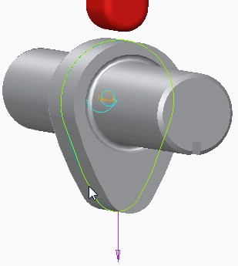

* + Properties – On the Properties tab, you can define the following:
    - Enable liftoff – If you want to enable your cam-follower connection to separate during a drag operation or analysis run, you must select the Enable liftoff check box.
    - Friction – If you have a Mechanism Dynamics Option license, you can define friction coefficients and a coefficient of restitution for cams with liftoff.

## Tips for Creating Cam-Follower Connections

Keep the following points in mind when defining and using cam-follower connections:

* Creo Parametric defines cams as extending infinitely in the extrusion direction.
* A cam-follower connection does not prevent the cam from tipping. When required, add additional constraints to prevent parts from tipping.
* Each cam can have only one follower. If you want to model a cam with multiple followers, you must define a new cam-follower connection for each new pair.
* Try to avoid a design with a connection along a straight line in the working plane.

## PROCEDURE - Creating Cam-Follower Connections

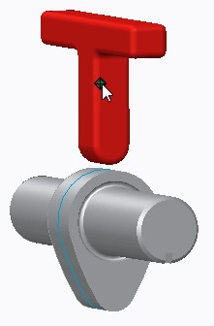**Task 1:** Use the Cam-Follower connection to constrain the model.

|  |
| --- |
| 1. Disable all Datum Display types. 2. Click **Drag Components**  from the Component group and select the red CAM_LEVER.PRT. 3. Drag the part to view the remaining degree of freedom that will be controlled by the Cam-Follower connection. 4. Click in the graphics window to release the model. 5. Click **Close** in the Drag dialog box. |
| 1. In the ribbon, select the **Applications** tab. 2. Click **Mechanism**  from the Motion group. |
| 1. Click **Cams**  from the Connections group. 2. Press CTRL and select the four curve segments that define Cam1, as shown. 3. Click **OK** in the Select dialog box when finished. |

|  |
| --- |
| 1. Select the **Cam2** tab. 2. Select the bottom, radial surface of CAM_LEVER.PRT that will connect to Cam1. 3. Click **OK** in the Select dialog box when finished. 4. Click **OK** to close the Cam-Follower Connection Definition dialog box. |
| 1. Click Drag Components  from the Motion group and select the gray CAM.PRT. 2. Drag the cam-follower connection through its motion. 3. Click in the graphics window to release the model. 4. Click Close in the Drag dialog box. 5. Click Regenerate  from the Quick Access toolbar. |
| Note: The regeneration does not cause the model to move because there is no Motion Axis or Regen Value to  define in a Cam-Follower connection. The initial position of a Cam-Follower connection must be defined in a servo motor. |

This completes the procedure.

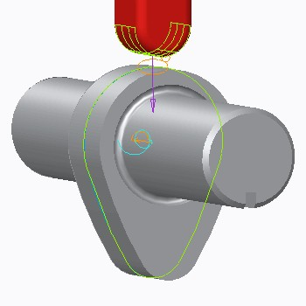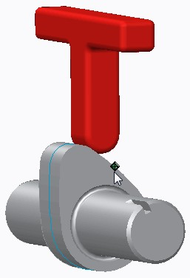

## 3D Contact

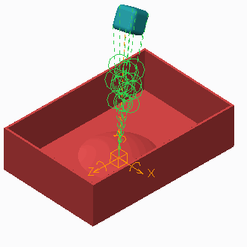3D Contact simulates contact between bodies in three-dimensional motion.

3D Contact:

* + Is based on real material properties.
  + Uses static and sliding friction.

Figure 1 – 3D Contact

3D Contact

Using 3D Contact you can simulate contact between bodies in three-dimensional motion. The system includes static and sliding friction in its calculations, which are based on real material properties such as Poisson's ratio, Young's modulus, and a damping coefficient. You can define 3D contact from a single analytical surface such as a spherical, cylindrical, or planar surface to multiple other analytical surfaces. Contact can also be defined from a vertex to other surfaces. The three-dimensional contact is also active while dragging.

In Figure 1, 3D contact is used to simulate dropping a rubber cube into a box to visualize the cube bouncing and rotating, and coming to rest.

PROCEDURE - 3D Contact

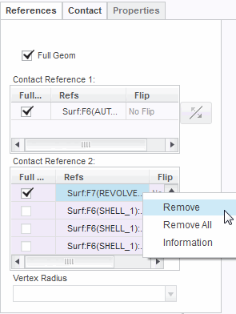**Task 1:** Edit an existing 3D contact model.

|  |
| --- |
| 1. Disable all Datum Display types. 2. Click **Settings**  from the model tree and select **Tree Filters** . 3. In the Model Tree Items dialog box, select the **Features** check box under Display and click **OK**. 4. In the model tree, expand CUBE1.PRT, if necessary. 5. Edit the definition of **Contact 1**. |
| 1. In the 3D Contact dashboard, select **No Friction**   from the with Friction drop-down menu.   1. In the dashboard, select the **References** tab and do the following:    * In the Contact Reference 2 list, right-click **Surf: F7(REVOLVE _1): TABLE** and select **Remove**. 2. Click **Complete Component** from the 3D Contact dashboard. |

**Task 2:** Insert a new contact.

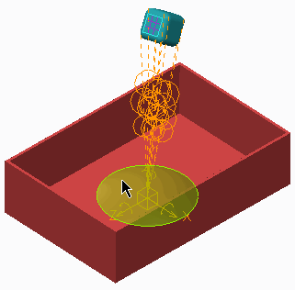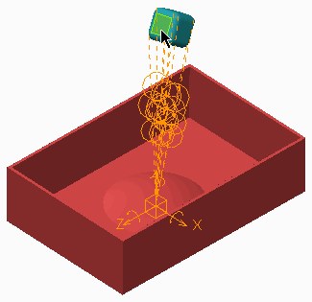

1. In the ribbon, select the **Applications** tab.
2. Click **Mechanism ** from the Motion group.
3. Click **3D Contacts ** from the Connections group. The 3D Contact dashboard appears.
4. In the 3D Contact dashboard, select **References**

tab and do the following:

* + Click in the **Contact Reference 1:** field. In the graphics window, select the left face of CUBE1.PRT.
  + Click in the **Contact References 2:** field. In the graphics window, select the base circle of TABLE.PRT.

1. In the dashboard, select the **Contact** Tab. Verify that Default is listed for Side 1 and Side 2 contact properties.
2. In the dashboard, select **with Friction** from the No Friction drop-down menu. Input fields appear for static and kinetic coefficients of friction.
3. Select **0.1** from the drop-down list for both static and kinetic coefficients of friction.
4. Click **Complete Component** from the 3D Contact dashboard.

**Task 3:** Run the model.

1. 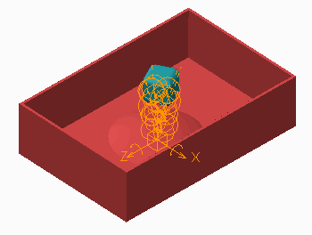In the Mechanism Tree, click to expand

##### ANALYSES.

1. Click **3D_contact_dynamic(DYNAMICS)** and click

**Run ** from the mini toolbar.

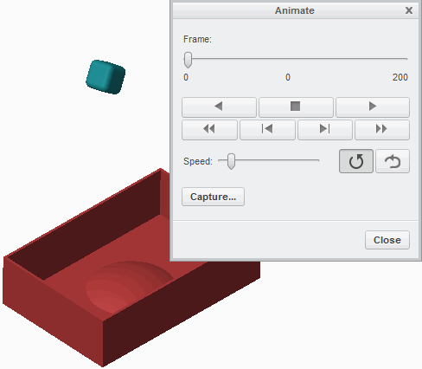**Task 4:** Play back the model run.

1. In the Mechanism Tree, click to expand

##### PLAYBACKS.

1. Click **3D_contact_dynamic** and select **Play**

from the mini toolbar.

1. The Animate dialog box appears. Click **Play** .
2. Click **Close** from the Animate dialog box.

This completes the procedure.

## Creating Generic Gear Connections

Capture any Rotational or Linear relationship using Generic gear connections.

* + 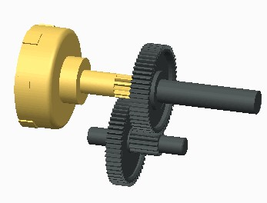Generic gear definition options:
    - Pitch circle diameters
    - Enter ratio values
  + Motion relationships:
    - Rotational/Rotational
    - Rotational/Linear
    - Linear/Rotational
    - Linear/Linear

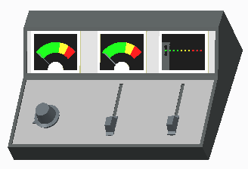Figure 1 – Gear Example

Figure 2 – Rotational/Linear Example

## Creating Generic Gear Connections

You can create a generic type gear connection to capture any rotational or linear relationship between components. When using the generic gear type, you are able to specify either two pitch circle diameters, or motion ratio values.

You can use generic gears to create a simple gear train but, unlike dynamic gear types, generic gear components do not actually have to touch. Therefore, you can locate them in different locations within the assembly, enabling you to create rotational and/or linear relationships between any set of components.

You can capture the following motion relationships using generic gears:

* Rotational/Rotational
* Rotational/Linear
* Linear/Rotational
* Linear/Linear

## PROCEDURE - Creating Generic Gear Connections

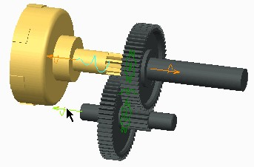**Task 1:** Create a generic gear connection for simple gears.

|  |
| --- |
| 1. Disable all Datum Display types. 2. Press CTRL+ALT and drag each of the three gears.    * Notice that the right gear connection is not created yet. |
| 1. In the ribbon, select the **Applications** tab. 2. Click **Mechanism**  from the Motion group.    * Notice the existing gear connection. 3. Click **Gears**  from the Connections group.  * Select **Generic** as the Type, if necessary.   1. Select the pin joint for the lower center gear, as shown.      + Type **12** for the Pitch Circle Diameter. |
| 1. Select the **Gear 2** tab from the Gear Pair Definition dialog box.    * Select the pin joint for the upper-right gear.    * Type **46** for the Pitch Circle Diameter.    * Click **OK** from the Gear Pair Definition dialog box. 2. Press CTRL+ALT anddrag any ofthethree gears.  * Click **Close** from the Quick Access toolbar. |

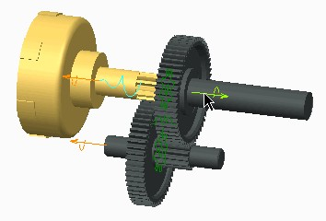***Note:*** *You can also click* ***Drag Components *** *to drag connected components.*

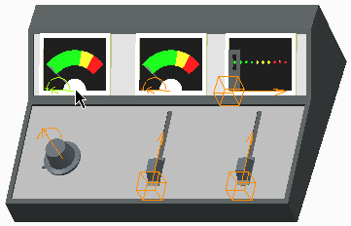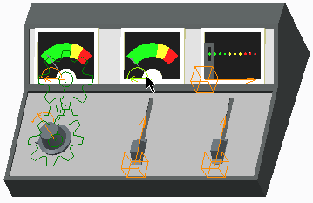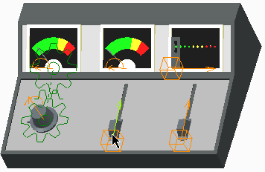

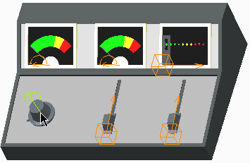**Task 2:** Create Rotational and Linear relationships using generic gears.

|  |
| --- |
| 1. Click Working Directory  from the Common Folders.    * Double-click GENERIC_GEARS.ASM. 2. In the ribbon, select the Applications tab. 3. Click Mechanism  from the Motion group. 4. Click Gears  from the Connections group.    * Select Generic as the Type, if necessary. 5. Select the pin joint on the left rotational control knob. |
| 1. Select the **Gear 2** tab in the Gear Pair Definition dialog box.    * Select the pin joint on the left indicator needle.    * Click **Flip Rotation** . 2. Select the **Properties** tab.    * Select **User defined** as the Gear Ratio type.    * Type **1** for D1.    * Type **2.5** for D2.    * Click **OK** in the Gear Pair Definition dialog box. 3. Press CTRL+ALT and drag either the knob or the needle. |
| 1. Click **Gears**  from the Connections group.    * Select **Generic** as the Type, if necessary. 2. Select the pin joint on the center indicator needle. |
| 1. Select the **Gear 2** tab in the Gear Pair Definition dialog box.    * Select the slider joint on the center linear control knob.    * Click **Flip Rotation** . 2. Select the **Properties** tab.    * Click **User defined** as the Rack Ratio type.    * Type **200** for the ratio.    * Click **OK** in the Gear Pair Definition dialog box. 3. Press CTRL+ALT and drag either the knob or the needle. |

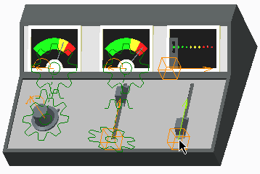

|  |
| --- |
| 1. Click **Gears**  from the Connections group.    * Select **Generic** as the Type, if necessary. 2. Select the slider joint on the right linear control knob. |
| 1. Select the Gear 2 tab in the Gear Pair Definition dialog box.    * Select the slider joint on the right indicator. 2. Select the Properties tab.    * Notice that User defined is the Rack Ratio type.    * Type 1.2 as the ratio.    * Click OK in the Gear Pair Definition dialog box. 3. Press CTRL+ALT and drag either the knob or the indicator. |

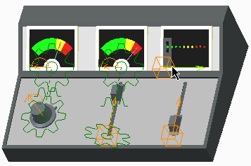This completes the procedure.

## Creating Dynamic Gear Connections

Create different types of common gear connections.

* + 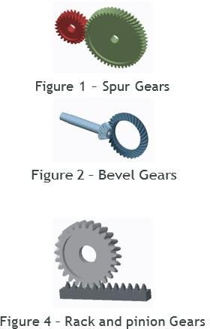Types
    - Spur
    - Bevel
    - Rack and pinion
    - Worm
  + Gear Properties
    - Pitch Diameter
    - Pressure angle
    - Helix Angle
    - Bevel angle
    - 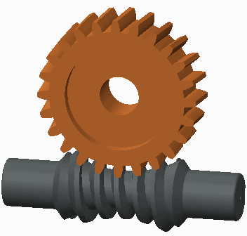Screw Angle

Figure 3 – Worm Gears

## Creating Dynamic Gear Connections

You can create gear connections in Mechanism mode that utilize manufacturing tooth angles to determine their motion properties. Properties such as pitch diameter, pressure angle, helix, bevel, and screw angles are used to compute motion, as well as kinematic and dynamic analyses. Dynamic analyses can include reaction forces based on the tooth geometry at the location where the pitch diameters meet. The system can automatically calculate pitch circle diameters and bevel angles.

Examples of the four dynamic gear types include:

* + Spur – Two meshing gears rotating on parallel axes.
  + Bevel – A pinion gear driving a crown gear on perpendicular axes.
  + Rack and pinion – A pinion gear meshing with a sliding rack gear.
  + Worm – A worm shaft rotating a pinion on Perpendicular axes. Dynamic gears also have several properties that you can define:
  + Pitch Diameter – Specify a pitch diameter for the first gear in the pair, and the corresponding pitch diameter is automatically calculated. You can also use the User Defined option to manually input both values or the ratio manually.
  + Pressure angle – A gear tooth pressure angle for all gear types.
  + Helix Angle – A gear tooth Helix angle for Spur, Bevel, and Rack and Pinion gears.
  + Bevel angle – Determined automatically for Bevel Gears based on geometry.
  + Screw Angle – Defines the screw angle for worm gears.
  + Icon location – Defines a plane to display and calculate the gear connection.

***Note:*** *Once defined, you can simply press CTRL+ALT to drag gears in Standard Assembly mode or in Mechanism mode. You can also click* ***Drag Components *** *to drag connected components with additional options, such as creating snapshots.*

## PROCEDURE - Creating Dynamic Gear Connections

**Task 1:** Create a Spur gear connection

1. 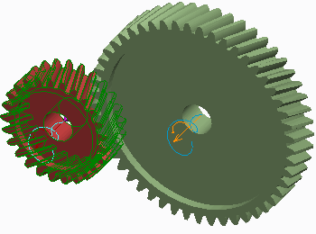Disable all Datum Display types.
2. In the ribbon, select the **Applications** tab.
3. Click **Mechanism ** from the Motion group.
4. Click **Gears ** from the Connections group.
   * Select **Spur** as the Type.
5. Select the pin joint on the smaller gear.
   * Type **100** for the Diameter and press ENTER.

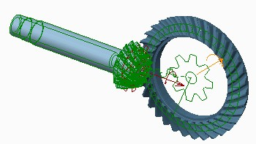

1. 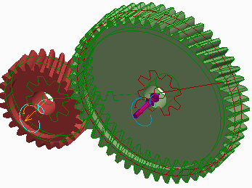Select the **Gear 2** tab in the Gear Pair Definition dialog box.
   * Select the pin joint on the larger gear.
2. Select the **Properties** tab.
   * Type **–20** for the Helix Angle and press ENTER.
   * Click **OK**.
3. Press CTRL+ALT and drag either gear.
   * Click **Close** from the Quick Access toolbar.

***Note:*** *You can also click* ***Drag Components *** *to drag connected components.*

**Task 2:** Create a Bevel gear connection.

1. Click **Working Directory ** from the Common Folders.
   * Double-click BEVEL_GEARS.ASM.
2. In the ribbon, select the **Applications** tab.
3. 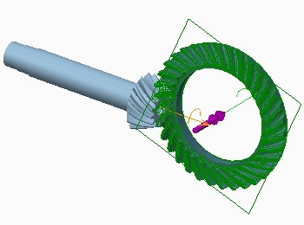Click **Mechanism **.

|  |
| --- |
| 1. Click **Gears** .    * Select **Bevel** as the Type. 2. Select the pin joint on the large crown gear.    * Type **175** for the Diameter and press ENTER.    * Enable **Plane Display** .    * Select DTM1 as the Icon location. 3. Disable **Plane Display** . |
| 1. Select the **Gear 2** tab in the Gear Pair Definition dialog box.    * Select the pin joint on the smaller pinion gear. 2. Select the **Properties** tab.    * Type **–36** for the Helix Angle and press ENTER.    * Click **OK** in the Gear Pair Definition dialog box. 3. Press CTRL+ALT and drag either gear.    * Click **Close** from the Quick Access toolbar. |

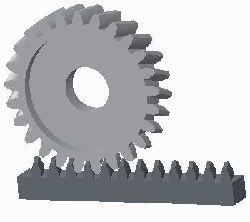**Task 3:** Examine the Rack and pinion and Worm gear connections

|  |
| --- |
| 1. Click **Working Directory**  from the Common Folders.    * Double-click RACK_PINION_GEARS.ASM. 2. Press CTRL+ALT and drag either gear.    * Click **Close** from the Quick Access toolbar. |
| 1. Click **Working Directory** .    * Double-click WORM_GEARS.ASM. 2. Press CTRL+ALT and drag either gear.    * Click **Close** from the Quick Access toolbar. |

This completes the procedure.

## Creating Belt Connections

Create belts that connect pulleys to create and analyze motion.

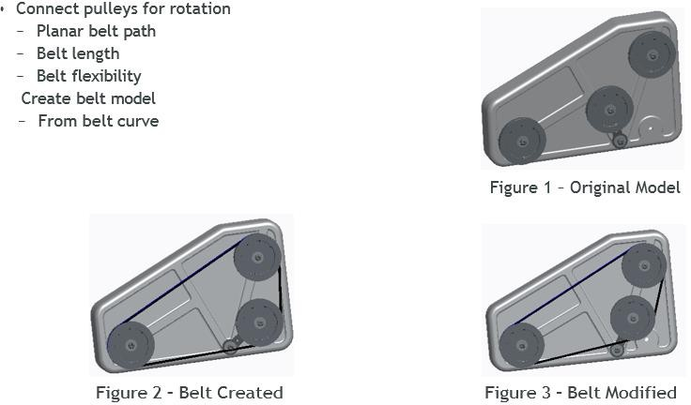

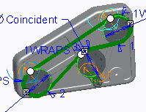

## Creating Belt Connections

In Mechanism mode, you create belts in a planar path that connect pulleys to transmit rotation. You can control the belt length and flexibility. Once a belt connection is defined, you can create a part model containing the belt curve. From this curve, you can create solid geometry to represent the belt.

Belts have several options:

* Belt Direction – Indicates on which side the belt travels around the pulley.
* Pulley Diameter – By default is coincident to the selected pulley surface. You can also specify a value from the dashboard or on-screen leaders.
* Number of wraps – Indicates the number of wraps the belt should take around the pulley. The default is 1 wrap.
* Belt Length – Belts default to a natural length defined by the belt path. You can then specify a fixed length.
* Belt plane – A selected plane that defines the centerline of the belt path.
* Flexibility – Indicates a set value for the E*A parameter. (Young’s Modulus multiplied by cross-section area.)
* Body Definition – Indicates which body is defined as the moving pulley body versus the stationary carrier body.

***Note:*** *You can perform kinematic and dynamic analyses of belts and pulleys in Mechanism mode.*

## PROCEDURE - Creating Belt Connections

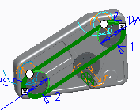**Task 1:** Create a belt on an existing pulley mechanism

|  |
| --- |
| 1. Disable all Datum Display types. 2. In the ribbon, select the **Applications** tab. 3. Click **Mechanism**  from the Motion group. 4. Click **Belts**  from the Connections group. 5. Press CTRL and select cylindrical surfaces from the two main pulleys. |
| 6. Press CTRL and select the cylindrical surface from the idler pulley. |

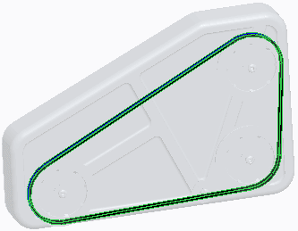

|  |  |
| --- | --- |
| 1. Right-click the belt handle on the idler pulley and select **Flip Belt Direction**.    * Notice that the belt now follows a different path. |  |
| 1. Type **80** for the E*A value and press ENTER. 2. Click **User-Defined Length** .    * Type **1250** for the belt length and press ENTER. 3. Click **Complete Feature** from the Belt dashboard. 4. Press CTRL+ALT and drag any of the pulleys. | |

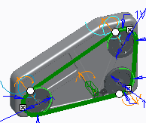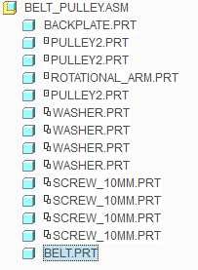**Task 2:** Create a solid belt part and some solid geometry.

|  |
| --- |
| 1. Select the belt, then right-click and select **Make Part**.    * Type **BELT** as the Name and click **OK**.    * Click **Browse**.    * Select TEMPLATE.PRT.    * Click **Open** and **OK**. 2. Right-click and select **Default Constraint**. 3. Click **Complete Component** from the Component Placement dashboard. |
| 1. In the ribbon, select the **Applications** tab. 2. Click **Mechanism** . 3. Click BELT.PRT in the model tree and select   **Activate**  from the mini toolbar.   1. Click **User-Defined Feature**  from the Get Data group.    * Select FLAT_BELT.GPH and click **Open**. Click   **OK**.   * + Select the belt curve in the graphics window and click **Apply Changes** in the User Defined Feature Placement dialog   box. |



1. In the ribbon, select the **Applications** tab.
2. 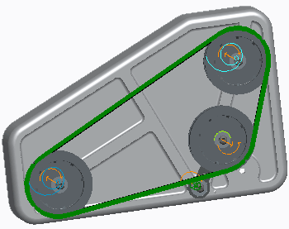Click **Mechanism **.
3. Select the belt in the graphics window, then click **Edit Definition ** from the mini

toolbar.

* + Type **1200** as the length and press ENTER.
  + Click **Complete Feature** from the Belt dashboard.
  + Click **Regenerate ** from the Quick Access toolbar.

This completes the procedure.

## Using the Drag and Snapshot Tools

##### Use the drag and snapshot tools to move and save your mechanism in various positions. Drag Components

* + - **Point Drag **

##### Body Drag

* + - **Snapshots**

Figure 1 – Weld Connections

## Using the Drag and Snapshot Tools

One method of verifying the connections you have made is to drag the assembly through its range of motion. To drag components through their motion and open the Drag dialog box, click **Drag Components ** and then click a part model.

The components move according to the connections that have been applied. The selected entity is always positioned as close as possible to the cursor location while the rest of the components stay connected to each other.

To quit dragging, you can either middle-click to return the components to their original position, or you can click to leave the components at their current position.

## The Drag Dialog Box

Within the Drag dialog box, you can work with the following tools:

* **Point Drag ** – Click selected edges, points, axes, datum planes, or surfaces and drag them to initiate the dragging movement. This is the default dragging option.
* **Body Drag ** – Click a selected body and drag it. When you drag a body, its position in the

graphics window changes but its orientation remains fixed. If the assembly requires that a body be reoriented in conjunction with a change in position, the body does not move at all, since the model cannot reassemble in the new position. Should this happen, try using point dragging instead.

* Snapshots – Use the Snapshots tab to display and create a list of saved snapshots of the mechanism in various positions. After you move the components to the desired location, you can save snapshots of your assembly in different positions and orientations.
* Constraints – Use the Constraints tab to apply or remove movement constraints. After you apply a constraint, its name is added to the constraints list. You can turn a constraint on and off by selecting or clearing the check box next to the constraint. Use the shortcut menu to copy, cut, paste, or delete the constraint.
* Advanced Drag Options – Use the Advanced Drag Options tab to access a set of drag options that enable you to more precisely control your drag operations. Specific translation and rotation directions can be defined for a drag operation. These options are only available in Mechanism mode.

## Creating Snapshots

After you move connected components to a desired position, you can create snapshots of that particular location in the graphics window. Snapshots enable you to return the assembly components to a particular position. You can create multiple snapshots and quickly move the assembly to specific positions by activating each snapshot. Snapshots can also be used in drawings.

***Tip:*** *Use snapshots to save your mechanism in positions you will frequently return to. For example, positions used in drawings, the design position, and positions where there is a collision issue you are working on.*

Use the following tools to create and manage snapshots:

* **Take Snapshot ** – Take a snapshot ofthe current mechanism position. Edit that name and press ENTER to change the name.
* **Display Snapshot** – View the selected snapshot.
* **Borrow Part Positions ** – Add the positionof selected components inone snapshot to theselected snapshot.
* **Update Snapshot ** – Update the selected snapshot with the current component positions.
* **Make Available In Drawings ** – Make the selected snapshot available in Drawing mode as an exploded view.
* **Delete Snapshot ** – Delete the selected snapshot.

## Adding Constraints

Use the Constraints tab to constrain the motion of your mechanism. After you apply a temporary constraint, its name is added to the constraints list. You can turn a constraint on and off by selecting or clearing the check box next to the constraint. Use the shortcut menu to copy, cut, paste, or delete the constraint.

* **Distance ** – Use the Distance constraint to position the component reference at a set distance from the assembly reference. References for a Distance constraint can be point-point, point-line, line-line, plane-plane, planar surface-planar surface, point-plane, or line-plane.
* **Angle Offset** – Use the Angle Offset constraint to position the selected component reference

at an angle to the selected assembly reference. References for an Angle constraint can be line- line (coplanar lines), line-plane, or plane-plane.

* **Parallel** – Use the Parallel constraint to place the component reference parallel to the assembly reference. References for a Parallel constraint can be line-line, line-plane, or plane-plane.
* **Coincident** – Use the Coincident constraint to place the component reference coincident to the assembly reference. References for a Coincident constraint can be line-line, line-plane, or plane-plane.
* **Body-Body Lock ** – Select bodies to be locked together.
* **Enable/Disable Connections ** – Select a connection. The connection is disabled.
* **Reconnect ** – Define the offset value for any mate or align constraints. Define a value for angle or distance, if you have chosen an orientation constraint.
* To delete a selected constraint from the list, click **Delete Constraint **.

## PROCEDURE - Using the Drag and Snapshot Tools

**Task 1:** Create a snapshot of the current position.

|  |
| --- |
| 1. Disable all Datum Display types. 2. In the ribbon, select the **Applications** tab. 3. Click **Mechanism**  from the Motion group. 4. Click **Drag Components**  from the Motion group. 5. In the Drag dialog box, expand the **Snapshots** area, if necessary. 6. Click **Take Snapshot** . 7. Edit the name Snapshot1 to **Design_Position** and press ENTER. |
| ***Note:*** *No matter where you drag components, you can now easily return to this assembly position by double-clicking* ***Design_Position****.* |

**Task 2:** Move the mechanism using both Point Drag and Body Drag.

1. 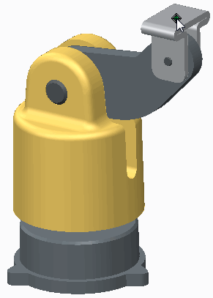Click **Body Drag ** in the Drag dialog box.
2. Select DRAG_CLIP.PRT and drag the model. Notice how the models react to the dragging of this body.
3. Click in the graphics window to stop the movement.
4. In the Drag dialog box, double-click **Design_Position** so the models return to their original positions.

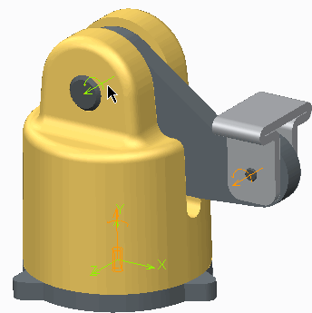

1. Click **Point Drag ** in the Drag dialog box.
2. Select DRAG_CLIP.PRT and drag the model.
3. Click in the graphics window to stop the movement.
4. Select other components of the assembly and drag them. Notice how the models react.
5. In the Drag dialog box, double-click **Design_Position**.

**Task 3:** Use constraints to control the movement of components while dragging

1. 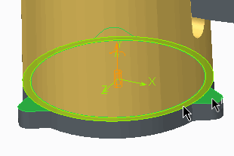Select the **Constraints** tab in the Drag dialog box.
2. 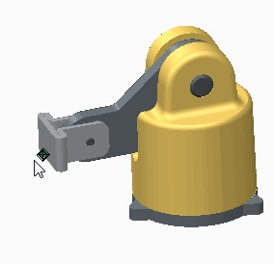Click **Mate ** and query-select the bottom surface of DRAG_BASE.PRT and the top of DRAG_LIFT.PRT to create a Plane-Plane Mate constraint.

|  |
| --- |
| 1. Select DRAG_CLIP.PRT and drag the model. Notice that DRAG_BASE.PRT no longer moves upward but it does spin. 2. Click in the graphics window to stop the movement. 3. Select the **Snapshots** tab and double-click   **Design_Position**.   1. Select the **Constraints** tab in the Drag dialog box. |
| ***Note:*** *The Plane-Plane Mate constraint is no longer in the constraint list. Constraints must be saved with a snapshot and that was not done.* |
| 1. Click **Body-Body Lock**  and select DRAG_LIFT.PRT. 2. Press CTRL, select DRAG_BASE.PRT, and click **OK**. 3. Click **Take Snapshot** . 4. Edit the name Snapshot1 to **Up** and press ENTER. |
| 1. Click **Motion Axis Constraint**  and select the motion axis shown. 2. Edit the Value field to **90** and press ENTER. 3. Select the **Snapshots** tab. 4. With Up selected, click **Update Snapshot**  to add the change to the Up snapshot. 5. Double-click each snapshot to alternate between each position. |

**Task 4:** Experiment with the various drag, snapshot, and constraint tools found in the Drag dialog box.

|  |
| --- |
| ***Note:*** *There is an unlimited number of drag, snapshot, and constraint combinations that can be used to deflne mechanism positions.You should spend flve minutes experimenting with the various options, using them to create your own snapshots. Use this time to get a better understanding of all the functionality in the Drag dialog box.* |
| 1. When finished, click **Close** in the Drag dialog box. |

This completes the procedure.

**Module 10**

## Configuring Motion and Analysis

## Understanding Servo Motors

Use servo motors to impose motion on your mechanism.

Driven Entity Types:

* + - Motion axis
    - Geometry Motion Types:
    - Translational
    - Rotational
    - Slot

Motor Profile Specifications:

* + - Motion Axis Settings
    - Position
    - Velocity
    - Acceleration

## Understanding Servo Motors

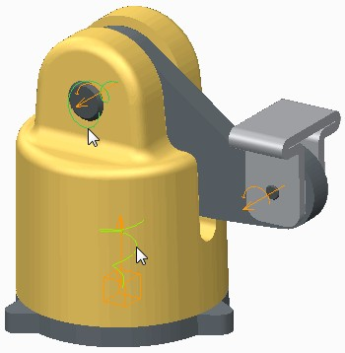

Figure 1 – Rotation and Translation Motors

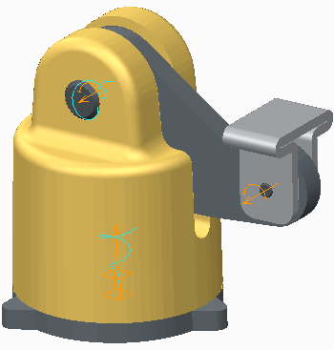

Figure 2 – Motion Applied by Servo Motors

Servo motors are used to apply translational or rotational motion to bodies of a mechanism. They are the driver that moves your mechanism about the connections you have defined. The motion is defined in terms of position, velocity, or acceleration.

## Driven Entity Types

There are two driven entity types that define a servo motor:

* + Motion axis – The motion axis entity type references the motion axis of a connection to define motor direction. You use this entity type to define the relative motion between two bodies in the direction of a motion axis. The direction can be translational or rotational. For example, in the rotational direction of a Pin connection, if a slot connection is selected as the motion axis, the motion is along the trajectory of the slot.
  + Geometry – The geometry entity type references points, edges, and planes to define motion direction. You use this type when the motion direction cannot be defined by a motion axis. There are five different types of geometry motors.

## Creating Servo Motors

The Servo Motor tool is only available in Mechanism mode and started using one of the following methods:

* + Select the Mechanism tab and click **Servo Motors ** from the Insert group.
  + Right-click MOTORS from the Mechanism tree and select New.

***Note:*** *If your license of Creo Parametric includes the MDO option, you have to expand MOTORS and right-click SERVO to select New.*

In the References tab of the Motor dashboard, select a Driven Entity to define the motor as a Motion axis or Geometry type motor:

* Motion axis – This is the default direction entity type. It requires you to select a motion axis to define the motor's direction of motion. The type of motion axis selected determines if the motor's motion is translational or rotational.

Flip – Changes the direction of the servo motor's motion.

* + Geometry – This direction entity type requires the following:
* Geometry reference – Select a point or plane from the model that is driven by the motor.
* Reference entity – Select a point or plane that the driven model moves with respect to. If a plane is selected, this also defines the direction of motion.
* Motion direction – If a point was selected as the Reference entity, an additional reference must be selected to define the direction of motion.
* Flip – Changes the direction of the servo motor's motion.
* Motion type – The motion type defines the motion of the geometry motor as being translational or rotational.

You use the Profile Details tab of the Motor dashboard to define specification for the motor.

Specifications – Define the type of movement the servo motor produces:

* Click **Motion Axis Settings ** to edit settings for the selected motion axis. This includes Current Position, Regen Value, Minimum Limit, and Maximum Limit.
* Position – Specifies the servo motor motion in terms of the position of a selected reference entity.
* Velocity – Specifies the servo motor motion in terms of its velocity.
* Acceleration – Specifies the servo motor motion in terms of its acceleration.
* Initial State – Defines the starting position for your servo motor and appears only if Velocity or Acceleration is selected. If you want to specify another Initial Position, clear the Current check box and specify the value at which the motion should start.
* Initial Velocity – Defines the velocity of the servo motor at the beginning of the analysis and appears only if Acceleration is selected.
* Function Type – Defines the magnitude of the motor as a function of time. It can be a constant value, or it can be defined by one of the functions you select. The function is used to generate the magnitude of the motor based on the time period the analysis is run for. For example, a translational Position motor using the Ramp function (q = A + B*t) moves a body 40 units, if A = 0, B = 10, and the analysis is run for 4 seconds.
* Graph – Enables you to generate and display a graph plotting the Position, Velocity, and Acceleration generated by your motor over time. This is a very useful tool for determining how a defined velocity or acceleration affects the position of a component in a mechanism, prior to actually running an analysis.

## Understanding Analysis Definitions

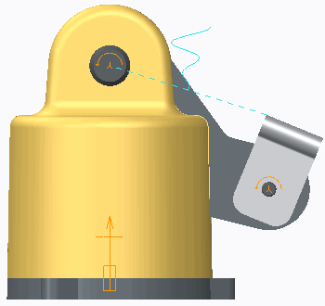Use analyses to record and display the motion of your mechanism over time. Use analyses to record and display the motion of your mechanism over time. Preferences:

* + Analysis Type – Position or Kinematic
  + Graphical Display Settings
  + Locked entities
  + Initial configuration Motors:
  + Select Motors to Run
  + Start and End Times Per Motor Figure 1 – Analysis Displayed at Start

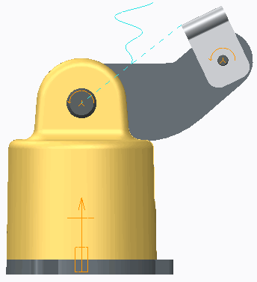

Figure 2 – Analysis Displayed at End

*Understanding Analysis Definitions*

After motors have been added to your mechanism model, you must define an analysis to display the motors running through their defined motion. You configure an analysis that records and displays the motion generated by selected motors over a specified time period.

*Creating Analysis Definitions*

The Analysis tool is only available in Mechanism mode. You start the Analysis tool by using one of the following methods:

* Select the Mechanism tab and click **Mechanism Analysis ** from the Analysis group.
* Click ANALYSES from the mechanism tree and select New from the mini toolbar.

*Analysis Type*

Using the MDX option in Creo Parametric, you can select two types of analyses:

* Position – You should only use a position type analysis when analyzing position motors and all geometry motors. The Position analysis jumps between each frame so you cannot use it to track velocity or acceleration, only position measures at each frame.
* Kinematic – A kinematic type analysis enables you to use position servo motors as well as velocity, and acceleration servo motors. The kinematic type analysis records a smoother motion that can better display changes in velocity and acceleration.

***Note:*** *It is important toknow that a Kinematic analysis cannot be used to runa geometry servo motor. In addition to Position and Kinematic, Dynamic, Static, and Force balance analyses are also visible in the drop-down list. These are MDO type analyses and you cannot run them without an MDO license.*

*Graphical Display*

You configure Graphical Display settings on the Preferences tab of the Analysis Definition dialog box. This enables you to determine how Creo Parametric records motion over time. There are three types of time domains:

* Length and rate – Specify the end time, frame rate, and minimum interval.
* Length and frame count – Specify the end time and frame count values.
* Rate and frame count – Specify the frame count, frame rate, and minimum interval.

*Locked Entities*

You can lock bodies and connections during your analysis run. Locking bodies or connections fixes the position of one body or connection relative to another during the defined analysis. Use the icons in the analysis dialog box to:

* **Create Body Lock ** – Lock bodies together during the motion analysis run.
* **Create Connection Lock ** – Lock the movement of a connection during the motion analysis run.
* **Enable/Disable Cam Liftoff ** – Enable or disable a cam liftoff during the motion analysis run.
* **Enable/Disable Connection ** – Enable or disable a connection during the motion analysis run.
* **Delete Locked Entity ** – Delete locked bodies and connections.

*Initial Configuration*

By selecting your initial configuration, you are setting a starting point for your position or kinematic analysis. There are two options:

* Current
* Snapshot

By default, each analysis starts with the mechanism displayed as the current screen position, which is the current orientation of the bodies displayed on the screen. However, you can set the initial configuration to establish the snapshot as the initial position. The snapshot captures the configuration of existing locked bodies and geometric constraints to define position constraints.

*Configuring Motors of the Analysis*

On the Motors tab, you can select and configure motors to run in the analysis. By default, each motor runs from start to the end of the analysis.

Alternatively, you can select and edit the Start and End values in the form and to cells to be numerical values. For example, in an analysis running 10 seconds, you can edit the first motor to run from 0

to 5, and the second motor to run from 6 to 10.

***Note:*** *The run time defined in the analysis is relative. The motion is not displayed in real time. The actual time it takes to run the motion is dependent on the complexity of the models as well as computer speed.*

## Creating Geometry Servo Motors

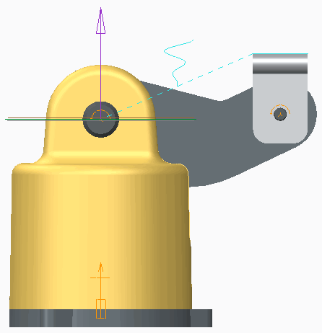Use geometry servo motors to define motion that cannot be defined with an existing motion axis. Geometry Servo Motors:

* + Plane-Plane Translation Motor
  + Plane-Plane Rotation Motor
  + Point-Plane Translation Motor
  + Plane-Point Translation Motor
  + Point-Point Translation Motor Motor Profiles

Figure 1 – Plane-Plane Translation Motor

*Using Geometry Servo Motors*

You use geometry servo motors to define motion on points or planes when the motion cannot be defined with a motion axis motor. This occurs when the connections defining your model do not contain axes that define motion in the direction you want to control.

Servo motors are displayed in the model as a swirling cone shape, as shown in Figure 1.

*Creating Geometry Servo Motors*

To create a geometry servo motor, on the Type option within the dash board of Motor tab, select Geometry as the driven entity type. Based on the Geometry reference, Reference entity, and Motion direction references selected, you can create the following five types of geometry servo motors:

* Plane-Plane Translation Motor – A plane-plane translation motor moves a plane in one body with respect to a plane on another body, keeping one plane parallel to the other. The shortest distance between the two planes measures the position value of the motor. The zero position occurs when the driven and reference planes are coincident.

In addition to the defined motion, the driven plane is free to rotate or translate in the reference plane, making it less restrictive than a motor on a slider or a cylinder connection. To explicitly tie down the remaining degrees of freedom, additional constraints such as a connection or another servo motor can be applied.

***Note:*** *In the example shown, the mechanism is connected using two pin connections. You can control the motion with a rotational motor referencing the motion axis of these motors. Instead, a translational geometry motor was added to control the distance of motion between the top of the clip and a horizontal plane through the upper pin.*

* Plane-Plane Rotation Motor – A plane-plane rotation motor moves a plane in one body at an angle to a plane in another body. During a motion run, the driven plane rotates about a reference direction, with the zero position defined when the driven and reference planes are coincident.

Because the axis of rotation on the driven body remains unspecified, a plane-plane rotation motor is less restrictive than a motor on a pin or cylinder connection.

***Tip:*** *You can use plane-plane rotation motors to define rotations around a ball connection. You can also define a rotation between the last body of an open-loop mechanism and the ground.*

* Point-Plane Translation Motor – A point-plane translation motor moves a point in one body along the normal of a plane in another body. The shortest distance from the point to the plane measures the position value of the motor.

You cannot define the orientation of one body with respect to the other using only a point-plane

motor. Also note that the driven point is free to move parallel to the reference plane, and may thus move in a direction unspecified by the motor. Lock these degrees of freedom using another motor or connection. By defining X, Y, and Z components of motion on a point with respect to a plane, you can make a point follow a 3-D curve.

* Plane-Point Translation Motor – A plane-point translation motor is the same as a point-plane translation motor, except that you define the direction in which a plane moves relative to a point. During a motion run, the driven plane moves in the specified motion direction while staying perpendicular to the point. The shortest distance from the point to the plane measures the position value of the motor. At a zero position, the point lies on the plane.

You cannot define the orientation of one body with respect to the other using only a plane-point motor. Also, note that the driven plane is free to move perpendicularly to the specified direction. Lock these degrees of freedom using another motor or connection. By defining X, Y, and Z components of motion on a point with respect to a plane, you can make a point follow a 3-D curve.

* Point-Point Translation Motor – A point-point translation motor moves a point on one body in a direction specified by another body. The shortest distance measures the position of the driven point to a plane that contains the reference point and is perpendicular to the motion direction. The zero position of a point-point motor occurs when both the reference and driven point lie in a plane whose normal is the motion direction.

*Geometry Motor Profiles*

The Profile Details tab in the Motor dashboard is where the motor's specifications are defined.

* Driven Quantity – The motor is controlled by Position, Velocity, or Acceleration.
* Initial State – You can set the initial position of the motor (but not for Position motors).
* Function Type – You can define the magnitude of motion using one of nine different types, including Constant and Ramp.
* Graph – You can graph the motor's Position, Velocity, and Acceleration.

## PROCEDURE - Creating Geometry Servo Motors

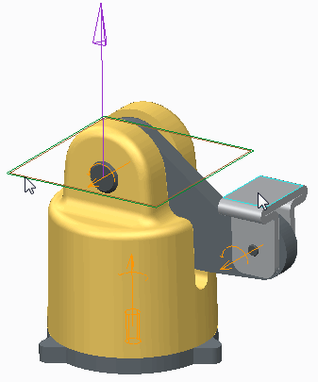**Task 1:** Create a planar-planar translational motion geometry motor.

|  |
| --- |
| 1. Enable only the following Datum Display types: . 2. In the ribbon, select the **Applications** tab. 3. Click **Mechanism**  from the Motion group. 4. Click **Servo Motors**  from the Insert group. |
| 1. Click **Geometry** in the Servo Motor Definition dashboard.    * Select the top planar surface of GEOM_MOTOR_CLIP.PRT.    * Select datum plane **CENTER** as the Reference entity.    * If necessary, click **Flip** so that the direction arrow points up.    * If necessary, select **References** tab and click   **Translational** to set the motion type. |
| ***Note:*** *You have just defined a Plane-Plane Translation servo motor. Had you selected a point as reference, rather than a plane, an additional Direction reference would have been required. In the case of a Plane-Plane motor, the*  *Reference entity defines both the reference and direction.* |

|  |
| --- |
| 1. Select the Profile Details tab in the dashboard from the Motor tab. 2. On the Profile Details tab, configure the magnitude of the motor's motion:    * In the Driven Quantity drop-down list, ensure that Position is selected.    * From the Function Type drop-down list, select Ramp.    * Edit the value of B from 0 to 6 and press ENTER. |
| Note: Cursor over the Ramp. Notice that the pop-up message reads q = A + B*t, where:   * q = Magnitude of motion. * A = Constant Coefficient, specified as 0 in the dialog box. * B = Slope, displayed as 6 in the dialog box. * t = The time that the motor will be run.   This means that at 0 seconds, the translational motion of the motor will be 0 mm (q = 0 + 0*0). If the motor is run for 10 seconds, the translational motion will be 60 mm (q = 0 + 6*10). |
| 8. Click Apply Changes . |

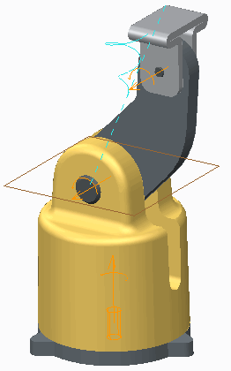**Task 2:** Create an analysis to run the new motor for 10 seconds.

|  |
| --- |
| 1. In the Mechanism Tree, click **ANALYSES** and select   **New**  from the mini toolbar.   1. Notice that in the Analysis Definition dialog box, the Start Time of the analysis is 0 and the End Time is 10 (a 10 second analysis). 2. Select the **Motors** tab. Observe that the motor you created has been placed in the list. 3. Click **Run** to run the motor. 4. Click **OK** to close the dialog box. |
| ***Note:*** *The motor has moved the clip 60 mm, a translational distance from datum plane CENTER. Notice that the 10 seconds deflned in the analysis is relative and not shown in real time.* |
| 6. Click **Regenerate**  from the Quick Access toolbar to return the model to its initial position. |

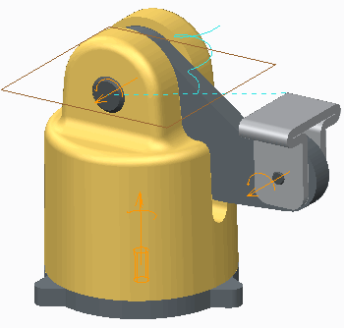***Note:*** *The model returned to its original position because each of the model's connections as a motion axis were deflned with a Regen Value and the option* ***Enable regeneration value*** *wasselected. The motion axis returns to those values each time the model is regenerated.*

This completes the procedure.

## Creating Motion Axis Servo Motors

Use motion axis servo motors to define motion in the direction of a connection's motion axis. Motion Axis Servo Motors

* About a Rotational Axis
* Along a Translational Axis
* Along a Slot Connection Motor Profiles
* Driven Quantity
* Initial State
* Function Type
* Graph

Figure 1 – Translational and Rotational

*Using Motion Axis Servo Motors*

You use motion axis servo motors to define a motor with motion in the remaining degree of freedom contained in a connection. For example, selecting the motion axis of a Pin connection creates a rotational servo motor.

Selecting the motion axis of a Slider connection creates a translational servo motor. Selecting a Slot connection creates a servo motor that drives motion along the direction

of the slot.

Servo motors are displayed in the model as swirling cone shapes, as shown in Figure 1.

*Creating Motion Axis Servo Motors*

To create a motion axis servo motor, on the References tab of the Motor dashboard, select Motion axis as the driven entity type.

You can click the Flip button to change the direction of the motor.

*Motion Axis Motor Profiles*

The Profile Details tab in the Motor dashboard is where the motor's specifications are defined:

* Driven Quantity – The motor is controlled by Position, Velocity, or Acceleration.
* Initial State – You can set the initial position of the motor (but not for Position motors).
* Function Type – You can define the magnitude of motion using one of nine different types such as Constant and Ramp.
* Graph – You can graph the motor's position, velocity, and acceleration.

## PROCEDURE - Creating Motion Axis Servo Motors

**Task 1:** Create a translational motion axis motor.

1. 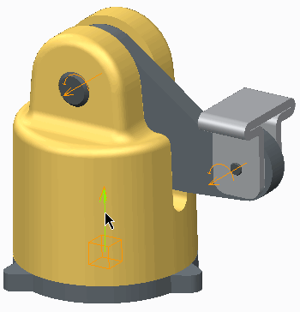Disable all Datum Display types.
2. In the ribbon, select the **Applications** tab.
3. Click **Mechanism ** from the Motion group.
4. In the ribbon, click **Servo Motors ** from the Insert group.
5. Select the motion axis of the Slider connection, as shown.



|  |
| --- |
| 1. Disable all Datum Display types. 2. In the ribbon, select the **Applications** tab. 3. Click **Mechanism**  from the Motion group. 4. In the ribbon, click **Servo Motors**  from the Insert group. 5. Select the motion axis of the Slider connection, as shown. |
| 1. Select the Profile Details tab in the Motor dashboard. 2. On the Profile Details tab, configure the magnitude of the motor's motion:    1. From the Driven Quantity drop-down list, select Velocity.    2. Clear the Use Current Position as Initial check box.    3. In the Function Type drop-down list, ensure that Constant is selected.    4. Edit the value of A from 0 to 1.5 and press ENTER.    5. Click Apply Changes . |
| Note: You have conflgured the motor as follows:   * Velocity – Magnitude of motion will be deflned as mm/second. * Initial State – You have deflned the initial position of the motor to be at 0 mm. * A – Velocity will be a constant 1.5 mm/second.   This means at 0 seconds, the translational position of the motor will be at 0 mm. If the motor is run for 10 seconds, the motor will move 15 mm in the direction of the axis. |

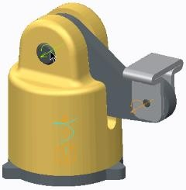**Task 2:** Create a rotational motion axis motor.

|  |
| --- |
| 1. Click **Servo Motors**  from the Insert group. 2. Select the motion axis of the Pin connection, as shown. |
| 1. Select the **Profile Details** tab in the Motor dashboard. 2. On the Profile Details tab, configure the magnitude of the motor's motion:    * From the Driven Quantity drop-down list, select **Angular Velocity**.    * Ensure that the units displayed to the right of Coefficient A are **deg/sec**. This verifies that a rotational axis was selected.    * Clear the Use Current Position as Initial check box.    * In the Function type drop-down list, ensure that **Constant** is selected.    * Edit the value of A from 0 to **9** and press ENTER.    * Click **Apply Changes** . |

***Note:*** *You have conflgured the motor as follows:*

* *Velocity – Magnitude of motion will be deflned as degrees/second.*
* *Initial Angle – You have deflned the initial position of the motor to be at 0 degrees.*
* *A – Velocity will be a constant 9 degrees/second.*

*This means at 0 seconds, the translational position of the motor will be at 0 degrees. If the motor is run for 10 seconds, the motor will move 90 degrees about the axis.*

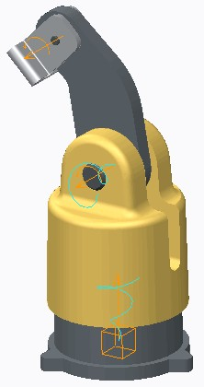**Task 3:** Create an analysis to run each motor for 10 seconds.

|  |
| --- |
| 1. In the Mechanism Tree, click **ANALYSES** and select   **New**  from the mini toolbar.   1. From the Type drop-down list, select **Kinematic**. 2. Edit the End Time value from 10 to **20** and press ENTER. 3. Select the **Motors** tab. Notice that both motors have been added to the list. 4. Edit the End value of Motor 1 to **10**. 5. Edit the Start value of Motor 2 to **5**. 6. Click **Run** to run the analysis. 7. Click **OK** to close the dialog box. |
| ***Note:*** *The 20 seconds deflned in the analysis is relative and not shown in real time.* |
| 9. Click **Regenerate**  from the Quick Access toolbar to return the model to its initial position. |

This completes the procedure.

## Creating Slot Motors

A slot motor can be used to provide greater control of motion of a slot connection.

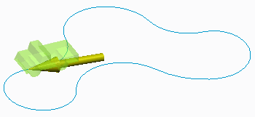A slot motor:

* Acts along the tangent of a slot connection.

Figure 1 – Slot Motor

*Creating Slot Motors*

A slot motor can be used to provide greater control of motion of a slot connection. It enables you to place a motor that acts upon the tangent of a slot connection. You can use any of the available motor profiles, and the slot motor can be used in both kinematic and dynamic analyses.

In Figure 1, a slot motor is used to “push” a model around a defined curve path.

## PROCEDURE - Creating Slot Motors

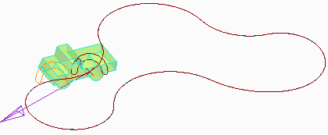**Task 1:** Create a slot motor.

|  |
| --- |
| 1. Disable all Datum Display types. 2. In the ribbon, select the **Applications** tab. 3. Click **Mechanism**  from the Motion group. 4. In the ribbon, click **Servo Motors**  from the Insert group. The Motor dashboard appears. 5. Select the **References** tab, if necessary. On the References tab, select the **Driven Entity** field, if necessary. |
| 6. Click **Select Point or Motion Axis**  and select the slot as shown. |
| 1. Select the **Profile Details** tab in the Motor dashboard. 2. On the Profile Details tab, configure the magnitude of the motor's motion:    * In the Driven Quantity drop-down list, select **Velocity**.    * Clear the **Use Current Position as Initial** check box.    * In the Function type drop-down list, ensure that **Constant** is selected.    * Edit the value of A from 0 to **10.0** and press ENTER.    * Click **Apply Changes** . |
| ***Note:*** *You have conflgured the motor as follows:*   * *Velocity – Magnitude of motion will be deflned as mm/second.* * *Initial State – You have deflned the initial position of the motor to be at 0 mm.* * *A – Velocity will be a constant 10.0 mm/second.*   *This means that at 0 seconds, the translational position of the motor will be at 0 mm. If the motor is run for 10 seconds, the motor will move 100 mm along the slot.* |

**Task 2:** Create an analysis to run the motor for 60 seconds.

* 1. 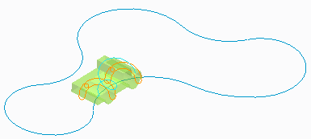In the Mechanism Tree, click **ANALYSES** and select **New ** from the mini toolbar. The Analysis Definition dialog box appears.
  2. In the Type drop-down list, select **Kinematic**.
  3. Edit the End Time value from 10 to **70** and press ENTER.
  4. Select the **Motors** tab. Notice that the motor has been added to the list.
  5. Edit the End value of Motor1 to **60**.
  6. Click **Run** to run the motor.
  7. Click **OK** to close the dialog box.

|  |
| --- |
| ***Note:*** *The 70 seconds deflned in the analysis is relative and not shown in real time.* |
| ***8. Click Regenerate***  ***from the Quick Access toolbar to regenerate the model.*** |

This completes the procedure.

## Graphing the Magnitude of Servo Motors

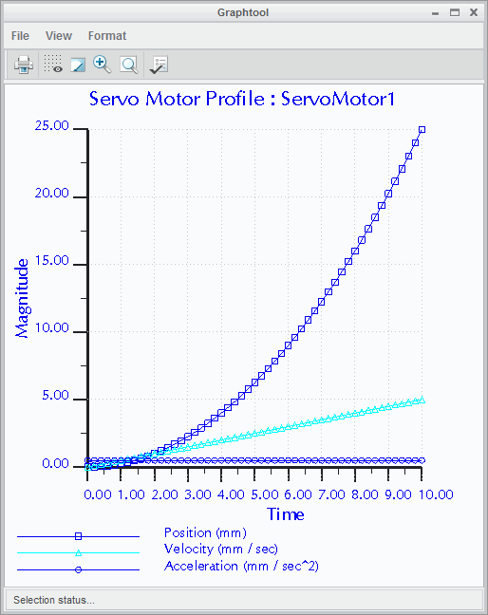Evaluate the magnitude of a motor by graphing its position, velocity, and acceleration. Graph Magnitude of Motion:

* Position
* Velocity
* Acceleration Graph Tools:
* Export
* Print
* Zoom and Refit
* Format

*Graphing the Magnitude of Servo Motors*

Figure 1 – Graph of Position, Velocity, and Acceleration

Graphing position, velocity, and acceleration of a motor enables you to evaluate the motor prior to running an analysis. This enables you to be sure that the specifications you have assigned to the motor produce the desired results.

*Creating a Servo Motor Graph*

To create a graph of a servo motor, select the Profile Details tab in the Motor dashboard of a selected motor. In the Graph area at the bottom of the Profile Details tab, select any combination of Position, Velocity, and Acceleration, then click **Graph Motor **. This generates a graph of the selected magnitudes with respect to time. By default, the time period graphed is 10 seconds.

The graph opens in a special Graph tool window.

*The Graph Tool Window*

The Graph tool window provides a set of tools that help you view, share, and configure the graph's display.

* **Print graph ** – Prints the graph.
* **Toggle Grid Lines ** – Toggles on/off the grid display in the graph.
* **Repaint ** – Redraws the current view of the graph.
* **Zoom In ** – Zooms in on an area of the graph.
* **Refit ** – Refits the graph into the window.
* **Format Graph ** – Opens the Graph Window Options dialog box to format the graph.
* File – In the File menu, you can export the graph as an Excel file or text file.

## Assigning Constant Motion

Assign constant motion to a servo motor as a magnitude of position, velocity, or acceleration.

Constant Motion:

* + Function: q = A
* q = Position, Velocity, or Acceleration
* A = Constant Coefficient
  + Graph Position, Velocity, and Acceleration

Figure 1 – Graph of Constant Acceleration, with Resulting Position and Velocity

*Assigning Constant Motion*

You use a constant function to assign motion to a servo motor. You can specify the motion as a magnitude of position, velocity, or acceleration.

*Graphing the Magnitude of Motion*

The **Graph Motor ** tool at the bottom of the Profile Details tab in the Motor dashboard enables you to graph the position, velocity, and acceleration of your constant motion motor.

***Tip:*** *Graphing position, velocity, and acceleration of any motor enables you to evaluate the motor prior to running an analysis. The graph helps you determine if the specifications you have assigned to the motor produce the desired results.*

## PROCEDURE - Assigning Constant Motion

**Task 1:** Assign and graph a translational position, constant motion.

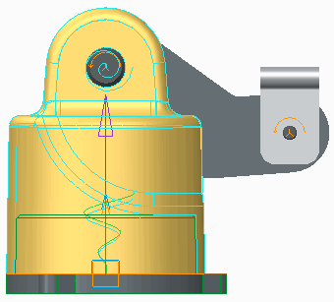

|  |
| --- |
| 1. Disable all Datum Display types. 2. In the ribbon, select the **Applications** tab. 3. Click **Mechanism**  from the Motion group. 4. Click **Saved Orientations**  from the In Graphics toolbar and select the FRONT view. |
| 1. In the Mechanism Tree, expand MOTORS (and SERVO, if necessary). 2. Click SERVOMOTOR1 (POS - CONSTANT) and select Edit Definition  from the mini toolbar. 3. Select the Profile Detail tab in the Motor dashboard.   Note: This motor provides upward translational motion of the base, along the motion axis shown. |
| 1. Configure the motor as a constant motion motor, with the motion defined as a magnitude of position:    * Notice that the Driven Quantity is set to Position and Function Type is set to Constant motion. Both are default settings for servo motors.    * Edit the constant A from 0 to 15 and press ENTER.    * In the Graph area, select the check boxes for Velocity and Acceleration.    * Click Graph Motor  to create a graph of the motor's position, velocity, and acceleration over time. |
| Note: The graph indicates the following:   * The position of the motor starts and ends at 15 mm, the constant value specified. * A constant magnitude produces zero velocity and acceleration. By default, the graph uses a range of 10 seconds for time. |
| 9. In the Graph tool dialog box, click File > Exit. |

**Task 2:** Assign and graph a translational velocity, constant motion.

|  |
| --- |
| 1. Configure the motor as a constant motion motor, with the motion defined as a magnitude of velocity:    * From the Driven Quantity drop-down list, select **Velocity**. Notice that units are now shown as mm/sec.    * Edit the constant A from 15 to **1.5** and press ENTER.    * In the Graph section, select the check boxes for **Position** and **Acceleration**.    * Click **Graph Motor**  to create a graph of the motor's position, velocity, and acceleration over time. |
| ***Note:*** *The graph indicates the following:*   * *The velocity of the motor is a constant 1.5 mm/sec.* * *The position magnitude increases from 0 to 15 mm, over 10 seconds.* * *A constant magnitude of velocity produces zero acceleration.* |
| 2. In the Graphtool dialog box, click **File > Exit**. |

**Task 3:** Assign and graph a translational acceleration, constant motion.

|  |
| --- |
| 1. Configure the motor as a constant motion motor, with the motion defined as a magnitude of acceleration:    * From the Driven Quantity drop-down list, select **Acceleration**. Notice that units are now shown as mm/sec².    * Edit the constant A from 1.5 to **.5** and press ENTER.    * In the Graph section, select the check boxes for **Position** and **Velocity**.    * Click **Graph Motor**  to create a graph of the motor's position, velocity, and acceleration over time. |
| ***Note:*** *The graph displays the following:*   * *The acceleration of the motor is a constant .5 mm/sec².* * *The position magnitude accelerates from 0 to 25 mm, over 10 seconds.* * *The velocity magnitude increases from 0 to 5 mm/sec, over 10 seconds.* |
| 1. In the Graphtool dialog box, click **File > Exit**. 2. Click **Apply Changes**  from the Motor dashboard. |
| 1. In the Mechanism Tree, click to expand **ANALYSES** node. 2. Click **AnalysisDefinition1 (KINEMATICS)**.    * Click **Run**  from the mini toolbar. |

This completes the procedure.

## Assigning Ramp Motion

Assign ramp motion to a servo motor as a magnitude of Position, Velocity, or Acceleration.

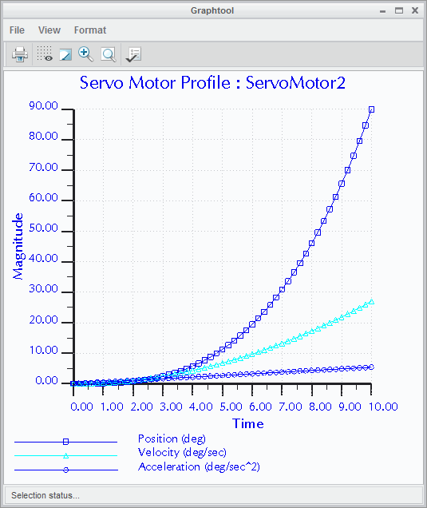Ramp Motion:

* + Function: q = A + B*t
* q = Position, Velocity, or Acceleration
* A = Constant Coefficient
* B = Slope
* t = time
  + Graph Position, Velocity, and Acceleration

## Assigning Ramp Motion

Figure 1 – Graph of Ramp Acceleration, with Resulting Position and Velocity

You use a ramp function to assign motion to a servo motor. You can specify the motion as a magnitude of position, velocity, or acceleration

## PROCEDURE - Assigning Ramp Motion

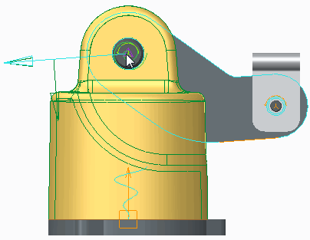**Task 1:** Assign and graph a rotational position, ramp motion.

|  |
| --- |
| 1. Disable all Datum Display types. 2. In the ribbon, select the **Applications** tab. 3. Click **Mechanism**  from the Motion group. 4. Click **Saved Orientations**  from the In Graphics toolbar and select the FRONT view. |
| 1. In the Mechanism Tree, expand **MOTORS** (and   **SERVO**, if necessary).   1. Click **SERVOMOTOR2 (POS - RAMP)** and select   **Edit Definition**  from the mini toolbar.   1. Select the **Profile Details** tab in the Motor dashboard.   ***Note:*** *This motor provides rotational motion of the arm, about the axis shown.* |
| 1. Configure the motor as a ramp motion motor, with the motion defined as a magnitude of position:    * Notice that the Driven Quantity is set to Position, the default setting for servo motors.    * Select **Ramp** (q = A + B*t) from the Function Type drop-down list.    * If necessary, edit constant coefficient A to be **0** and press ENTER.    * Edit the slope B to **9** and press ENTER.    * In the Graph section, select the check boxes for **Velocity** and **Acceleration**.    * Click **Graph Motor**  to create a graph of the motor's position, velocity, and acceleration over time. |
| ***Note:*** *The graph indicates the following:*   * *The position of the motor ramps from 0 to 90 degrees, over 10 seconds.* * *Velocity is at a constant 9 deg/sec.* * *There is zero acceleration.*   *By default, the graph uses a range of 10 seconds for time.* |
| 9. In the Graphtool dialog box, click **File > Exit**. |

**Task 2:** Assign and graph a rotational velocity, ramp motion.

|  |
| --- |
| 1. Configure the motor as a ramp motion motor, with the motion defined as a magnitude of velocity:    * From the Driven Quantity drop-down list, select **Angular Velocity**. Notice that units are now shown as deg/sec.    * Edit the slope B to **1.8** and press ENTER.    * In the Graph section, select the check boxes for **Position** and **Acceleration**.    * Click **Graph Motor**  to create a graph of the motor's position, velocity, and acceleration over time. |
| Note: The graph indicates the following:   * The velocity of the motor ramps from 0 to 18 deg/sec. * The position magnitude increases from 0 to 90 degrees, over 10 seconds. * Acceleration is a constant 1.8 deg/sec². |

2. In the Graph tool dialog box, click File > Exit.

**Task 3:** Assign and graph a rotational acceleration, ramp motion.

|  |
| --- |
| 1. Configure the motor as a ramp motion motor, with the motion defined as a magnitude of acceleration:    * From the Driven Quantity drop-down list, select **Angular Acceleration**. Notice that units are now shown as deg/sec².    * Edit the slope B to **.54** and press ENTER.    * In the Graph section, select the check boxes for **Position** and **Velocity**.    * Click **Graph Motor**  to create a graph of the motor's position, velocity, and acceleration over time. |
| ***Note:*** *The graph indicates the following:*   * *The acceleration of the motor ramps up from 0 to 5.4 deg/sec².* * *The position magnitude accelerates from 0 to 90 degrees, over 10 seconds.* * *The velocity magnitude accelerates from 0 to 27 deg/sec, over 10 seconds.* |
| 1. In the Graphtool dialog box, click **File > Exit**. 2. Click **Apply Changes**  from the Motor dashboard. |
| 1. In the Mechanism Tree, click to expand the **ANALYSES** node. 2. Click **AnalysisDefinition1 (KINEMATICS)**.    * Click **Run**  from the mini toolbar. |

This completes the procedure.

## Assigning Cosine Motion

Assign cosine motion to a servo motor as a magnitude of position, velocity, or acceleration.

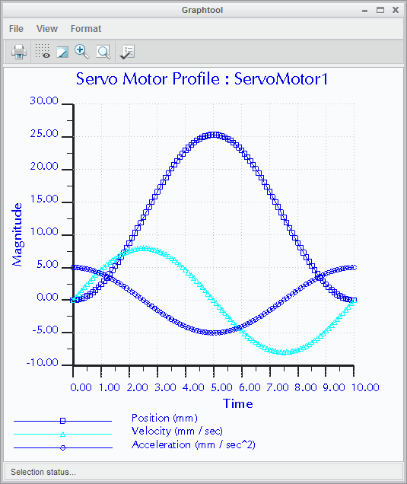Cosine Motion:

* Function:

q = A*cos (360*t/T + B) + C

* + q = Position, Velocity, or Acceleration
  + A = Amplitude
  + B = Phase
  + C = Offset
  + T = Period
* Graph Position, Velocity, and Acceleration

Figure 1 – Graph of Cosine Acceleration, with Resulting Position and Velocity

*Assigning Cosine Motion*

You use a cosine function to assign motion to a servo motor. You can specify the motion as a magnitude of position, velocity, or acceleration.

## PROCEDURE - Assigning Cosine Motion

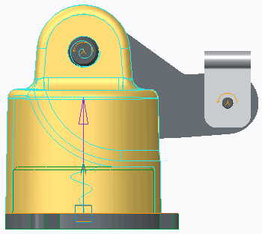**Task 1:** Assign and graph a translational position, cosine motion.

|  |
| --- |
| 1. Disable all Datum Display types. 2. In the ribbon, select the **Applications** tab. 3. Click **Mechanism**  from the Motion group. 4. Click **Saved Orientations**  from the In Graphics toolbar and select the FRONT view. |
| 1. In the Mechanism Tree, expand **MOTORS** (and   **SERVO**, if necessary).   1. Click **SERVOMOTOR1 (POS - COSINE)** and select **Edit Definition** . 2. Select the **Profile Details** tab in the Motor dashboard.   ***Note:*** *This motor provides upward translational motion of the base, along the motion axis shown.* |
| 1. Configure the motor as a cosine motion motor, with the motion defined as a magnitude of position:    * Notice that the Driven Quantity is set to Position, the default setting for servo motors.    * Select **Cosine** (q = A*cos (360 *t/T + B) + C) from the Function Type drop-down list.    * Edit the amplitude A to **10** and press ENTER.    * Edit the phase B to **0** and press ENTER, if necessary.    * Edit the offset C to **10** and press ENTER.    * Edit the period T to **10** and press ENTER.    * In the Graph section, select the check boxes for **Velocity** and **Acceleration**.    * Click **Graph Motor**  to create a graph of the motor's position, velocity, and acceleration over time. |
| ***Note:*** *The graph indicates that the position of the motor starts at 20 mm, then transitions as a cosine down to 0 and back to 20 mm.* |
| 9. In the Graphtool dialog box, click **File > Exit**. |

**Task 2:** Assign and graph a translational velocity, cosine motion.

1. Configure the motor as a cosine motion motor, with the motion defined as a magnitude of velocity:
   * From the Driven Quantity drop-down list, select **Velocity**. Notice that units are now shown as mm/sec.
   * Edit the amplitude A to **4** and press ENTER.
   * Edit the phase B to **2** and press ENTER.
   * Edit the offset C to **0** and press ENTER.
   * In the Graph section, select the check boxes for **Position** and **Acceleration**.
   * Click **Graph Motor ** to create a graph of the motor's position, velocity, and acceleration over time.

|  |
| --- |
| ***Note:*** *The graph indicates that the velocity of the motor starts at 4 mm/sec, transitions as a cosine down to –4 mm/sec*  *and then back to 4 mm/sec, in the shape of a cosine.* |
| 2. In the Graphtool dialog box, click **File > Exit**. |

**Task 3:** Assign and graph a translational acceleration, cosine motion.

|  |
| --- |
| 1. Configure the motor as a cosine motion motor, with the motion defined as a magnitude of acceleration:    * From the Driven Quantity drop-down list, select **Acceleration**. Notice that units are now shown as mm/sec².    * Edit the amplitude A to **5** and press ENTER.    * Edit the phase B to **0** and press ENTER.    * In the Graph section, select the check boxes for **Position** and **Velocity**.    * Click **Graph Motor**  to create a graph of the motor's position, velocity, and acceleration over time. |
| ***Note:*** *The graph indicates that the acceleration of the motor starts at 5 mm/sec², transitions as a cosine down to –5 mm/sec² and then back to 5 mm/sec², in the shape of a cosine.* |
| 1. In the Graphtool dialog box, click **File > Exit**. 2. Click **Apply Changes**  from the Motor dashboard. |
| 1. In the Mechanism Tree, click to expand ANALYSES node. 2. Click AnalysisDefinition1 (KINEMATICS).    * Click Run  from the mini toolbar. |

This completes the procedure.

## Assigning SCCA Motion

Assign SCCA motion to simulate a cam profile output.

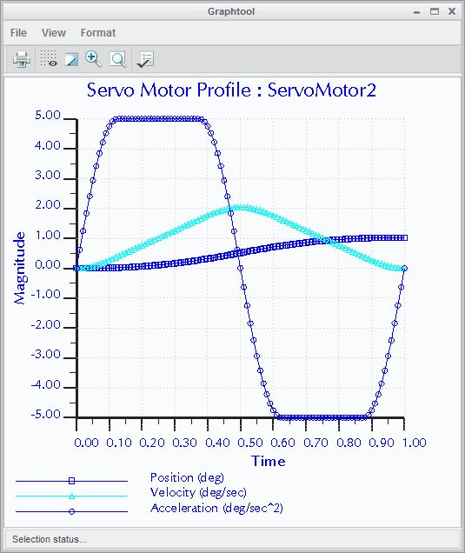SCCA Motion:

* Function:

Sine Constant Cosine Acceleration

* + q = Acceleration
  + A = Increasing Acceleration
  + B = Constant Acceleration
  + H = Amplitude
  + T = Period
* Graph Acceleration



Figure 1 – Graph of SCCA Acceleration

*Assigning SCCA Motion*

You use an SCCA function to simulate a cam profile output. You can specify the motion only as a magnitude of acceleration.

## PROCEDURE - Assigning SCCA Motion

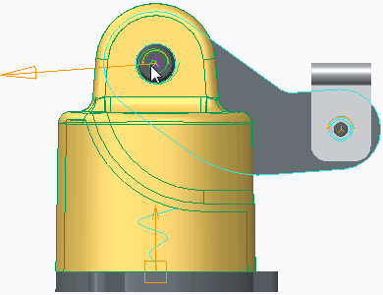**Task 1:** Assign and graph a translational acceleration, SCCA motion.

|  |
| --- |
| 1. Disable all Datum Display types. 2. In the ribbon, select the **Applications** tab. 3. Click **Mechanism**  from the Motion group. 4. Click **Saved Orientations**  from the In Graphics toolbar and select the FRONT view. |
| 1. In the Mechanism Tree, expand **MOTORS** (and   **SERVO**, if necessary).   1. Click **SERVOMOTOR2 (POS - SCCA)** and select   **Edit Definition**  from the mini toolbar.   1. Select the **Profile Details** tab in the Servo dashboard. |
| ***Note:*** *This motor provides rotational motion of the arm, about the axis shown.* |
| 1. Configure the motor as an SCCA motion motor, with the motion defined as a magnitude of acceleration:    * Select **Angular Acceletation** from the Driven Quantity drop-down list.    * Select **SCCA** from the Function Type drop-down list.    * Edit the amplitude A to be **.25** and press ENTER, if necessary.    * Edit the phase B to be **.5** and press ENTER, if necessary.    * Edit the offset H to be **5** and press ENTER.    * Edit the period T to be **1** and press ENTER, if necessary. |
| 1. In the Graph section of the Profile Detail tab, select the check boxes for **Position** and **Velocity**. 2. Click **Graph Motor**  to create a graph of the motor's position, velocity, and acceleration over time. |

|  |
| --- |
| ***Note:*** *The graph indicates the acceleration as a CAM profile.* |
| 1. In the Graph tool dialog box, click **File > Exit**. 2. Click **Apply Changes** . |

This completes the procedure.

## Assigning Parabolic Motion

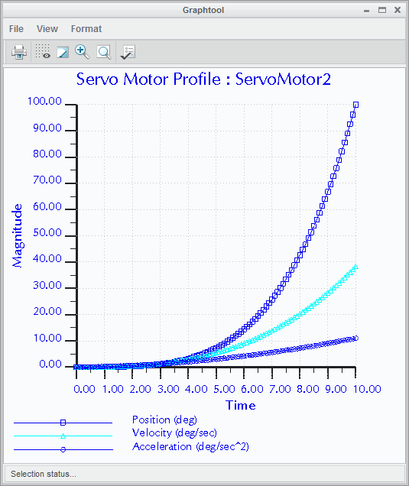Assign parabolic motion to a servo motor as a magnitude of position, velocity, or acceleration. Parabolic Motion:

* Function: q = A*t +1/2 B*t²
  + q = Position, Velocity, or Acceleration
  + A = Linear Coefficient
  + B = Quadratic Coefficient
  + t = time
* Graph Position, Velocity, and Acceleration

*Assigning Parabolic Motion*

Figure 1 – Graph of Parabolic Acceleration, with Resulting Position and Velocity

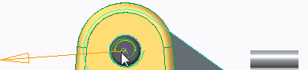You use a parabolic function to assign motion to a servo motor. You can specify the motion as a magnitude of position, velocity, or acceleration.

## PROCEDURE - Assigning Parabolic Motion

**Task 1:** Assign and graph a rotational position, parabolic motion.

|  |
| --- |
| 1. Disable all Datum Display types. 2. In the ribbon, select the **Applications** tab. 3. Click **Mechanism**  from the Motion group. 4. Click **Saved Orientations**  from the In Graphics toolbar and select the FRONT view. |
| 1. In the Mechanism Tree, expand **MOTORS** (and   **SERVO**, if necessary).   1. Click **SERVOMOTOR2 (POS - PARABOLIC)** and select **Edit Definition** . 2. Select the **Profile Details** tab in the Motor dashboard.   ***Note:*** *This motor provides rotational motion of the arm, about the axis shown.* |

|  |
| --- |
| 1. Configure the motor as a parabolic motion motor, with the motion defined as a magnitude of position:    * Notice that the Driven Quantity is set to Angular Position, the default setting for servo motors.    * Select **Parabolic** (q = A*t +1/2 B*t²) from the Function Type drop-down list.    * Edit the linear coefficient A to **1** and press ENTER.    * Edit the quadratic coefficient B to **2** and press ENTER.    * In the Graph section, select the check boxes for **Velocity** and **Acceleration**.    * Click **Graph Motor**  to create a graph of the motor's position, velocity, and acceleration over time. |
| ***Note:*** *The graph indicates the following:*   * *The position increases parabolically from 0 to 110 degrees.* * *Velocity increases uniformly to 21 deg/sec.* * *There is constant acceleration of 2 deg/sec².* |
| 9. In the Graphtool dialog box, click **File > Exit**. |

**Task 2:** Assign and graph a rotational velocity, parabolic motion.

|  |
| --- |
| 1. Configure the motor as a parabolic motion motor, with the motion defined as a magnitude of velocity:    * From the Driven Quantity drop-down list, select **Angular Velocity**. Notice that units are now shown as deg/sec.    * Edit the quadratic coefficient B to **.2** and press ENTER.    * In the Graph section, select the check boxes for **Position** and **Acceleration**.    * Click **Graph Motor**  to create a graph of the motor's position, velocity, and acceleration over time. |
| ***Note:*** *The graph indicates the following:*   * *The velocity of the motor ramps from 0 to 20 deg/sec.* * *The position increases from 0 to approximately 85 degrees.* * *Acceleration increases uniformly from 0 to 3 deg/sec².* |
| 2. In the Graphtool dialog box, click **File > Exit**. |

**Task 3:** Assign and graph a rotational acceleration, parabolic motion.

|  |
| --- |
| 1. Configure the motor as a parabolic motion motor, with the motion defined as a magnitude of acceleration:    * From the Driven Quantity drop-down list, select **Angular Acceleration**. Notice that units are now shown as deg/sec².    * Edit the linear coefficient A to **.1** and press ENTER.    * In the Graph section, select the check boxes for **Position** and **Velocity**.    * Click **Graph Motor**  to create a graph of the motor's position, velocity, and acceleration over time. |
| ***Note:*** *The graph indicates the following:*   * *The acceleration increases parabolically 0 to 11 deg/sec².* * *The position magnitude moves from 0 to 100 degrees.* * *The velocity magnitude accelerates from 0 to 38 deg/sec.* |

|  |
| --- |
| 1. In the Graphtool dialog box, click **File > Exit**. 2. Click **Apply Changes**  from the Motor dashboard. |
| 1. In the Mechanism Tree, click to expand **ANALYSES** node. 2. Click **AnalysisDefinition1 (KINEMATICS)**.    * Click **Run**  from the mini toolbar. |

This completes the procedure.

## Assigning Polynomial Motion

Assign polynomial motion to a servo motor as a magnitude of position, velocity, or acceleration.

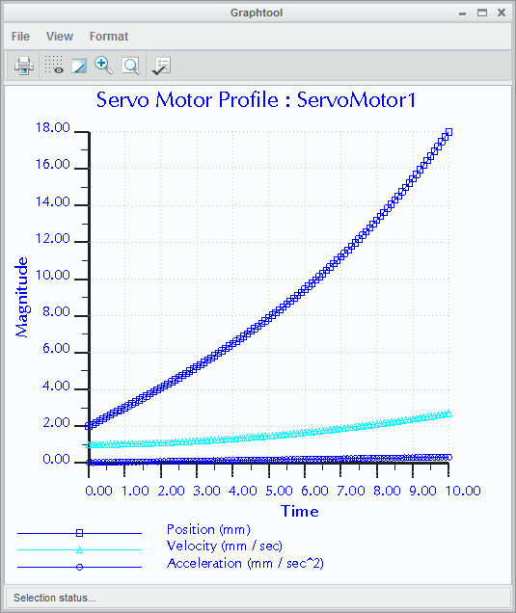Polynomial Motion:

* Function: q = A + B*t + C*t² + D*t³
  + q = Position, Velocity, or Acceleration
  + A = Constant Coefficient
  + B = Linear Coefficient
  + C = Quadratic Coefficient
  + D = Cubic Coefficient
  + t = time
* Graph Position, Velocity, and Acceleration

Figure 1 – Graph of Polynomial Acceleration, with Resulting Position and Velocity

*Assigning Polynomial Motion*

You use a polynomial function to assign motion to a servo motor. You can specify the motion as a magnitude of position, velocity, or acceleration.

## PROCEDURE - Assigning Polynomial Motion

**Task 1:** Assign and graph a translational position, polynomial motion.

1. Disable all Datum Display types.
2. In the ribbon, select the **Applications** tab.
3. Click **Mechanism ** from the Motion group.
4. Click **Saved Orientations ** from the In Graphics toolbar and select the FRONT view.

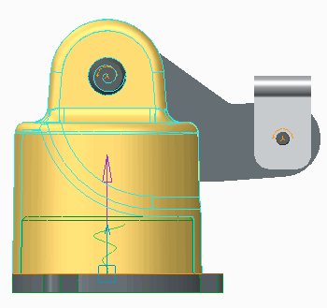

|  |
| --- |
| 1. In the Mechanism Tree, expand **MOTORS** (and   **SERVO**, if necessary).   1. Click **SERVOMOTOR1 (POS - POLYNOMIAL)** and select   **Edit Definition** .   1. Select the **Profile Details** tab in the Motor dashboard.   ***Note:*** *This motor provides upward translational motion of the base, along the motion axis shown.* |
| 1. Configure the motor as a polynomial motion motor, with the motion defined as a magnitude of position:    * Notice that the Driven Quantity is set to Position, the default setting for servo motors.    * Select **Polynomial** (q = A + B*t + C*t² + D*t³) from the Function Type drop-down list.    * Edit the constant coefficient A to **2** and press ENTER.    * Edit the linear coefficient B to **1** and press ENTER.    * Edit the quadratic coefficient C to **.01** and press ENTER.    * Edit the cubic coefficient D to **.005** and press ENTER.    * In the Graph section, select the check boxes for **Velocity** and **Acceleration**. |
| 9. Click **Graph Motor**  to create a graph of the motor's position, velocity, and acceleration over time.  ***Note:*** *The graph indicates the following:*   * *The position increases from 2 to 18 mm.* * *Velocity increases from 1 to 2.7 mm/sec.* * *Acceleration increases from .02 to .32 mm/sec².* |
| 1. In the Graphtool dialog box, click **File > Exit**. 2. Click **Apply Changes**  from the Servo Motor Definition dashboard.   ***Note:*** *Like most motion types, polynomial motion can also be deflned as a magnitude of velocity and acceleration.* |
| 1. In the Mechanism Tree, click to expand **ANALYSES** node. 2. Click **AnalysisDefinition1 (KINEMATICS)**.    * Click **Run**  from the mini toolbar. |

This completes the procedure.

## Assigning Table Motion

Assign table motion to a servo motor as a magnitude of position, velocity, or acceleration.

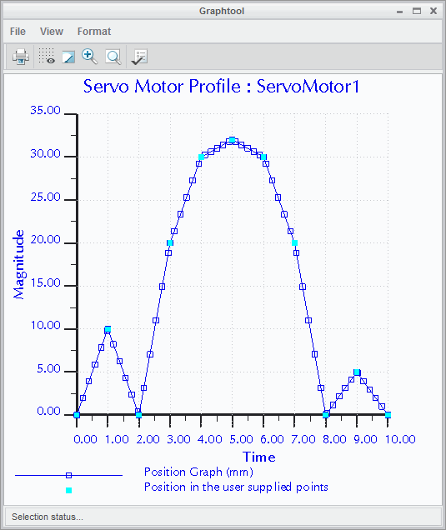Table Motion:

* Create custom motor profiles.
* Read data from text file.

*Assigning Table Motion*

Figure 1 – Graph of Table Acceleration, with Resulting Position and Velocity

You use a table function to assign custom motion profiles to a servo motor. You can create motion profiles that cannot be defined by a function. You can also specify the motion as a magnitude of position, velocity, or acceleration.

The table motion is defined by a two-column table, the first column being time and the second being magnitude. You can read the table from a text file or create it in the Motor dashboard.

## PROCEDURE - Assigning Table Motion

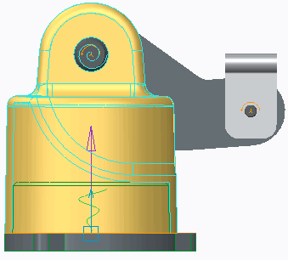**Task 1:** Assign and graph a translational position, table-defined motion.

|  |
| --- |
| 1. Disable all Datum Display types. 2. In the ribbon, select the **Applications** tab. 3. Click **Mechanism**  from the Motion group. 4. Click **Saved Orientations**  from the In Graphics toolbar and select the FRONT view. |
| 1. In the Mechanism Tree, click to expand   **MOTORS** (and **SERVO**, if necessary).   1. Click **SERVOMOTOR1 (POS - TABLE)** and select   **Edit Definition** .   1. Select the **Profile Details** tab in the Motor dashboard.   ***Note:*** *This motor provides upward translational motion of the base, along the motion axis shown.* |

* 1. Configure the motor as a table-defined motion motor, with the motion defined as a magnitude of position:
     + Notice that the Driven Quantity is set to Position, the default setting for servo motors.
     + Select **Table** from the Function Type drop-down list.
     + Click **Open File ** and double-click TRANS_TABLE.TAB.
     + Click **Graph Motor ** to create a graph of the motor's position as driven by the table.
  2. In the Graphtool dialog box, click **File > Exit**.
  3. Click **Apply Changes ** from the Motor dashboard.

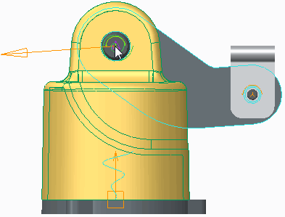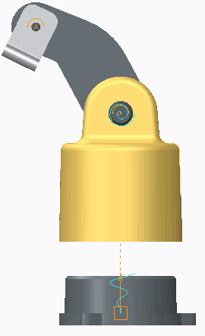**Task 2:** Assign and graph a rotational position, table motion.

|  |
| --- |
| 1. In the Mechanism Tree, expand **MOTORS** (and   **SERVO**, if necessary).   1. Click **SERVOMOTOR2 (POS - TABLE)** and select   **Edit Definition** .   1. Select the **Profile Details** tab in the Motor dashboard. |
| ***Note:*** *This motor provides rotational motion of the arm, about the axis shown.* |
| 1. Configure the motor as a table-defined motion motor, with the motion defined as a magnitude of position:    * Select **Table** from the Function Type drop-down list.    * Click **Open File**  and double-click ROT_TABLE.TAB.    * Click **Graph Motor**  to create a graph of the motor's position as driven by the table. 2. In the Graphtool dialog box, click **File > Exit**. 3. Click **Apply Changes**  from the Motor dashboard. 4. In the Mechanism Tree, click to expand the   **ANALYSES** node.   1. Click **AnalysisDefinition1 (KINEMATICS)**.    * Click **Run**  from the mini toolbar. 2. In the Linear Fit servo Motors dialog box, click   **Confirm**. |

This completes the procedure.

# Module 11

## Adding Dynamic Entities to a Mechanism

## Defining Mass Properties for a Dynamic Analysis

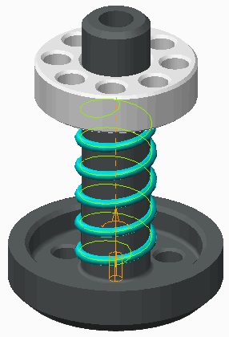To run a dynamic analysis of a mechanism, each component must have an assigned density. Assigning Mass Properties:

* Assign a material.
* Assign density and other mass properties.
* Assign mechanism mass properties.

Figure 1 – Gravity Enabled Analysis

###### Defining Mass Properties for a Dynamic Analysis

To run Mechanical Dynamic analysis, you must assign mass properties to components of your mechanism.

The mass properties of a mechanism component consist of its applied density and associated volume, mass, center of gravity, and moment of inertia. These properties determine how your mechanism resists a change in its speed or position upon the application of a force.

###### Assigning Mass Properties

You can assign mass properties using a variety of methods from within standard Creo Parametric or from within Mechanism Dynamics mode:

* Material – In standard Creo Parametric, you can assign a material to each component. To do this, click File **>** Prepare **>** Model Properties and then click change from the Material field in the Materials section of the Model Properties dialog box. Finally, select the material you wish to apply. Each material definition contains the density, Poisson's ratio, and Young's modulus associated with the material. Volume, mass, center of gravity, and moment of inertia are then calculated based on the material information.
* Density and Other Properties – In standard Creo Parametric, you can assign a density to the geometry of a component. By using a file as the source of mass properties, you can assign not only density but volume, mass, center of gravity, and moment of inertia to components. To do this, click File **>** Prepare

**>** Model Properties and then click change from the Mass Properties field in the Materials section of the Model Properties dialog box. Finally, select the source to be Geometry and Density, Geometry and Parameters, or Fully Assigned. Using the Fully Assigned option, you can assign volume and mass values to a component that does not yet have a defined volume.

* Mechanism Mass Properties – You use the Mass Properties dialog box in Mechanism Dynamics to specify or review the mass properties of a selected part, assembly, or body. You start the Mass Properties dialog box by clicking **Mass Properties ** from the Properties and Conditions group in the Mechanism tab. This option is helpful for evaluating a mechanism based on various material

properties, without actually changing the properties in the Creo Parametric components.

###### Using the Mass Properties Dialog Box

Mass property information defined in Mechanism Dynamics is valid only in Mechanism Dynamics and overrides Creo Parametric mass definitions during any Mechanism Dynamics session. The Mass Properties dialog box provides the following functionality and limitations:

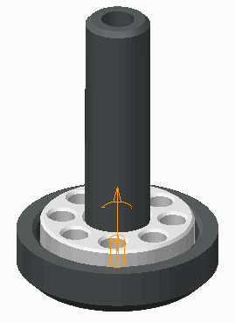

* You can specify mass, center of gravity, and inertia for a part. If the part has non-zero volume, you can specify its density, and its mass is calculated accordingly.
* You can only specify an assembly's density for the mass to be calculated.
* A body's mass properties can be reviewed but not edited.

###### Viewing Mass Property Information

To view the mass property information associated to a mechanism, right-click Mechanism in the Mechanism Tree and click Info **>** Mass Property. You can also click **Mass Property ** from the Information group in the Mechanism tab.

## PROCEDURE - Defining Mass Properties for a Dynamic Analysis

**Task 1:** Run an analysis to observe gravity's effect on the model.

|  |
| --- |
| 1. Disable all Datum Display types. 2. In the ribbon, select the **Applications** tab. 3. Click **Mechanism**  from the Motion group. 4. In the Mechanism Tree, expand the **ANALYSES** node. 5. Click **Gravity1(DYNAMICS)** and select **Edit Definition**  from the mini toolbar. 6. In the Analysis Definition dialog box, select the **External loads** tab. 7. Click **Run**.   ***Note:*** *The mechanism does not move because gravity is not enabled and there is no motor or force driving the mechanism.* |
| 1. Select the **Enable gravity** check box and click   **Run**.   1. Click **Yes** to confirm.   ***Note:*** *Gravity completely compressed the spring. The stiffness coefflcient of the spring is too small, or the mass of MP2.PRT is too large.* |
| 1. Click **OK** to close the dialog box. 2. At the top of the model tree, click **Settings**  and select **Tree Filters** . 3. Select the **Features** check box and click **OK**.   ***Note:*** *Notice in the dashboard that the stiffness coefflcient is 250 kg/sec².*   1. In the model tree, edit the definition of Spring 1. 2. Click **Cancel Feature** . |

**Task 2:** Change the mass properties of the model by assigning a material.

|  |
| --- |
| 1. In the model tree, select .PRT and click **Open**  from the mini toolbar. 2. Click **Don’t save** in the Save Playbacks dialog box. 3. Click **File > Prepare > Model Properties**. 4. In the Materials section, click **change** in the Mass Properties row. Review the Density.   ***Note:*** *The density for this model is 1. This explains why the mass was large enough to compress the spring.*   1. Click **OK** to close the Mass Properties dialog box. 2. In the Materials section, click **change** in the Material row. |
| 1. In the Materials dialog box, double-click the Legacy Materials folder.    * Right-click **al2014.mtl** and select **Assign**. 2. Click **OK** to close the dialog box. 3. In the Materials section, click **change** in the Mass Properties row. Review the Density.   ***Note:*** *The density for this model is now 2.793554e-06 kg/mm³ per the assigned material.* |
| 1. Click **OK** to close the Mass Properties dialog box. 2. Click **Close**. 3. In the Quick Access toolbar, click **Close** to close the part window. 4. In the Mechanism Tree, expand the **ANALYSES**   node.  Select **Gravity1(DYNAMICS)**, and click **Run** from the mini  toolbar. |

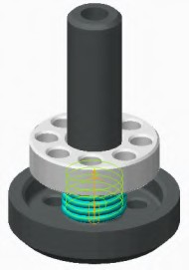**Task 3:** Analyze the mechanism by editing the density within the mechanism.

|  |
| --- |
| 1. Click **Mass Properties**  from the Properties and Conditions group. 2. Select MP2.PRT from the model tree. 3. In the Mass Properties dialog box, select **Density** from the Define properties by drop-down list. |
| 1. Edit the Density to **6.5e-06** (the approximate density of iron), press ENTER, and click **OK**. 2. In the Mechanism Tree, select **Gravity1(DYNAMICS)** and click **Run** from the mini toolbar. 3. Click **Yes** in the Confirmation message window to confirm. 4. Open MP2.PRT from the model tree.    * Click **Don’t save** in the Save Playbacks dialog box. |

##### Click File > Prepare > Model Properties.

1. In the Materials section, click **change** in the Mass Properties row. Review the Density.

***Note:*** *The density previously deflned is only valid in the mechanism in which it was deflned. It is best to use this tool for temporary edits of mass property values.*

1. Click **OK** to close the Mass Properties dialog box.
2. Click **Close**.

This completes the procedure.

## Creating Force Motors

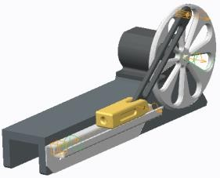Force motors enable you to apply force to the motion axis of a connection. Force Motors:

* + Translational Force
  + Rotational Torque
  + Slot Motor
  + Same magnitude options as servo motors

Figure 1 – Force Motors

###### Creating Force Motors

Force motors enable you to apply force to the translational force motor, or torque to the rotational motion axis of a connection. A force motor will impose a load between two bodies within a single degree of freedom.

The Force Motor tool is only available in Mechanism mode and can be started using one of the following methods:

* Click **Force Motors ** from the Insert group.
* Expand MOTORS in the Mechanism Tree, select FORCE, and click **New** from the mini toolbar.

***Note:*** *Force motors are only available when your license of Creo Parametric contains the Mechanism Dynamics Option (MDO).*

###### Types of Force Motors

There are three types of force motors: translational, rotational, and slot. The type of force motor created is dependent on the type of motion axis to which it is referenced:

* Translational Force Motor – A force motor applied to a translational motion axis of a connection imposes a force along that axis.
* Rotational Torque Motor – A force motor applied to a rotational motion axis of a connection imposes a torque about that axis.
* Slot Motor – A force motor applied along a slot axis.

###### Magnitude of Force Motors

The magnitude options within the Force Motor dashboard are similar to the Servo Motor dashboard. There are nine options:

* Constant – Imparts a constant force or torque.
* Ramp – Imparts a force or torque that changes linearly over time.
  + Cosine – Imparts an oscillating force or torque load.
  + Cycloidal – Enables you to simulate a cam profile output.
  + Parabolic – Enables you to simulate a trajectory.
  + Polynomial – Enables you to create custom polynomial force/torque loads.
  + Table – Enables you to create custom motor profiles that cannot be defined by a function.
  + User defined – Enables you to create custom motor profiles that cannot be defined by a function.
  + Custom load – Enables you to create custom motor profiles that cannot be defined by a function.

## PROCEDURE - Creating Force Motors

Close Window  Erase Not Displayed 

**Task 1:** Create a rotational torque motor.

|  |
| --- |
| 1. Disable all Datum Display types. 2. In the ribbon, select the **Applications** tab. 3. Click **Mechanism**  from the Motion group. |
| 1. Click **Force Motors**  from the Insert group.    * Select the **Connection_1** rotation axis, as shown.    * Select the **Profile Details** tab.    * In the Motor dashboard, select **Ramp** from the Function Type drop-down list.    * Edit the value of A to **1** and press ENTER.    * Edit the value of B to **20** and press ENTER.    * Click **Complete Feature** . |
| 1. In the Mechanism Tree, select **ANALYSES** and click   **New** from the mini toolbar.   1. Select **Dynamic** from the Type drop-down list. 2. Edit the Duration value to **11** and press ENTER. 3. In the Initial Configuration section, select   **I.C.State:**.   1. Click **Run**. 2. Click **OK**. |

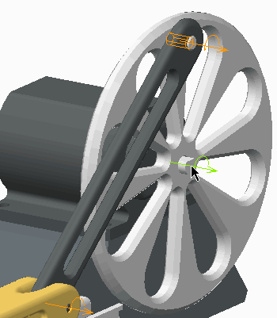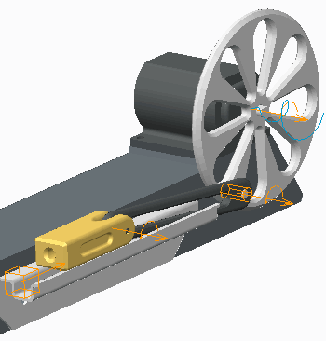

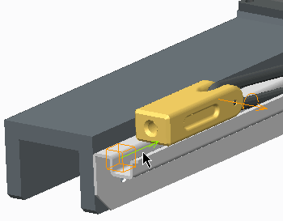**Task 2:** Create a translational force motor.

|  |
| --- |
| 1. In the Mechanism Tree, expand the **MOTORS**   node, select **FORCE**.  Select **FORCE**, and click **New** from the mini toolbar.   * + Select the **Connection_7** translation axis, as the Driven Entity.   + Select the **Profile Details** tab.   + Edit the value of A to **10** and press ENTER.   + Click **Complete Feature** . |
| 1. In the Mechanism Tree, click to expand **ANALYSES** . 2. Select **AnalysisDefinition1(DYNAMICS)**, and click **Edit Definition**  from the mini toolbar. 3. In the Analysis Definition dialog box, select the **Motors** tab. 4. Click **Add New Row** . 5. Click the second **Motor1** listed. 6. Select **Motor2** from the drop-down list. |
| 1. Select the **External loads** tab. 2. Select the **Enable gravity** check box. 3. Click **Run** and then click **Yes** to confirm. 4. Click **OK**. |
| ***Note:*** *The initial rotational force of Motor1 is not large enough to overcome the translational force of Motor2. However, because the magnitude of the force applied by Motor1 is deflned as a Ramp proflle, the magnitude*  *eventually increases enough to overcome Motor2.* |

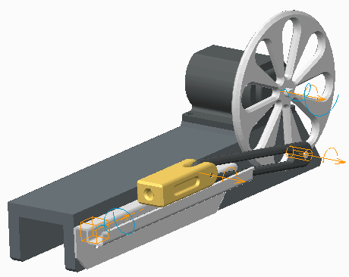**Task 3:** Build relation between motors.

|  |
| --- |
| 1. Select the **Tools** tab. 2. Click **Relations** from the Model Intent group. 3. In the Relations dialog box, click **Insert Parameter**  . 4. Select **Feature** from the Object Type drop-down list. |
| 1. Expand the **Force** node in the Mechanism Tree and select **Motor 2 (FORCE_MOTOR)**. 2. Click **Insert Selected**. 3. Place the cursor at the end of the expression and type **=**. 4. Click **Insert Parameter**  . |
| 1. Select **Feature** from the Object Type drop-down list. 2. Select **Motor 1 (FORCE_MOTOR)**. 3. Select the parameter name **A** and click **Insert Selected**. 4. Type **\*10**. |

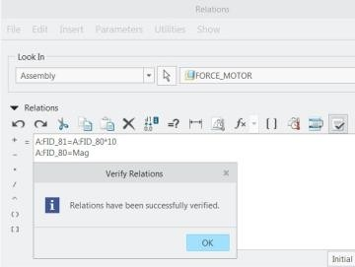

|  |
| --- |
| 1. Press ENTER and type **A:FID_80=Mag** in the next line. 2. Expand the **Local Parameters** node. 3. Click **Add New Parameter** in the Local Parameters. 4. Edit the name to Mag and press ENTER. 5. Ensure Type is set to Real Number and click   **Verify Relations** . |
| 18. Click **OK** to close the Verify Relations dialog box. |

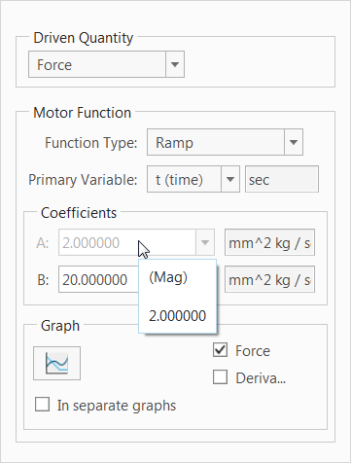**Task 4:** Update and Verify the relations.

|  |
| --- |
| 1. Edit the value of parameter MAG to **2** and press ENTER. 2. Click **OK** to close the Relations dialog box. 3. Click **Regenerate**  twice from the Quick Access toolbar. 4. Expand the **MOTORS** node and then the **FORCE**   node.   1. Edit the definition of Motor 1 (FORCE_MOTOR). 2. Select the **Profile Details** tab.    * Notice the value of Coefficient A is set to 2 and grayed out. |
| 1. Click **Cancel Feature** . 2. Edit the definition of Motor 2 (FORCE_MOTOR) and select the **Profile Details** tab.    * Notice the value of Coefficient A is set to 20 and grayed out. 3. Click **Cancel Feature** . |

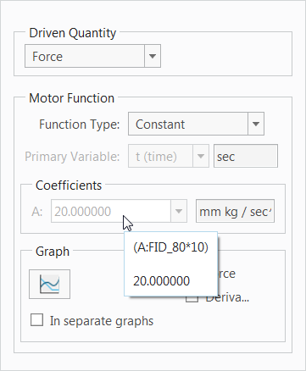This completes the procedure.

## Creating Springs

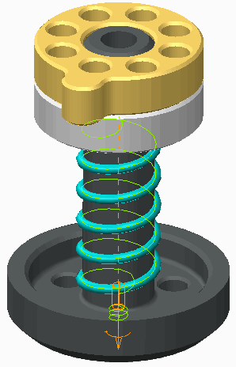A spring generates a translational or rotational spring force in a mechanism. Springs:

* Extension and Compression Springs
* Torsion Spring
* Force = K * (x–U)

Figure 1 – Mechanism Springs

###### Creating Springs

Mechanism springs are used to simulate a real spring by imparting linear and rotational forces on components of a mechanism. Springs produce a linear force when stretched or compressed, and a torsional force when rotated. This force returns the spring to a position of equilibrium; that is, the position in which it is not affected by any external force (relaxation).

Springs are a special mechanism feature that can be viewed in Mechanism and Standard mode; they are not separate part models.

The Spring tool is only available in Mechanism mode and can be started using one of the following methods:

* Click **Springs ** from the Insert group.
* In the Mechanism Tree, select Springs and click **New** from the mini toolbar.

***Note:*** *Springs are only available when your license of Creo Parametric contains the Mechanism Dynamics Option (MDO).*

###### Spring Types

Spring types include:

* Extension and Compression Springs – You create an extension or compression spring by referencing either a connection's translation axis or two points in the mechanism that define the start and end locations of the spring. A referenced translation axis creates an extension spring, which produces linear force upon extension or compression. Referenced points produce an extension or compression between the two points and can be used to dampen two bodies not connected by a connection. The referenced points can be datum points, model vertices, or geometry points.
* Torsion Spring – You create torsion springs by selecting a connection's rotation axis. The spring produces a torque about the referenced axis.

*Spring Properties*

When you place a spring in your model, you can specify its stiffness at that location. The stiffness can be translational (force per unit length) or torsional (torque). The force generated by the spring is proportional to the amount of displacement that occurs. For example, if you double the displacement, you double the force.

The magnitude of the spring force is proportional to the amount of displacement from the position of equilibrium. This is shown in the equation Force = K * (x–U) where:

* + K – Sets the stiffness coefficient of the spring.
  + U – Sets the unstretched length of the spring.
  + x – Stretched or compressed length of the spring.

In the Options tab, you can click Adjust Icon Diameter and set the diameter of an extension spring icon. The size of the torsion spring icon cannot be adjusted.

## PROCEDURE - Creating Springs

Close Window  Erase Not Displayed 

**Task 1:** Create a linear spring.

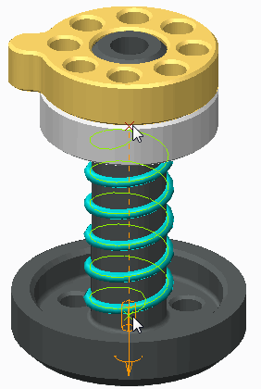

|  |
| --- |
| 1. Enable only the following Datum Display types: . 2. In the ribbon, select the **Applications** tab. 3. Click **Mechanism**  from the Motion group. |
| 1. Select **Springs**  from the Insert group.    * In the graphics window, select datum point   **BOTTOM_SPRING**.   * + Press CTRL and select datum point   **TOP_SPRING**.   * + Edit the stiffness coefficient K to **300** and press ENTER.   + Click the **Options** tab and then select the   **Adjust Icon Diameter** check box.   * + Edit the Diameter to **52** and press ENTER.   + Click **Complete Feature** . |

**Task 2:** Create a torsion spring.

* 1. 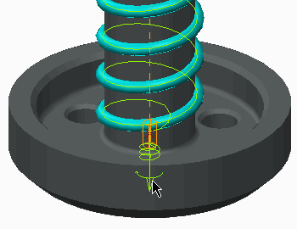Click **Springs ** .
     + Right-click in the graphics window and select

##### Torsion .

* + - Select the motion axis of **Connection_1**, as shown.
    - Edit the stiffness coefficient K to **200** and press ENTER.
    - Edit the spring equilibrium displacement U to

**180** and press ENTER.

* + - Click **Complete Feature** .

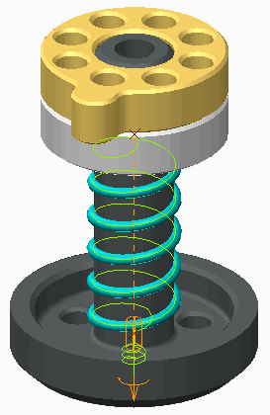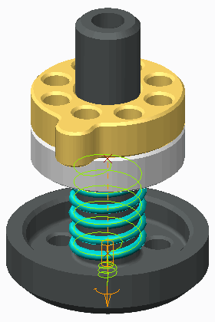**Task 3:** Run an analysis of the mechanism's motion.

|  |
| --- |
| 1. In the Mechanism Tree, select **ANALYSES** and click   **New**  from the mini toolbar.   1. Select **Dynamic** from the Type drop-down list. 2. Edit the Duration value to **5** and press ENTER. 3. In the Initial Configuration section of the dialog box, select the **I.C.State:** option. 4. Click **Run**. |
| 1. Select the **External loads** tab and select the   **Enable gravity** check box.   1. Click **Run** and then click **Yes** to confirm. 2. Click **OK**. |
| 1. In the Mechanism Tree, expand the **SPRINGS**   node.   1. Edit the definition of **Spring1(SPRINGS)**. 2. Edit the stiffness coefficient K to **900** and press ENTER. 3. Click **Complete Feature** . 4. In the Mechanism Tree, expand the **ANALYSES** node, select **AnalysisDefinition1(DYNAMICS)** and click **Run**  from the mini toolbar. 5. Click **Yes** to confirm. |
| ***Note:*** *Because you increased the stiffness of the linear spring, there is less movement depicted in the analysis run.* |

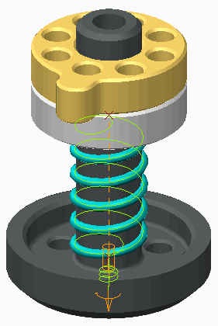This completes the procedure.

## Creating Dampers

Dampers are a type of load you create to simulate friction forces on your mechanism.

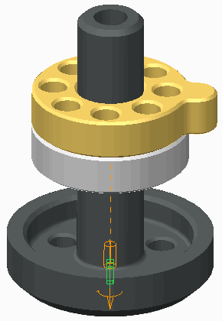Dampers:

* + - Extension Damper
    - Torsion Damper
    - Force = C * Velocity

Figure 1 – Dampers Remove Energy

###### Creating Dampers

Dampers enable you to create a linear or torsional damping force on your assemblies. A damper is a type of load you create to simulate friction forces on your mechanism. The force generated by the damper removes energy from a moving mechanism, thus dampening its motion.

The Damper tool is only available in Mechanism mode and can be started using one of the following methods:

* + Click **Dampers ** from the Insert group.
  + In the Mechanism Tree, select Dampers and click **New** from the mini toolbar.

***Note:*** *Dampers are only available when your license of Creo Parametric contains the Mechanism Dynamics Option (MDO).*

###### Damper Types

There are two types of dampers:

* + Extension Damper – You create an extension damper by referencing either a connection's translation axis (two points in the mechanism that define the start and end locations of the damper), or by referencing a slot connection. A referenced translation axis creates an extension damper, which produces a linear damping force. A damper created between points produces a damping force between the two points. The referenced points can be datum points, model vertices, or geometry points. A damper created by referencing a slot connection applies a dampening force along the path of the slot.
  + Torsion Damper – You create torsion dampers by selecting a connection's rotation axis. The damper produces a dampening torque about the referenced axis.

###### Damper Properties

The damper force is always proportional to the velocity of the entity on which you are applying the damper and it acts opposite to its motion.

The magnitude of the dampening force is defined as Force = C * Velocity, where C is the dampening coefficient of the damper.

## PROCEDURE - Creating Dampers

Close Window  Erase Not Displayed 

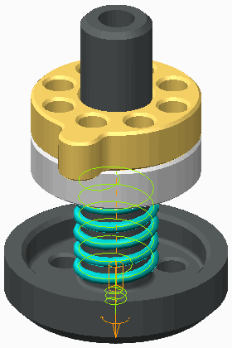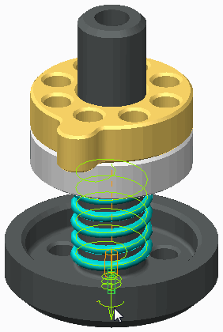**Task 1:** Create an extension/compression damper.

|  |
| --- |
| 1. Disable all Datum Display types. 2. In the ribbon, select the **Applications** tab. 3. Click **Mechanism**  from the Motion group. 4. In the Mechanism Tree, expand the **ANALYSES** node, select **AnalysisDefinition1(DYNAMICS)**, and click **Run**  from the mini toolbar.   ***Note:*** *There is no force removing energy from the mechanism's movement.* |
| 1. Click **Dampers**  from the Insert group.    * Select the motion axis of **Connection_1**.    * Edit the dampening coefficient C to **200** and press ENTER.    * Click **Complete Feature** . 2. In the Mechanism Tree, select **AnalysisDefinition1(DYNAMICS)** and click **Run**  from the mini toolbar. 3. Click **Yes** to confirm. |
| ***Note:*** *The damper removed energy from themechanism.* |

**Task 2:** Create a torsion damper.

1. 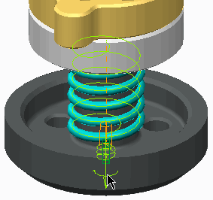Click **Dampers **.
   * Right-click in the graphics window and select

##### Torsion .

* + Select the motion axis of **Connection_1**.
  + Edit the dampening coefficient C to **200** and press ENTER.
  + Click **Complete Feature** .

1. In the Mechanism Tree, select **AnalysisDefinition1(DYNAMI CS)** and click **Run ** from the mini toolbar.
2. Click **Yes** to confirm.

***Note:*** *The damper removed torsional energy from the mechanism.*

This completes the procedure.

## Creating Dynamic Gear Connections

Create different types of common gear connections.

* + Types
    - Spur
    - Bevel
    - Rack and pinion
    - Worm
  + Gear Properties
    - Pitch Diameter
    - Pressure angle
    - Helix Angle
    - Bevel angle
    - Screw Angle

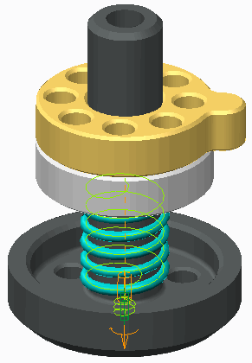

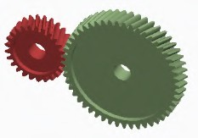

Figure 1 – Spur Gears

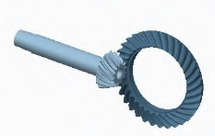

Figure 2 – Bevel Gears

 

Figure 3 – Worm Gears Figure 4 – Rack and pinion Gears

###### Creating Dynamic Gear Connections

You can create gear connections in Mechanism mode that utilize manufacturing tooth angles to determine their motion properties. Properties such as pitch diameter, pressure angle, helix, bevel, and screw angles are used to compute motion, as well as kinematic and dynamic analyses. Dynamic analyses can include reaction forces based on the tooth geometry at the location where the pitch diameters meet. The system can automatically calculate pitch circle diameters and bevel angles.

Examples of the four dynamic gear types include:

* Spur – Two meshing gears rotating on parallel axes.
* Bevel – A pinion gear driving a crown gear on perpendicular axes.
* Rack and pinion – A pinion gear meshing with a sliding rack gear.
* Worm – A worm shaft rotating a pinion on perpendicular axes. Dynamic gears also have several properties that you can define:
* Pitch Diameter – Specify a pitch diameter for the first gear in the pair, and the corresponding pitch diameter is automatically calculated. You can also use the User Defined option to manually input both values or the ratio manually.
* Pressure angle – A gear tooth pressure angle for all gear types.
* Helix Angle – A gear tooth Helix angle for Spur, Bevel, and Rack and Pinion gears.
* Bevel angle – Determined automatically for Bevel Gears based on geometry.
* Screw Angle – Defines the screw angle for worm gears.
* Icon location – Defines a plane to display and calculate the gear connection.

***Note:*** *Once deflned, you can simply press CTRL+ALT to drag gears in Standard Assembly mode or in Mechanism mode.You can also click* ***Drag Components*** *to drag connected components with additional options, such as creating snapshots.*

## PROCEDURE - Creating Dynamic Gear Connections

**Task 1:** Create a Spur gear connection.

|  |
| --- |
| 1. Disable all Datum Display types. 2. In the ribbon, select the **Applications** tab. 3. Click **Mechanism**  from the Motion group. 4. Click **Gears**  from the Connections group.    * Select **Spur** as the Type. 5. Select the pin joint on the smaller gear.    * Type **100** for the Diameter and press ENTER. |
| 1. Select the **Gear 2** tab in the Gear Pair Definition dialog box.    * Select the pin joint on the larger gear. 2. Select the **Properties** tab.    * Type **–20** for the Helix Angle and press ENTER.    * Click **OK**. 3. Press CTRL+ALT and drag either gear.    * Click **Close** from the Quick Access toolbar. |

***Note:*** *You can also click* ***Drag Components *** *to drag connected components.*

**Task 2:** Create a Bevel gear connection.

1. Click **Working Directory ** from the Common Folders.
   * Double-click BEVEL_GEARS.ASM.
2. In the ribbon, select the **Applications** tab.
3. Click **Mechanism **.
4. Click **Gears **.
   * Select **Bevel** as the Type.
5. Select the pin joint on the large crown gear.
   * Type **175** for the Diameter and press ENTER.
   * Enable **Plane Display **.
   * Select DTM1 as the Icon location.
6. Disable **Plane Display **.
7. Select the **Gear 2** tab in the Gear Pair Definition dialog box.
   * Select the pin joint on the smaller pinion gear.
8. Select the **Properties** tab.
   * Type **–36** for the Helix Angle and press ENTER.
   * Click **OK** in the Gear Pair Definition dialog box.
9. Press CTRL+ALT and drag either gear.
   * Click **Close** from the Quick Access toolbar.





**Task 3:** Examine the Rack and pinion and Worm gear connections

|  |
| --- |
| 1. Click **Working Directory**  from the Common Folders.    * Double-click RACK_PINION_GEARS.ASM. 2. Press CTRL+ALT and drag either gear.    * Click **Close** from the Quick Access toolbar. |
| 1. Click **Working Directory** .    * Double-click WORM_GEARS.ASM. 2. Press CTRL+ALT and drag either gear.    * Click **Close** from the Quick Access toolbar. |

This completes the procedure.

## Creating Belt Connections

Create belts that connect pulleys to create and analyze motion.

* + 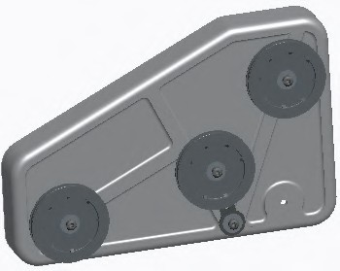Connect pulleys for rotation
* Planar belt path
* Belt length
* Belt flexibility
* Create belt model

– From belt curve

Figure 1 – Original Model

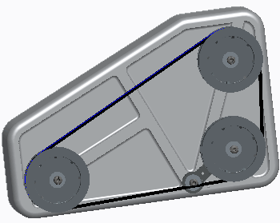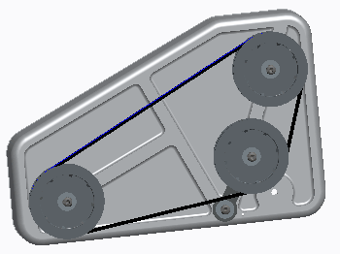

Figure 2 – Belt Created Figure 3 – Belt Modified

###### Creating Belt Connections

In Mechanism mode, you create belts in a planar path that connect pulleys to transmit rotation. You can control the belt length and flexibility. Once a belt connection is defined, you can create a part model containing the belt curve. From this curve, you can create solid geometry to represent the belt.

**Belts have several options:**

* + Belt Direction – Indicates on which side the belt travels around the pulley.
  + Pulley Diameter – By default is coincident to the selected pulley surface. You can also specify a value from the dashboard or on-screen leaders.
  + Number of wraps – Indicates the number of wraps the belt should take around the pulley. The default is 1 wrap.
  + Belt Length – Belts default to a natural length defined by the belt path. You can then specify a fixed length.
  + Belt plane – A selected plane that defines the centerline of the belt path.
  + Flexibility – Indicates a set value for the E*A parameter. (Young’s Modulus multiplied by cross-section area.)
  + Body Definition – Indicates which body is defined as the moving pulley body versus the stationary carrier body.

***Note:*** *You can perform kinematic and dynamic analyses of belts and pulleys in Mechanism mode.*

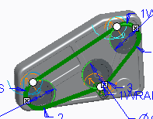

## PROCEDURE - Creating Belt Connections

**Task 1:** Create a belt on an existing pulley mechanism.

|  |
| --- |
| 1. Disable all Datum Display types. 2. In the ribbon, select the **Applications** tab. 3. Click **Mechanism**  from the Motion group. 4. Click **Belts**  from the Connections group. 5. Press CTRL and select cylindrical surfaces from the two main pulleys. |
| 6. Press CTRL and select the cylindrical surface from the idler pulley. |
| 1. Right-click the belt handle on the idler pulley and select **Flip Belt Direction**.    * Notice that the belt now follows a different path. |
| 1. Type **80** for the E*A value and press ENTER. 2. Click **User-Defined Length** .    * Type **1250** for the belt length and press ENTER. 3. Click **Complete Feature** from the Belt dashboard. 4. Press CTRL+ALT and drag any of the pulleys. |

**Task 2:** Create a solid belt part and some solid geometry.

|  |
| --- |
| 1. Select the belt, then right-click and select **Make Part**.    * Type **BELT** as the Name and click **OK**.    * Click **Browse**.    * Select TEMPLATE.PRT.    * Click **Open** and **OK**. 2. Right-click and select **Default Constraint**. 3. Click **Complete Component** from the Component Placement dashboard. |
| 1. In the ribbon, select the **Applications** tab. 2. Click **Mechanism** . 3. Click BELT.PRT in the model tree and select   **Activate**  from the mini toolbar.   1. Click **User-Defined Feature**  from the Get Data group.    * Select FLAT_BELT.GPH and click **Open**. Click   **OK**.   * + Select the belt curve in the graphics window and   click **Apply Changes**  in the User Defined Feature Placement dialog box. |
| 1. In the ribbon, select the **Applications** tab. 2. Click **Mechanism** . 3. Select the belt in the graphics window, then click   **Edit Definition**  from the mini toolbar.   * + Type **1200** as the length and press ENTER. * Click **Complete Feature** from the Belt dashboard. * Click **Regenerate**  from the Quick Access toolbar. |

This completes the procedure.

## Using Dynamic Properties and Set Zero Position

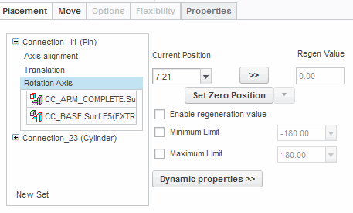The Mechanism Dynamics Option (MDO) enables you to define a zero position and apply restitution and friction to the motion axis of a connection.

Defining Set Zero Position:

* + - Set Zero Position
    - Default Zero Position Applying Dynamic Properties:
    - Display Dynamic Properties
    - Hide Dynamic Properties

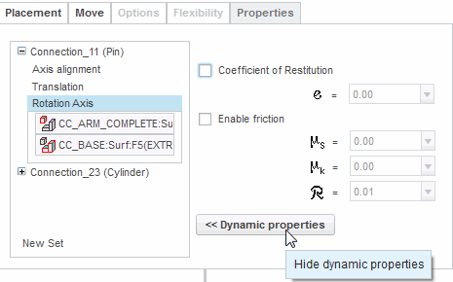Figure 1 – Set Zero Position and Display Dynamic Properties

Figure 2 – Hide Dynamic Properties

###### Using Dynamic Properties and Set Zero Position

The Mechanism Dynamics Option (MDO) enables you to define a zero position and apply dynamic properties to each motion axis of your mechanism. Without the MDO option, the Set Zero Position and Dynamic properties buttons in the Motion Axis Definition tab are grayed out and are not accessible.

###### Defining Set Zero Position

You change the dimension defining the current position of a component's motion axis to be zero by clicking the Set Zero Position button found in the Motion Axis tab. For example, if you have a rotation axis with the Current Position set at 90 degrees, clicking Set Zero Position leaves the component in the current position, but automatically edits the dimension scheme so that the dimension value is 0 at that position.

To revert to the original dimension scheme used to define the components position, select Default Zero Position from the Set Zero Position drop-down list.

###### Applying Dynamic Properties

The Dynamic properties button opens the Dynamic properties tab. Within the tab, you can enable, disable, and specify parameters that define coefficients of restitution and friction. To hide the Dynamic properties tab and return to the Motion Axis Settings tab, click Dynamic properties.

* Coefficient of Restitution – The coefficient of restitution simulates impact forces when a motion axis reaches its limit. You enable the coefficient of restitution in your mechanism to simulate nonrigid properties in a rigid body calculation.
* Friction – You enable friction to simulate the friction in connections of a dynamic mechanism.

## Applying Friction and Restitution

You can define friction and restitution properties for mechanism connections. Friction:

* Static Coefficient
* Kinematic Coefficient
* Contact Radius Coefficient Restitution:
* Restitution Coefficient
* Liftoff for Cam-Follower

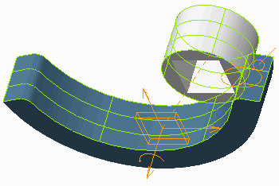Figure 1 – Friction Causes the Component to Roll, Not Slide

Figure 2 – Friction Applied to Cam-Follower

###### Applying Friction and Restitution

The Mechanism Dynamics Option (MDO) enables you to define friction and restitution properties for connections.

You enable the restitution and friction in connections by selecting Dynamic properties from the Motion Axis dashboard. Cam-Follower connections, however, are enabled on the Properties tab of the

Cam-Follower Definition dialog box.

***Note:*** *Friction and restitution are only available when your license of Creo Parametric contains the Mechanism Dynamics Option (MDO).*

###### Friction Coefficients

There are three friction coefficients used to simulate friction in mechanism dynamics:

* + Static (μs) – You use the static coefficient to specify the friction force that prevents the surfaces of the connection axis from moving against each other until a limit. After reaching this limit, the

motion begins. The static coefficient of friction is always larger than or equal to the kinetic coefficient of friction.

* + Kinetic (μk) – You use the kinetic coefficient to specify the friction force that prevents the axis surfaces from moving freely against each other, which slows down the motion.
  + Contact Radius (*R*) – You use the contact coefficient *R* for simulating friction on rotational axes. The contact coefficient specifies a value for the distance between the motion axis and the point of contact. This value defines the radius of a circular area on which the friction torque acts and should be greater than zero.

###### Coefficient of Restitution

The coefficient of restitution simulates impact forces when a motion axis reaches its limit. You enable the coefficient of restitution in your mechanism to simulate nonrigid properties in a rigid body calculation.

* + Restitution (℮) – The coefficient of restitution is the ratio of the velocity of two entities after and before a collision.

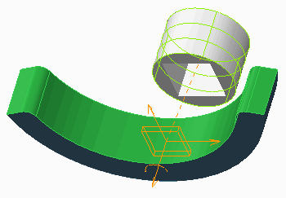

In a Cam-Follower connection, you enable Liftoff to specify whether the two bodies remain in contact during a dragging operation or a motion run. This is the same as enabling Restitution in other connection types. If you enable liftoff, you can also define a coefficient of restitution. If you do not select Enable Liftoff, the two cams remain in contact.

***Note:*** *Coefflcients of restitution depend on factors including material properties, body geometry, and impact velocity. For example, a perfectly elastic collision has a coefflcient of restitution of 1. A perfectly inelastic collision has a coefflcient of restitution of 0. A rubber ball has a relatively high coefflcient of restitution. A wet lump of clay has a value close to 0. Typical coefflcients of restitution can be found in engineering textbooks or from empirical studies.*

## PROCEDURE - Applying Friction and Restitution

Close Window  Erase Not Displayed 

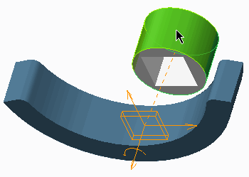**Task 1:** Add and analyze a Cam-Follower connection without friction.

|  |
| --- |
| 1. Disable all Datum Display types. 2. In the ribbon, select the **Applications** tab. 3. Click **Mechanism**  from the Motion group. |
| ***Note:*** *The two components are currently constrained using only a* ***Planar***  *connection set.* |
| 4. Click **Cams**  from the Connections group to further define the connection. |
| 1. In the Cam1 tab, select the **Autoselect** check box. 2. Select the cylindrical surface shown. 3. Click **OK** from the Select dialog box. |
| 1. Select the **Cam2** tab.    * Press CTRL and select the five surfaces shown.    * Click **OK** from the Select dialog box. |
| 1. Click **OK** to complete the Cam-Follower connection. 2. Click **Saved Orientations**  and select **FRONT**. 3. Click **Drag Components**  from the Motion group. 4. In the Drag dialog box, expand the Snapshots node, click **Take Snapshot** , and then click **Close**. 5. In the Mechanism Tree, expand the **ANALYSES** node, select **AnalysisDefinition1(DYNAMICS)**, and click   **Run**  from the mini toolbar.  ***Note:*** *The model FRICTION2.PRT does not roll.* |

**Task 2:** Enable friction and liftoff in the connection and analyze the results.

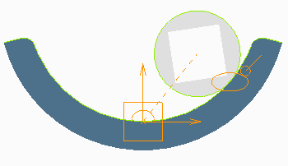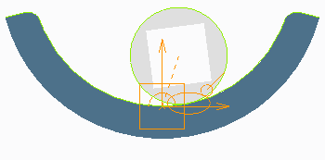

|  |
| --- |
| 1. In the Mechanism Tree, expand the **Connections**   and **Cams** nodes.   1. Select **Cam Follower1(FRICTION)** and click **Edit Definition**  from the mini toolbar. 2. Select the **Properties** tab.    * Select the **Enable Liftoff** check box, edit е to   **1**, and press ENTER.   * + Select the **Enable Friction** check box.   + Edit µs to **.6** and press ENTER.   + Edit µk to **.5** and press ENTER.   + Click **OK**.  1. In the Mechanism Tree, select **AnalysisDefinition1(DYNAMICS)** and click **Run**  from the mini toolbar. 2. Click **Yes** to confirm.   ***Note:*** *With friction and liftoff applied to the connection, the model FRICTION2.PRT rolls along the part and lifts off or separates from the other model during the analysis run.* |
| 1. In the Mechanism Tree, select **Cam Follower1(FRICTION)** and select **Edit Definition**  from the mini toolbar. 2. Select the **Properties** tab.    * Edit е to **.1** and press ENTER.    * Edit µs to **.8** and press ENTER.    * Edit µk to **.7** and press ENTER.    * Click **OK**. 3. In the Mechanism Tree, select **AnalysisDefinition1(DYNAMICS)** and click **Run**  from the mini toolbar. 4. Click **Yes** to confirm.   ***Note:*** *There is a signiflcant decrease in liftoff and sliding due to the reduced restitution coefflcient and increased friction coefflcient.* |

This completes the procedure.

## Applying Force and Torque Loads

You create motion in a mechanism by applying external forces and torques.

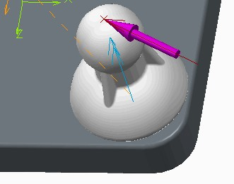Force and Torque Loads:

* + - Point Force
    - Body Torque
    - Point-to-Point Torque

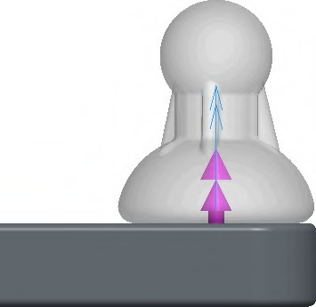Figure 1 – Force Applied to a Point

Figure 2 – Torque Applied to a Model

###### Applying Force and Torque Loads

You can apply a magnitude of force or torque to simulate external influences on the motion of a mechanism. The force or torque usually represents a dynamic interaction of your mechanism with another body and can arise from a contact between parts belonging to the mechanism and entities external to the mechanism. A force is always a push or a pull, causing objects to change their translation motion. For example, the force of your finger pushing a box causes the box to move according to the direction of the push. A torque is a turning or twisting force, such as the one applied to spin the top of a box.

The Force/Torque tool is only available in Mechanism mode and can be started using one of the following methods:

* Click **Force/Torque **from the Insert group.
* In the Mechanism Tree, select FORCE/TORQUE and click **New** .

***Note:*** *You can only apply force/torque to a model if your license of Creo Parametric contains the Mechanism Dynamics Option (MDO).*

###### Types of Force/Torque

There are three types of force or torque to choose from:

* Point force – Select a datum point, vertex, or geometry point to apply the force.
* Body torque – Select a body as a reference for a torque at the center of mass.
* Point-to-point force – Select two points or vertices on different bodies as reference entities. The force acts equally in opposite directions moving the two points toward each other when they are negative and away from each other when they are positive. If the two points are coincident, the magnitude of the force is zero. The first point is the origin of the force; the second indicates the direction. Results are displayed for the force acting on the first body you select when creating the force.

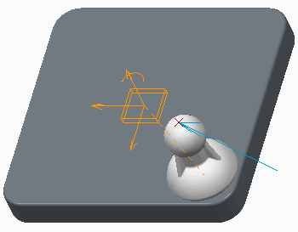

###### Force/Torque Direction

You use the Direction tab to specify the direction of the force/torque vector for point force and body torque. Direction for a point-to-point force is inherently defined by the two reference points.

In the Define Direction by area of the Direction tab, you can select from the following options:

* + Typed Vector – Specify coordinates to indicate the direction of the force vector, relative to either the default WCS coordinate system or a chosen body and its LCS.
  + Straight edge, curve, or axis – Select a straight edge, a curve, or an axis on the body to place the vector along or parallel to your selection. Click Flip to reverse the direction of the force/torque.
  + Point to Point – Select two body points or vertices to indicate the direction of the vector. Click Flip to reverse the direction of the force/torque.

***Note:*** *The WCS (World Coordinate System) is the default coordinate system of the ground body. The LCS (Local Coordinate System) is the default coordinate system of a selected body.*

In the Direction relative to area of the Direction tab, you can select to define the direction relative to either Ground or Body.

## PROCEDURE - Applying Force and Torque Loads

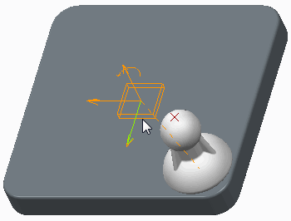**Task 1:** Apply a force to a point on the model and run an analysis.

|  |
| --- |
| 1. Enable only the following Datum Display types: . 2. In the ribbon, select the **Applications** tab. 3. Click **Mechanism**  from the Motion group.   ***Note:*** *The orange icon in the middle of the model indicates that this component was assembled using the* ***Planar***  *connection set.* |
| 1. Click **Force/Torque** from the Insert group. 2. In the graphics window, select the **LOAD_POINT** datum point. |
| 1. In the Motor dashboard, complete the following:    * Select the **Profile Details** tab.    * Edit the value of Coefficient A to **.005** and press ENTER.    * Select the **References** tab, edit the X vector to **–**   **.5**, and press ENTER.   * + Edit the Z vector to **–.25** and press ENTER.   + Click **Complete Feature** . |
| 1. In the Mechanism Tree, select **ANALYSES** and click **New New** from the mini toolbar. 2. Select **Dynamic** from the Type drop-down list. 3. Edit the value for Duration to **17** and press ENTER. 4. Select the **I.C.State:** radio button. |

|  |
| --- |
| 1. Select the **External loads** tab and select the   **Enablegravity** and **Enable all friction** check boxes.   1. Click **Run**. 2. Click **OK**. |
| ***Note:*** *The translation axes of the planar connection limit the movement of FORCE2.PRT, ensuring that it does not move off of FORCE1.PRT. That explains why FORCE2.PRT changed directions after reaching the edge of FORCE1.PRT.* |

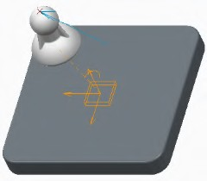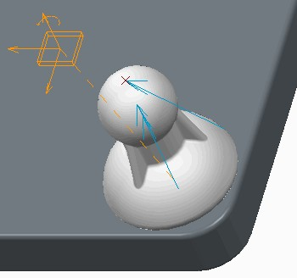**Task 2:** Apply a torque force to the model and run an analysis.

|  |
| --- |
| 1. Click **Force/Torque** . 2. In the Force or Torque Definition dashboard, complete the following:    * In the graphics window, query-select FORCE2.PRT.    * Click **Profile Details** tab.    * Edit the value of Coefficient A to **.8** and press ENTER.    * Select the **Reference** tab.    * Edit the Y vector to **1** and press ENTER.    * Edit the Z vector to **0** and press ENTER.    * Click **Complete Feature** . |
| 1. In the Mechanism Tree, click to expand **ANALYSES** , click   **AnalysisDefinition1(DYNAMICS)**, and select  **Edit Definition**  from the mini toolbar.   1. Select the **External loads** tab. 2. Click **Motor 1** and select **Motor 2** from the drop- down list. 3. Click **Run** and then click **Yes** to confirm. |
| 1. Select the **Start** cell, type **7**, and press ENTER. 2. Click **Add New Row** . 3. Click **Run** and then click **Yes** to confirm running the analysis using both forces. 4. Click **OK**. |

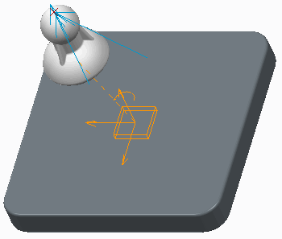This completes the procedure.

## Applying Gravity

Use gravity to simulate the effect of a gravitational force on the motion of your mechanism.

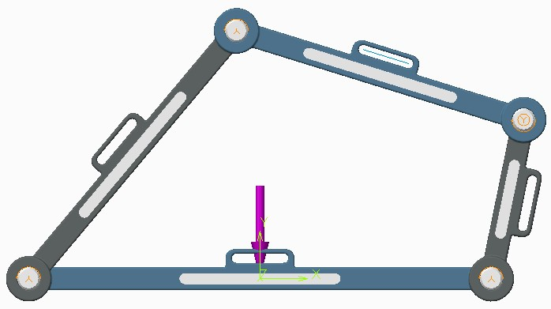Gravity:

* + - Magnitude
    - Direction
    - Enable gravity

Figure 1 – Gravitational Acceleration Vector Displayed on a Mechanism

###### Applying Gravity

The Gravity tool enables you to edit the magnitude and direction of the gravitational acceleration applied to your mechanism. Once defined, a single, uniform, gravitational force is applied to the entire top-level assembly. Bodies in your assembly, with the exception of the ground body, will move in the direction of the specified gravitational acceleration.

A gravitational force of 9806.65 mm/sec² is applied to every Creo Parametric assembly. However, for gravity to affect the motion of your mechanism, you must enable gravity in your analysis. To do this, select the Enable gravity check box in the External loads tab of the Analysis Definition dialog box.

###### Editing Gravity

You can edit the magnitude or direction of the default gravitational force in the Gravity dialog box. You can open the Gravity dialog box using one of the following methods:

* + Click **Gravity ** from the Properties and Conditions group.
  + In the Mechanism Tree, select Gravity and click **Edit Definition ** from the mini toolbar.

You define the direction of gravity by specifying X, Y, and Z coordinates to define the vector of the gravitational acceleration and force. The direction is defined with respect to the default coordinate system of the top-level assembly in your mechanism. The default direction for the gravitational acceleration is the negative Y direction.

## PROCEDURE - Applying Gravity

**Task 1:** Analyze the effect of gravity on the mechanism.

1. 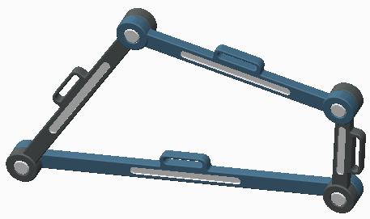Disable all Datum Display types.
2. In the ribbon, select the **Applications** tab.
3. Click **Mechanism ** from the Motion group.
4. Click **Saved Orientations ** and select **FRONT**.

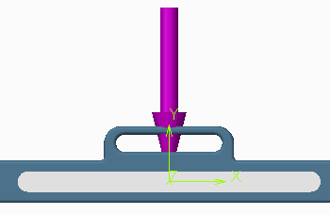

|  |
| --- |
| 5. Click **Gravity**  from the Properties and Conditions group. |
| ***Note:*** *The gravitational acceleration vector is shown in the dialog box as –1 in the Y direction. The purple arrow displays this vector in a downward direction on the model.* |
| 1. Click **OK** to close the dialog box. 2. In the Mechanism Tree, expand the **ANALYSES** node. 3. Select **AnalysisDefinition1(DYNAMICS)**, and click **Edit Definition**  from the mini toolbar. 4. Select the **External loads** tab.    * Ensure that the Enable gravity check box is not selected. |
| 10. Click **Run**. |
| ***Note:*** *The mechanism does not move because gravity was not enabled.* |
| 1. Select the **Enable gravity** check box. 2. Click **Run** and **Yes** to confirm. 3. Click **OK** to close the dialog box. |

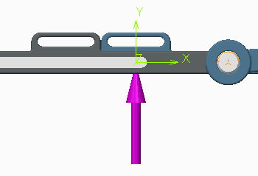**Task 2:** Edit the direction of gravity.

|  |
| --- |
| 1. Click **Gravity**  . 2. Edit the Y direction value to **1** and press ENTER. 3. Click **OK** to close the dialog box. |
| 1. In the Mechanism Tree, select **AnalysisDefinition1(DYNAMICS)** and click **Run**  from the mini toolbar. 2. Click **Yes** to confirm.   ***Note:*** *The continued motion of the mechanism is due to inertia.* |

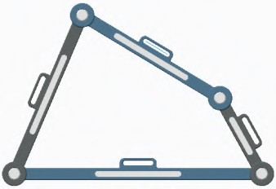**Task 3:** Analyze the mechanism's motion on the moon.

|  |
| --- |
| 1. Click **Gravity** . 2. Edit the Magnitude value to **1607.65** and press ENTER. |
| ***Note:*** *This is the approximate force of gravity on the moon.* |
| 1. Edit the Y direction value to **–1** and press ENTER. 2. Click **OK** to close the dialog box. |

1. In the Mechanism Tree, select **AnalysisDefinition1(DYNAMICS)** and click **Run ** from the mini toolbar.
2. Click **Yes** to confirm.

***Note:*** *The force of gravity on the moon still moves the mechanism; it just moves slower than here on earth.*

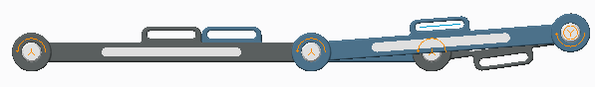

This completes the procedure.

## Exercise 1: Developing an Overhead Cam Model

### Objectives

After successfully completing this exercise, you will be able to:

* + Assemble components using pin and slider joint connections.
  + Create cam and cam-follower connections.
  + Create spring connections.

### Scenario

Due to customer demands, the marketing department has asked you to analyze the motion of a four-stroke engine. They are considering using this engine as a replacement to a similar two-stroke engine because the four-stroke engine has much lower emissions, which makes it more suitable for

today's green market. In this exercise, you create slider, pin, cam, and cam-follower connections while assembling selected parts of a single overhead cam engine.

**Task 1:** Assemble the valve components using connections.

1. Enable only the following Datum Display types: .
2. Perform the following steps to load the specific configuration file:
   * Click **File > Options**.
   * Click **Configuration Editor** and select **Import configuration file** from the Import/Export drop-down menu.
   * Click **Working Directory **.
   * Select CONFIG.PRO and click **Open**.
   * Click **OK** in the PTC Creo Parametric Options dialog box.
   * Click **No** in the PTC Creo Parametric Options message window.

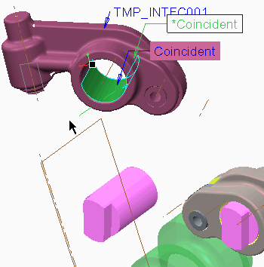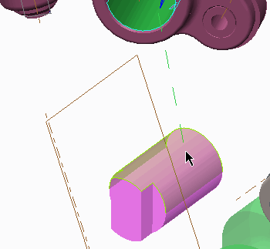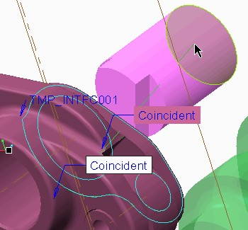

|  |
| --- |
| 1. Click **Assemble**  from the Component group, select ROCKER.ASM, and click **Open**. 2. In the dashboard, verify that **Interface To Geom**   is selected as the interface type.   1. Click to place the component in the graphics window. 2. Click **3D Dragger**  in the Component Placement dashboard, to hide the 3D Dragger display. 3. Press CTRL+ALT, and then right-click and drag. Press CTRL+ALT and middle-click and drag to position the component approximately as shown. |
| 8. Select the outer cylindrical surface on SHAFT_ROCKER.PRT for the axis alignment references.  ***Note:*** *The inner cylindrical surface on ROCKER.PRT is already selected in the temporary component interface that was created when the other ROCKER.ASM was assembled.* |
| 9. Right-click to query and then select the  rear-facing surface on SHAFT_ROCKER.PRT as the  translation references. |

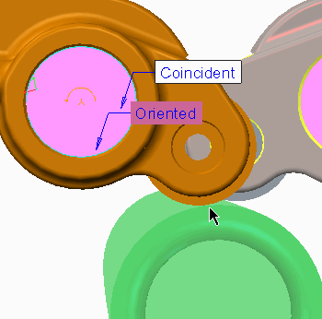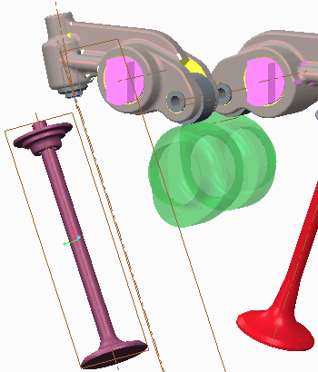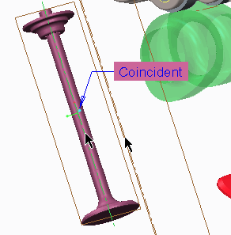

|  |
| --- |
| 1. Press CTRL+ALT, and then click and drag ROCKER.ASM so it is nearly touching CAMSHAFT.PRT, as shown. 2. Click **Complete Component** .   ***Tip:*** *If the ROLLER.PRT is not close enough to the CAMSHAFT.PRT (as previously instructed), an error may appear when you create Cam connections in the next task.* |
| 1. Click **Assemble** , select VALVE _IN.ASM, and click   **Open**.   1. Click to place the component in the graphics window. 2. Press CTRL+ALT and right-click and drag. Then press CTRL+ALT and middle-click and drag   to position the component approximately as shown. |
| 1. In the dashboard, click **User Defined** and select   **Slider**  as the connection type.   1. Pre-highlight and select axis A_1 on VALVE   _INTAKE.PRT, and then pre-highlight and select INTAKE_VALVE _AXIS on  VALVE _SOHC_SKEL.PRT for the axis alignment references. |

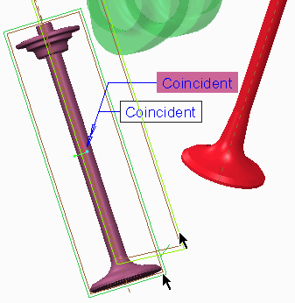

|  |
| --- |
| 1. Pre-highlight and select datum plane FRONT on VALVE _INTAKE.PRT, and then pre-highlight and select datum plane INTAKE_PLANE   on VALVE _SOHC_SKEL.PRT for the rotation references.   1. Click **Complete Component** . |
| 1. Click **Drag Components**  from the Component group and drag VALVE _IN.ASM upward, and position it as shown. 2. Click **Close** to close the Drag dialog box. 3. Click **Regenerate**  from the Quick Access toolbar. 4. Click **Save**  from the Quick Access toolbar to save the model. |

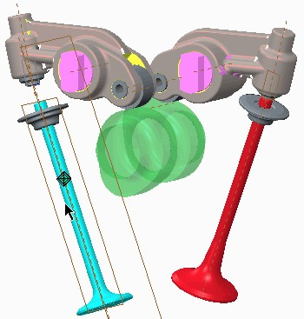**Task 2:** Create cam connections between the camshaft and valve components.

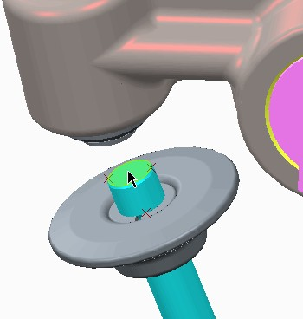

|  |
| --- |
| 1. In the ribbon, select the **Applications** tab. 2. Click **Mechanism**  from the Motion group. 3. Enable only the following Datum Display types: . 4. In the ribbon, click **Cams**  from the Connections group. |
| 1. With the **Cam1** tab already selected, complete the following tasks:    * Middle-click and drag to spin the model as shown.    * Select the circular surface, as shown, to define Cam1.    * Press the middle mouse button.    * Select both points **P1** and **P2** as the front and back references. |

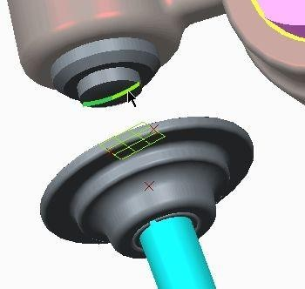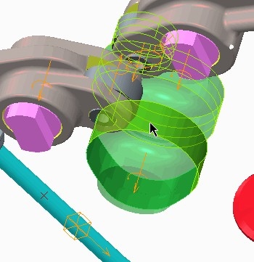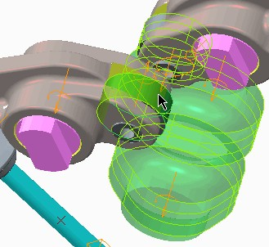

|  |
| --- |
| 1. Select the **Cam2** tab.    * Middle-click and drag to spin the model as shown.    * Press CTRL and select the two halves of the datum curve shown (under the follower).    * Press the middle mouse button.    * Click **OK** to complete the connection. |
| 1. Press CTRL+D to orient to the standard orientation. 2. Click **Cams**  from the Connections group. 3. With the Cam1 tab already selected, complete the following steps:    * Select the **Autoselect** check box.    * Select the surface of CAMSHAFT.PRT, as shown.    * Click **OK** in the Select dialog box. |
| 1. Select the **Cam2** tab.    * Select the **Autoselect** check box.    * Select the surface of ROLLER.PRT as shown.    * Click **OK** in the Select dialog box.    * Click **OK** to complete the connection. 2. Click **Regenerate**  from the Quick Access toolbar. 3. Click **Save**  from the Quick Access toolbar to save the model.   ***Note:*** *Regenerate the model twice if necessary.* |

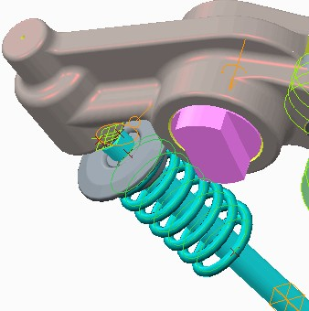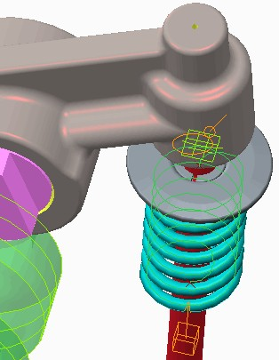**Task 3:** Create springs on the single overhead cam engine.

|  |
| --- |
| 1. Click **Springs**  from the Insert group. 2. In the graphics window, pre-highlight and select datum point SPRING_IN_REF. 3. Press CTRL, and pre-highlight and select datum point **VALVE_SPRING_PNT**, located just above SPRING_IN_REF. 4. Edit the stiffness coefficient K to **30** and press ENTER. 5. Edit the value for the length of the unstretched spring U to **50** and press ENTER. 6. Select the **Options** tab and then select the   **Adjust Icon Diameter** check box.   1. Edit the Diameter to **15** and press ENTER.      1. Click **Complete Feature** . |
| 1. Click **Springs**  . 2. In the graphics window, pre-highlight and select datum point SPRING_EX_REF. 3. Press CTRL, and pre-highlight and select datum point VALVE _SPRING_PNT, located just above SPRING_EX_REF. 4. Edit the stiffness coefficient K to **30** and press ENTER. 5. Edit the value for the length of the unstretched spring U to **50** and press ENTER. 6. Select the **Options** tab and then select the   **Adjust Icon Diameter** check box.   1. Edit the Diameter to **15** and press ENTER. 2. Click **Complete Feature** . 3. Click **Regenerate**  from the Quick Access toolbar. 4. Click **Save**  from the Quick Access toolbar to save the model. |

**Task 4:** Run an analysis of the overhead cam engine.

1. Click **Drag Components ** from the Motion group.
2. Expand the Snapshots section, click **Take Snapshot **, and then click **Close**.
3. Click **Initial Conditions** from the Properties and Conditions group.
4. Click **Current Screen** in the Snapshot section of the dialog box and select **Snapshot1** from the drop-down list.
5. Click **OK** to close the dialog box.

  

1. In the Mechanism Tree, click **ANALYSES** and select

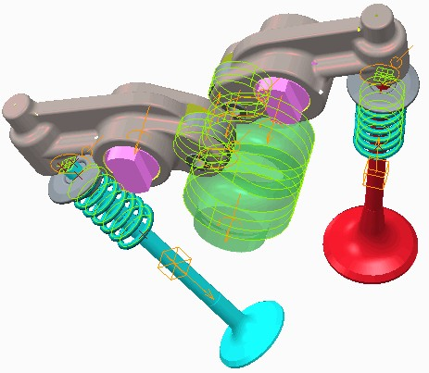**New** from the mini toolbar.

1. Select **Dynamic** from the Type drop-down list.
2. Click **Length and rate** and select **Length and frame count** from the drop-down list.
3. Edit the value for Duration to **0.025** and press ENTER.
4. Edit the value for Frame count to **360** and press ENTER.
5. In the Initial Configuration section of the dialog box, select the **I.C.State:** radio button.
6. Click **Run**.
7. Click **OK**.
8. Click **Regenerate ** from the Quick Access toolbar.
9. Click **Save ** from the Quick Access toolbar to save the model.

This completes the exercise.

273

# Module 12

## Analyzing the Mechanism Model

## Understanding Mechanism Dynamics Option Analysis Definitions

You can use Mechanism Dynamics Option (MDO) specific analysis definitions to record and display the simulation of your mechanism over time.

MDO Type Analysis:

* + - Position
    - Kinematic
    - Dynamic
    - Static
    - Force Balance Preferences:
    - Graphical Display Settings
    - Locked Entities
    - Initial Configuration
    - Motors and External Loads to Run
    - Start Time and End Time

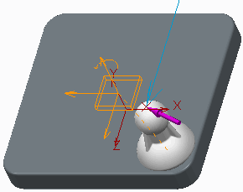

Figure 1 – Force Applied at Start of Analysis

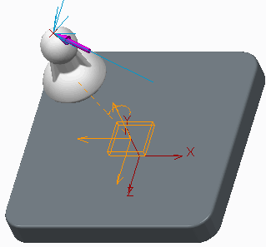

Figure 2 – Force Applied at End of Analysis

###### Understanding Mechanism Dynamics Option Analysis Definitions

After motors and external loads have been added to your mechanism model, you must define an analysis to view the effect they have on your mechanism. You configure an analysis that records and displays the motion generated by selected motors and loads over a specified time period. The Mechanism Dynamics Option (MDO) contains three analysis types that are only available with an MDO license.

###### Creating Analysis Definitions

Start Mechanism mode and Mechanism Analysis as follows:

* + In the ribbon, select the Applications tab.
  + Click **Mechanism ** from the Motion group.
  + Click **Mechanism Analysis ** from the Analysis group.
  + In the Mechanism Tree, select ANALYSES and click **New** from the mini toolbar.

###### Analysis Type

Using the MDO option in Creo Parametric, you can select five types of analyses. Position and Kinematic analysis are available in every license of Creo Parametric. Dynamic, Static, and Force Balance analyses are only available with an MDO license.

* + Position – You should only use a position type analysis when analyzing position motors and all geometry motors. The position analysis jumps between each frame so you cannot use it to track velocity or acceleration, only position measures at each frame.
  + Kinematic – A kinematic type analysis enables you to use position servo motors, velocity, and acceleration servo motors as well. The kinematic type analysis records a smoother motion that can better display changes in velocity and acceleration.
    - Dynamic – A dynamic analysis enables you to analyze the relationship between inertia, gravitational, and external forces acting on the mass of bodies in your mechanism. This type of analysis also provides you with position, velocity, and acceleration measurements.
    - Static – A static analysis enables you to analyze the forces on a body when it has reached equilibrium.
    - Force Balance – A force balance analysis enables you to analyze the forces required to keep a mechanism in a fixed position.

###### Graphical Display

You configure Graphical Display settings in the Preferences tab of the Analysis Definition dialog box. This enables you to determine how Creo Parametric records motion over time. There are three types of time domains:

* + - Length and rate – Specifies the end time, frame rate, and minimum interval.
    - Length and frame count – Specifies the end time and frame count values.
    - Rate and frame count – Specifies the frame count, frame rate, and minimum interval.

###### Locked Entities

You can lock bodies and connections during your analysis run. Locking bodies or connections fixes the position of one body or connection relative to another during the defined analysis. Use the icons in the analysis dialog box to:

* + - **Create Body Lock ** – Locks bodies together during the motion analysis run.
    - **Create Connection Lock ** – Locks the movement of a connection during the motion analysis run.
    - **Enable/Disable Cam Liftoff **– Enables or disables a Cam Liftoff during the motion analysis run.
    - **Delete Locked Entity ** – Deletes locked bodies and connections.
    - **Enable/Disable Connection ** – Enables or disables a connection during the motion analysis run.

###### Initial Configuration

By selecting your initial configuration, you are setting a starting point for your analysis. There are two initial configuration options available for each analysis type; however, they vary depending on the analysis type.

* + - Current Screen – The analysis starts from its current position.
    - Snapshot – The analysis starts from a selected snapshot. This option is available using every analysis type except Dynamic. The snapshot captures the configuration of existing locked bodies and geometric constraints to define position constraints.
    - I.C.State – The analysis starts from a predefined Initial Condition. This option replaces snapshot when configuring a Dynamic analysis. Like the snapshot, the I.C.State captures the configuration of existing locked bodies and geometric constraints to define position constraints. You define an I.C.State in the Initial Condition Definition dialog box.

By default, each analysis starts with the mechanism displayed as the current screen position, which is the current orientation of the bodies as you see them on the screen.

###### Configuring Motors and Loads of the Analysis

In the Motors and External loads tabs, you can select and configure motors and loads to be analyzed. By default, each motor and load will run from the start to the end of the analysis.

Alternatively, you can edit the start and end times to be numerical values in the From and To cells. For example, in an analysis running 10 seconds, you can edit the first motor to run from 0 to 5, and the second motor to run from 6 to 10.

In the External loads tab, you can also enable gravity and friction to be applied throughout your analysis.

***Note:*** *The runtime deflned in the analysis is relative. The motion is not displayed in real time. The actual time it takes to run the motion is dependent on the complexity of the models as well as computer speed.*

## Configuring a Dynamic Analysis

Dynamic analyses enable you to study the relationship between the forces acting on a body, the mass of the body, and the motion of the body.

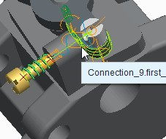Use dynamic analyses to analyze motion from:

* Servo Motors
* Force Motors
* Applied Force and Torque
* Gravity

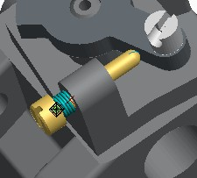Figure 1 – Cam Connection Between Components

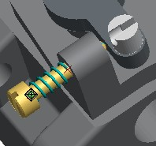

Figure 2 – Dynamic Analysis at Start

Figure 3 – Dynamic Analysis Running

###### Configuring a Dynamic Analysis

Dynamic analysis is a branch of mechanics that primarily deals with forces and their relation to motion, and also to the equilibrium of bodies. You can use a dynamic analysis to analyze motion generated by applied loads, servo motors, force motors, and gravity.

Unlike a kinematic analysis, you can add applied force/torque and force motors entities to a dynamic analysis. You can configure them to start and stop at any time during the analysis. As with a kinematic analysis, you can also add servo motors to a dynamic analysis. You add force/torque and force motors entities from the External loads tab of the Analysis Definition dialog box. Gravity and friction are also enabled in this tab.

Key points to keep in mind when configuring a dynamic analysis:

* + Motion axis servo motors are active the entire duration of the analysis run time. For this reason, you cannot edit the Start and End times of these motors in an analysis.
  + If you add a servo or force motor with a noncontinuous profile, Mechanism Design tries to make the profile continuous before running a dynamic analysis. If the profile cannot be made continuous, the motor is not used for the analysis. This situation may occur when a servo motor uses a time domain shorter than the dynamic analysis to define the motors magnitude.

***Tip:*** *You can evaluate the positions, velocities, accelerations, and reaction forces at the beginning of your dynamic analysis by specifying a zero time duration and running as usual. A suitable time interval for the calculations is determined automatically. If you graph measures from the analysis, the graph will contain only a single line.*

## PROCEDURE - Configuring a Dynamic Analysis

**Task 1:** Investigate the setup of the current model.

1. 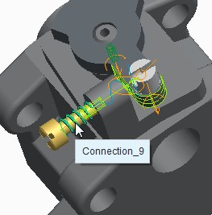Disable all Datum Display types.
2. In the ribbon, select the **Applications** tab.
3. Click **Mechanism ** from the Motion group.
4. At the top of the model tree, click **Settings **

and select **Tree Filters **.

* + Select the **Features** check box in the Model Tree Items dialog box.
  + Click **OK**.

1. In the model tree, press CTRL and select both **Spring 1** and **Damper 1** so that they highlight on the model.

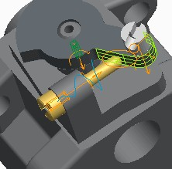

|  |
| --- |
| 1. In the Mechanism Tree, expand the **MOTORS** node and then expand the **SERVO** node.    * Select **Turn (VEL — DYNAMIC)** and click **Edit Definition**  from the mini toolbar.    * Select the **Profile Details** tab from the Motor dashboard.    * Notice that the magnitude of the motor's velocity is defined over a time domain of 8 seconds.    * Click **Close**  to exit the Motor dashboard. 2. In the Mechanism Tree, expand the **FORCE** node.    * Select **Push (Dynamic)** and click **Edit Definition**  from the mini toolbar.    * Notice that the magnitude of the motor's force is defined using the **Ramp** profile in the Function Type drop-down list.    * Click **Close**  to close the Motor dashboard. 3. In the Mechanism Tree, expand the **INITIAL CONDITIONS** and notice that an initial condition has been defined. |
| 1. Click **Drag Components**  from the Motion group. 2. Select DYNAMIC_SCREW.PRT. 3. Drag the screw to observe the motion of the mechanism. 4. Click in the graphics window to stop the movement. 5. Click **Close**. |

**Task 2:** Create a dynamic analysis to run the mechanism.

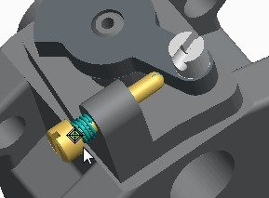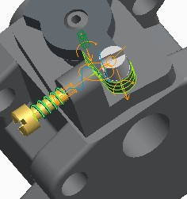

1. In the Mechanism Tree, select **ANALYSES** and click **New** from the mini toolbar.
2. Select **Dynamic** from the Type drop-down list.
3. 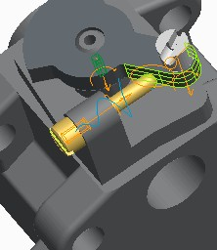Select the **I.C.State:** option.

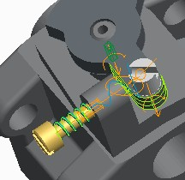

|  |
| --- |
| 1. Select the **Motors** tab. 2. Select the force motor **Turn** and click **Delete Highlighted Row** . 3. Click **Run** to run the motor. |
| 1. Click the servo motor **Push** and select **Turn**   from the drop-down list.   1. Click **Run** and then click **Yes** to confirm. |

|  |
| --- |
| ***Note:*** *Scroll down to read the following warning message in the message area of your Creo Parametric window:*  *“Proflle for Turn is not deflned for the entire analysis time. Hence, the servomotor will be excluded from the current analysis.” The time domain for the servo motor was 8 seconds, and your analysis is set up to run for 10 seconds. This is why the servo motor turns the screw.* |
| 1. Select the **Preferences** tab. 2. Edit the Duration to **8** and press ENTER. 3. Click **Run** and then click **Yes** to confirm.   ***Note:*** *The servo motor now turns the screw and there is no warning message.* |
| 1. Select the **Motors** tab. 2. Click **Add New Row**  to add the Push motor to the analysis. 3. Click **Run** and then click **Yes** to confirm. |
| 1. In the row containing the Push motor, click the   **End** cell.   1. Edit the End value to **4** (which is half of the analysis duration), and press ENTER. 2. Click **OK** to close the dialog box. 3. In the Mechanism Tree, expand the **ANALYSES** node, select **AnalysisDefinition1(DYNAMICS)** and click **Run**  from the mini toolbar. 4. Click **Yes** to confirm. |

***Note:*** *Because you set the Push force to end 4 seconds into the analysis run, the Push force is removed and the force of the spring then brings the screw back in the other direction.*

This completes the procedure.

## Configuring a Static Analysis

Static analyses enable you to determine the resting state of a mechanism when it is subject to known forces.

##### Static Analysis:

* + - Find the resting state.
    - Graph acceleration versus iteration number.
    - Adjust the maximum step factor.

Figure 1 – Acceleration Versus Iteration Number

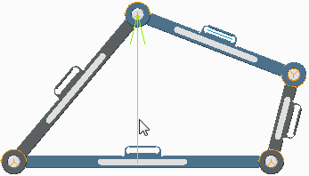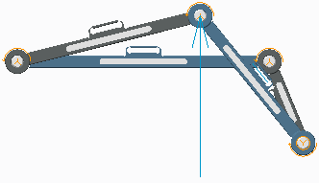

Figure 2 – Initial State Figure 3 – Resting State

###### Configuring a Static Analysis

Static analysis is a branch of mechanics that deals with forces acting on a body when it is at equilibrium. In a static analysis, Creo Parametric searches for a configuration in which all loads and forces in your mechanism balance each other (meaning, potential energy equals zero). You can use a static analysis to find a stable configuration of your mechanism before setting your mechanism in motion.

When you run a static analysis, a graph of acceleration versus iteration number appears, displaying the maximum acceleration of the mechanism's entities. As the analysis calculation proceeds, both the graph display and the model display change to reflect the intermediate positions reached during the calculation. When the maximum acceleration for the mechanism reaches 0, your mechanism has reached a static configuration.

If the Mechanism Dynamics Option (MDO) cannot locate a static configuration for your mechanism, the analysis ends and the mechanism remains in the last configuration reached during the analysis.

***Tip:*** *Any measures computed will be for the flnal times and positions, not a time history for the settling process.*

###### Maximum Step Factor

You can adjust the maximum step size between each iteration of the static analysis by changing the Maximum step factor on the Preferences tab in the Analysis Definition dialog box. Reducing this value reduces the positional change between each iteration and can be useful when analyzing mechanisms incorporating large accelerations. The default step size is 1.

## PROCEDURE - Configuring a Static Analysis

**Task 1:** Create and use a static analysis to evaluate the mechanism.

|  |
| --- |
| 1. Disable all Datum Display types. 2. In the ribbon, select the **Applications** tab. 3. Click **Mechanism**  from the Motion group. 4. From the In Graphics toolbar, click **Saved Orientations**  and select **FRONT**. |
| ***Note:*** *Notice the force pointing upward.* |
| 5. In the Mechanism Tree, select **ANALYSES** and click **New** from the mini toolbar. |

|  |
| --- |
| 1. In the Analysis Definition dialog box, complete the following:    * Select **Static** from the Type drop-down list.    * In the Initial configuration section, select the   **Snapshot** option.   * + Select the **External loads** tab and select the   **Enable gravity** check box.   * + Click **Run**.  1. Close the Graphtool window. |
| ***Note:*** *The static analysis has positioned and graphed the mechanism's static position. Note that even withthe effects of gravity, theupward force placed on the mechanism prevents it from collapsing.* |

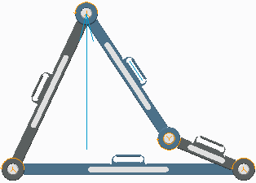**Task 2:** Analyze the mechanism without the effect of the upward force.

|  |
| --- |
| 1. In the **External loads** tab, complete the following:    * Select the load **ForceTorque1** .    * Click **Delete Highlighted Row**  to remove the force.    * Click **Run**.    * Click **Yes** to confirm. 2. Close the Graphtool window. |
| ***Note:*** *As you might expect, without theupward force, gravity collapses the mechanism to a more compressed static position.* |

**Task 3:** Edit the analysis preferences.

1. 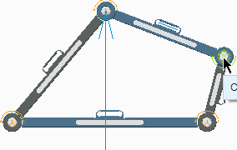Select the **Preferences** tab.
   * Click **Display Snapshot** .
   * Click **Enable/Disable Connection ** and select the upper-right connection as shown.
   * 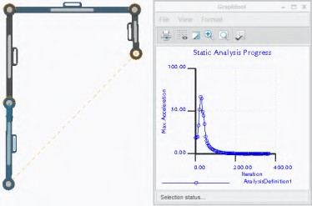Middle-click to accept the changes.
2. In the Maximum step factor section, complete the following:
   * Clear the **Default** check box.
   * Edit the Maximum step factor value to **0.02** and press ENTER.
3. 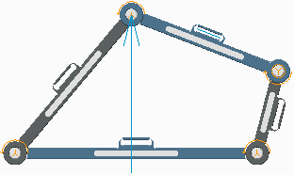Click **Run**.
4. Click **Yes** to confirm.

***Note:*** *With the connection removed, the static analysis leaves the links at each end of the ground link hanging as shown.*

|  |
| --- |
| 1. Click **OK** to close the dialog box. 2. Click **Regenerate Model**  from the Quick Access Toolbar update the model to its assembled configuration. |
| ***Note:*** *The removal of the connection was only applied during the static analysis. When you close the analysis and regenerate the assembly, it returns to the original conflguration.* |

This completes the procedure.

## Configuring a Force Balance Analysis

Force balance analyses enable you to determine the forces required to keep your mechanism fixed in a particular configuration.

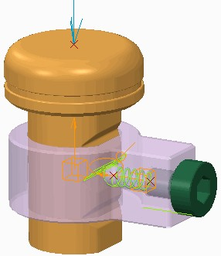Force Balance Analysis:

* Finds the force required to keep a mechanism in its current position.
* Requires zero degrees of freedom (DOF).

Figure 1 – Force Balance Analysis

*Configuring a Force Balance Analysis*

A force balance analysis is an inverse static analysis. In this analysis, you derive the resulting reaction forces from a specific static configuration, whereas in a static analysis, you apply forces to a mechanism to derive the resulting static configuration. This analysis is useful if your model contains applied forces and you want to bring it to an equilibrium state. After you run this analysis, you obtain the magnitude of force applied at a specific point that will keep your mechanism motionless. You also can obtain the connection or motor reaction force necessary to maintain an equilibrium state.

*Zero Degrees of Freedom*

Force balance analyses require that degrees of freedom (DOF) within the mechanism equal zero. You can use connection locks, body locks between two bodies, loadcell locks at a point, or active servo motors applied at connection axes to reduce the DOF. Because these are applied within the analysis, they do not affect your mechanism outside of the analysis.

## PROCEDURE - Configuring a Force Balance Analysis

**Task 1:** Add a force and spring to the mechanism.

1. Enable only the following Datum Display types: .
2. In the ribbon, select the **Applications** tab.
3. 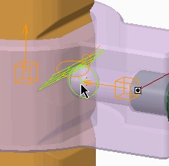Click **Mechanism ** from the Motion group.

|  |
| --- |
| 1. Click **Springs**  from the Insert group.    * Select datum point **S1** from the graphics window.    * Press CTRL and select datum point **S2**.    * In the dashboard, edit K to **3.45** and press ENTER.    * Edit U to **152.4** and press ENTER.    * Select the **Options** tab and select the **Adjust Icon Diameter** check box.    * Edit the Diameter to **50** and press ENTER.    * Click **Complete Feature** . |
| 1. Click **Force/Torque**  from the Insert group.    * Select the datum point **LOAD** from the model.    * Select the **Profile Details** tab.    * Edit the coefficient to **3.45** and press ENTER.    * Select the **References** tab.    * Edit the Y vector to **–1** and press ENTER.    * Edit the Z vector to **0** and press ENTER.    * Click **Apply Changes** . |

**Task 2:** Create an analysis to determine the force required to balance the mechanism.

* 1. 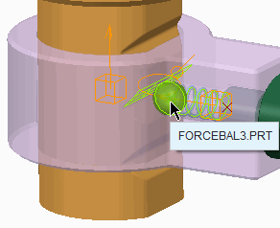Click **Mechanism Analysis ** from the Analysis group.
     + Select **Force balance** from the Type drop- down list.
     + Click **Create Loadcell Lock **.
     + Select the datum point **S2** and then query-select the ball bearing part FORCEBAL3.PRT.
     + For the X component, type **0** and press ENTER.
     + For the Y component, type **1** and press ENTER.
     + For the Z component, type **0** and press ENTER.
     + In the Initial configuration section, select the

**Snapshot** option.

* + - Click **OK**.

|  |
| --- |
| 1. In the Mechanism Tree, expand the **ANALYSES**   node.   1. Click **AnalysisDefinition1(FORCE BALANCE)**   and click **Run**  from the mini toolbar.   1. Click **Yes** to confirm. |
| ***Note:*** *The value displayed in the Force Balance Reaction Load dialog box is the force required to keep the mechanism balanced in its current position.* |
| 5. Click **OK** to close the Force Balance Reaction Load dialog box. |

This completes the procedure.

Defining Initial Configurations

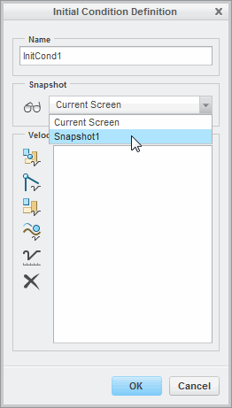Use initial configurations to define the starting position of your mechanism in an analysis. Initial Configurations:

* Current Screen
* Snapshot
* I.C. States

Initial Condition State Definition:

* Current Screen
* Snapshot
* Velocity of a Point
* Motion Axis Velocity
* Angular Velocity
* Tangential Slot Velocity

Figure 1 – Initial Condition Definition

###### Defining Initial Configurations

By default, each mechanism analysis type begins with the mechanism positioned as it is displayed; this is called the *initial conflguration* of the analysis. You can use the default Current Screen configuration or select Snapshot as the initial configuration of an analysis. This is true for all analysis types except for the Dynamic type analysis, where I.C.State (instead of snapshots) are used to set the initial configuration

of the analysis.

You can use the current screen position as the initial configuration of your analysis; however, it is suggested that you use a snapshot or initial condition state (I.C.State) to establish a consistent starting

configuration for each analysis. A snapshot captures the configuration of existing locked bodies and geometric constraints to define position constraints. You define snapshots in the Drag dialog box and then select them when setting the initial configuration of your analysis.

You can also select snapshots when defining an initial condition state. The initial condition state (I.C.State) is then selected as the initial configuration of a Dynamic analysis.

***Note:*** *In an analysis, exceptions occur to the deflned initial conflguration if you add activated servo motors to your model.*

*The initial position deflned by the servo motor overrides the initial conflguration set in the analysis.*

###### Initial Condition Definition

Initial condition states are used to set the initial configuration of a Dynamic type analysis. The initial condition is created by setting the configuration of the mechanism to be the Current Screen or a Snapshot.

In addition to this configuration of components, you can also assign starting velocity settings in an initial condition. You can define point, motion axis, angular, and tangential slot velocity settings. For example, if you are modeling a car, at the start of the analysis you might want to analyze the car moving at 100 km/h. Another example of a velocity initial condition would be the body angular velocity in degrees per second of a door closing.

There are four types of velocities that you can configure:

* + **Point Velocity ** – Enables you to define the linear velocity at a point or vertex.
  + **Axis Velocity ** – Enables you to define the rotational or translational velocity of a motion axis.
  + **Angular Velocity ** – Enables you to define the angular displacement of the body along a defined vector.
  + **Tangential Slot Velocity ** – Enables you to define the tangential velocity of the follower point relative to the slot curve.

Use **Velocity Conditions ** to ensure the validity of the defined conditions. Also ensure that the initial conditions you create are physically possible and do not conflict with each other. For example, if you set initial conditions on the orientation of two parts that are connected with a joint, be sure that the required body positions are possible with the degrees of freedom (DOF) allowed by the joint.

###### Tips for Using Initial Conditions

When using initial conditions, adhere to the following best practices:

* + When defining initial conditions for angular velocity, select a vector that does not conflict with any rotational motion axis connections. The axis of rotation is parallel to the specified vector, depending on the degree of freedom and how it is connected to the assembly.
  + Initial conditions for angular velocity are most useful for packaged components rather than components with motion axis connections. Applying these initial conditions to components with motion axis connections increases the likelihood of inconsistency in the initial conditions set and the possibility of failure due to conflicts with other constraints.

## PROCEDURE - Defining Initial Configurations

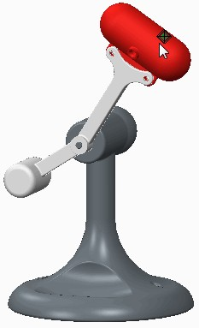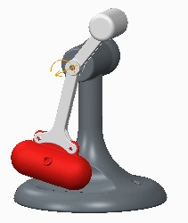**Task 1:** Create a snapshot to be used in an analysis and initial condition.

|  |
| --- |
| 1. Disable all Datum Display types. 2. In the ribbon, select the **Applications** tab. 3. Click **Mechanism**  from the Motion group. 4. Click **Drag Components**  from the Motion group select the red part INITIAL3.PRT. 5. Drag the part and click in the graphics window to drop the part in the position shown. 6. Expand the **Snapshots** node, select **Take Snapshot** , and click **Close**. |
| 1. Click **Regenerate**  from the Quick Access toolbar. 2. In the Mechanism Tree, select **ANALYSES** and click **New** from the mini toolbar. |
| 1. In the Analysis Definition dialog box, complete the following:    * Select **Static** from the Type drop-down list.    * In the Initial configuration section, click   **Snapshot**.   * + Click **Display Snapshot** .   + Select the **External loads** tab and select the   **Enable gravity** check box.   * + Click **Run**. |
| 1. Click **OK** to close the dialog box. 2. From the In Graphics toolbar, click **Saved Orientations**  and select **FRONT**. 3. In the Mechanism Tree, select **ANALYSES** and click **New** .    * Select **Dynamic** from the Type drop-down list. |
| ***Note:*** *In the Initial Conflguration section of the dialog box, the Dynamic analysis type requires an initial condition (instead of a Snapshot) to be deflned.* |
| 13. Click **Cancel** to cancel the analysis creation. |

**Task 2:** Create an initial condition to use in a dynamic analysis.

1. 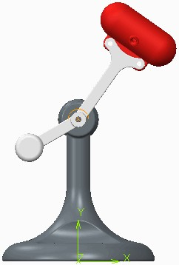Click **Initial Conditions** from the Properties and Conditions group.
2. In the Snapshot section of the Initial Condition Definition dialog box, complete the following:
   * Select **Snapshot1** from the Snapshots drop-down list.
   * Click **Display Snapshot** .

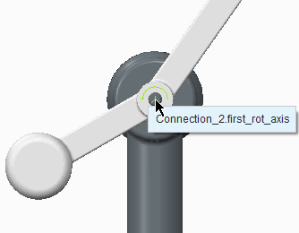

|  |
| --- |
| 1. In the Velocity Conditions section, complete the following:    * Click **Axis Velocity** .    * In the graphics window, select the connection shown.    * Edit the Magnitude to **300** deg/sec and press ENTER.    * Click **OK**. |
| 1. In the Mechanism Tree, select **ANALYSES** and click   **New** .   * + Select **Dynamic** from the Type drop-down list.   + In the Initial configuration section, select the   **I.C.State:** option.   * Click **Display Snapshot** . * Select the **External loads** tab and select the   **Enable gravity** check box.   * Click **Run**. |
| ***Note:*** *The mechanism rotates completely around the connection multiple times because the analysis was started with an initial velocity about that connection of 300 degrees per second.* |

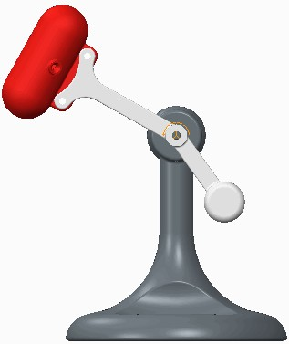This completes the procedure.

## Creating Measures

Create analysis measures to evaluate and verify your mechanism. Measure Types:

* + Position, Velocity, and Acceleration
  + Connection Reaction, Net Load, and Loadcell Reaction
  + Impact and Impulse
  + System
  + Body, Separation, and Cam
  + User-Defined
  + Belt
  + 3D Contact Figure 1 – Measure Definition

###### Creating Measures

Analysis measures are measurements that are evaluated when a mechanism analysis is run. You can create measures for specific model entities or for the entire mechanism. You can also include measures in your own expressions for user-defined measures.

You can create measures by clicking **New Measure ** from the Measure Results dialog box. The Measure Results dialog box is opened by clicking **Measures ** from the Analysis group.

###### Measure Types

In the Type area of the Measure Definition dialog box, you can create the following types of measures:

* Position – Measures the location of a point, vertex, or motion axis during the analysis.
  + Velocity – Measures the velocity of a point, vertex, or motion axis during the analysis.
  + Acceleration – Measures the acceleration of a point, vertex, or motion axis during the analysis.
  + Connection Reaction – Measures the reaction forces and moments at connections.
  + Net Load – Measures the magnitude of a force load on a spring, damper, servo motor, force, torque, or motion axis. You can also confirm the force load on a force motor.
  + Loadcell Reaction – Measures the load on a loadcell lock during a force balance analysis.
  + Impact – Determines whether impact occurred during an analysis at a connection limit, slot end, or between two cams.
  + Impulse – Measures the change in momentum resulting from an impact event. You can measure impulses for connections with limits, for cam-follower connections with liftoff, or for slot-follower connections.
  + System – Measures several properties that describe the behavior of the entire system. Properties that can be measured are Degrees of Freedom (DOF), Redundancies, Time, Kinetic Energy, Linear Momentum, Angular Momentum, Total Mass, Center of Mass, and Total Centroidal Inertia.
  + Body – Measures several properties that describe the behavior of a selected body.
  + Separation – Measures the separation distance, separation speed, and change in separation speed between two selected points.
  + Cam – Measures the curvature, pressure angle, and slip velocity for either of the cams in a cam- follower connection.
  + User Defined – Defines a measure as a mathematical expression that includes measures, constants, arithmetical operators, Creo Parametric parameters and algebraic functions.
  + Belt – Measures the belt tension or slip.
  + 3D Contact – Measures the contact area, pressure angle, or slip velocity during contact.

###### References and Other Options

The references and options required to create measurements will vary depending on the type of measure being created. For the typical position, velocity, or acceleration measure, a point or motion axis reference is required.

You can define the component of the measure as an overall magnitude or you can specify it to be the X, Y, or Z component of the magnitude.

###### Evaluation Methods

When you define analysis measures, you can select from several evaluation methods. The graph of the measure and the value quantity displayed in the Measure Results dialog box are different for different evaluation methods.

For Each Time Step, you can define your measure after you run the analysis. For the other methods, you must define the measure before running an analysis. If you define a measure with Maximum, Minimum, Integral, Average, Root Mean Square or At Time evaluation methods after you run an analysis, the Status column on the Measure Results dialog box reports “Not computed” when you select the analysis.

## Understanding Redundancies and Degrees of Freedom

You must be aware of the degrees of freedom and any redundancies in your mechanism to accurately run a motion simulation.

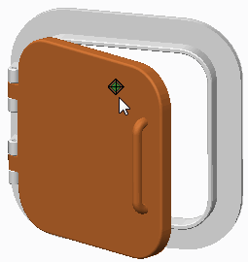Degrees of Freedom (DOFs):

* + - Unconstrained bodies have six DOFs.
    - Connections, motors, and loads remove DOF.

Redundancies:

* + - Over-constrained mechanisms.
    - Produce inaccurate simulations.

Figure 1 – Assembly with One DOF and Zero Redundancies

###### Understanding Redundancies and Degrees of Freedom

Redundancies and degrees of freedom (DOFs) affect the accuracy of a motion simulation. For this reason, you must understand your mechanism's DOF and be aware of any redundancies in the system.

###### Measuring Redundancies and Degrees of Freedom

The system type measure can be used to measure the number of redundancies and DOF in your mechanism. Redundancies and DOF are property types that can be assigned when creating the system type measure.

###### Degrees of Freedom

In mechanical systems, DOFs are the number of parameters required to define the position or motion of each body in the system. Unconstrained bodies have six DOFs. Each connection, load, or motor removes a specific number of DOFs from the mechanism.

You can manually use the following equation to determine the number of DOFs in your mechanism:

* DOF = (6 x Number of Bodies (excluding grounds) – (Number of Connections x DOF per Connection)).

###### Redundancies

Redundancies occur when two or more connections constrain the same DOF. A redundancy is essentially an over-constrained mechanism. The existence of the redundancy will affect the accuracy of a motion simulation.

Redundancies are important because a mechanism is a system of parts that is governed by the mathematical equations of dynamic motion. These same equations are solved numerically by Creo Parametric. Each connection, load, and motor adds an additional equation to this system.

You require an equation for each unknown variable for which you are solving in a system of equations. If you have a redundancy, you have an extra equation; unknown variables in an extra equation are inexactly defined. In the mechanism world, a redundancy or over-constraint means that the force results, in that particular constrained direction, can be anything and still satisfy the dynamic equations of motion. Therefore, unless you are dealing exclusively with kinematic analysis, you must intelligently assemble your joint connections before running a Mechanism Dynamics Option (MDO) analysis.

## PROCEDURE - Understanding Redundancies and Degrees of Freedom

**Task 1:** Create measures to determine degrees of freedom and redundancy.

|  |
| --- |
| 1. Disable all Datum Display types. 2. In the ribbon, select the **Applications** tab. 3. Click **Mechanism**  from the Motion group. 4. Click **Drag Components**  from the Motion group. 5. Select the door part DOF2.PRT and drag it open, as shown. Then click in the graphics window   to drop the door.   1. Click **Close** to close the Drag dialog box. |
| 1. In the Mechanism Tree, expand the **ANALYSES** node. 2. Select **Open-Close(DYNAMICS)** and click **Run**  from the mini toolbar. 3. Click **Measures**  from the Analysis group. 4. In the Measure Results dialog box, click **New Measure** .    * Edit the Name to **DOF**.    * Select **System** from the Type drop-down list.    * Click **OK**. 5. Click **New Measure** .    * Edit the Name to **Redund**.    * Select **System** from the Type drop-down list.    * Select **Redundancies** from the Property drop-down list.    * Click **OK**. 6. Select **Open-Close** from the Result set list. |
| ***Note:*** *There are zero degrees of freedom and zero redundancies in the Open-Close analysis.* |
| 13. Click **Close** to close the Measure Results dialog box. |

**Task 2:** Change and verify the degrees of freedom and redundancies in the analysis.

|  |
| --- |
| 1. At the top of the model tree, click **Settings**  and select **Tree Filters** .    * Select the **Features** check box in the Model Tree Items dialog box.    * Click **OK**. 2. In the model tree, select **Spring 1** and click **Suppress**  from the mini toolbar. 3. Click **OK** to confirm. 4. In the Mechanism Tree, select **Open-Close(DYNAMICS)** and click **Run** . 5. Click **Yes** to confirm. 6. Click **Measures** . 7. Select **Open-Close** from the Result set list. |
| ***Note:*** *Without the spring, there are still zero degrees of freedom and zero redundancies.* |
| 8. Click **Close** to close the Measure Results dialog box. |

|  |
| --- |
| 1. In the Mechanism Tree, select **Open-Close(DYNAMICS)** and click **Edit Definition**  from the mini toolbar. 2. Select the **External loads** tab and select **FORCETORQUE1**. 3. Click **Delete Highlighted Row** . 4. Click **Run** and **Yes** to confirm. 5. Click **OK** to close the dialog box. 6. Click **Measures** . 7. Select **Open-Close** from the Results set list. |
| ***Note:*** *There is now 1 degree of freedom and zero redundancies.* |
| 16. Click **Close** to close the Measure Results dialog box. |
| 1. In the model tree, select DOF2.PRT and click **Edit Definition** . 2. In the dashboard, click **Placement** tab. 3. Select the **hinge2(Cylinder)** constraint set and select the **Set Enabled** check box (to enable an extra constraint set). 4. Click **Complete Component** . 5. Expand the **ANALYSES** node, select **Open-Close(DYNAMICS)**, and click **Run** . 6. Click **Yes** to confirm. 7. Click **Measures** . 8. Select **Open-Close** from the Results set list. |
| ***Note:*** *There is now 1 degree of freedom and 4 redundancies.* |
| 25. Click **Close** to close the Measure Results dialog box. |

This completes the procedure.

## Exercise 1: Analyzing 3D Contact

### Objectives

After successfully completing this exercise, you will be able to:

* + Create measures.
  + Create and run a dynamic analysis.

### Scenario

In this exercise, you learn how to create measures that record position, velocity, and acceleration. You also learn how to create a dynamic analysis to find these measured values and graph them.

**Task 1:** Create measures for position and velocity.

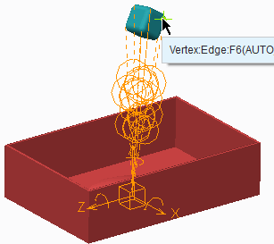

|  |
| --- |
| 1. Disable all Datum Display types. 2. In the ribbon, select the **Applications** tab. 3. Click **Mechanism**  from the Motion group. 4. Enable only the following Datum Display types: . 5. Click **Measures**  from the Analysis group. 6. Click **New Measure**  to create a Position type measure.    * Edit the Name to **Position1**.    * Select datum point **Vertex:Edge:F6** on Cube1.    * Click **OK**. |
| 1. Click **New Measure**  to create a Velocity type measure.    * Edit the Name to **Velocity1**.    * Select **Velocity** from the Type drop-down list.    * Select datum point **Vertex:Edge:F6** on Cube1.    * Click **OK**.    * Click **Close**. |

**Task 2:** Create and run a dynamic analysis.

1. In the Mechanism Tree, click **ANALYSES** and select **New** from the mini toolbar.
2. Select the **Preferences** tab and complete the following:
   * Edit the Name to **Cube_Drop**.
   * Select **Dynamic** from the Type drop-down list.
   * Select **Length and rate** from the drop-down list, if necessary.
   * Edit the Duration to **5** and press ENTER.
   * Edit the Frame rate to **2** and press ENTER.
   * In the Initial configuration section of the dialog box, click **Current**, if necessary.
3. Select the **External loads** tab and complete the following:
   * Select the **Enable gravity** check box.
   * Select the **Enable all friction** check box.
4. Click **Run**.
5. After the analysis has run, click **OK**.

**Task 3:** Plot measures for position and velocity.

1. 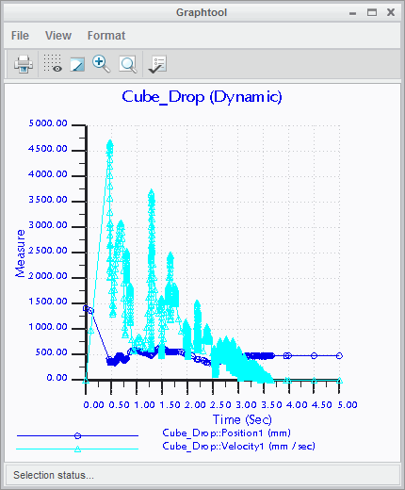Click **Measures ** from the Analysis group.
   * Press CTRL and select **Position1** and

**Velocity1** from the Measures list.

* + Select **Cube_Drop** from the Result set list.
  + Click **Graph Measure ** at the top of the Measure Results dialog box.

1. Close the Graphtool window.
2. Click **Close** from the Measure Results dialog box.
3. Click **Regenerate ** from the Quick Access toolbar.
4. Click **Save ** from the Quick Access toolbar.

This completes the exercise.

## Exercise 2: Analyzing the Overhead Cam

### Objectives

After successfully completing this exercise, you will be able to:

* + Create a servo motor.
  + Configure a dynamic analysis.
  + Check for redundancies in the analysis.
  + Create measures.

### Scenario

In this exercise, you create a servo motor on the single overhead cam engine and configure a dynamic analysis. You learn how to create measures to evaluate the intake and exhaust spring load reactions. You also need to determine the normal forces on the cams. To fulfill this task, you create the necessary measures on the connections. The measures are important because they enable you to find the load reactions and normal forces without a physical prototype.

**Task 1:** Create a servo motor.

1. 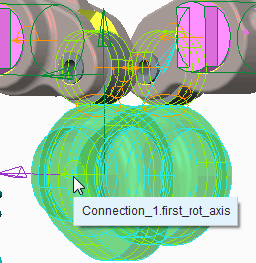Disable all Datum Display types.
2. In the ribbon, select the **Applications** tab.
3. Click **Mechanism ** from the Motion group.
4. Click **Servo Motors ** from the Insert group.
   * Select the joint axis at the center of CAMSHAFT.PRT.
   * Select the **Profile Details** tab.
   * Select **Angular Velocity** from the Function Type drop-down list.
   * Edit the constant velocity A to **15000**.
   * Click **Complete Feature **.

**Task 2:** Create an analysis and check for redundancies in the analysis.

1. Click **Mechanism Analysis ** from the Analysis group.
   * In the Type drop-down list, select **Dynamic**.
   * Select **Rate and frame count** from the Graphical Display drop-down list.
   * Edit the value for Frame count to **360** and press ENTER.
   * Edit the value for Frame rate to **15000** and press ENTER.
   * In the Initial configuration area of the dialog box, select the **I.C.State:** radio button.
   * Click **Run**.
   * Click **OK** when the analysis has completed its run.
2. Click **Measures ** from the Analysis group.
   * Click **AnalysisDefinition1** from the Result set list.
   * Note that there are zero redundancies in the analysis.

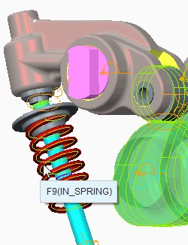

|  |
| --- |
| 1. In the Measure Results dialog box, click **New Measure** .    * Edit the Name to **IN_SPRING_RX_LOAD**.    * Select **Net load** from the Type drop-down list.    * Select IN_SPRING.PRT, as shown.    * Click **OK** to complete the measure. |
| 1. Click **New Measure** .    * Edit the Name to **EX_SPRING_RX_LOAD**.    * Select **Net load** from the Type drop-down list.    * Select EX_SPRING.PRT, as shown.    * Click **OK** to complete the measure. |

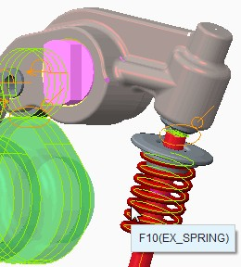**Task 3:** Create measures to record the normal force on Cam1 and Cam2.

1. 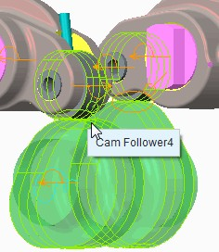Click **New Measure **.
   * Edit the Name to **CAM1_NORMAL_RX**.
   * Select **Connection reaction** from the Type drop-down list.
   * Select the **Cam Follower4** connection, as shown.
   * Click **OK** to complete the measure.

  

1. 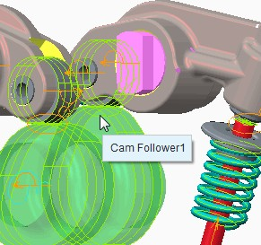Click **New Measure **.
   * Edit the Name to **CAM2_NORMAL_RX**.
   * Select **Connection reaction** from the Type drop-down list.
   * Select the **Cam Follower1** connection, as shown.
   * Click **OK** to complete the measure.

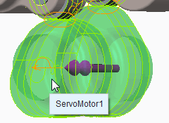**Task 4:** Create a measure for the motor load reaction.

|  |
| --- |
| 1. Click **New Measure** .    * Edit the Name to **MOTOR_LOAD_RX**.    * Select **Net load** from the Type drop-down list.    * Select **ServoMotor1** as shown.    * Click **OK** to complete the measure. |
| ***Note:*** *Observe the measure values calculated from theanalysis.* |
| 1. Click **Close** to close the Measure Results dialog box. 2. Click **Regenerate**  from the Quick Access toolbar. 3. Click **Save**  from the Quick Access toolbar. |

This completes the exercise.

298

# Module 13

## Evaluating Analysis Results

## Running Mechanism Analyses

Run a mechanism analysis to animate the results, plot measures, save the results, and check for collisions.

Run analyses to:

* + - Animate results.
    - Plot measures.
    - Save results.
    - Check for collisions.

Figure 1 – Mechanism after a Static Analysis was Run

###### Running Mechanism Analyses

Each time you configure an analysis of a mechanism, you must run the analysis to view the mechanism and its results. This is typically performed immediately after configuring an analysis.

Mechanism analyses are run for reasons other than simply animating the analyses. Running an analysis enables you to:

* + Plot measures to determine whether the design meets specifications.
  + Store and export analysis results for evaluation. These saved results can be used for design review or supplier/customer interaction.
  + Check for collisions between components in your mechanism.

## Evaluating Playback Results for Collisions

You can evaluate playback results to find collisions in the analysis of your mechanism designs.

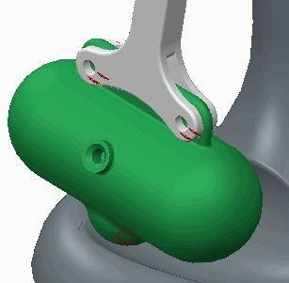General collision detection settings:

* + - No collision detection
    - Global collision detection
    - Partial collision detection
    - Include quilts

Collision identification settings:

* + - Sound warning upon collision
    - Stop animation playback upon collision

Figure 1 – Detected Collisions in Red



###### Evaluating Playback Results for Collisions

If you enable collision detection from the Playbacks dialog box, collisions between moving components are detected during the playback of results. You can stop movement when a collision is detected, or continue the animation and get a continuous collision view.

You can enable collision detection and configure the settings by clicking Collision Detection Settings from the Playbacks dialog box. These settings enable you to specify whether your result set playback includes collision detection, how much it includes, and how the playback displays the collision.

By default, Creo Parametric does not check for collisions between moving components. You must enable and configure collision detection using the following general collision detection settings:

* + - * No collision detection – This is the default setting. When set, collision detection is not performed and the animation plays smoothly, even when a collision occurs.
      * Global collision detection – Collisions are detected and identified during the animation run in accordance with the optional selected settings.
      * Partial collision detection – Enables you to specify which components should be checked for collision. This is especially useful for large assemblies, in which performance can be an issue.
      * Include quilts – Selects whether surface quilts are included in the collision detection process.

Use the following settings to determine how Creo Parametric notifies you that a collision has been detected:

* + - * Sound warning upon collision – With this option enabled, a warning bell sounds upon collision.
      * Stop animation playback upon collision – With this option enabled, the playback stops upon collision.

## PROCEDURE - Evaluating Playback Results for Collisions

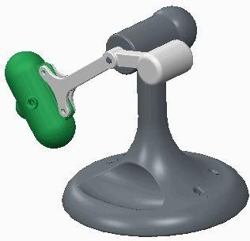**Task 1:** Run the analysis named AnalysisDefinition2 to create playback results.

|  |
| --- |
| 1. Disable all Datum Display types. 2. In the ribbon, select the **Applications** tab. 3. Click **Mechanism**  from the Motion group. 4. In the Mechanism Tree, expand the **ANALYSES**   node.   1. Select **AnalysisDefinition2(DYNAMICS)** and click **Run**  from the mini toolbar. 2. Click **Playback**  from the Analysis group. 3. Click **Play Result Set**  in the Playbacks dialog box. |
| 1. Click **Play** to start the animation. 2. Click **Close** to stop the animation and return to the Playbacks dialog box.   ***Note:*** *Notice how quickly the playback results generate and run. With the collision detection turned on (as seen in the next task), the playback results take a lot longer.* |

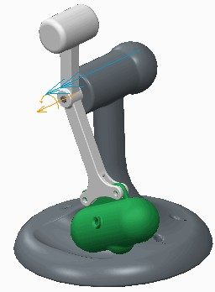

**Task 2:** Run playback results with collision detection turned on.

1. Click **Collision Detection Settings** in the Playbacks dialog box.
   * Select the **Global collision detection** option.
   * Ensure that the **Sound warning upon collision** and **Stop animation playback upon collision**

check boxes are selected.

* + Click **OK**.

1. Click **Play Result Set ** in the Playbacks dialog box.

***Note:*** *Because it takes longer to generate and run playback results with collision detection, it is a best practice to enable this setting only when you are looking for collisions.*

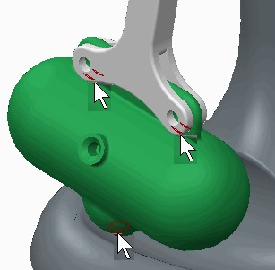**Task 3:** Eliminate the collisions and verify using playback results.

|  |
| --- |
| 1. Notice that a collision has been detected. 2. In the graphics window, notice that the collision is highlighted in the model, as shown. 3. Click **Play** to start the animation. 4. Notice that the animation stops when another collision is detected, as shown. |
| 1. At the top of the model tree, click **Settings**  and select **Tree Filters** .    * Select the **Features** check box in the Model Tree Items dialog box.    * Click **OK**. 2. In the model tree, select COLLISION3.PRT and click **Activate**  from the mini toolbar.    * Expand the COLLISION3.PRT node.    * In the model tree, select **Extrude 1** and click **Edit Dimensions**  from the mini toolbar.    * In the graphics window, edit the dimension 50 to **52** and press ENTER.    * Click in the graphics window to de-select all.    * In the model tree, select **Revolve 3** and click **Edit Dimensions** .    * In the graphics window, edit the dimension 18 to **12** and press ENTER. 3. Press CTRL+G to regenerate the model. 4. In the model tree, select COLLISION.ASM and click **Activate** . |
| 1. In the Mechanism Tree, expand the **ANALYSES**   node.   1. Select **AnalysisDefinition2(DYNAMICS)** and click   **Run** .   1. Click **Yes** to confirm. 2. Click **Playback** . 3. In the Playbacks dialog box, click **Play Result Set** . 4. Click **Play** . |

1. Click **Close** to stop the animation.

##### Click Collision Detection Settings.

* + Select the **No collision detection** option.
  + Click **OK**.

1. Click **Close**.

This completes the procedure.

## Configuring Playback Results

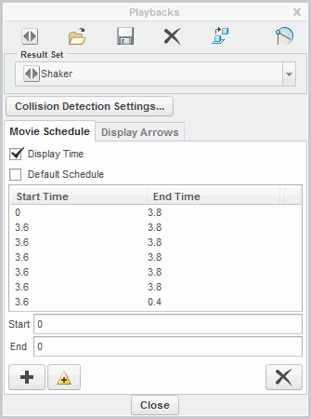Use the Playbacks tool to play, restore, configure, export, and save analysis results. Playback Analyses:

* Play
* Restore
* Save

Movie Schedule Tab:

* Display Time
* Default Schedule
* Add Movie Segments

Figure 1 – Analysis Configured Using Multiple Movie Segments

Configuring Playback Results

The Playbacks dialog box contains many tools for working with analysis results. You can play, save, and restore analyses. You can also learn to configure the start and end times of an analysis in the Movie Schedule tab.

###### Opening the Playbacks Dialog Box

You can open the Playbacks dialog box using the following methods:

* Select the Applications tab. Click **Mechanism ** from the Motion group. Click **Playback ** from the Analysis group.
* Right-click PLAYBACKS and select Play from the Mechanism Tree.

###### Using Playbacks Dialog Box Tools

The following tools are available from the Playbacks dialog box:

* **Play Result Set ** – Click to play back an analysis and open the Animate dialog box. Use the options within the Animate dialog box to control playback speed and direction.
* **Restore Result Set ** – Click to restore a result set. A dialog box opens with a list of previously saved result set files. Browse and select a saved result set from disk.



* + **Save Result Set ** – Click to save a results file to disk. A playback file has a .pbk extension. You can retrieve this file in the current session or a later session to play back the results or calculate measures. The saved file includes all Display Arrows and Movie Schedule settings.

###### Using the Movie Schedule Tab

You use the Movie Schedule tab to configure the playback of your analysis.

* + Display Time – Enables or disables the display of the analysis run time in the Creo Parametric window.
  + Default Schedule – Enables or disables the movie scheduling section of the Playbacks dialog box. With the Default Schedule check box cleared, you can access tools that enable you to create movie segments.

A movie segment is a portion of an analysis, and is defined by the start and end times in the playback. You can add multiple movie segments to a single playback.

* Start – Determines the start time of a movie segment. If the start time is greater than the end time, the animation plays in reverse.
* End – Sets the end time of a movie segment.
* **Add Movie Segment** – Adds a movie segment based on specified start and end times.
* **Update Movie Segment ** – Updates a selected movie segment with edited start and end times.
* **Delete Movie Segment ** – Deletes a selected movie segment from a playback animation.

## PROCEDURE - Configuring Playback Results

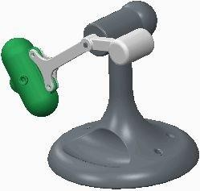**Task 1:** Run analysis AnalysisDefinition2 to create playback results.

|  |
| --- |
| 1. Disable all Datum Display types. 2. In the ribbon, select the **Applications** tab. 3. Click **Mechanism**  from the Motion group. 4. In the Mechanism Tree, select **PLAYBACKS** and click **Play** from the mini toolbar. |
| 1. Notice that the Result Set list is empty. Click   **Close**.   1. In the Mechanism Tree, expand the **ANALYSES**   node.   1. Select **AnalysisDefinition2(DYNAMICS)** and click **Run**  from the mini toolbar. 2. Select **PLAYBACKS** and click **Play** . |
| 1. Select **AnalysisDefinition2** from the Result Set drop-down list. Notice that it is the only result set in the list. 2. Click **Restore Result Set** , select **Shaker.pbk** and click **Open**. 3. Select **Shaker** from the Result Set drop-down list and notice that both result sets are now listed.   ***Note:*** *Result sets are not saved with the Creo Parametric model. They are created by running an analysis or opening a saved set. Notice in the Movie Schedule tab that Shaker has been conflgured by adding various start and end times*  *to the animation.* |

1. 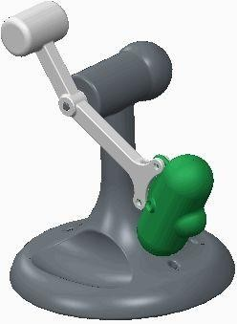With the Shaker result set still selected, click

##### Play Result Set .

1. Click **Repeat Animation ** to disable looping of the animation.
2. Click **Play** to start the animation.
3. Click **Close** to close the Animate dialog box.

**Task 2:** Configure, play, and save the AnalysisDefinition2 result set.

1. Select **AnalysisDefinition2** from the Result Set drop-down list.
2. Clear the **Default Schedule** check box.
   * Edit the End value from 0 to **3** and press ENTER.
   * Click **Add Movie Segment** .
   * Click **Play Result Set **.

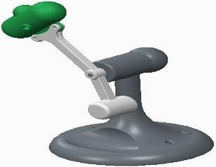***Note:*** *The duration deflned in AnalysisDeflnition2 is four seconds. By editing the End Time to 3 seconds, you have reduced the number of animation frames by one-fourth.*

1. Click **Repeat Animation **.
2. Click **Play** to start the animation.
3. Click **Close**.
4. In the Movie Schedule tab, complete the following:
   * Select the one movie segment listed (it has a Start Time of 0 and End Time of 3).
   * Edit the End value from 3 to **2** and press ENTER.
   * Click **Update Movie Segment ** to update the selected movie segment.
   * Edit the Start value from 0 to **2** and press ENTER.
   * Edit the End value from 2 to **0** and press ENTER.
   * Click **Add Movie Segment** .

***Note:*** *You should now have two movie segments: the flrst starting at 0 and ending at 2, and the second segment starting at 2 and ending at 0. This causes the animation to move forward and then backward.*

* + Click **Play Result Set **.

1. Click **Repeat Animation **.
2. Click **Play** to start the animation.
3. Click **Close**.
4. Click **Save Result Set ** and then click **Save** from the Save Analysis Results dialog box.
5. Click **Close**.

This completes the procedure.

## Evaluating Results Using Display Arrows

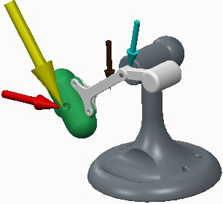Display arrows enable you to dynamically assess the relative loads on your mechanism as it is animated. Color-Coded Arrow Displays:

* + - Force
    - Torque
    - Gravity
    - Force Motor
    - Measure

Arrow Identifications:

* + - Single Head for Linear Force
    - Double Head for Moment or Angular Measure Annotation Options:
    - Display Name and Value
    - Scale Selected Arrows

###### Evaluating Results Using Display Arrows

*Figure 1 – Display Arrows*

In the Display Arrows tab of the Playbacks dialog box, you can enable the display of analysis display arrows. These display arrows enable you to dynamically assess the relative loads applied to a mechanism during an analysis.

When you save the result set, the arrows and annotations are saved with the result set. Display arrows appear and dynamically update during the analysis, making them a great tool for use in design reviews and demonstrations.

###### Color-Coded Arrow Displays

*Each display arrow represents magnitude and the direction of a force, torque, gravity, force motor, or measure. The direction of the arrow changes as the calculated vector direction increases and decreases. The display arrows are color coded as follows:*

* + Cyan – The cyan arrow indicates a connection reaction on a joint or cam. The arrow tip is at the specified joint axis, pointing in the direction of the joint's degrees of freedom (DOF). For normal reaction on cams, the arrow tip is at the point of contact between the two cams, pointing normal to the cam. For tangential reaction forces, the arrow tip is at the point of contact between the two cams, pointing in a direction tangential to the cam.
  + Magenta – The magenta arrow indicates a load reaction. The arrow points at the joint axis for servo motors or, for point-to-point springs and dampers, and extends between the points used to define the entity. The arrow points in the direction of the applied force.
  + Dark Green – The dark green arrow indicates a load cell reaction. The arrow identifies the point at which the force is applied, and in the direction of the force.
  + Yellow – The yellow arrow indicates velocity. The arrow identifies the joint axis or point, and points in the direction of velocity.
  + Red – The red arrow indicates acceleration. The arrow identifies the joint axis or point, and points in the direction of acceleration.
  + Brown – The brown arrow indicates gravity. The arrow identifies the center of mass in the direction of gravitational acceleration.
  + Green – The green arrow indicates a force motor. The arrow identifies the joint axis and points in the direction of a joint's DOF.
  + Orange – The orange arrow indicates a force or torque. The arrow identifies the point of application for forces, or toward the center of mass of the body for torques.

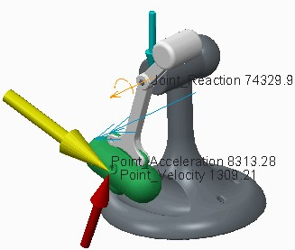

###### Arrow Identifications

Each display arrow uses a single head for linear force and double head for moment or angular measurements.

###### Annotation Options

There are two options to further configure the appearance of the displaying arrows:

* + - Annotation – Each display arrow displays a name and a value if you select optional check boxes.
    - Scale – Select a category from the drop-down list and adjust the initial size of the arrow in the category by selecting a percent. At 0%, the arrow is not shown. There is no maximum limit for scale. You can select from Force, Moment, Acceleration, and Velocity arrows to be scaled.

## PROCEDURE - Evaluating Results Using Display Arrows

**Task 1:** Play analysis results without display arrows.

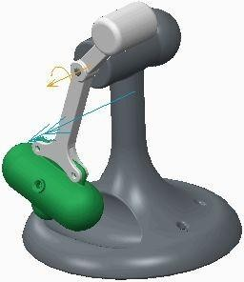

|  |
| --- |
| 1. Disable all Datum Display types. 2. In the ribbon, select the **Applications** tab. 3. Click **Mechanism**  from the Motion group. 4. In the Mechanism Tree, expand the **ANALYSES**   node.   1. Select **AnalysisDefinition1(DYNAMICS)** and click   **Run**  from the mini toolbar. |
| 1. Click **Playback**  from the Analysis group. 2. Click **Play Result Set**  in the Playbacks dialog box. 3. Click **Repeat Animation**  to disable it. 4. Click **Play** to start the animation. 5. Click **Close**. |

**Task 2:** Play analysis results with display arrows.

|  |
| --- |
| 1. Select the **Display Arrows** tab in the Playbacks dialog box.    * Select the **Joint_Reaction**, **Point_Acceleration**, and **Point_Velocity** check boxes from the Measures list.    * Adjust the scale wheel so the scale for the Force arrow is approximately 75%.    * Select **Velocity** from the Scale drop-down list.    * Adjust the scale wheel so the scale for the Velocity arrow is approximately 150%.    * Select the **Name** and **Value** check boxes to enable their display. |
| 2. Click **Play Result Set**  in the Playbacks dialog box. |

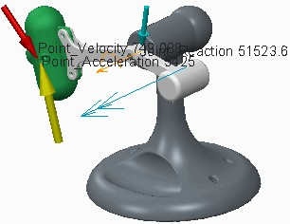

|  |
| --- |
| 1. Click **Repeat Animation**  to disable it. 2. Click **Play** to start the animation. 3. Drag the Frame slide bar to move the animation one frame at a time. |
| ***Note:*** *Notice how the arrows and values representing the measures and force change during the analysis.* |
| 6. Click **Close**. |
| 1. Click **Save Result Set**  in the Playbacks dialog box. 2. Click **Save** in the Save Analysis Results dialog box. 3. Click Yes in the Confirmation dialog box. 4. Click **Remove Result Set**  to remove the result set from session. 5. Click **Restore Result Set** , select   **AnalysisDefinition1.pbk**, and click **Open**. |
| ***Note:*** *Notice that the display arrows and their options were saved with and restored with the result set.* |
| 12. Click **Close**. |

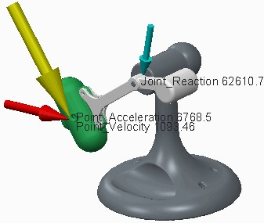This completes the procedure.

## Graphing Measure Results

You can graph analysis measurements to help you understand and evaluate your mechanism.

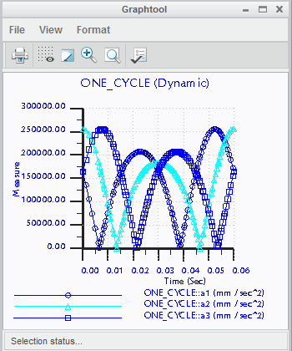Measure Results Dialog Box:

* Graph Type
* Measures
* Result Set
* Graph Measure
* Load Result Set
* Export Results

Figure 1 – Graphed Acceleration Magnitude

  

###### Graphing Measure Results

You graph and export the results of analysis measures to verify and evaluate the movement of the mechanism.

###### The Measure Results Dialog Box

Access the Measure Results dialog box as follows:

* + Select the Applications tab. Click **Mechanism ** from the Motion group.
  + Click **Measures ** from the Analysis group.

###### Measures and Results

The Measure Results dialog box provides three functions: to create measures, to graph the results of selected measures, and to export the result of a measure to models as a parameter.

* + Graph Type – Display the results of a measure graph as Measure vs. Time or Measure vs. Measure.

– Measure for X axis – For a Measure vs. Measure type graph, you can select the measure that are placed on the X-axis.

* + Measures – In the Measures section of the dialog box, you can select, create, edit, copy, and delete measures. You can also toggle Graph measures separately to either graph measures as multiple plots in one graph or as separate graphs.

***Note:*** *You can display up to nine separate graphs.*

* + Result Set – In the Result Set section of the dialog box, you can select one or more result sets from previously run analyses. The graph displays a plot of different colored curves, one for each result set.

Along the top of the dialog box, there are three operations that you can perform on selected measures:

* + **Graph Measure ** – Graphs the selected measure based on the selected result set. After the measure results are complete, the Graphtool window opens. Use the items in this window to change the display of your graph, print it, or save it in tabular form.
  + **Load Result Set ** – Enables you to use results from a saved analysis run. Select a saved results file and it displays in the Result Set section of the dialog box.
  + **Export Results ** – Creates a Creo Parametric parameter from the selected measure and analysis. The parameter has the name MDO_<measure_name>. When you first create a parameter from a measure, it is given the value of the measure at the last time step of the analysis. The value of the Creo Parametric parameter remains constant until you update it in the Measure Results dialog box or until you return to Creo Parametric and change the value. If you create a parameter and then rerun an analysis, select the measure and analysis and click **Export Results**

to update the value of the parameter with the value from the new analysis.

309

# Module 14

## Creating Model Property Features on Creo Parametric Models

## Comparing Model Property Analyses

Using model analysis, you can analyze model properties.

Before learning about each individual model property analysis, you must understand:

* The differences between the model property analyses.
* The similarities between the model property analyses.

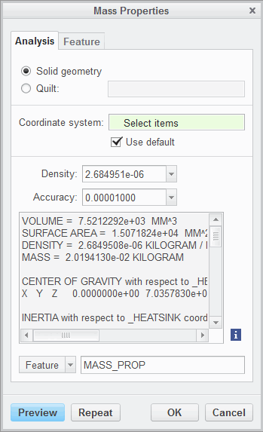

Figure 1 – Measuring Mass Properties

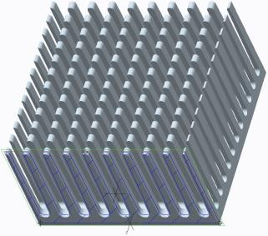

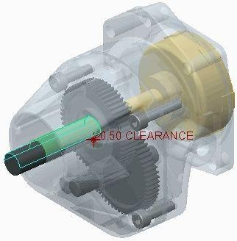Figure 2 – Analyzing X-Section Mass

Properties at XSEC Figure 3 – Measuring Pairs Clearance

###### Differences Between the Model Property Analyses

Using model analysis, you can analyze model properties. You can create the following model property features using BMX:

* Mass Properties – Computes the mass properties.
* X-Section Mass Properties – Computes the mass properties for a cross-section.
* Pairs Clearance – Computes the clearance distance or interference between two objects or entities in a model.

###### Similarities Between the Model Property Analyses

When starting any model property analysis, you can decide how the analysis is captured in Creo Parametric. Your choices include the following:

* Quick – Enables you to compute model properties without saving the analysis or creating a feature in the model tree.
* Saved – Enables you to save the analysis for future use. You can retrieve a saved analysis by selecting the Analysis tab and clicking **Saved Analysis ** from the Manage group.
* Feature – Enables you to save the analysis as a feature in the model tree. Additionally, you can now access the Feature tab in the model Analysis dialog box. Within the Feature tab, you can create optional parameters and/or datum features when creating your analysis feature.

## Measuring Mass Properties

Mass properties analysis enables you to compute volume, surface area, density, mass, center of gravity, moment of inertia, and other properties associated with the model.

The mass property values for your model depend on the following:

* Model density or material
* Suppress features
* Simplified representations
* Layered parts
* Dimension bounds
* Welds

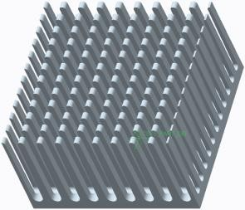

Figure 1 – Coordinate System at Center of Gravity Figure 2 – Analyzing Mass Properties

###### Measuring Mass Properties Overview

The mass property values for your model depend on the following:

* + Setting model density or material – To properly calculate mass properties, you must configure either the density of each part model or assign a material to each part model prior to executing the analysis.

***Note:*** *If the mass properties or material of assembly components have not been conflgured, you have the option to edit the density of each component before executing the calculation on an assembly.*

* + Suppressed Features – If features are suppressed, then the mass properties are calculated as if the features do not exist.
  + Simplified Reps – Models must be set to Master Rep or Geometry Rep to be included in mass properties calculation.
  + Layered Parts – Parts of layers that are hidden from the current view are included in the mass properties of an assembly.
  + Dimension Bounds – If the dimension bounds used for tolerances have been set, then the mass property calculations are based upon hypothetical dimension values.
  + Welds – The mass properties of a weld can be included or excluded in assembly mass property calculations by setting add_weld_mp to yes in config.pro. The default setting is no.

###### Mass Properties Definition

By default, Creo Parametric uses the default coordinate system when calculating mass properties. You have the option to specify a different coordinate system.

You can also override the initial density setting for a part if a material has not been assigned to the part. You cannot override any assembly density settings.

Finally, you can also adjust the accuracy of the calculation.

###### BMXFeature Options

You can create the following mass properties parameters:

* + - VOLUME
    - SURF_AREA
    - MASS
    - Principal moments of inertia (3)
    - Center of gravity (X, Y, and Z)
    - Inertia tensors (6)
    - Rotation angles (X, Y, and Z)

You can create the following mass properties datums:

* + - Coordinate system at the center of gravity.
    - Datum point at the center of mass.

## PROCEDURE - Measuring Mass Properties

**Task 1:** Compute the mass properties of a model, create the surface area parameter, and create a coordinate system at the center of gravity.

|  |
| --- |
| 1. Disable all Datum Display types. 2. In the ribbon, select the **Analysis** tab. 3. Click **Mass Properties**  from the Model Report group.    * Select **Feature** from the drop-down list.    * Type **MASS_PROP** as the name.    * Click **Preview**. |
| 1. Type **1.3e-06** as the density. 2. Click **Preview**. |
| 1. Select the Feature tab in the Mass Properties dialog box.    * Clear the VOLUME and MASS parameter check boxes.    * Select the CSYS_COG datum feature check box.    * Click OK.   completes the procedure. |

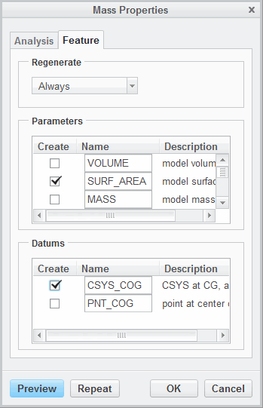This

## Measuring X-Section Mass Properties

1. section mass properties analysis enables you to compute surface area, center of gravity, and other

properties associated with a model’s cross-section.

The x-section mass property values for your model depend on the following:

* + Suppressed features
  + Simplified representations
  + Layered parts
  + Dimension bounds
  + Welds

 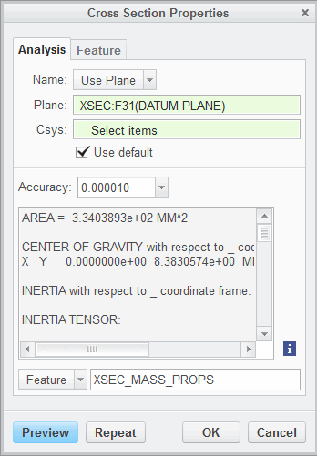

Figure 1 – Analyzing X-Section Mass Figure 2 – Analyzing X-Section Mass Properties Properties at XSEC

###### Measuring X-Section Mass Properties

1. section mass properties analysis enables you to compute surface area, center of gravity, and other properties associated with a model’s cross-section.

The x-section mass property values for your model depend on the following:

* + Suppressed Features – If features are suppressed, then the mass properties are calculated as if the features do not exist.
  + Simplified Reps – Models must be set to Master Rep or Geometry Rep to be included in mass properties calculation.
  + Layered Parts – Parts on layers that are hidden from the current view are included in the mass properties of an assembly.
  + Dimension Bounds – If the dimension bounds used for tolerances have been set, then the mass property calculations are based upon hypothetical dimension values.
  + Welds – The mass properties of a weld can be included or excluded in assembly mass property calculations by setting add_weld_mp to yes in config.pro. The default setting is no.

###### Mass Properties Definition

To calculate the cross-section, you can either:

* + Select a plane before starting the analysis.
  + Select a plane after starting the analysis.
  + Select a previously created cross-section.

Creo Parametric uses the default coordinate system when calculating mass properties. You have the option to specify a different coordinate system.

Finally, you can also adjust the accuracy of the calculation.



###### BMXFeature Options

You can create the following mass properties parameters:

* + - XSEC_AREA
    - Principal moments of inertia (2)
    - Center of gravity (x and y)
    - Inertia at center of gravity (3)

You can create the following mass properties datums:

* + - Coordinate system at the center of gravity.
    - Datum point at the center of gravity.

## PROCEDURE - Measuring X-Section Mass Properties

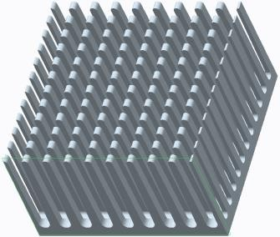**Task 1:** Compute the cross-sectional mass properties using a datum plane.

|  |
| --- |
| 1. Enable only the following Datum Display type:   **Plane Display** .   1. Select datum plane **XSEC**. |
| 1. In the ribbon, select the **Analysis** tab. 2. In the Model Report group, select the **Mass Properties**  drop-down list and select   **X-Section Mass Properties** .   * Select **Feature**. * Type **XSEC_MASS_PROPS** as the name. |
| 1. Select the **Feature** tab in the Cross Section Properties dialog box.    * Type **XSEC_AREA_XSEC** as the name of the area of the XSEC.    * Click **OK**. |

**Task 2:** Compute the cross-sectional mass properties using a previously created cross-section.

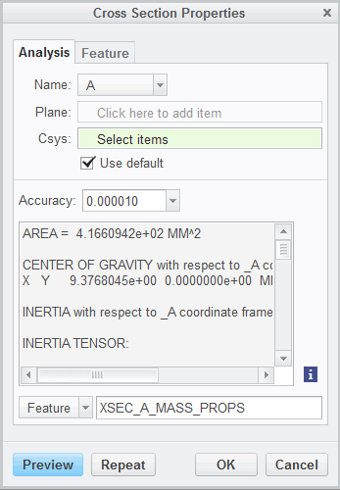

|  |
| --- |
| 1. In the Model Report group, select the **Mass**  **Properties**  drop-down list and select  **X-Section Mass Properties** .   * Select **Feature**. * Type **XSEC_A_MASS_PROPS** as the name. * Select **A** from the Name list. |
| 1. Select the **Feature** tab in the Cross Section Properties dialog box.    * Type **XSEC_AREA_XSEC** as the name of the area of the XSEC.    * Click **OK**. |

This completes the procedure.

## Measuring Pairs Clearance

Pairs clearance enables you to compute the clearance distance or interference between two objects or entities in a model.

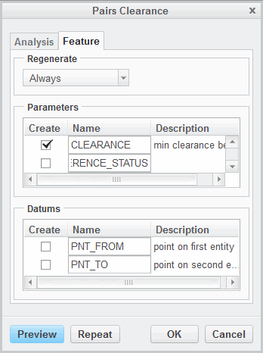

Figure 1 – Analyzing Pairs Clearance Figure 2 – Parameters and Datums

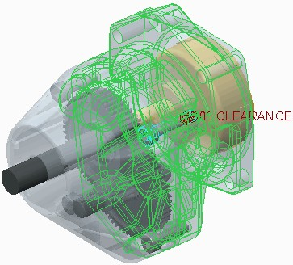 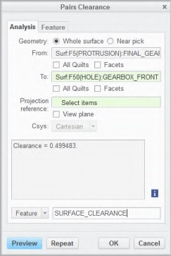

Figure 3 – Analyzing Pairs for Interference Figure 4 – Detecting Interference

###### Measuring Pairs Clearance Overview

Pairs clearance enables you to compute the clearance distance or interference between two objects or entities in a model. Pairs clearance can be calculated between:

* + - Sub-assemblies
    - Parts
    - Surfaces
    - Cables
    - Edges, curves, and datum points

Pairs clearance analysis is available in Part, Assembly, and Drawing modes.

***Note:*** *Exploded views in Assembly mode are cosmetic and have no effect on clearance computations.*

###### BMXFeature Options

You can create parameters named CLEARANCE, INTERFERENCE_STATUS, and INTERFERENCE_VOLUME.

* + - The CLEARANCE parameter contains the minimum clearance value between the two entities.
    - The INTERFERENCE_STATUS parameter value equals 1 if there is interference between the two entities, or equals 0 if there is no interference.
    - The INTERFERENCE_VOLUME parameter contains the volume interference value.

You can create a datum point on either the From reference, the To reference, both references, or neither reference.

## PROCEDURE - Measuring Pairs Clearance

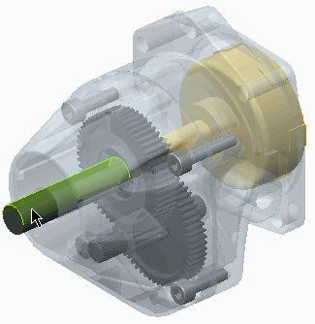**Task 1:** Compute the pairs clearance between two surfaces.

|  |
| --- |
| 1. Disable all Datum Display types. 2. In the model tree, click **Settings**  and select   **Tree Filters** .   1. Enable **Features** in the Model Tree Items dialog box and click **OK**. 2. In the ribbon, select the **Analysis** tab. 3. In the Inspect Geometry group, select the Interference drop-down list and select **Pairs Clearance** .    * Select **Feature** from the drop-down list.    * Type **SURFACE_CLEARANCE** as the name. 4. Select the surface as shown. |
| 1. Right-click the surface and select **to Collector**.    * Select the surface as shown. |
| 1. Select the **Feature** tab.    * Ensure that the **CLEARANCE** parameter is selected.    * Click **OK**. |

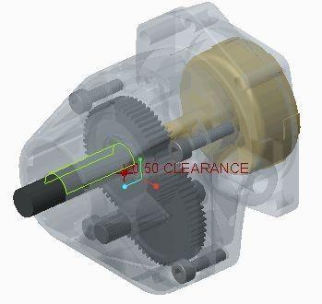**Task 2:** Compute the volume interference between two parts and display the interference status in the model tree.

* 1. 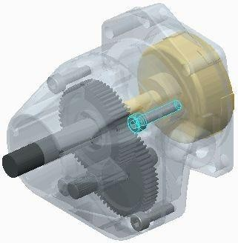In the Inspect Geometry group, select the Interference drop-down list and select **Pairs Clearance **.
     + Select **Feature** from the drop-down list.
     + Type **PART_CLEARANCE** as the name.
  2. Select BOLT_5–24<BOLT>.PRT from the model tree.



|  |
| --- |
| 3. Select GEARBOX_REAR.PRT from the model tree.  ***Note:*** *The volume of interference is displayed in the Results section of the Analysis tab.* |
| 1. Select the **Feature** tab in the Pairs Clearance dialog box.    * Ensure that the **CLEARANCE** parameter is selected.    * Select **INTERFERENCE_STATUS** .    * Click **OK**. 2. In the model tree, click **Settings**  and select   **Tree Columns** .   1. Select **Feat Params** from the Type drop-down list.    * Type **INTERFERENCE_STATUS** as the name and press ENTER.    * Click **OK**. |

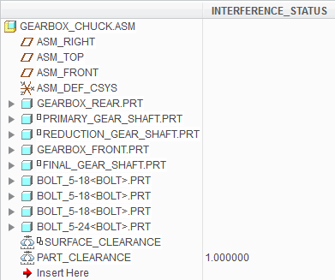This completes the procedure.

## Exercise : Analyzing Clearance in the Hand Pump

### Objectives

After successfully completing this exercise, you will be able to:

* + - Create a pairs clearance analysis feature.
  + Create a parameter to measure clearance.

### Scenario

You are part of a design team tasked with optimizing a hand pump to increase the volume of water pumped per stroke. To complete this task, you need to create several BMX features. One of the features has already been completed: a distance analysis feature that measures the height of the valve from the bottom surface of the cylinder.

In this exercise, you create a pairs clearance analysis feature that measures the distance between the rod top and cylinder parts. This measurement is important because the design specification requires a clearance distance of at least 1/8 inch. Therefore, this measurement must be captured as a parameter so that it can be tracked.

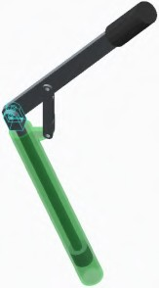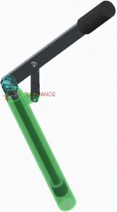**Task 1:** Create an analysis feature to measure clearance between the rod top and the cylinder.



|  |
| --- |
| 1. Disable all Datum Display types. 2. In the ribbon, select the **Analysis** tab. 3. In the Inspect Geometry group, select the **Global Interference** drop-down list and   select **Pairs Clearance** .   * + Select **Feature** from the drop-down list.   + Type **CLEARANCE** as the name.  1. In the model tree, expand ROD_ASM.ASM and select ROD_TOP.PRT. |
| 5. Select CYLINDER.PRT. |
| 1. Select the **Feature** tab.    * Ensure that the **CLEARANCE** parameter is selected.    * Click **OK**. 2. Click **Save**  from the Quick Access toolbar. |

This completes the exercise.

# Module 15

## Creating Analysis Features on Creo Parametric Models

## Comparing Analysis Features

Before learning about each individual analysis feature, you must understand:

* + - 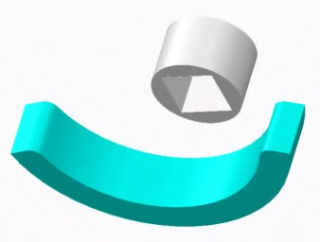Differences between analysis features.
    - Similarities between analysis features.

Figure 1 – Motion Analysis

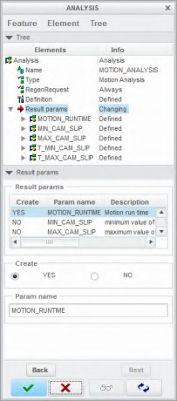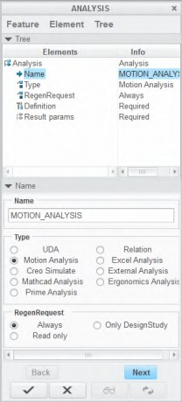

Figure 2 – Analysis Parameters Figure 3 – Analysis Feature Types

###### Comparing Analysis Features

Before learning about each individual analysis feature, you must understand:

* + Differences between the analysis features.
  + Similarities between the analysis features.

###### Differences Between the Analysis Features

Using the **Analysis ** feature, you can create the following analysis types:

* + Relation – Creates mathematical functions that capture design intent between model features.
  + Motion – Runs a Mechanism Design Extension (MDX) or Mechanism Dynamics Option (MDO) analysis during regeneration.
  + Creo Simulate – Retrieves structural or thermal analysis measures as feature parameters.
  + Excel – Retrieves an external Microsoft Excel file to define the analysis that you want to perform on a Creo Parametric model.
  + External – Creates a customized analysis using Creo Toolkit and starts it from within Creo Parametric in a parametric, associative fashion.
  + UDA – Calculates custom measurements on models that cannot be calculated using the default capabilities of the other analysis features.

###### Similarities Between the Analysis Features

When starting an analysis feature, you should name the feature. After typing the name, you must press ENTER to configure the new name.

You can also select a RegenRequest option. There are three choices:

* + - Always – Always regenerates the analysis feature during model regeneration.
    - Only Design Study – Regenerates the analysis feature only when it is used by the design study.
    - Read Only – Excludes the analysis feature from regeneration.

After you have completed a specific analysis feature, you have the opportunity to create parameters and/or datums.

## Creating a Relation Analysis Feature

Relation analysis features enable you to create mathematical functions that capture the design intent between model features.

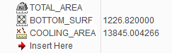Relation analysis is well suited to calculate values based on other BMX parameter outputs.

Figure 1 – Displaying Feature Parameters in the Model Tree

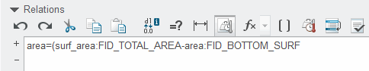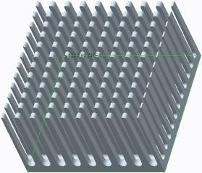

Figure 2 – Creating a Relation Figure 3 – Determining the Cooling Area

###### Creating a Relation Analysis Feature Overview

Relation analysis features enable you to create mathematical functions that capture the design intent between model features. Relation analysis is well suited to calculate values based on other BMX parameter outputs.

Relations enable you to capture the design intent of a model. Relations exist as mathematical functions, and enforce mathematical rules or limits to the model each time it is regenerated. There are several types of relations:

* + - Part relations
    - Feature relations
    - Sketcher relations

###### BMXFeature Options

Due to the flexibility of this feature, the output parameters depend on the relation you create. There are no BMX datums for the relation analysis feature.

**Best Practices**

To ensure full understanding of the relation's equation, the following is a breakdown of the equation: area = (surf_area:FID_TOTAL_AREA - area:FID_BOTTOM_SURF)

* + - area – The output parameter. Note that you can type any name for this output parameter.
    - surf_area:FID_TOTAL_AREA – Directs the relation to retrieve the parameter surf_area from feature TOTAL_AREA.
    - area:FID_BOTTOM_SURF – Directs the relation to retrieve the parameter area from feature BOTTOM_SURF.
    - FID – An acronym for Feature ID. Using FID, you can call out the feature from the model tree.

## PROCEDURE - Creating a Relation Analysis Feature

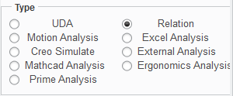**Task 1:** Compute the difference between the total surface area and the bottom surface area.

|  |
| --- |
| 1. Disable all Datum Display types. 2. In the ribbon, select the **Analysis** tab. 3. Click **Analysis**  from the Manage group. 4. Type **COOLING_AREA** as the name and press ENTER. 5. Select **Relation** as the type and click **Next**. |
| 1. Type **area=(surf_area:FID_TOTAL_AREA- area:FID_BOTTOM_SURF)**. 2. Click **Verify Relations** . 3. In the dialog boxes that appear, click **OK**, **OK**, and   **Apply-Save Changes** . |

**Task 2:** Display the computed area in the model tree.

1. In the model tree, click **Settings ** and select

##### Tree Columns .

1. Select **Feat Params** from the Type list.
2. Type **AREA** as the name.
3. Press ENTER.
4. Click **OK**.

This completes the procedure.

## Exercise 1: Determining Hand Pump Water Volume Using Relation Analysis

### Scenario

You are part of a design team tasked with optimizing a hand pump to increase the volume of water pumped per stroke. To complete this task, you need to create several BMX features. Three of the features have already been completed: a distance analysis feature that measures the height of the valve from the bottom surface of the cylinder, a pairs clearance analysis feature that measures the clearance distance between ROD_TOP.PRT and CYLINDER.PRT, and a motion analysis feature that measures minimum y-distance, maximum y-distance, and minimum clearance.

In this exercise, you create a relation analysis feature that calculates the water volume based on the maximum y- distance and minimum y-distance.

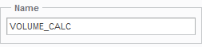**Task 1:** Create an analysis feature that calculates total volume.

|  |
| --- |
| 1. Disable all Datum Display types. 2. In the ribbon, select the **Analysis** tab. 3. Click **Analysis**  from the Manage group. 4. Type **VOLUME_CALC** as the name and press ENTER. |
| 5. Select **Relation** as the type and click **Next**. |
| 6. Type **volume=(MAX_DISTANCE_Y:FID_RANGE_OF_MOTION - MIN_DISTANCE_Y:FID_RANGE_ OF_MOTION) * pi**.  ***Note:*** *The radius of the cylinder is 1. Since r = 1, volume = π * length.* |
| ***Note:*** *You can insert the feature parameters instead of typing them into the relation equation. To insert the features in the equation above, complete the following steps:*   * *Enable Features in the model tree.* * *Type* ***volume=(*** * *Select* ***Insert > From List****.* * *The Select Parameter dialog box appears. Select* ***Feature*** *from the Look In drop-down list.* * *In the model tree, select* ***RANGE_OF_MOTION****.* * *In the Select Parameter dialog box, select* ***MAX_DISTANCE_Y*** *and click* ***Insert Selected****.* * *In the Relations dialog box, type* ***-*** *after the inserted feature and repeat the process to insert*   ***MIN_DISTANCE_Y:FID_RANGE_OF_MOTION****.*   * *Type* ***)*pi*** *to complete the equation.* |
| 1. Click **Verify Relations** . 2. Click **OK > OK > Apply-Save Changes** . |

This completes the exercise.

## Exercise 2: Using Relation Analysis to Calculate Fuel Tank Volume

### Scenario

The design specification of a fuel tank requires it to hold at least 0.35 liters of fuel. The design specification also requires that the fuel tank is able to identify when it is half full. You are assigned to ensure that the fuel tank meets these design specifications. In this exercise, you determine the volume of the fuel tank. Two analysis features have been created: the first feature calculates the volume of the solid model prior to the shell feature; the second feature calculates the volume of the shelled model. To calculate the volume of fuel that the tank can hold, you need to determine the difference of these two volumes.

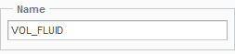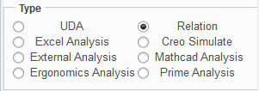**Task 1:** Create an analysis feature that calculates total volume.

|  |
| --- |
| 1. Enable only the following Datum Display type:   **Plane Display** .   1. Select the **Analysis** tab. 2. Click **Analysis**  from the Manage group. 3. Type **VOL_FLUID** in the Name field and press ENTER. |
| 5. Select **Relation** as the type and click **Next**. |
| 6. Type **volume=(volume:FID_VOL_SOLID-volume:FID_VOL_SHELL)/1000000**.  ***Note:*** *By dividing the right side of the equation by one million, you effectively convert mm3 to liters. Also note that the remaining features in the model tree do not signiflcantly affect the volume of the fuel tank, so it is acceptable to include them after the volume calculation.* |
| 1. Click **Verify Relations** . 2. Click **OK > OK > Apply-Save Changes** . 3. Click **Save**  from the Quick Access toolbar. |

**Task 2:** Display the parameter volume in the model tree.

1. 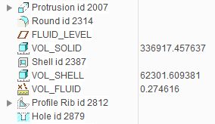Drag feature VOL_FLUID in the model tree and place it after feature VOL_SHELL.
2. In the model tree, click **Settings ** and select

##### Tree Columns .

1. Select **Feat Params** from the Type list.
2. Type **VOLUME** as the name and press ENTER.
3. Click **OK**.

**Task 3:** Experiment with the fluid level of the fuel tank by simulating a full fuel tank.

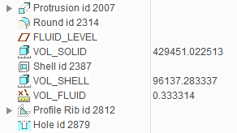

|  |
| --- |
| 1. In the model, tree select datum plane FLUID_LEVEL. 2. Right-click and select **Edit Definition** . 3. Double-click the value **20**, type **0** as the new level, and press ENTER. 4. Click **OK**. 5. Note that the total fuel capacity is 0.33 liters.   ***Note:*** *The fuel tank does not currently satisfy its design speciflcation of holding 0.35 liters of fuel. While we can randomly edit dimensions to modify the fuel tank, a better method is to use a BMX design study to flnd a dimension(s) that effectively increases the volume. This calculation can easily be accomplished using sensitivity analysis.* |
| 6. Click **Save**  from the Quick Access toolbar to save the model. |

This completes the exercise.

## Creating a Motion Analysis Feature

Motion analysis enables you to run a Mechanism Design Extension (MDX) or Mechanism Dynamics Option (MDO) analysis during regeneration.

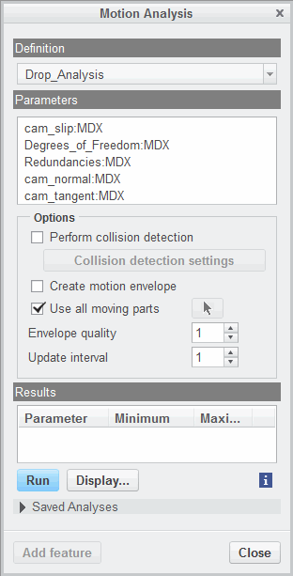The motion analysis feature enables you to create:

* + Top-level assembly feature parameters.
  + A graphical display of the motion envelope.

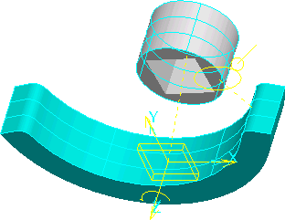

Figure 1 – Determining Cam Slip Figure 2 – Configuring the Motion Analysis

###### Creating a Motion Analysis Feature Overview

Motion analysis enables you to run a Mechanism Design Extension (MDX) or Mechanism Dynamics Option (MDO) analysis during regeneration. The motion analysis feature enables you to create:

* Top-level assembly feature parameters.
* A graphical display of the motion envelope.

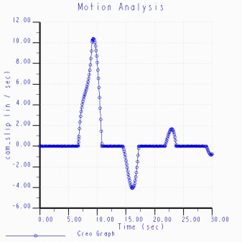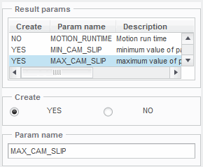

The motion analysis feature is important because it enables you to retrieve measures created in the MDX/MDO analysis as feature parameters.

***Note:*** *You need to create the MDX or MDO analysis, including any measures, before starting a motion analysis feature.*

*BMX Feature Options*

Since this feature retrieves an MDX or MDO analysis, the output parameters depend on the parameters within the analysis. When analysis parameters are present, you can create the maximum and minimum values of the top-level assembly feature parameters and the time when these values were reached.

There are no BMX datums for the motion analysis feature.

## PROCEDURE - Creating a Motion Analysis Feature

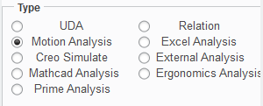**Task 1:** Create the motion analysis feature.

|  |
| --- |
| 1. Disable all Datum Display types. 2. In the ribbon, select the **Analysis** tab. 3. Click **Analysis**  from the Manage group. 4. Type **MOTION_ANALYSIS** as the name and press ENTER. 5. Select **Motion Analysis** as the type and click   **Next**. |
| 1. The Motion Analysis dialog box appears. Select   **cam_slip:MDX** from the parameter list and click **Run**.   1. The Motion Analysis graph appears. Review the graph. |
| 1. When the review is complete, close the Graphtool dialog box. Click **Close** in the Motion Analysis dialog box. 2. In the Analysis dialog box, select **NO** to ensure that the MOTION_RUNTIME parameter is not created. 3. Select **MIN_cam_slip** and select **YES** to create the parameter. 4. Select **MAX_cam_slip** and select **YES** to create the parameter. |
| 12. Click **Apply-Save Changes** . |

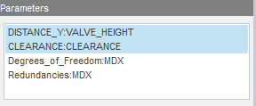

**Task 2:** Display the minimum cam slip parameter in the model tree.

1. 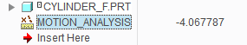In the model tree, click **Settings ** and select

##### Tree Filters .

1. Enable **Features** in the Model Tree Items dialog box and click **OK**.
2. In the model tree, click **Settings ** and select

##### Tree Columns .

1. Select **Feat Params** from the Type list.
2. Type **MIN_cam_slip** as the name.
3. Press ENTER.
4. Click **OK**.

This completes the procedure.

## Exercise 3: Analyzing Hand Pump Motion

### Scenario

You are part of a design team tasked with optimizing a hand pump to increase the volume of water pumped per stroke. To complete this task, you need to create several BMX features. Two of the features have already been completed: a distance analysis feature that measures the height of the valve from the bottom surface of the cylinder, and a pairs clearance analysis feature that measures the clearance distance between ROD_TOP.PRT and CYLINDER.PRT.

In this exercise, you create a motion analysis feature that reports the maximum and minimum points of selected parameters. In the hand pump, you are interested in finding the minimum y-distance, maximum y-distance, and minimum clearance.

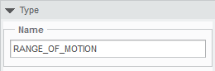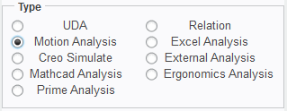**Task 1:** Create an analysis feature to find minimum y-distance, maximum y-distance, and minimum clearance as the mechanism runs through its range of motion.

|  |
| --- |
| 1. Disable all Datum Display types. 2. In the ribbon, select the **Analysis** tab. 3. Click **Analysis**  from the Manage group. 4. Type **RANGE_OF_MOTION** as the name and press ENTER. |
| 5. Select **Motion Analysis** as the type and click  **Next**. |
| 6. Select **DISTANCE_Y:VALVE _HEIGHT** and **CLEARANCE:CLEARANCE** from the parameter list and click **Run**. |

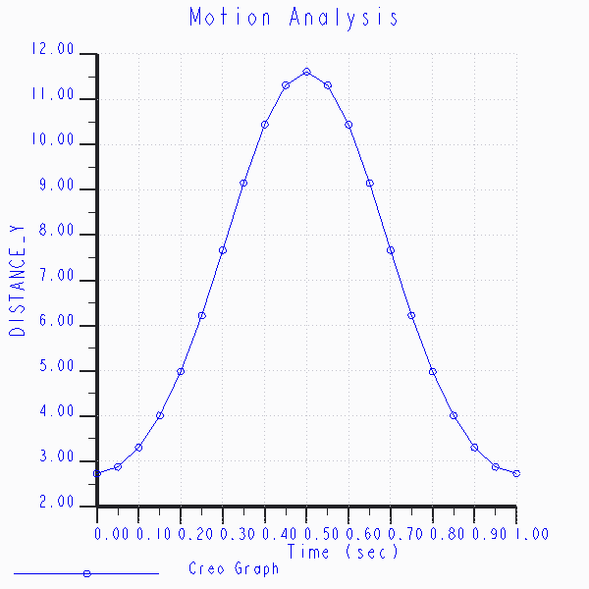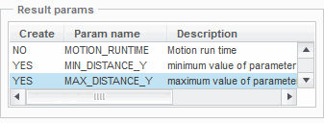

|  |
| --- |
| 7. Review and close the graphs. |
| 1. Click **Close** in the Motion Analysis dialog box. 2. Select **NO** to ensure that the MOTION_RUNTIME parameter is not created. 3. Select **MIN_DISTANCE_Y** from the parameter list and select **YES** to create it. 4. Select **MAX_DISTANCE_Y** from the parameter list and select **YES** to create it. |
| 12. Select **MIN_CLEARANCE** from the parameter list and select **YES** to create it. |
| 13. Click **Apply-Save Changes** . |

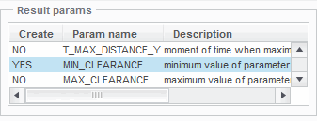This completes the exercise.

## Creating a Creo Simulate Analysis Feature

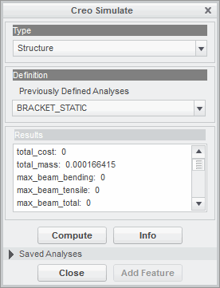Simulate analysis enables you to retrieve structural or thermal analysis measures as feature parameters. All default measures, as well as custom measures, can be created as parameters.

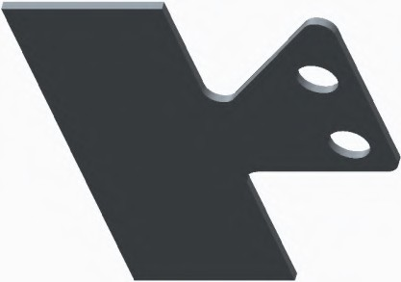

Figure 1– Determining Structural Stress Figure 2 – Configuring Simulate Analysis

###### Creating a Simulate Analysis Feature Overview

Creo Simulate analysis enables you to retrieve structural or thermal analysis measures as feature parameters.

###### Creo Simulate Analysis Feature Notes

Keep the following in mind when creating a Creo Simulate analysis feature:

* The Creo Simulate analysis must be created before creating the BMX Creo Simulate analysis feature.
* You can create multiple structural and/or thermal analyses in Creo Simulate. You then can select a specific analysis to reference in the BMX Simulate analysis feature.
* You do not have to run the Creo Simulate analysis in Creo Simulate mode since the analysis runs in BMX. However, there are no troubleshooting techniques available in BMX if there is an error in the Creo Simulate analysis.

###### BMXFeature Options

All default analysis measures available in Creo Simulate, and any custom measures that you create, can be created as BMX parameters. There are no BMX datums for the Creo Simulate analysis feature.

**Best Practices**

If you wish to optimize the structural or thermal responses of your model, you should conduct your optimization studies using Creo Simulate Structure Thermal. You should not use the BMX Feasibility and Optimization functionality to optimize the structural or thermal responses of your model.

## PROCEDURE - Creating a Creo Simulate Analysis Feature

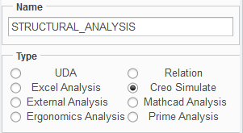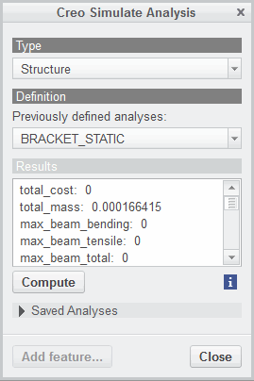**Task 1:** Create the Creo Simulate analysis feature.

|  |
| --- |
| 1. Disable all Datum Display types. 2. In the ribbon, select the **Analysis** tab. 3. Click **Analysis**  from the Manage group. 4. Type **STRUCTURAL_ANALYSIS** as the name and press ENTER. 5. Select **Creo Simulate** as the type and click **Next**. |
| 1. In the Creo Simulate Analysis dialog box, click   **Compute**. Click **Yes** in the Warning dialog box.   1. Review the results. |
| 1. In the Creo Simulate Analysis dialog box, click   **Close**.   1. Select **NO** to ensure that the total_cost parameter is not created. 2. Repeat the previous step for all other parameters, except max_stress_vm, so that they are also not created. |
| 11. Click **Apply-Save Changes** . |

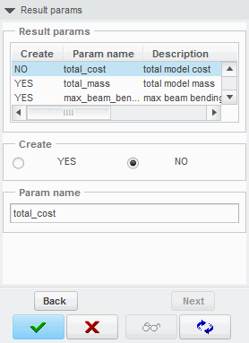**Task 2:** Display the maximum Von Mises stress parameter in the model tree.

1. 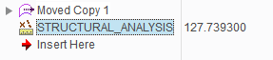In the model tree, click **Settings ** and select

##### Tree Columns .

1. Select **Feat Params** from the Type list.
2. Type **max_stress_vm** as the name.
3. Press ENTER.
4. Click **OK**.

This completes the procedure.

## Creating an MS Excel Analysis Feature

Excel analysis enables you to use an external Microsoft Excel file to define the analysis to perform on a Creo Parametric model.

Using Excel analysis, you can:

* + Configure one or more inputs.
  + 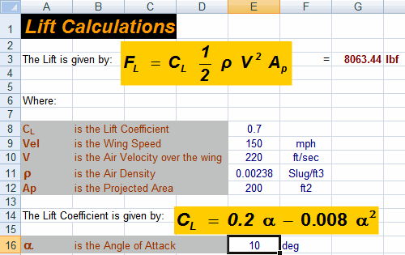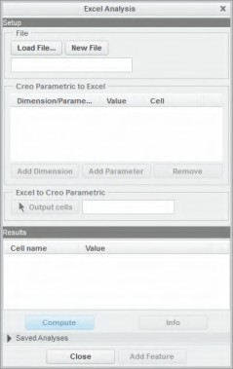Specify one or more outputs as parameters.

Figure 1 – Configuring the Excel Analysis Figure 1 – MS Excel Workbook

###### Creating an MS Excel Analysis Feature Overview

Excel analysis enables you to use an external Microsoft Excel file to define the analysis to perform on a Creo Parametric model. Using Excel analysis, you can:

* Configure one or more inputs.
* Specify one or more outputs as parameters.

In an Excel analysis feature, dimensions and parameters are passed to an Excel spreadsheet as input to a formula. Calculation results are transferred back into the Creo Parametric model and can be used to create an output parameter(s).

Input values for the Excel analysis can be the following:

* Model dimensions.
* Top-level parameters.
* Analysis feature parameters.

When you save an Excel analysis or create an Excel Analysis feature, the system saves the complete path to the

.xls file. When you retrieve an Excel analysis or when an Excel Analysis feature is regenerated, the system searches for the .xls file in these locations in the following order:

* The original location of the file from which it was selected for the analysis.
* The current working directory.
* The directory specified by the excel_analysis_directory configuration option.

***Note:*** *This functionality is intended for Windows machines. You cannot access Excel analysis on a UNIX workstation. If you retrieve a model with an Excel analysis on a UNIX workstation, the Analysis feature becomes frozen.*

###### BMXFeature Options

Due to the flexibility of this feature, the output parameters depend on the Excel spreadsheet. There are no BMX datums for the Excel analysis feature.

## PROCEDURE - Creating an MS Excel Analysis Feature

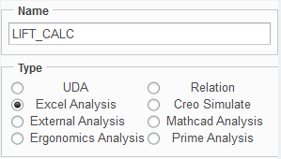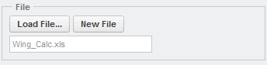**Task 1:** Create the Excel analysis feature.

|  |
| --- |
| 1. Disable all Datum Display types. 2. In the ribbon, select the **Analysis** tab. 3. Click **Analysis**  from the Manage group. 4. Type **LIFT_CALC** as the name and press ENTER. 5. Select **Excel Analysis** as the type and click **Next**. |
| 1. Click the **Load File...** button.    * Select **Wing_Calc.xls** and click **Open**.   ***Warning:*** *Do not close Book1.xls, as it is part of the Excel analysis feature.* |
| 1. Open Creo Parametric from the task bar. 2. Click **Add Dimension** and click the model to display its dimensions. |
| 9. Select the **10** degree dimension. |
| 10. Select cell **E16** in the Excel worksheet and click  **Done Sel**. |
| 1. Click **Add Parameter**.    * Select **PROJ_AREA:AREA_PAS** and click **OK**. |
| 1. Select cell **E12** in the Excel worksheet and click   **Done Sel**.   1. Select **Output Cells**. |

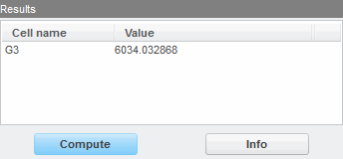

|  |
| --- |
| 14. Select cell **G3** in the Excel worksheet and click  **Done Sel**. Click **Compute**. |
| 1. Click **Close**. 2. Type **LIFT** as the parameter name and press ENTER. |
| 17. Click **Apply-Save Changes** . |

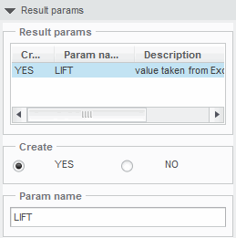This completes the procedure.

## Exercise 4: Calculate a Carbrake Rotor Temperature Using an MS Excel Analysis (CHALLENGE)

### Scenario

You are assigned to review the braking system on the new 490x prototype car. In this review, you are to determine whether the current airflow across the rotor is sufficient to keep the rotor temperature around 600°. The process to determine rotor temperature involves determining the area of a brake flute, number of brake flutes, area of air exit, and the area of the air intake. These values have been determined using Behavioral Modeling features. In this exercise, you input these numbers into a spreadsheet which calculates temperature.

**Task 1:** Calculate the rotor temperature using an MS Excel analysis feature.

|  |
| --- |
| 1. Disable all Datum Display types. 2. Add parameter **NUMBER_OF_FLUTES:4904000_BMX** and set it to cell **B7**. 3. Add parameter **BRAKE_FORCE:FORCE_ANALYSIS** and set it to cell **B5**. 4. Add parameter **FLUTE_SURF_AREA:FLUTE_SURF_ANALYSIS** and set it to cell **B8** . 5. Add parameter **AIR_INTAKE_AREA:AIR_INTAKE_ANALYSIS** and set it to cell **B9**. 6. Add parameter **AIR_EXIT_AREA:AIR_EXIT_ANALYSIS** and set it to cell **B10**. |
| 1. Configure cell A164 as the output cell and compute the temperature. 2. Type **ROTOR_TEMP** as the output parameter. |

This completes the exercise.

## Creating an External Analysis Feature

External analysis enables you to create parameters and datum geometry based upon the results. Some examples of external programs include:

* Computational Fluid Dynamics
* Finite Element Analysis

###### Creating an External Analysis Feature Overview

External analysis enables you to create a customized analysis using Creo Toolkit and start it from within Creo Parametric in an associative fashion. Some examples of external programs include:

* + Computational Fluid Dynamics
  + Finite Element Analysis

External analysis enables you to create parameters and datum geometry based upon the results.

In addition to standard analyses provided by Creo Parametric, you can create a customized analysis using a Creo Toolkit application, register the application, and start it from within Creo Parametric in an associative fashion.

You can also create an analysis feature that is driven by an external analysis. The external application determines which parameters and datum features are created as a result of this analysis feature.

The external application enables you to create geometry (for example, datum curves) and use this geometry as regular Creo Parametric features for modeling and analysis.

###### BMXFeature Options

Due to the flexibility of this feature, the output parameters depend on the external analysis. Additionally, external analyses can be programmed to include BMX datum features.

## Monitoring the Parameters of Analysis Features

Performance monitoring enables you to monitor the values of the parameters in the analysis features.

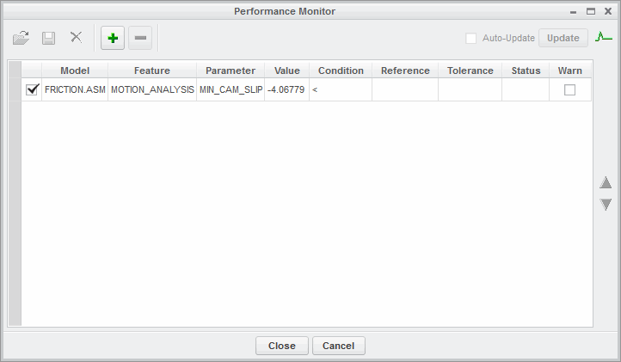

Figure 1 – Performance Monitor

###### Monitoring the Parameters of Analysis Features

You can monitor the parameters created by analysis features in the Performance Monitor dialog box. The Performance Monitor is an asynchronous and modeless dialog box that enables you to monitor the values of parameters of the analysis features, to specify the constraints that those parameters must satisfy, and to verify whether those constraints are satisfied. The dialog box contains a monitoring table with the following columns where you can specify information related to the parameters to be monitored:

* + Performance Monitoring – Specifies whether to monitor a parameter. The check box in this column enables you to switch on or off the monitoring of a specific parameter. If a parameter is not monitored, its status is not updated.
    - Model – Displays the name of the model that owns the parameter to be monitored.
    - Feature – Displays the name of the analysis feature that computes the parameter.
    - Parameter – Displays the parameter to be monitored.
    - Value – Displays the current value of the parameter and its units.
    - Condition – Displays the mathematical operator of the type <, =, >, >=, or <= selected for the constraint that the parameter must satisfy.
    - Reference – Displays the value you specify or the reference parameter you select against which the monitored parameter is compared. The selected reference parameters are assumed to be in the same type of units as the parameter being tracked. For example, if the monitored parameter is measured in meters, then the reference parameter can be in inches. Creo Parametric automatically displays the units for the reference value.
    - Tolerance – Displays the tolerance value within which the constraint should be satisfied. You can specify the tolerance as an absolute value or as a percentage of the reference value. To specify the tolerance in percentage, add the % symbol. Tolerance values that you enter are assumed to be in the same type of units as the parameter being tracked unless the % symbol is added. Creo Parametric automatically displays the units for the tolerance value.
    - Status – Displays the current status of the constraint. The status indicates whether the parameter satisfies the desired constraint or whether it is updated.

There are five possible statuses:

* The green dot specifies that the constraint is satisfied.
* The yellow dot specifies that the constraint is satisfied within the specified tolerance value.
* The red dot specifies that the constraint is not satisfied.
* The white dot specifies that the constraint is not updated. This status specifies the following conditions:
  + Constraint is not being monitored.
  + Analysis feature that computes the parameter is read-only or only regenerates during design studies.
  + Analysis feature failed to regenerate.
  + Analysis feature has not regenerated because regeneration of an earlier feature has failed.
*  The black dot specifies that the constraint is not valid. If either the parameter, or the reference parameter are missing, the constraint is considered to be invalid.
  + - Warn – Specifies whether a warning should be issued when a constraint is updated and if the status of the constraint is within tolerance, not satisfied, or not valid. The check box in this column enables you to switch on or off the issuing of warnings.

The 3-states button available for each of above listed columns enables you to sort and display all the rows under that column in a particular order. By default, the rows under each column are not sorted in any particular order. Each column can be sorted as follows:

•  – Specifies that the rows under the column are sorted in the descending order.

•  – Specifies that the rows under the column are sorted in the ascending order.

###### Auto-Update

Auto-Update in the Performance Monitor dialog box enables you to automatically update the status of the constraints when the model is regenerated or when the parameters are modified. If Auto-Update is not selected, you can use Update to evaluate the constraints and update the status.

In the Assembly mode, you can monitor the parameters at all levels within the assembly (top, subassembly, or part). Several models can be monitored simultaneously. However, the Performance Monitor dialog box corresponding only to the active model is displayed at any time. When a model is being monitored and a different model is activated, the Performance Monitor dialog box for the initial

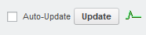

model collapses into the Overall Performance Status indicator. The parameters are monitored only if you have selected Auto-Update, but warnings are not displayed for models that are not active.

The Overall Performance Status indicator displays the overall status of all the parameters being monitored. It is displayed in the top-right corner in the Performance Monitor dialog box.

The overall status consists of the following three items:

* + Status of valid and updated constraints – If all the constraints are satisfied, then the Overall Performance Status indicator appears in green. If even one of the constraints is within tolerance, then the indicator appears in yellow. If even one of the constraints is not satisfied, then the indicator appears in red.
  + Presence of not updated constraints
  + Presence of not valid constraints

When you click Close, the Performance Monitor dialog box collapses into the Overall Performance Status indicator in the Creo Parametric status area. If you have selected Auto-Update before collapsing the dialog box, the monitoring continues and the Overall Performance Status indicator provides the updated status of all the parameters being monitored. If you double-click the Overall Performance Status indicator, the Performance Monitor dialog box is restored.

You can save a setup defined for the selected parameters and their constraints along with the model. The saved setup can easily be retrieved or deleted from the Setup List dialog box.

## PROCEDURE - Monitoring the Parameters of Analysis Features

**Task 1:** Compute the difference between the total surface area and the bottom surface area.

|  |
| --- |
| 1. Disable all Datum Display types. 2. In the ribbon, select the **Analysis** tab. 3. Click **Performance Monitor**  from the Manage group. |
| 4. Click **Add** from the Performance Monitor dialog box. This adds FRICTION.ASM to the Model column and MOTION_ANALYSIS to the Feature.  ***Note:*** *If the selected model has more than one analysis feature, a list of all the analysis features displays in the Feature column.* |
| 1. Click **MIN_CAM_SLIP** in the Parameter column and edit it to **MAX_CAM_SLIP**. 2. If necessary, select **<** from the Condition column. 3. Type **8.0** as the Reference number. 4. Type **0.1** as the Tolerance and press ENTER. |
| 9. Select the check box under the Warn column.  Notice the status symbol.  ***Note:*** *When the check box below the Parameter Monitoring column for a particular parameter is not selected, or if the model whose parameters are monitored is not active, then the warnings are not displayed.* |
| 10. Click **Update** to evaluate all the constraints and update their status. |

 



|  |
| --- |
| 1. Click **Confirm** to return. 2. Click **MAX_CAM_SLIP** in the Parameter column and edit it to **MIN_CAM_SLIP**. 3. Click **Update**. Notice the change in the status symbol. |
| 14. Click **Add** from the Performance Monitor dialog box. |
| 1. Select the additional parameter with the empty reference   field. Click **Delete** .   1. Click **Close** to close the Performance Monitor dialog box. |

This completes the procedure.

## Statistical Design Study

Before learning about each individual analysis feature, you must understand the statistical distributions used.

Following are the available types of statistical distributions:

* + - Exponential
    - Lognormal
    - Normal
    - Uniform
    - Weibull

###### Conducting a Statistical Design Study

A Statistical Design Study enables you to assign statistical distributions to dimensions and parameters that are design variables and to parameters that are design goals of a Multi-Objective Design Study (MODS). Using the response surface corresponding to a MODS (MODSRS) and the statistical distributions assigned to the corresponding design variables, Creo Parametric runs a large number of approximate experiments to determine the distribution parameters of the design goals of a MODS. You can use the results of a statistical design study to find a “close to optimal” operating point for your design goals.

You can select a type of statistical distribution for the design goals of a MODS. Accordingly, the distribution parameters that provide the best fit to the sampling of the response surface are computed. The Normal type of statistical distribution is selected by default for the design variables listed under the Design Variables section and for the design goals listed under the Design Goals section in the Statistical Design Study dialog box.

Methods of conducting a statistical design study are as follows:

* Single – A single operating point is used for the study and all the samples are in the neighborhood of the operating point according to the statistical distributions of the design variables. In case of Lognormal and Normal types of statistical distributions, the operating point is the mean of the distribution.
* MODS – Points uniformly distributed in the design space of MODSRS are used for the study. The number of operating points is equal to the number of experiments specified for the MODS. For each operating point, a statistical design study is conducted and the statistical distribution parameters for the design goals are computed. These parameters are displayed under the Table Data section in the Multi-Objective Design Study dialog box. The column names for these parameters appear in the format DISTRIBUTIONPARAMETERNAME-DESIGNGOALNAME. Fo

example, Standard Deviation for an analysis feature having the name LENGTH:CIRCUMFERENCE_1 is displayed in the format STANDARD_DEVIATION-LENGTH:CIRCUMFERENCE_

# Module 16

## Conducting Design Studies and Optimizing Models

## Comparing Design Studies

Before learning about each individual analysis feature, you must understand:

* 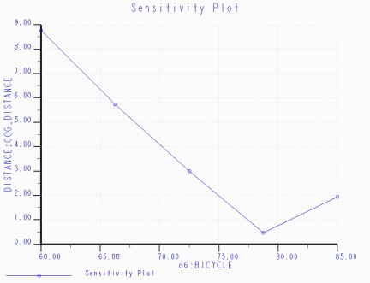Differences between the design studies.
* Similarities between the design studies.

Figure 1 – Sensitivity Analysis Results

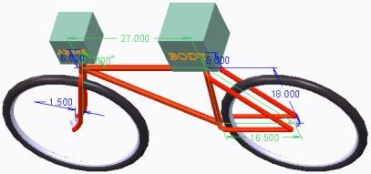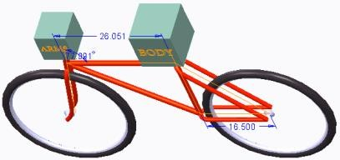

Figure 2 – Model Prior to Feasibility Study Figure 3 – Model After Feasibility Study

###### Comparing Design Studies

Before learning about each individual analysis feature, you must understand:

* + Differences between the design studies.
  + Similarities between the design studies.

You can use analysis features in conjunction with other parameters in iterative design studies. These design studies enable you to investigate and optimize your model designs, enabling Creo Parametric to determine an optimal model based upon your specified design constraints and design variables.

###### Similarities and Differences Between Design Studies

In this module, you learn how to create sensitivity, feasibility, and optimization studies that enable you to create products that meet or exceed your design specifications.

* + Sensitivity analysis enables you to measure and graph how changing a single dimension or parameter affects other model parameters.
  + Feasibility design studies enable you to search for solutions within a range of dimensions that satisfy your design constraints.
  + Optimization design studies enable you to search for a solution to an objective/goal.

Additionally, you can save feasibility and optimization design studies as model features. The only difference between feasibility and optimization design studies is that optimization design studies include a design goal, such as minimizing the mass of the model. You should use sensitivity analysis to narrow the number of dimensions or parameters used in both the feasibility and optimization design studies.

## Translating Design Specifications

You must be able to translate design specifications into Creo Parametric terminology.

The following are Creo Parametric terms for feasibility studies.

* + - Design Constraint – Feasibility Terms
* Model must contain exact volume. – Volume = 7.51
* Gap between two edges must be greater than a specified value. – Distance > 140
* Center of gravity must be aligned with axis of rotation. – Distance = 0 The following are Creo Parametric terms for optimization studies.
  + - Design Goal – Optimization Terms
* Lightest – Minimize Mass
* Fastest – Maximize Velocity
* Least Material – Minimize Volume
* Least Cost – Minimize Cost or Mass

###### Translating Design Specifications

Since all product designs are based upon predetermined specifications, you must be able to translate the specifications into Creo Parametric terminology. Some design constraints specify:

* The model must contain an exact volume.
  + Configure a design constraint of volume to equal a specific amount. For example, 7.51.
* The gap between two edges must be greater than a specified value.
  + Configure a design constraint of distance greater than a specific amount. For example, 140.
* The center of gravity must be aligned with the axis of rotation.
  + Configure a design constraint of distance equal to zero.

Examples of design goals include:

* Lightest – You want to minimize mass. Therefore, you need an analysis feature that outputs mass as a parameter.
* Fastest – You want to maximize velocity. Therefore, you need an analysis feature that outputs velocity as a parameter.
* Least Material – You want to minimize volume. Therefore, you need an analysis feature that outputs volume as a parameter.
* Least Cost – You want to minimize either cost or mass. Therefore, you need an analysis feature that outputs either cost or mass as a parameter.

## Performing Sensitivity Analysis

Sensitivity analysis enables you to analyze how measured quantities or parameters change as a model dimension or parameter is varied within a specified range.

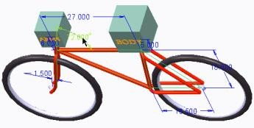Sensitivity analysis enables you to determine how changes will impact your design.

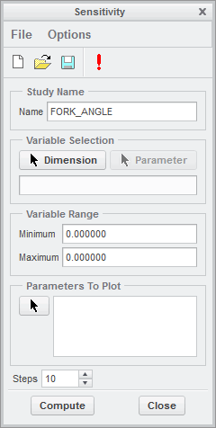Figure 1 – Selecting a Dimension for Analysis

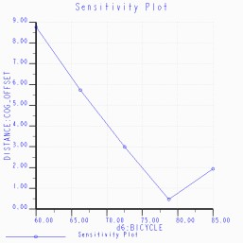

Figure 2 – Sensitivity of Center of Gravity

to a Varying Dimension Figure 3 – Sensitivity Analysis Window

###### Performing Sensitivity Analysis

Sensitivity analysis enables you to analyze how measured quantities or parameters change as a model dimension or model parameter is varied within a specified range. The result is a graph for each selected parameter, which displays the value of the parameter as a function of the dimension.

To create a sensitivity analysis, you define:

* + A model dimension or parameter to vary.
  + The range of values within which the dimension will vary.
  + Parameters to plot.
  + The number of computation steps in a range.

When executing a sensitivity analysis, Creo Parametric:

* + Varies the selected dimension or parameter within the specified range.
  + Regenerates the model at each step.
  + Computes the selected parameter(s).
  + Generates a resultant graph.

###### Graphing Results

A sensitivity analysis displays dependencies between analysis feature parameters and model dimensions or independent model parameters. It also helps locate the values of dimensions or independent model parameters that result in meeting a desired constraint or goal in a feasibility or optimization design study.

Within the sensitivity analysis graph:

* + The X-axis displays the dimension that is allowed to vary within a specified range.
  + The Y-axis displays an analysis feature value as determined by the parameter to plot.

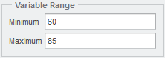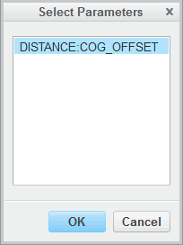

###### Sensitivity Analysis

Sensitivity analysis enables you to examine dimensions to determine how varying a dimension affects the design model. For example, you can determine which of three dimensions must change the least to move the center of gravity of the model. This dimension is a good candidate when executing a feasibility or optimization design study.

## PROCEDURE - Performing a Sensitivity Analysis

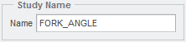**Task 1:** Perform a sensitivity analysis.

|  |
| --- |
| 1. Disable all Datum Display types. 2. In the model tree, click **Settings**  and select   **Tree Filters** .   1. Under Display, select the **Features** check box and click **OK**. 2. In the ribbon, select the **Analysis** tab. 3. Click **Sensitivity Analysis**  from the Design Study group. 4. Type **FORK_ANGLE** as the name. |
| 1. Click **Dimension**.    * Select **MODIFY_THIS** from the model tree and select **72°**. |
| 1. Configure the variable range.    * Type **60** for the minimum.    * Type **85** as the maximum. |
| 1. In the Parameters to Plot section click **Select Parameters** .    * Select **DISTANCE:COG_OFFSET** from the Select Parameters dialog box and click **OK**. |



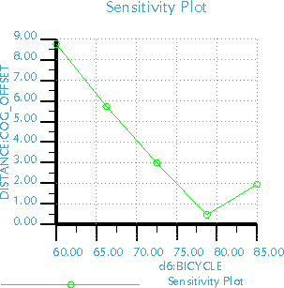

|  |
| --- |
| 10. Type **5** as the number of steps and click  **Compute**.  ***Note:*** *The center of gravity of the bicycle is very responsive to a change in the angle of the front fork. Therefore, this is a good dimension to select for any feasibility/optimization design studies.* |
| 1. Close the Graphtool dialog box. 2. In the Sensitivity dialog box, click **Close**. |

This completes the procedure.

## Exercise 1: Applying Sensitivity Analysis to Increase Pump Volume

### Scenario

You are part of a design team tasked with optimizing a hand pump to increase the volume of water pumped per stroke. To complete this task, you create several BMX features. Four of the features have already been completed: a Distance Analysis feature that measures the height of the valve from

the bottom surface of the cylinder, a Pairs Clearance analysis feature that measures the clearance distance between ROD_TOP.PRT and CYLINDER.PRT, a Motion Analysis feature that measures minimum y-distance, maximum y-distance, and minimum clearance, and a Relation Analysis feature that calculates the pumping volume.

**Task 1:** Perform a Sensitivity Analysis to determine if pump volume is sensitive to changes in link length.

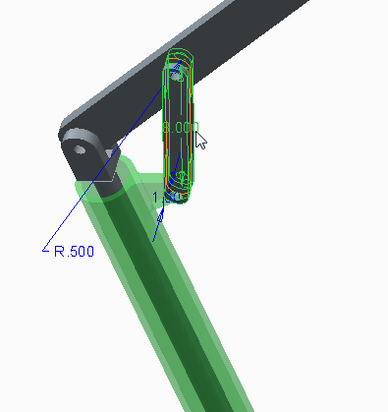

|  |
| --- |
| 1. Disable all Datum Display types. 2. In the model tree, click **Settings**  and select   **Tree Filters** .   1. Enable **Features** in the Model Tree Items dialog box and click **OK**. 2. In the ribbon, select the **Analysis** tab. 3. Click **Sensitivity Analysis**  from the Design Study group. 4. Click **Dimension**.    * Select LINK.PRT from the graphics window and select **8**. |
| 1. Run the sensitivity analysis.    * Type **6** as the minimum variable range and type   **10** as the maximum variable range. |

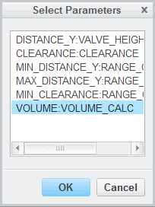

|  |
| --- |
| 1. In the Parameters to Plot section click **Select Parameters** .    * Select **VOLUME:VOLUME_CALC** and click **OK**. |
| 9. Click **Compute**.  ***Note:*** *The volumeranges approximately +/- 7%, which indicates that the volume is somewhat sensitive to change in link length.* |
| 1. Close the Graphtool dialog box. 2. Click **Close** from the Sensitivity dialog box. |

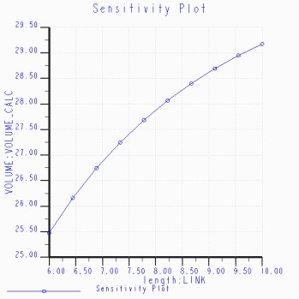**Task 2:** Perform a Sensitivity Analysis to determine if pump volume is sensitive to changes in handle length.

|  |
| --- |
| 1. Click **Sensitivity Analysis**  from the Design Study group. 2. Click **Dimension**.    * Select HANDLE.PRT from the graphics window and select **20**. |
| 3. Ensure that the minimum variable range is 18 and ensure that the maximum variable range is 22. |

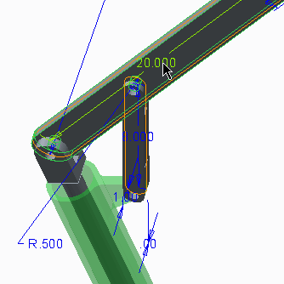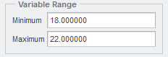

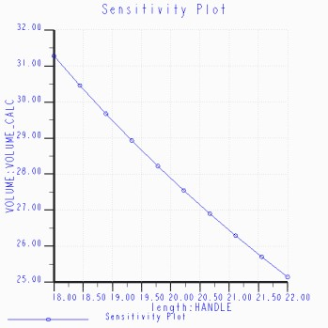

|  |
| --- |
| 1. Ensure that VOLUME:VOLUME _CALC is configured as the parameter to plot. 2. Click **Compute**.   ***Note:*** *The volume ranges approximately +/- 10% from the original value, which indicates that the volume is somewhat sensitive to change in handle length.* |
| 1. Close the Graphtool dialog box. 2. Click **Close** from the Sensitivity dialog box. |

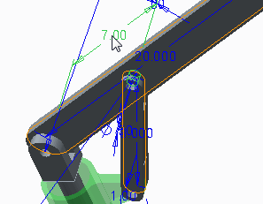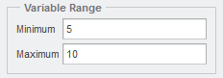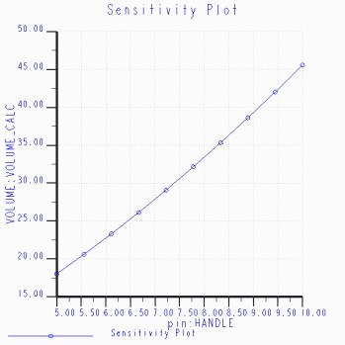**Task 3:** Perform a Sensitivity Analysis to determine if pump volume is sensitive to changes in handle pin location.

|  |
| --- |
| 1. Click **Sensitivity Analysis**  from the Design Study group. 2. Expand the HANDLE.PRT node in the model tree. 3. Click **Dimension**.    * Select **Hole id 153** in the model tree and select   **7**. |
| 4. Type **5** as the minimum variable range and type  **10** as the maximum variable range. |
| 1. Ensure that **VOLUME:VOLUME_CALC** is configured as the parameter to plot. 2. Click **Compute**.   ***Note:*** *The volume increased approximately 150% from the minimal range value, which indicates that the volume is very sensitive to change in handle pin location.* |
| 1. Close the Graphtool dialog box. 2. Click **Close** from the Sensitivity dialog box. |

This completes the exercise.

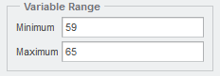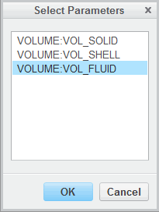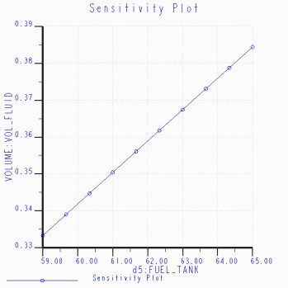

## Exercise 2: Applying Sensitivity Analysis to Increase Fuel Capacity

### Scenario

The design specification of a fuel tank requires it to hold at least 0.35 liters of fuel. The design specification also requires that the fuel tank be able to identify when it is half full. You are assigned to ensure that the fuel tank meets these design specifications. In this exercise, you determine how to increase the volume of the fuel tank. Three analysis features have been created: the first feature calculates the volume of the solid model prior to the shell feature, the second feature calculates the volume of the shelled model, and the third feature calculates the difference between the initial two features to provide the volume of fuel that the tank can hold.

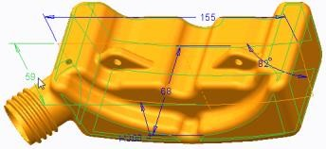**Task 1:** Perform a Sensitivity Analysis to determine if fuel capacity can be increased.

|  |
| --- |
| 1. Disable all Datum Display types. 2. In the ribbon, select the **Analysis** tab. 3. Click **Sensitivity Analysis**  from the Design Study group. 4. Run the sensitivity analysis.    * Click **Dimension**.    * Select **BASE_PROTRUSION** from the model tree, and select **59**. |
| 5. Type **59** as the minimum variable range and type **65**  as the maximum variable range. |
| 1. In the Parameters to Plot section click **Select Parameters** .    * Select **VOLUME:VOL_FLUID** and click **OK**. |
| 7. Click **Compute**.  ***Note:*** *When dimension d5 = 61, the volume is approximately 0.350 liters.* |

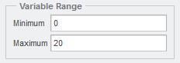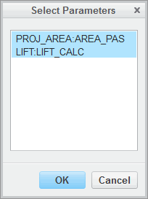

1. Close the Graphtool dialog box.
2. Click **Close** from the Sensitivity dialog box. This completes the exercise.

## Exercise 3: Calculating the Lift Effect of Angling the Wing Using the Sensitivity Study

### Scenario

You are tasked with finding the lift of a prototype wing. In the past, this calculation was completed manually using several pages in Microsoft Excel. However, now you will complete this task using several BMX features in Creo Parametric. Two of the features have already been created: the first feature determines the projected area of the wing that affects lift. The second feature uses the projected area parameter to determine the lift of the wing at a specified angle of attack. In this exercise, you perform a Sensitivity Analysis to determine how changing the angle of attack affects the wing's lift characteristics.

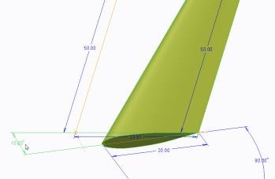**Task 1:** Perform a Sensitivity Analysis to determine lift as a function of angle of attack.

|  |
| --- |
| 1. Disable all Datum Display types. 2. In the ribbon, select the **Analysis** tab. 3. Click **Sensitivity Analysis**  from the Design Study group.    * Click **Dimension**.    * In the model tree, select **Protrusion id 39**. On the model select **10°**. |
| 4. Type **0.0** as the minimum variable range and type  **20.0** as the maximum variable range. |
| 1. In the Parameters to Plot section click **Select Parameters** .    * Press CTRL and select **PROJ_AREA:AREA_PAS**   and **LIFT:LIFT_CALC**.   * + Click **OK**. |

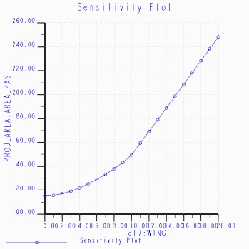

|  |
| --- |
| 6. Type **21** as the number of steps and click  **Compute**. |
| 1. After reviewing the Sensitivity plots, close both Graphtool dialog boxes. 2. Click **Close** from the Sensitivity dialog box. |

This completes the exercise.

## Performing Feasibility Design Studies

Feasibility design studies enable you to search for solutions within a range of dimensions that satisfy your design constraints.

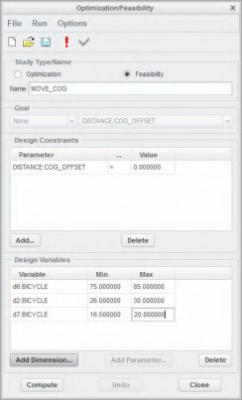You can determine the most desirable result based upon your design constraints.



Figure 1 – Model After Feasibility Study Figure 2 – Feasibility Design Study

###### Performing Feasibility Design Studies

Feasibility design studies enable you to search for solutions within a range of dimensions that satisfy your design constraints. You specify the constraints by using one or more analysis feature parameters.

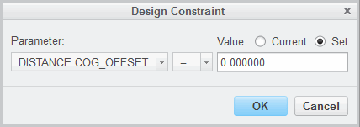

In a feasibility study, you define:

* + A set of constraints for the design to satisfy.
  + One or more model dimensions to vary.
  + A range within which each dimension can vary.

The constraints are defined as equalities or inequalities that use constant values and parameters, which are the result of analysis features. A sample constraint may appear as: DISTANCE:COG_OFFSET

= 0 or LENGTH < 6.3.

When executing a feasibility design study, Creo Parametric:

* + Attempts to define a set of dimension values within the specified range that satisfies all constraints.
  + Displays the changes to the model if a solution is found.

You can either accept the new dimension values or undo the change, reverting the model to its state before the study.

***Note:*** *There can be many solutions that satisfy all constraints. Creo Parametric converges to one of the solutions based on the initial state of the model.*

###### Feasibility Design Study

Feasibility design studies enable you to determine the most desirable result based on your design constraints.

**Best Practices**

Feasibility design studies enable you to search for solutions within a range of dimensions that satisfy your design constraints. You specify the constraints by using one or more analysis feature parameters.

## PROCEDURE - Performing a Feasibility Design Study

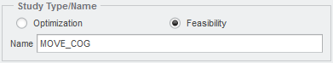**Task 1:** Create a feasibility design study and add the design constraint.

|  |
| --- |
| 1. In the model tree, click **Settings**  and select **Tree Filters** . 2. Under Display, select the **Features** check box and click **OK**. 3. Disable all Datum Display types. |
| 1. In the ribbon, select the **Analysis** tab. 2. Click **Feasibility/Optimization**  from the Design Study group.    * Select **Feasibility**.    * Type **MOVE_COG** as the name. |
| 1. Click **Add...** within Design Constraints. 2. Select the **Set** option. 3. Click **OK** to add the design constraint. 4. Click **Cancel** to stop adding design constraints. |

**Task 2:** Configure the design study preferences.

* 1. 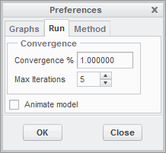Click **Options > Preferences...** from the Optimization/Feasibility dialog box.
     + Select the **Run** tab.
     + Type **1** for Convergence %.
     + Type **5** as the Max Iterations.
     + Click **OK**.

**Task 3:** Add multiple design variables.

1. Click **Add Dimension...** within Design Variables.
2. Select **MODIFY_THIS** from the model tree, and select **72.000°**.
   * 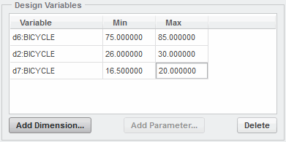Type **75** as the minimum and type **85** as the maximum.
3. Select **27** on the model.
   * Type **26** as the minimum and type **30** as the maximum.
4. Select **16.5** on the model.
   * Type **16.5** as the minimum and type **20** as the maximum and press ENTER.
5. Click **Compute** and click **Close > Confirm** to accept the results.

This completes the procedure.

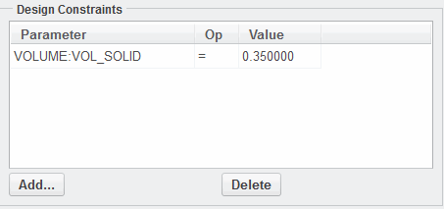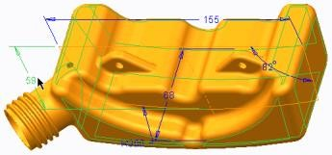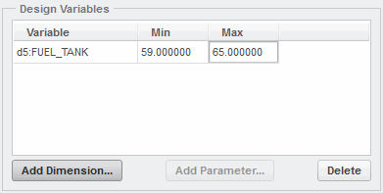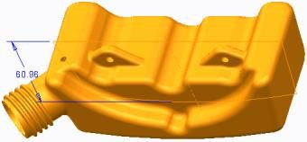

## Exercise 4: Perform Feasibility Studies to Meet Design Specifications

### Scenario

The design specification of a fuel tank requires it to hold at least 0.35 liters of fuel. The design specification also requires that the fuel tank be able to identify when it is half full. You are assigned to ensure that the fuel tank meets these design specifications. In this exercise, you increase the volume of the fuel tank. Three analysis features have been created: the first feature calculates the volume

of the solid model prior to the shell feature; the second feature calculates the volume of the shelled model; and the third feature calculates the difference between the initial two features to provide the volume of fuel that the tank can hold.

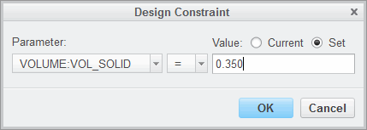**Task 1:** Perform a feasibility design study to increase fuel capacity to 0.350 liters.

|  |
| --- |
| 1. Disable all Datum Display types. 2. In the ribbon, select the **Analysis** tab. 3. Click **Feasibility/Optimization**  from the Design Study group. 4. Select **Feasibility** and click **Add...** within Design Constraints.    * Select **VOLUME:VOL_FLUID** from the Parameter drop-down list.    * Select the **Set** option.    * Type **0.350** as the Value.    * Click **OK** to add the design constraint. |
| 5. Click **Cancel** to stop adding design constraints. |
| 6. Click **Add Dimension...** within Design Variables. In the model tree select **BASE_PROTRUSION**, and select **59** on the model. |
| 7. Type **59** as the minimum and type **65** as the maximum. Press ENTER. |
| 8. Click **Compute** and when complete, click **Close**  **> Confirm** to accept the results.  ***Note:*** *A feasible solution was found.* |
| 9. Click **Save**  from the Quick Access toolbar. |

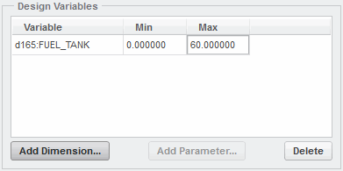

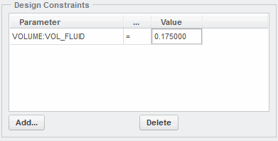**Task 2:** Perform a feasibility design study to place a half full indicator line.

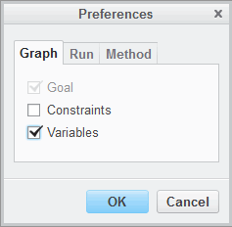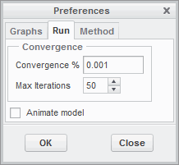

|  |
| --- |
| 1. Click **Feasibility/Optimization**  from the Design Study group. 2. Edit the design constraint to **VOLUME:VOL_ FLUID**=**0.175** and press ENTER.   ***Note:*** *Note that 0.175 = 0.350/2.* |
| 1. Configure the design study preferences.    * Click **Options > Preferences...** and select   **Variables**. |
| 1. Select the **Run** tab.    * Type **0.001** as the Convergence %.    * Click **OK**. |
| 1. Delete the design variable.    * Select **d5:FUEL_TANK** and click **Delete**. 2. Click **Add Dimension...** within Design Variables.    * Select **FLUID_LEVEL** from the model tree.    * Select **0** on the model. 3. Type **0** as the minimum and type **60** as the maximum. Press ENTER. |

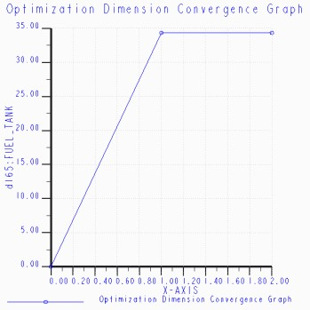

|  |
| --- |
| 8. Click **Compute**.  ***Note:*** *The tank is half full when datum plane FLUID_LEVEL is 34.34mm offset from datum plane TOP.* |
| 1. Close the Graphtool dialog box. 2. Click **Close > Confirm** to accept the results. |

This completes the exercise.

## Performing Optimization Design Studies

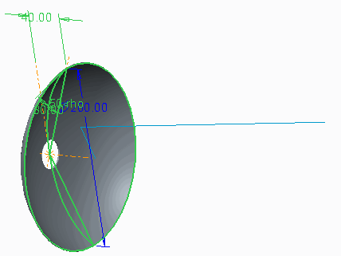Optimization design studies enable you to search for a solution to an objective.

Optimization design studies also enable you to optimize your models based upon your design goals.

Figure 1 – Part Model

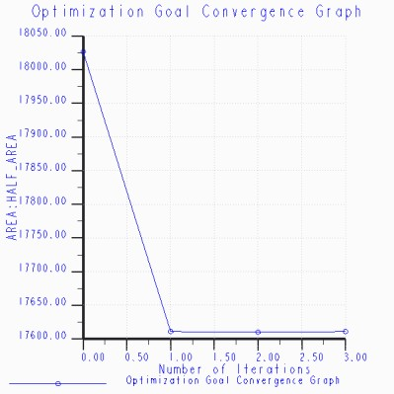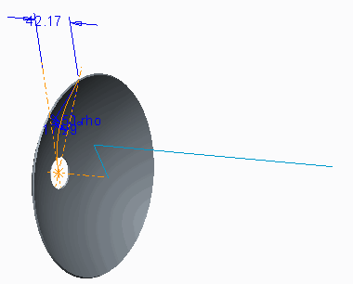

Figure 2 – Optimization of Area and Angle Figure 3 – Optimized Part

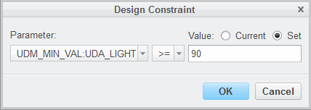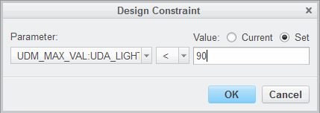

###### Performing Optimization Design Studies

An optimization design study seeks a solution to an objective (meaning, minimization or maximization of an analysis feature parameter) while being constrained. The constraint rules can be specified in the form of an allowable range for model dimensions or other analysis feature parameters. If a solution exists for the given set of constraints, then the model can be optimized and changed to the new configuration.

In an optimization design study, you define:

* + - A goal function to maximize or minimize.
    - A set of constraints for the design to satisfy.
    - One or more dimensions to vary.
    - A range within which each dimension can vary.

When executing an optimization design study, Creo Parametric:

* + - Searches for feasible solutions.
    - Selects the best solution that satisfies the goal function out of the possible solutions.

###### Optimization Design Study

Optimization design studies enable you to optimize your models based upon your design goals.

## PROCEDURE - Performing an Optimization Design Study

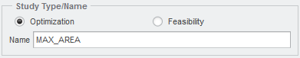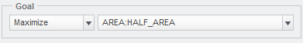**Task 1:** Create an optimization design study and add design constraints.

|  |
| --- |
| 1. Disable all Datum Display types. 2. Select the **Analysis** tab. Click **Feasibility/ Optimization**  from the Design Study group. 3. Type **MAX_AREA** as the name. |
| 4. Select **Maximize** as the goal and select  **AREA:HALF_AREA** as the parameter. |
| 1. To add the first design constraint, click **Add...**   within the Design Constraints section.   * + Select **UDM_MIN_VAL:UDA_LIGHT** and select   **>=** .   * + Select **Set** and type **90**.   + Click **OK** to add the design constraint. |
| 1. To add the second design constraint, perform the following:    * Select **UDM_MAX_VAL:UDA_LIGHT** and select **<**.    * Select **Set** and type **90**.    * Click **OK** to add the design constraint. 2. Click **Cancel** to stop adding design constraints. |



**Task 2:** Add multiple design variables.

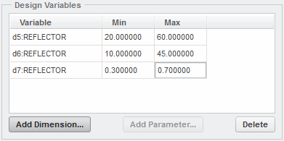

|  |
| --- |
| 1. Click **Add Dimension** within the Design   Variables section.   1. Select **Surface id 14** from the model tree, and select   **40**.   * + Type **20** as the minimum and type **60** as the maximum.  1. Select **30°** on the model.    * Type **10** as the minimum and type **45** as the maximum. 2. Select **0.50 rho** on the model.    * Type **0.30** as the minimum and type **0.70** as the maximum.    * Press ENTER. |
| 1. Click **Compute**.   ***Note:*** *Your results may not exactly match the results shown in the flgures, but the optimization study should be successful.*   1. Close the Graphtool dialog box. |
| 7. Click **Close > Confirm** to accept the results. |

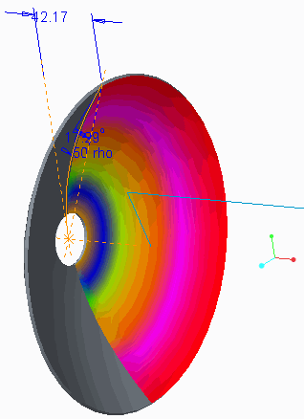**Task 3:** Run the UDA to ensure that the goal has been fulfilled.

|  |
| --- |
| 1. Click **User-Defined Analysis**  from the Custom group. 2. Click **Compute** from the User-Defined Analysis window.   ***Note:*** *As indicated in the flgures, the light reflection angle is approximately 90° for REFLECTOR.PRT .* |
| 3. Close all dialog boxes. |

This completes the procedure.

## Exercise 5: Optimizing the Hand Pump

### Scenario

You are part of a design team tasked with optimizing a hand pump to increase the volume of water pumped per stroke. To complete this task, you create several BMX features. Four of the features have already been completed: a distance analysis feature that measures the height of the valve from the bottom surface of the cylinder, a pairs clearance analysis feature that measures the clearance distance between ROD_TOP.PRT and CYLINDER.PRT, a motion analysis feature that measures minimum y-distance, maximum y-distance, and minimum clearance, and a relation analysis feature that calculates the pumping volume.

**Task 1:** Optimize the water volume for the hand pump using the handle pin location as a design variable.

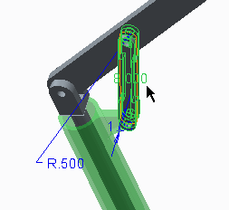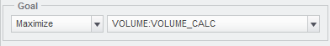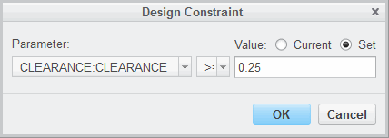

|  |
| --- |
| 1. Disable all Datum Display types. 2. In the model tree, click **Settings** , and select   **Tree Filters** .   1. Enable **Features** in the Model Tree Items dialog box and click **OK**. 2. In the ribbon, select the **Analysis** tab. 3. Perform the optimization design study.    * Click **Feasibility/Optimization**  from the Design Study group. 4. Type **MAX_VOLUME** as the name. 5. Select **Maximize** as the goal and select   **VOLUME:VOLUME_CALC** as the parameter. |
| 1. Click **Add...** within Design Constraints.    * Select **CLEARANCE:CLEARANCE** and select   **>=** .   * + Select **Set** and type **0.25** .   + Click **OK** to add the design constraint.  1. Click **Cancel** to stop adding design constraints. |
| 1. Click **Add Dimension...** within Design Variables.    * Select LINK.PRT from the graphics window and select **8**. |

  

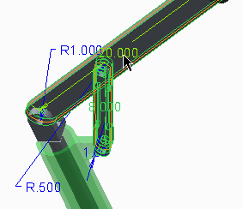

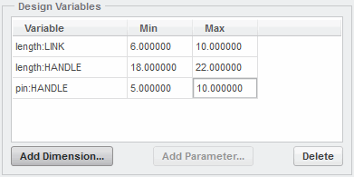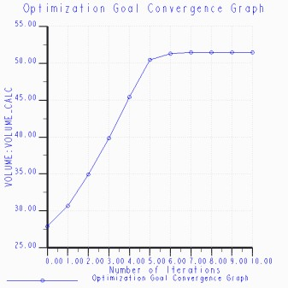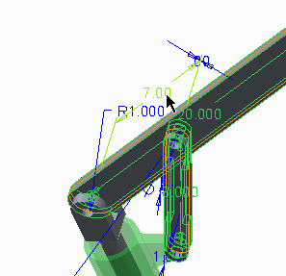

|  |
| --- |
| 11. Select HANDLE.PRT from the graphics window and  select **20**. |
| 1. Expand the node of HANDLE.PRT in the model tree. 2. Select **Hole id 153** in the model tree and select   **7**. |
| 1. For length:LINK, type **6** as the minimum and type   **10** as the maximum.   1. For length:HANDLE, type **18** as the minimum and type **22** as the maximum. 2. For pin:HANDLE, type **5** as the minimum and type   **10** as the maximum. Press ENTER. |
| 17. Click **Compute**.  ***Note:*** *Your results may not exactly match the results shown in the flgures, but the optimization study should be successful.* |
| 1. Close the Graphtool dialog box. 2. Click **Close > Confirm** to accept the results. |

This completes the exercise.